District UIP/READ Act Requirements

Submission Guide

Overview
The following instructions are provided as a tool to support districts in reporting K-3 literacy instructional program data as described in the READ Act. Please use the blank spreadsheet template provided on the UIP Resources website. This template will be submitted as an attachment to the district UIP and included in public posting. Districts are required to report K-3 literacy instructional program data for each elementary school in their district.

Naming Convention
As part of the file naming convention it is important to include a unique identifier. When you download the spreadsheet from the website, we recommend saving the spreadsheet using the following naming convention: UIP_READ_DATA_[District Code]. This naming convention should also be used when attaching the spreadsheet to the district UIP.

Getting Started
Review the instructions tab in the spreadsheet.
Steps to Enter District/School Codes, District/School Names, and Grade Levels
*You will repeat the following steps 1-5 on each of the tabs in the spreadsheet.
- Input your district’s four-digit district code in Column A
- Input the name of your district in Column B
- Input the four-digit school code for the specified school district in Column C
- Input the name of school for the specified school code in Column D

Note: List of valid district and school codes/names can be found on the District & School Codes tab in the spreadsheet. They can also be found here: http://www.cde.state.co.us/datapipeline/org_orgcodes

- Select from the drop down the appropriate grade level in Column E
- Must be a grade level between kindergarten and third
- All grade levels between K-3 served by the school must be reported

Example:
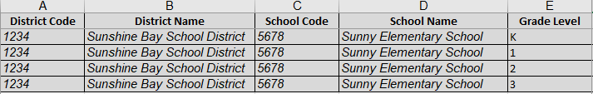

Steps to Complete the Interim Assessment Tab
- Click on the Interim Assessment tab.
- Complete steps 1-5 listed in the orange box on page 1 of this document.
- Column F: Click on the drop-down menu and select the READ Act Interim assessment that is administered for the specified school and grade level selected.

Example:
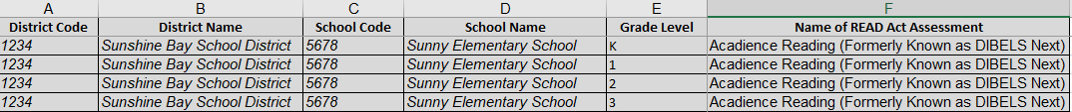

Potential Assessment Scenario:
- If multiple assessments are used in one grade level (ex: English and Spanish), scroll to Column G and select additional assessment that is used.

Example:
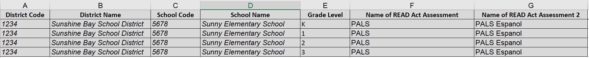

Steps to Complete the Diagnostic Tab
- Click on the Diagnostic Assessment tab.
- Complete steps 1-5 listed in the orange box on page 1 of this document.
- Column F: Click on the drop-down menu and select the READ Act diagnostic assessment that is administered for the specified school and grade level selected.

Example:
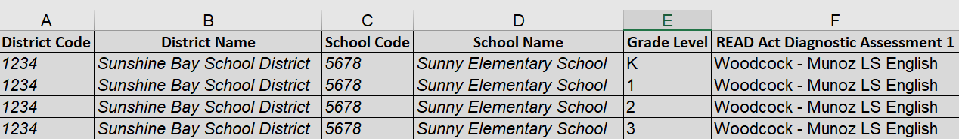

Potential Scenario when reporting Diagnostic Assessments:
If multiple READ Act diagnostic assessments are used in one grade level (ex: English and Spanish), scroll to Column G and select the additional READ Act diagnostic assessment that is used.

Example:
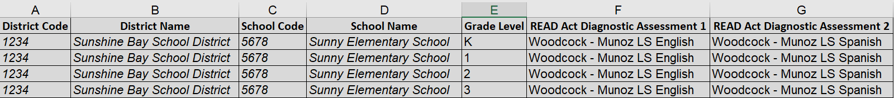

Steps to Complete the Core Programming Tab
- Click on the Core tab in the spreadsheet.
- Complete steps 1-5 listed in the orange box on page 1 of this document.
- Column F: Click on the drop-down menu and select the core program in use at each school and grade level.
- Column G: Click on the drop-down menu and select from which year the specified core program was published.

Example:
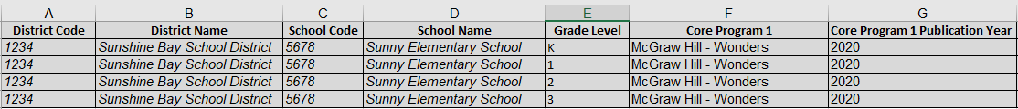
Potential Scenarios when reporting Core Programs:

Core Program Scenario 1:
If a school has multiple core programs in place at the same grade level (ex: English and Spanish), scroll to the right and enter additional programs/publication year in the columns provided (Columns H-K).

Example:
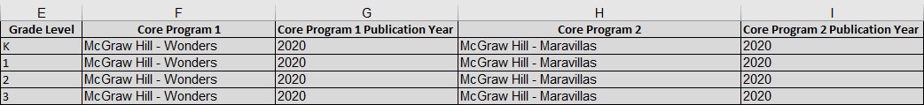

Core Program Scenario 2:
If the core program used by a school for a grade level is not listed in the drop-down menu, please select “Other” in Column F and write in the name of the core program in Column M.

Example:
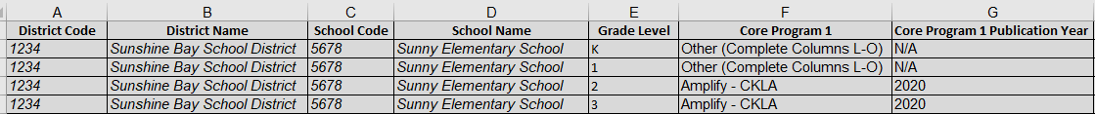

Core Program Scenario 3:
If the school does not use a published core program, please select “No published core program in use” in the drop-down menu in Column F.

Example:
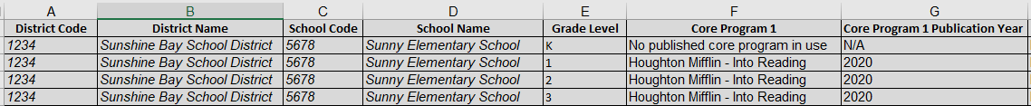

Steps to Complete the Supplemental Programming Tab
Steps to Complete Supplemental Programming Tab
- Click on the Supplemental tab in the spreadsheet.
- Complete steps 1-5 listed in the orange box on page 1 of this document.
- Column F: Click on the drop-down menu and select the supplemental program used for that specific school and grade level.

Example:
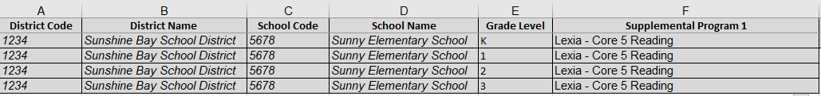
Potential Scenarios when reporting Supplemental Programs:
Supplemental Program Scenario 1:
If a school has multiple supplemental programs in place at the same grade level, scroll to the right and enter additional programs in the extra columns provided (Columns G & H).

Example:
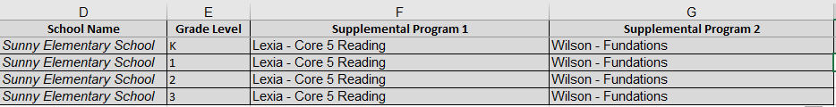

Supplemental Program Scenario 2:
If the supplemental program used by a school for a grade level is not listed in the drop-down menu, please select “Other” in Column F and write in the name of the supplemental program in Column J.

Example:
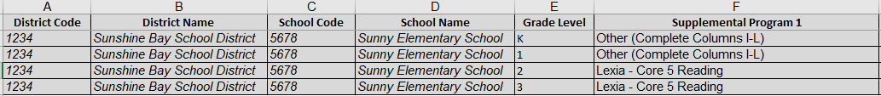

Supplemental Program Scenario 3:
If supplemental programming is not used in a particular school or grade level, please select “No published supplemental program in use” in the drop-down menu in Column F.

Example:
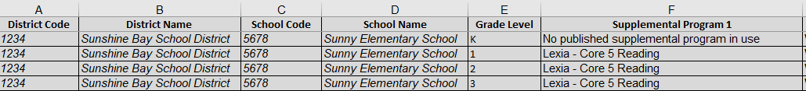

Steps to Complete the Intervention Programming Tab
- Click on Intervention tab in spreadsheet
- Complete steps 1-5 listed in the orange box on page 1 of this document.
- Column F: Click on the drop-down menu and select from the intervention program used for that specific school and grade level.

Example:
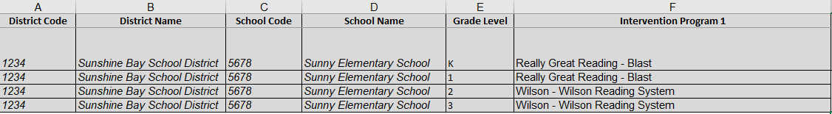

Potential Scenarios when reporting Intervention Programs:

Intervention Program Scenario 1:
If a school has multiple intervention programs in place at the same grade level, scroll to the right and enter additional programs in the extra columns provided (Columns G & H).

Example:
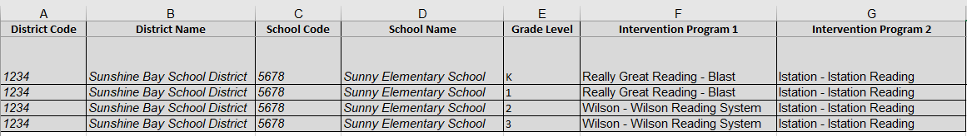

Intervention Program Scenario 2:
If the intervention program used by a school for a grade level is not listed in the drop-down menu, please select “Other” in Column F and write in the name of the intervention program in Column J.

Example: 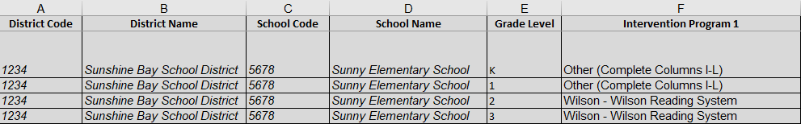

Intervention Program Scenario 3:
If the READ Act intervention supports and services are not captured in the information already provided, use Column M to provide a short explanation of any unique intervention implementation practices, supports, and/or services (500-character limit).

Example:
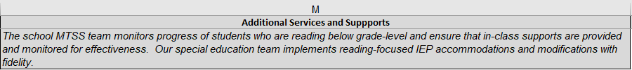

Steps to Report READ Act and/or Early Literacy Grant funded Professional Development
For most districts, this reporting will happen in the body of the district UIP as a Major Improvement Strategy and/or Action Steps.

Navigate to Section IV of the UIP: Action Plans
To add teacher PD as a Major Improvement Strategy, add a Major Improvement Strategy and complete the relevant fields:

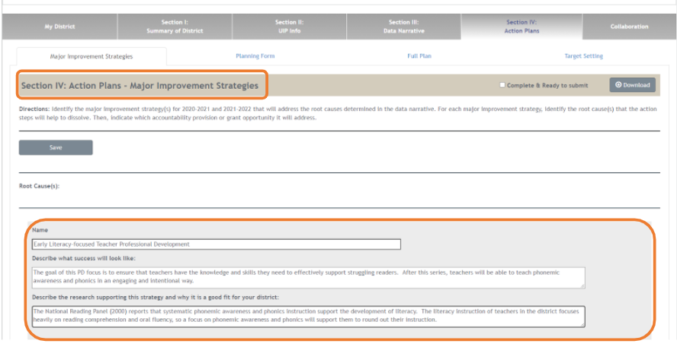

To add implementation benchmarks under a Major Improvement Strategy, navigate to the “Planning Form” and click “Add New +”.
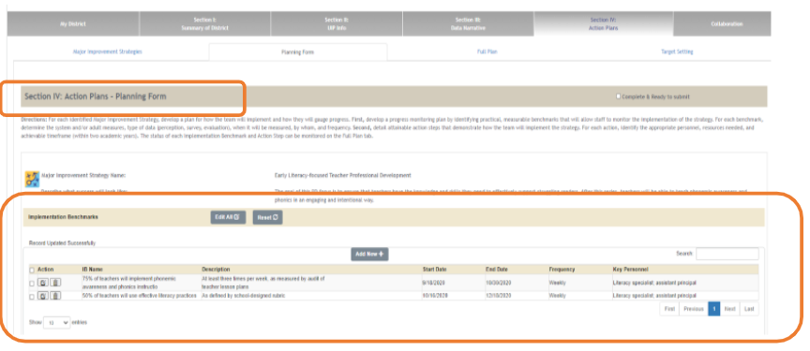

To add Improvement Action Steps, scroll down to the bottom of the Planning Form to the field Improvement Action Steps. Click “Add New +”
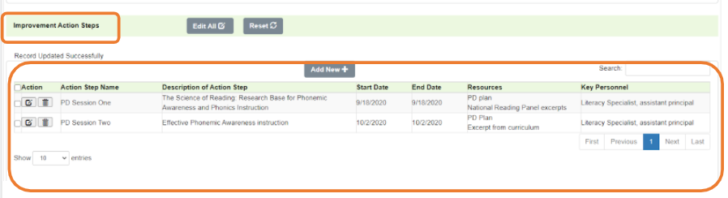
Click “Save” when you have finished entering the relevant professional development information.

Directions for Reporting Teacher Professional Development for Districts not submitting a 2020-21 UIP
For districts that are not submitting a 2020-21 UIP due to biennial flexibility or participation in a Local Accountability System grant, use the READ Act UIP Requirements submission template for districts with biennial flexibility.
There is an additional tab to capture a narrative description of READ Act and/or Early Literacy Grant funded teacher professional development.
Enter information about your PD plan in the narrative box on that tab.
Steps to Submit the READ Act reporting template (for districts submitting a 2020-21 UIP)

Submit the template as an attachment to the UIP.
In the UIP Online System home page, locate the button at the bottom of the page that says “Add attachment”. Click that button.
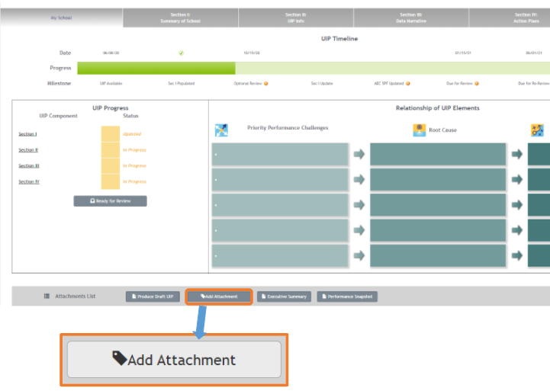
Follow the prompts to finish uploading your attachment.

Steps to Submit the READ Act reporting template (for districts not submitting a 2020-21 UIP)

Email the attachment to readact@cde.state.co.us

