Student Name ______________________________________ Date ______________

Letter Game
Dear Parent,
We are learning letters and the sounds that they make. I hope you enjoy this activity with
your child. This assignment is due _________________________________. Thank you!

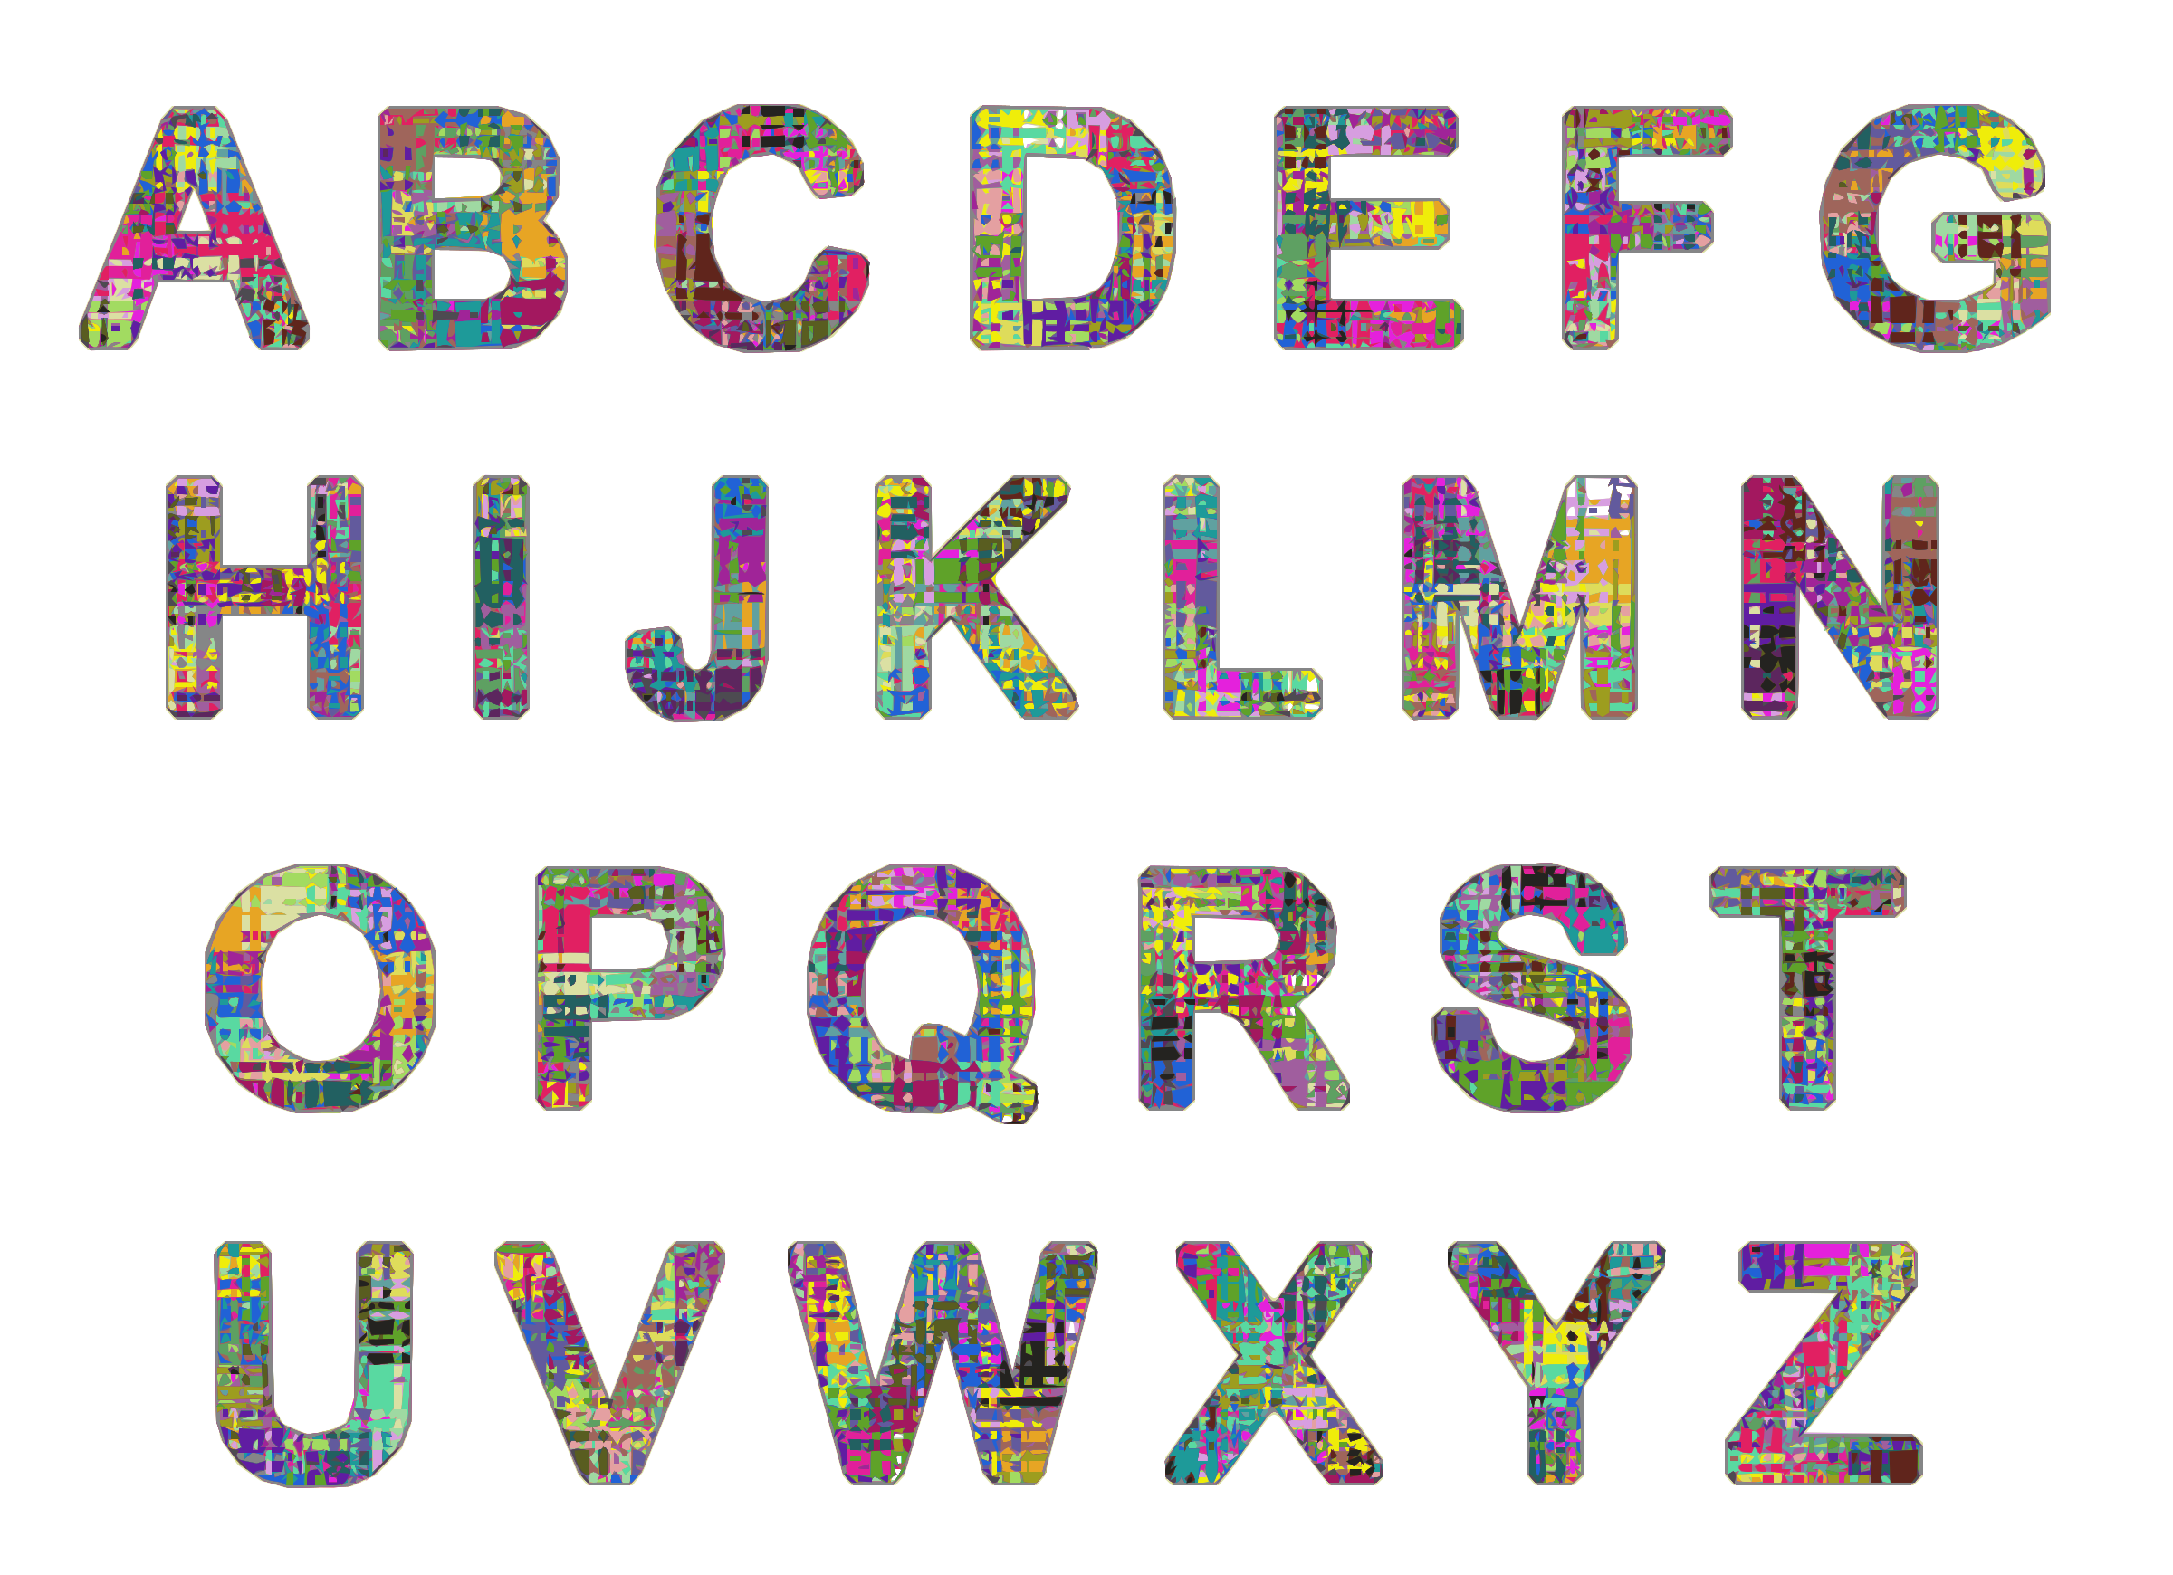

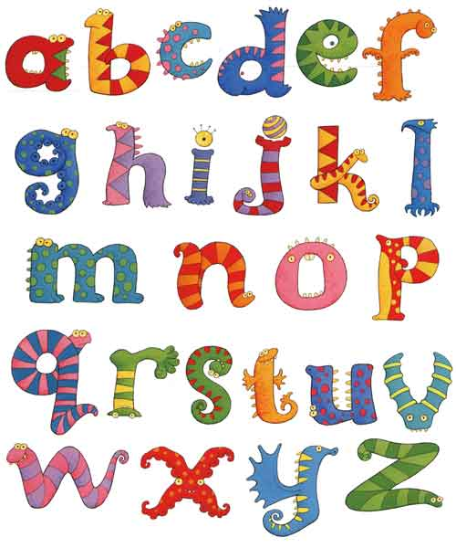

LET’S DO THIS

Let’s play a letter game.

Round 1
Ask your child: Think of a letter that you are learning in class.

My child chose the letter ______.

Ask your child: What sound does that letter make?

Take turns: Tell two words that start with that sound?

Round 2
Play the game again. Choose another letter.

Ask your child: Think of another letter that you are learning in class.

My child chose the letter ______.

Ask your child: What sound does that letter make?

Take turns: Tell two words that start with that sound?

Round 3
Play the game once more with another letter.

Ask your child: Think of another letter that you are learning in class.

My child chose the letter ______.

Ask your child: What sound does that letter make?

Take turns: Tell two words that start with that sound?

LET’S FIND OUT

- Ask your child: What is your favorite letter?
What sound does it make?
Why is that your favorite letter?
Draw that letter nice and big in the square.

- Ask your child: In the circles, draw 2 things that start with the sound
of your favorite letter.

Say the word for each picture so we hear the sound
the letter makes.

HOME-TO-SCHOOL COMMUNICATION

Dear Parent,

Please give your reactions to your child’s work on this activity.
Write YES or NO for each statement.
______ 1. My child understood the homework and was able to complete it.
______ 2. My child and I enjoyed the activity.
______ 3. This assignment helped me know what my child is learning in class.

Comment ________________________________________________________________________

Parent Signature __________________________________________________________________

Sampish, A., Wallace, R., Epstein, J., & Greenfeld, M. (2016). Teachers Involve Parents in Schoolwork (TIPS) Interactive Homework-Literacy K-3. Colorado Series. Baltimore: Center on School, Family, and Community Partnerships, Johns Hopkins University.

