Student Name _____________________________________________ Date ________________

All About Me
Dear Parent,
We are learning about how to write a letter. I hope you enjoy this activity with your child.
This assignment is due ____________________________. Thank you!

LET’S DO THIS OBJECTIVE

- Ask your child: What are you most proud about your work in Kindergarten?

What do you want to learn in first grade?

Your first grade teacher would like to know something about you.

Draw a picture of something that you liked doing in kindergarten.

I liked this in kindergarten!

- Ask your child: Tell me one sentence about the picture of YOU in kindergarten.

_______________________________________________________________

_______________________________________________________________.

- Read the sentence together, pointing to each word.

LET’S FIND OUT
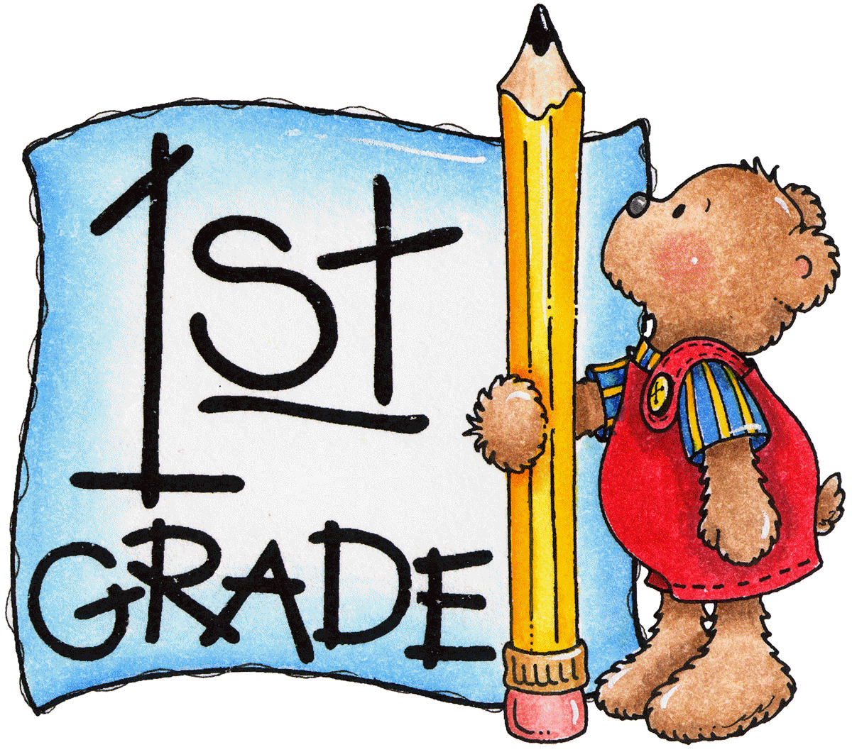

- Ask your child: Now, put your ideas into a letter to your first grade teacher
to tell what you liked about kindergarten and what you
hope to learn in first grade.

Fill in the information in this letter.
(Please help your child write his or her ideas, as needed.)

Dear 1st Grade Teacher,
In kindergarten, I really liked to __________________________________________.

I was very proud that I ________________________________________________.

In first grade, I hope to learn ___________________________________________.
It will be great to be a first grader!
Your friend,
_____________________________________
- With your child: Read the letter aloud. Ask your child to read the letter to you.
- Tell your child something that you remember when you were in the first grade.

HOME-TO-SCHOOL COMMUNICATION

Dear Parent,

Please give your reactions to your child’s work on this activity.
Write YES or NO for each statement.
______ 1. My child understood the homework and was able to complete it.
______ 2. My child and I enjoyed the activity.
______ 3. This assignment helped me know what my child is learning in class.

Comment ________________________________________________________________________

Parent Signature __________________________________________________________________

Sampish, A., Wallace, R., Epstein, J., & Greenfeld, M. (2016). Teachers Involve Parents in Schoolwork (TIPS) Interactive Homework-Literacy K-3. Colorado Series. Baltimore: Center on School, Family, and Community Partnerships, Johns Hopkins University.

