Student Name _______________________________________ Date ____________

In My World
Dear Parent,
We are learning to read print that is all around us. This is called “environmental print.”
I hope you enjoy this activity with your child. This assignment is due _____________________.
Thank you!

LET’S DO THIS

It is fun to read words that are all around us. There are letters and words on signs,
in windows, in stores, on toys, and on packages or jars in the kitchen.
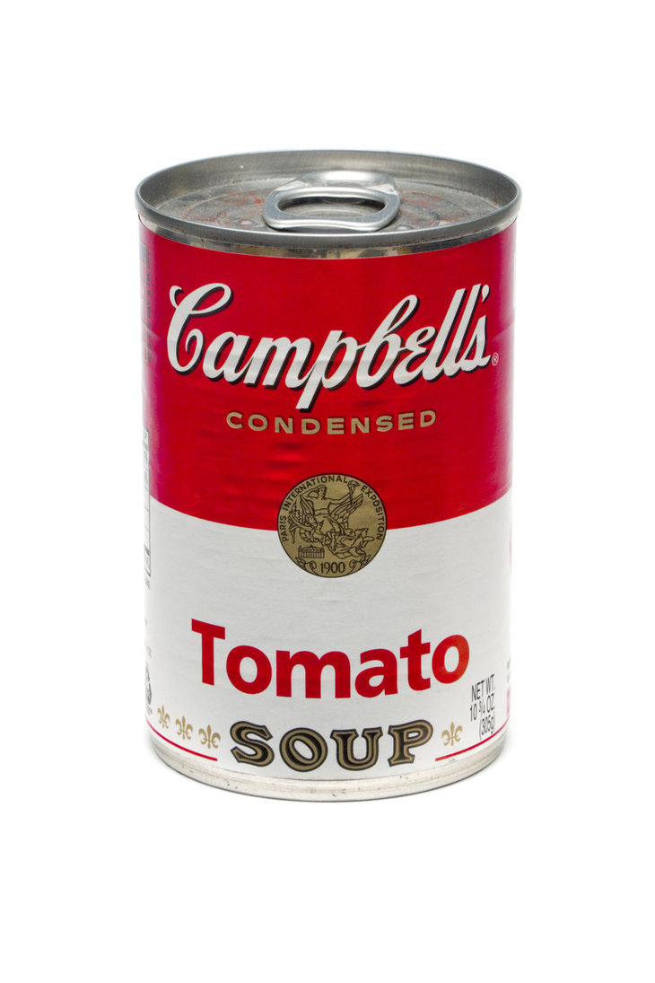

- Ask your child: Let’s go on a word hunt inside or outside.
We can find 5 words to read on signs or labels.

For example, STOP is on a stop sign.
SOUP is on a soup can.

Copy the 5 words you found onto the chart, below.
Read the words with your child, pointing to each one.

Words We See Around Us

1.
2.
3.
4.
5.

LET’S FIND OUT

- With your child: Select 5 items at home to label in English or another language.

Write the word on an index card or piece of paper.
Tape or put the label on the item.
table
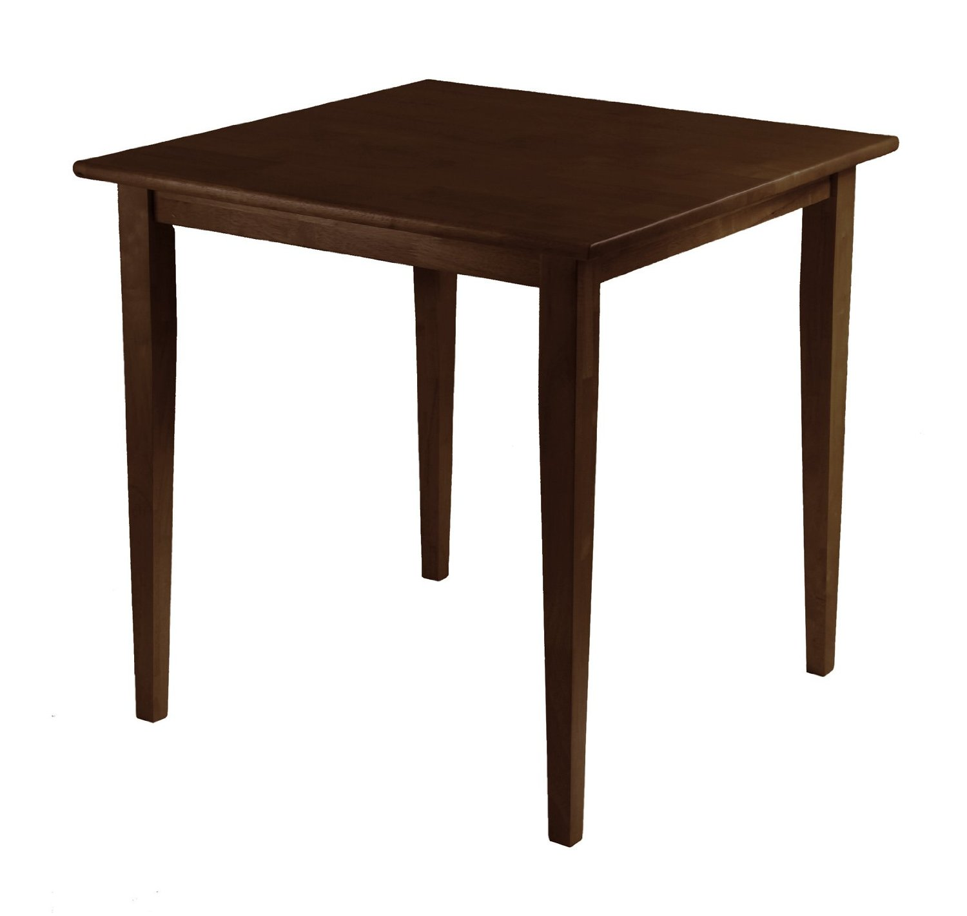
Read the 5 labels with your child.

- Discuss with your child: Why are signs and labels a big help. . .

. . . inside our home?
. . . outside on the street?
. . . in stores?
. . . another place? _________________

HOME-TO-SCHOOL COMMUNICATION

Dear Parent,

Please give your reactions to your child’s work on this activity.
Write YES or NO for each statement.
______ 1. My child understood the homework and was able to complete it.
______ 2. My child and I enjoyed the activity.
______ 3. This assignment helped me know what my child is learning in class.

Comment ________________________________________________________________________

Parent Signature __________________________________________________________________

Sampish, A., Wallace, R., Epstein, J., & Greenfeld, M. (2016). Teachers Involve Parents in Schoolwork (TIPS) Interactive Homework-Literacy K-3. Colorado Series. Baltimore: Center on School, Family, and Community Partnerships, Johns Hopkins University.

