Student Name ________________________________________ Date _____________

Come On, Comma!
Dear Parent,
We are learning to use commas in our writing. I hope you enjoy this activity with me.
This assignment is due __________________________.
Sincerely,
_______________________
Student Signature

THINGS TO REMEMBER

Punctuation helps a reader understand what is written.
The comma says, “Slow down.” The period says, “Stop.”

LET’S DO THIS

- Work with a family partner. Who is working with you? ______________________
Read this poster aloud to your family partner.
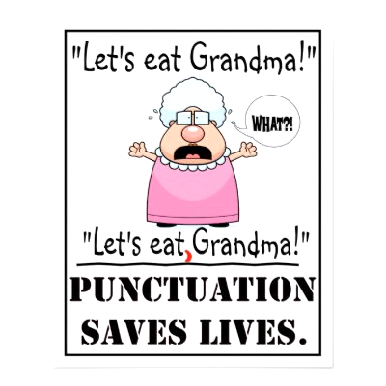

- Tell how the comma helps Grandma.
Without the comma, the poster means__________________________________

With the comma, the poster means ____________________________________
LET’S FIND OUT

- Read each sentence aloud to your family partner the way it is written.

  - Rashid named his dogs Tex Rex Charlie and Grace.
  - My favorite numbers are three one sixty and twenty-three.
  - Rosa took her red hat umbrella boots and jacket.
  - Let’s eat grandpa.
  - Dolphins live in the Atlantic Pacific and Indian Oceans.
Now, put commas in each sentence where you think they belong.

- Read each sentence aloud, again, to your family partner. Tell how each sentence changed when you added commas.

- Ask your family partner: What are your 4 favorite colors?
YOU write 1 sentence to report the answer to that question.
Use commas where you think they belong.

_________________________________________________________________

_________________________________________________________________
Read the sentence aloud to your family partner.
HOME-TO-SCHOOL COMMUNICATION

Dear Parent,

Please give your reactions to your child’s work on this activity.
Write YES or NO for each statement.
______ 1. My child understood the homework and was able to complete it.
______ 2. My child and I enjoyed the activity.
______ 3. This assignment helped me know what my child is learning in class.

Comment ______________________________________________________________________

Parent Signature ________________________________________________________________

Marshall, J.M., Izzo, A., Schimmel, I., Epstein, J. L., Greenfeld, M. (2016). Teachers Involve Parents in Schoolwork (TIPS) Interactive Homework, Literacy K-3. Colorado Series. Baltimore: Center on School, Family, and Community Partnerships, Johns Hopkins University.

