Student Name_________________________ Date____________________

What’s the Big Idea?
Dear Parent,
We are learning about main idea and details. I hope you enjoy this activity with me.
This assignment is due ________________________.
Sincerely,
___________________________
Student Signature

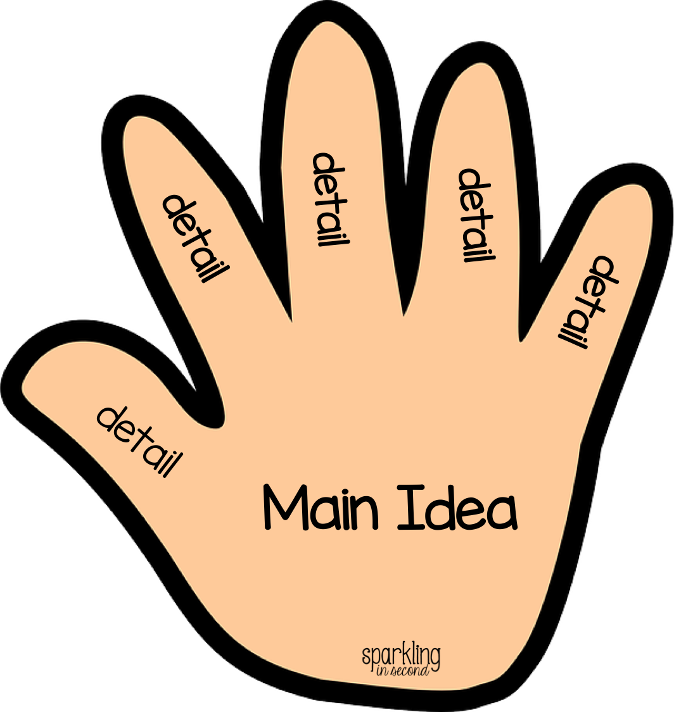

THINGS TO REMEMBER

- The main idea is what the story is mostly about.
- The details in the story support the main idea.

LET’S DO THIS

- Work with a family partner. Who is working with you? ____________________

Ask your family partner: Think of when you were my age in 3rd grade.
Tell me something funny, important, or serious
that happened to you in 3rd grade.

Listen carefully. YOU make a list of the important details that you hear.

1._____________________________________________________

2._____________________________________________________

3._____________________________________________________

4._____________________________________________________

5._____________________________________________________

LET’S FIND OUT

What is the main idea of your family partner’s story? _______________________

__________________________________________________________________

With your family partner, think of a good title for this story.

Title: ____________________________________________________

Tell your family partner: What is your favorite part of the story? Why?

Draw a picture illustrating one part of your family partner’s story.
Include as many details as you can.

HOME-TO-SCHOOL COMMUNICATION

Dear Parent,

Please give your reactions to your child’s work on this activity.
Write YES or NO for each statement.
______ 1. My child understood the homework and was able to complete it.
______ 2. My child and I enjoyed the activity.
______ 3. This assignment helped me know what my child is learning in class.

Comment ______________________________________________________________________

Parent Signature ________________________________________________________________

Marshall, J.M., Izzo, A., Schimmel, I., Epstein, J. L., Greenfeld, M. (2016). Teachers Involve Parents in Schoolwork (TIPS) Interactive Homework, Literacy K-3. Colorado Series. Baltimore: Center on School, Family, and Community Partnerships, Johns Hopkins University.

