Student Name____________________________________ Date_______________

What Happens Next?
Dear Parent,
We are learning about sequencing and the words that signal a transition in a story. I hope you enjoy this activity with me. This assignment is due ________________________.
Sincerely,
___________________________
Student Signature

THINGS TO REMEMBER

Sequencing means to put events in the order they happened.
Signal or transition words tell the reader that a something is about to happen.
For example, transition words include next, then, after, and later.
Also, phrases can alert you that something is coming next.

LET’S DO THIS

- Work with a family partner. Who is working with you? _____________________

- Read and discuss the following story with your family partner.

It Was a Dark and Stormy Day
There once was a student who was walking to school on a very rainy Monday morning. To his surprise, he stepped in a deep puddle and completely soaked his shoes. Next, he was sprayed with dirty water by a passing car. Then, he tripped over his shoelaces and fell in the mud. By the time he arrived at school, he was a wet, muddy mess. Thank goodness, his mom gave him a change of clean clothes in his backpack. After he changed to nice, dry clothes, he was able to do his schoolwork.

- Underline the signal or transition words and phrases in the story.

- Use the story to draw a picture OR write a phrase in each box in the
flow-diagram on the back page to show the sequence of the story.

In each arrow, write the signal or transition word or phrase that gave you a clue to the next part of the story. The first one is done for you.

LET’S FIND OUT

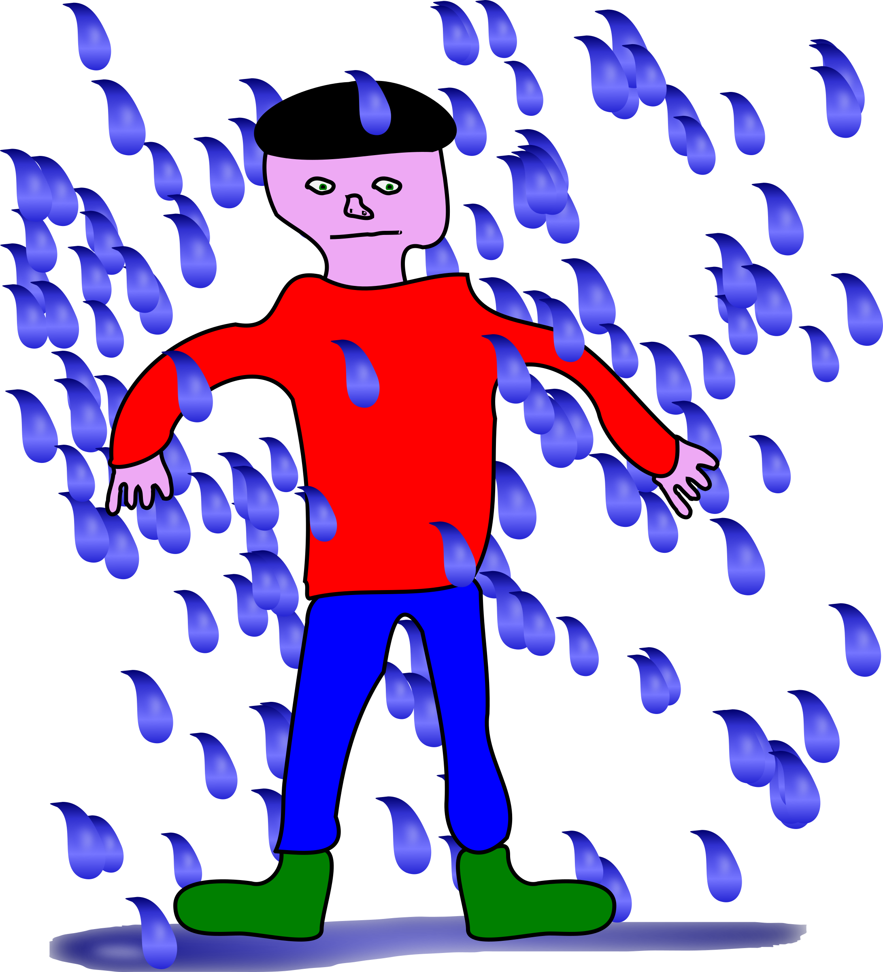

Then,

1
2

4
3

5
6

- Show your family partner the flow diagram and explain the transition words
that were used to tell the story.

- Tell your family partner how the signal or transition words and phrases helped you to understand what is happening in the story.

HOME-TO-SCHOOL COMMUNICATION

Dear Parent,

Please give your reactions to your child’s work on this activity.
Write YES or NO for each statement.
______ 1. My child understood the homework and was able to complete it.
______ 2. My child and I enjoyed the activity.
______ 3. This assignment helped me know what my child is learning in class.

Comment ________________________________________________________________________

Parent Signature __________________________________________________________________

Marshall, J.M., Izzo, A., Schimmel, I., Epstein, J. L., Greenfeld, M. (2016). Teachers Involve Parents in Schoolwork (TIPS) Interactive Homework, Literacy K-3. Colorado Series. Baltimore: Center on School, Family, and Community Partnerships, Johns Hopkins University.

