Student Name______________________________________ Date _______________

Sum It Up in a Caption
Dear Parent,
We are learning about captions and how they provide important information. I hope you
enjoy this activity with me. This assignment is due ____________________________.
Sincerely,
___________________________
Student Signature

REMEMBER

A caption under a drawing or photograph gives information that increases
understanding about a story or text. A caption is usually about one sentence long.

LET’S DO THIS

Work with a family partner. Who is working with you? _________________________
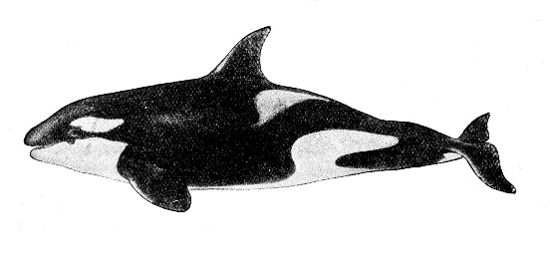

- Read the story Killer Whales. First read it to yourself.

The black and white whales in the photos on the back of this page are commonly known as Killer Whales or Orcas. Orcas are mammals, which means they have warm blood and nurse their babies. They live in the ocean.
Male Orcas can grow to be 32 feet long and female Orcas can grow to 28 feet long. Orcas can weigh from 16,000 pounds to up to 22,000 pounds. Their diet will vary because of where they live and what food is available. They may eat fish or other ocean mammals.
Orcas or Killer Whales swim and travel together in large groups called “pods.” There may be 30 to 100 whales in a pod. They “talk” to each other using sounds of clicks and whistles.

- Now, read the story aloud to your family partner.

LET’S FIND OUT

Write a caption of 1 sentence under each picture of Killer Whales.

Use information from the story to make an interesting and informative caption.

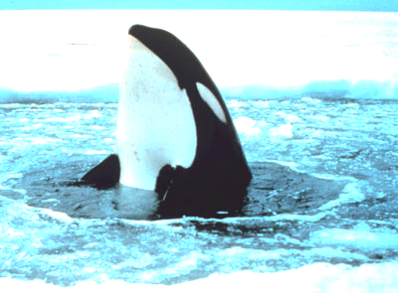

YOUR CAPTION: _________________________________________________________

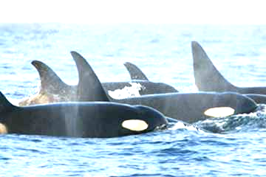

YOUR CAPTION: _________________________________________________________

Show your family partner each picture and read your caption aloud.

Discuss with your family partner: What did you learn about Orcas from my captions?

HOME-TO-SCHOOL COMMUNICATION

Dear Parent,

Please give your reactions to your child’s work on this activity.
Write YES or NO for each statement.
______ 1. My child understood the homework and was able to complete it.
______ 2. My child and I enjoyed the activity.
______ 3. This assignment helped me know what my child is learning in class.

Comment _____________________________________________________________________

Parent Signature ________________________________________________________________

Parker, C. K., Castillo, M. D., Firme, K. K., Epstein, J. L., & Greenfeld, M. (2016). Teachers Involve Parents in Schoolwork (TIPS) Interactive Homework-Literacy K-3. Colorado Series. Baltimore: Center on School, Family, and Community Partnerships, Johns Hopkins University.

Photo credit: The photos are from the U. S. National Oceanic and Atmospheric Administration (NOAA).

