Student Name____________________________________ Date______________

Use the Clues
Dear Parent,
We are learning how pictures provide clues to help clarify a story or text. I hope you enjoy this activity with me. This assignment is due _______________________________.
Sincerely,
___________________________
Student Signature

LET’S DO THIS

- Work with a family partner. Who is working with you? _____________________

- With your family partner, look at the pictures and discuss what you think the story is about.

- Next, you read the passage aloud to your family partner.

- Then, use the words in the passage and the pictures to answer the questions.

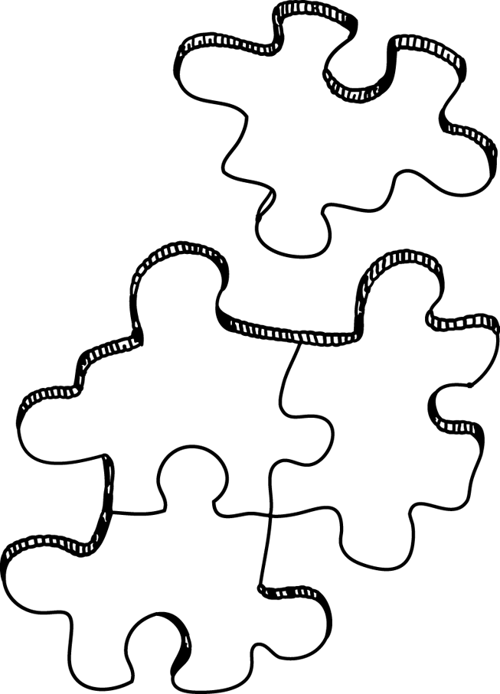
John Spilsbury, a mapmaker and engraver in London, England, invented the first jigsaw puzzle in 1767. He glued a map of the world on a piece of wood and then cut the wood in odd shaped pieces.

Teachers began to use Mr. Spilsbury's puzzles. Students in classrooms started to learn about geography by putting the pieces of the world map back together. This was fun for both students and teachers.
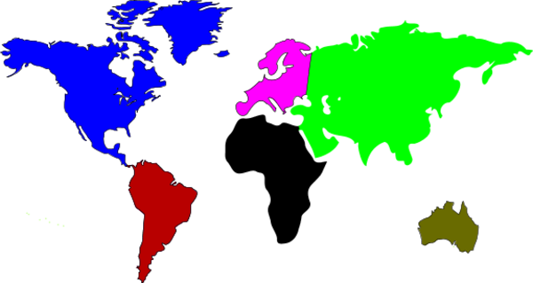

LET’S FIND OUT

- Talk with your family partner about the questions, below. Then, you write a phrase or sentence to answer the questions.

What did John Spilsbury invent? _____________________________________
________________________________________________________________

What words, pictures, or phrases in the passage helped you figure this out?

________________________________________________________________

________________________________________________________________

Why was this a good invention? _____________________________________

________________________________________________________________

- If you could make a jigsaw puzzle to help students learn something, what puzzle

would you make to help your class? _________________________________

Why? ___________________________________________________________
HOME-TO-SCHOOL COMMUNICATION

Dear Parent,

Please give your reactions to your child’s work on this activity.
Write YES or NO for each statement.
______ 1. My child understood the homework and was able to complete it.
______ 2. My child and I enjoyed the activity.
______ 3. This assignment helped me know what my child is learning in class.

Comments _____________________________________________________________________

Parent Signature ________________________________________________________________

Parker, C. K., Castillo, M. D., Firme, K. K., Epstein, J. L., & Greenfeld, M. (2016). Teachers Involve Parents in Schoolwork (TIPS) Interactive Homework-Literacy K-3. Colorado Series. Baltimore: Center on School, Family, and Community Partnerships, Johns Hopkins University.

