Student Name ______________________________________ Date_____________

What Did You Say?
Dear Parent,
We are learning to identify different ways we speak to people. I hope you enjoy this activity with me. This assignment is due ________________________________.
Sincerely,
___________________________
Student Signature

THINGS TO REMEMBER

People listen to what you say and how you say it. This includes tone of your voice
and your body language.

LET’S DO THIS

Role Play

Here are 3 role-play scenes to conduct with your family partner.

Who is working with you? _______________________________________________

Role Play 1:
You left your homework at home and it is due today.
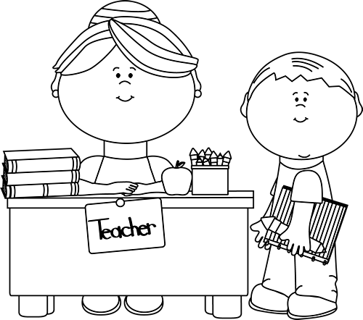

How would you communicate with your teacher to solve this problem?

You take the role of the child and your family partner will take the role of the teacher.

Role Play 2:
You got lost and could not find your family at the local market.


You see a police officer near the check-out counter.

How would you communicate with him to solve this problem?

You take the role of the child and your family partner will take the role
of the police officer.

Role Play 3:

Your friend bumped into you but did not say “I’m sorry.”

How would you communicate with your friend and solve this problem?

You take the role of yourself and your family partner will take the role of your friend.

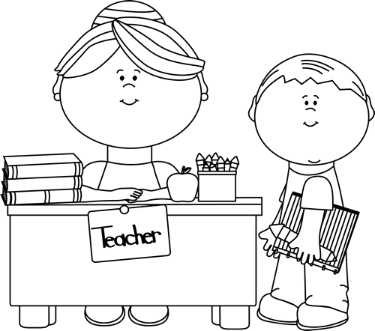

LET’S FIND OUT

Discuss each question with your family partner and then write your sentence.

- How did the tone of your voice change when you were talking to your teacher, the police officer, and your friend? Tell how it changed in one sentence.

________________________________________________________________

________________________________________________________________

- How did your body language change when you were talking to your teacher, the police officer, and your friend? Tell how it changed in one sentence.

________________________________________________________________

________________________________________________________________

- In one sentence, tell how you felt when you were talking to the teacher
OR the police officer OR your friend.

________________________________________________________________

________________________________________________________________
HOME-TO-SCHOOL COMMUNICATION

Dear Parent,

Please give your reactions to your child’s work on this activity.
Write YES or NO for each statement.
______ 1. My child understood the homework and was able to complete it.
______ 2. My child and I enjoyed the activity.
______ 3. This assignment helped me know what my child is learning in class.

Comment _____________________________________________________________________

Parent Signature ________________________________________________________________

Parker, C. K., Castillo, M. D., Firme, K. K., Epstein, J. L., & Greenfeld, M. (2016). Teachers Involve Parents in Schoolwork (TIPS) Interactive Homework-Literacy K-3. Colorado Series. Baltimore: Center on School, Family, and Community Partnerships, Johns Hopkins University.

