UIP Online System User Guide

This user guide provides a walkthrough of completing the Unified Improvement Plan (UIP) template via the UIP Online System. This guide applies to both the school and district templates, and any differences in functionality and/or features between the templates are highlighted. Reference this guide in conjunction with additional UIP resources and training to develop and submit a UIP.
Table of Contents
Getting Started
Homepages: My School and My District Tab
Data Narrative
UIP Narrative
Brief Description
Prior Year Targets
Current Performance
Trend Analysis
Priority Performance Challenges
Root Causes
Action Plans
Major Improvement Strategies
Planning Form
Full Plan
Target Setting
Report
Collaboration
Submitting a Completed Plan

Getting Started
Gaining Access to the UIP Online System
Users must be assigned to a UIP role in CDE’s Identity Management (IDM) system to access the UIP Online System. Every district should have a Local Access Manager (LAM) who is responsible for assigning UIP roles within IDM. To gain access to the system:
- Contact your district’s LAM to request that you be assigned to a UIP role in IDM. If you do not know your district’s LAM, use CDE’s Request Assistance form to contact them.
- Following the instructions in the UIP Online System Set Up & Management Guide, the LAM will assign you to either a school-level or district-level UIP role, depending on your needs. Users can only be assigned to one UIP role in IDM at a time and cannot have multiple roles for different schools. If users are assigned to more than one UIP role, they will receive an error when attempting to log into the system.
  - Users with a School Admin or School User role can view, edit, and submit UIPs for district review for a single school to which they are assigned.
  - Users with a District Admin or District User role can view, edit, and submit UIPs for public posting for all schools and the district. If a school staff member requires access to more than one school’s UIP, they can be assigned to a district-level role.
  - Users with an Accountability Contact role have the same access to UIPs as District Admins and District Users, but they can also view and submit the district’s Accreditation and Request to Reconsider form on additional pages of the UIP Online System.

Logging in to the UIP Online System
Once assigned to a UIP role in IDM, users can log into the system via the UIP Online System webpage (bookmark this page!). Depending on their UIP role, users must select either the District or School log in button. Users must enter their CDE username and password, which are the same credentials used to access other systems managed through IDM (e.g., CEDAR, RANDA). BROWSER NOTE: CDE recommends using Chrome or Firefox to access the UIP Online System.

Upon logging in, users with a school-level role will enter directly into the school’s current UIP template and can follow the rest of this guide to complete the UIP. District Admins, District Users, and Accountability Contacts will need to navigate through the administrative pages of the UIP Online System to access the UIP templates and should reference the District Admin Guide for additional information.

Troubleshooting Login Issues
- If you forgot your CDE password, reset it using the Identity Management password reset form.
- Confirm that you are signing in using the correct button. School users cannot access the system through the District login, and vice versa.
- If you still cannot log in, confirm with your district’s LAM that you are only assigned to one role in IDM.
- If needed, reach out to uiphelp@cde.state.co.us for additional troubleshooting support.
Homepages: My School or My District Tab
The UIP template opens on the My District tab (for district templates) or the My School tab (for school templates). This tab contains several components and provides important information designed to assist with developing the UIP, as detailed in the table and screenshots below.
Section | Description | Important Notes
UIP Progress | Progress bar that shows the completion status of the two major tabs of the UIP | Progress status will change from “In Progress” to “Ready to Submit” when all of the “Complete & Ready to Submit” checkboxes have been checked on each subtab of the Data Narrative or Action Plan tabs.
Relationship of UIP Elements | Visual displaying the associations between Priority Performance Challenges, Root Causes, and Major Improvement Strategies | This visual will remain blank until Priority Performance Challenges have been saved. Root Causes will display when properly associated to one or more Priority Performance Challenge, and Major Improvement Strategies will display when associated with one or more Root Causes.
School or District Information | Displays information for the school/district from CDE’s Data Warehouse | Contact information can be updated in the Directory collection in Pipeline.
Plan Details | Serves as a reference for schools/districts and provides site-specific information to support the annual improvement planning process | Users are not required to enter information in this section, as CDE pre-populates the identifications and plan information displayed in this box.
Context | Optional text box for users to write a short description (3-5 sentences) of their school/district | This description may be used to introduce and provide additional context about the school in CDE public reports.
Assurances | Statements that reflect planning expectations that schools/districts must complete to meet state and federal requirements | While some assurances apply to all schools, others will be added based on state and federal identifications. All assurances can be reviewed in the the School or District Quality Criteria.

Additionally, this tab offers school-level users the ability to view past plans via the dropdown in the righthand corner (this feature does not work for district-level users, as they can access previous years’ plans via the administrative pages of the UIP Online System). Users can also use the buttons on this tab for the following functions:
- Copy from Last Year: Use this button to copy content from a previous UIP into the current template. Typically, users will copy from last year’s plan, but if biennial flexibility was exercised and a plan was not created, the plan from two years ago should be selected. Copying from a previous plan can only be done once. School users should contact their district to reset this functionality if the wrong plan was copied over.
- Performance Snapshot: This button opens a new webpage that contains a dashboard where users can quickly and easily view key elements of the most recently reported District or School Performance Framework and UIP.
- Visit UIP Webpage: This button opens a new webpage and takes users directly to CDE’s UIP website, where resources and additional information about the planning process can be found.
- Email UIP Help: This button opens an email window for users to contact CDE’s School Improvement and Planning team to ask questions or request help with the UIP.
- Produce Draft UIP: Use this button to open a new screen where the entire UIP can be downloaded as a PDF and printed.
- Executive Summary: Use this button to open a new screen where a shortened version of the UIP can be downloaded as a PDF and printed. This summary is often used to provide an overview of the UIP with relevant stakeholders that may not need the entire plan.

My District Tab
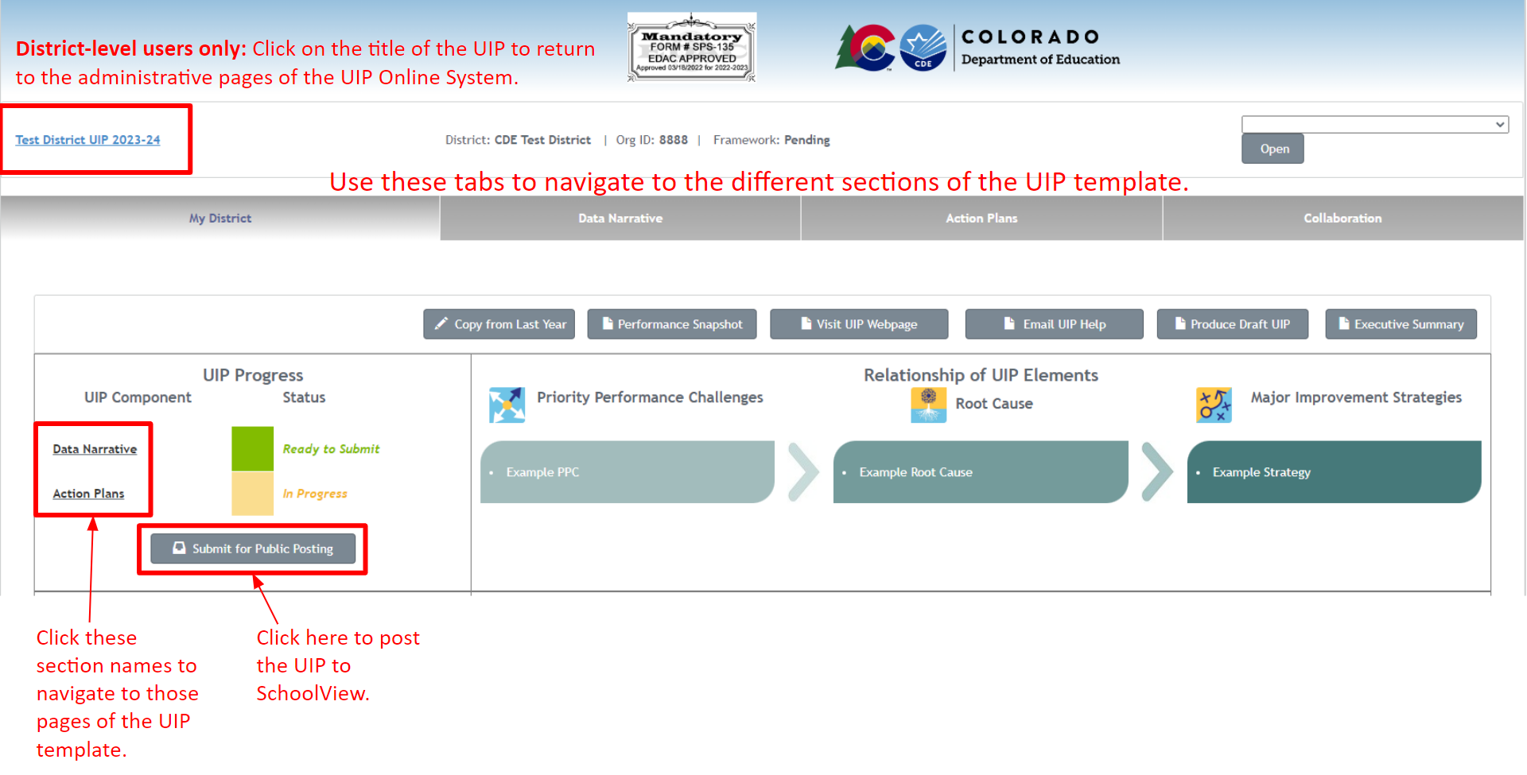
My School Tab
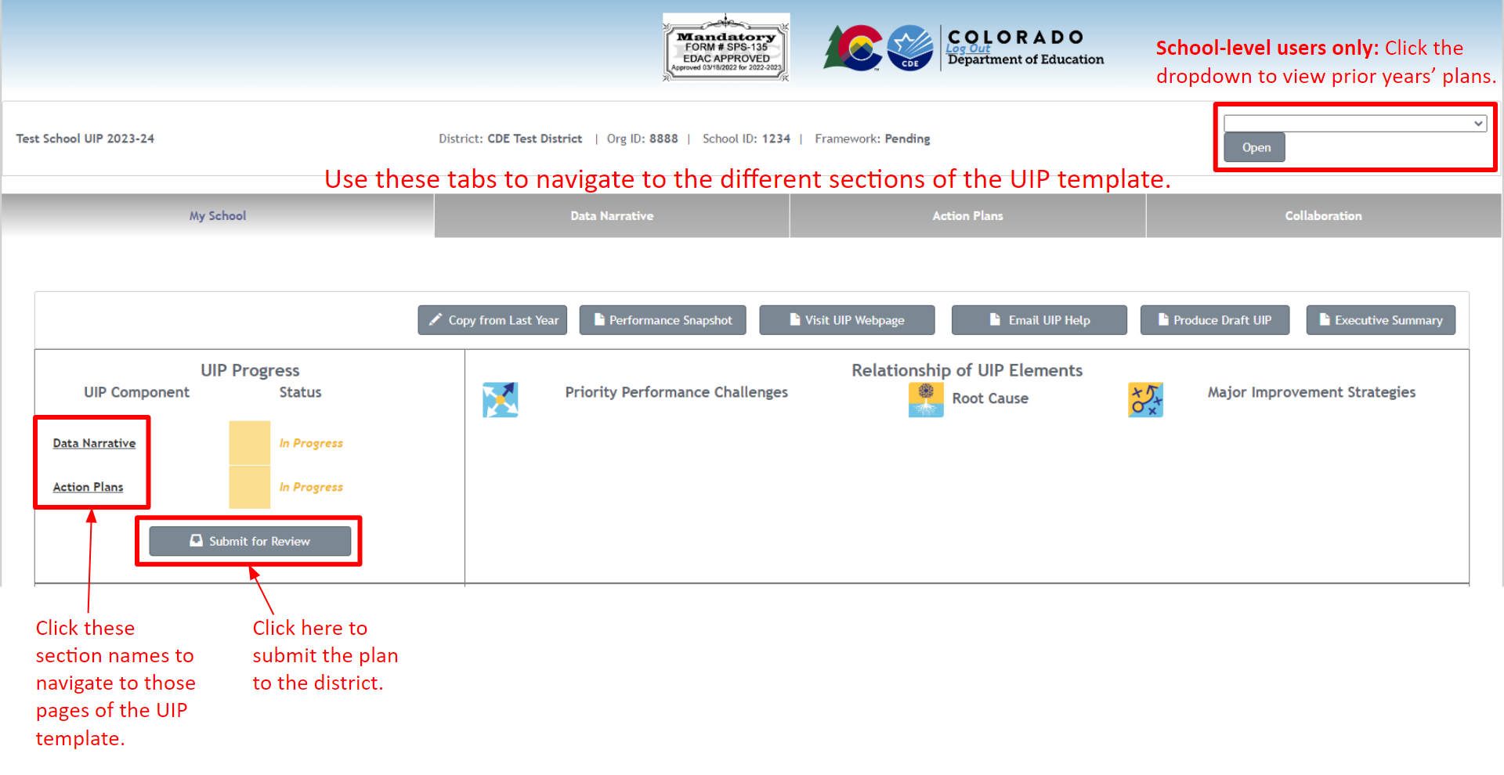

Data Narrative
This section includes six components that weave together to create the Data Narrative: (1) Brief Description; (2) Prior Year Targets; (3) Current Performance; (4) Trend Analysis; (5) Priority Performance Challenges; and (6) Root Causes.
UIP Narrative
The first tab in this section is the UIP Narrative summary page. As a school or district completes the UIP, this page populates with all components of the Data Narrative. Schools and districts can utilize this page as a launch pad for each step of the Data Narrative. It is important to complete the Data Narrative in order, as each step builds on the previous step. For example, as the school or district writes/updates Priority Performance Challenges (PPCs), PPCs populate in the root cause (RC) section to make distinct connections. Schools or districts may add additional narrative at the end in the “Additional Narrative/Conclusion” section.
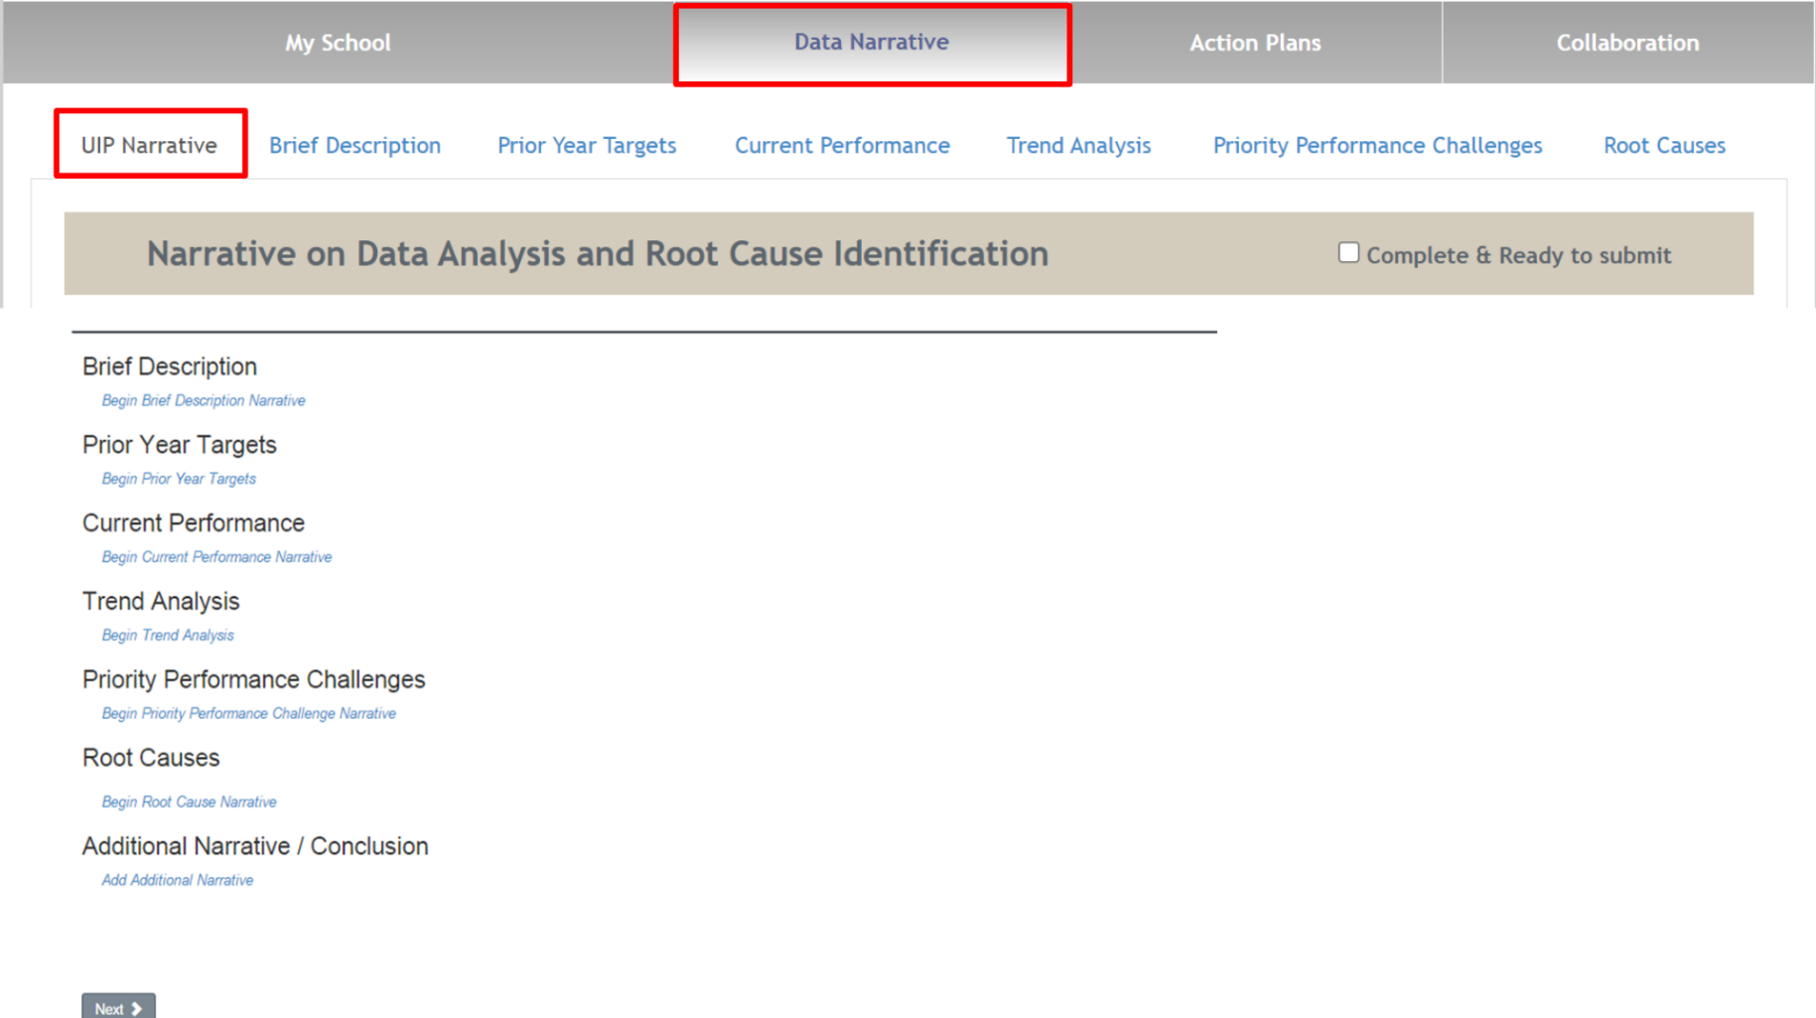

Brief Description
Schools and districts use this step to provide context and begin the narrative. In the text box, users provide a summary of the school or district, including any background information that helps the reader understand the context, focus of the school, and process that the school or district used to involve stakeholders in the development of the UIP. The tab includes an Enrollment & Demographics dashboard to aid with your narrative.
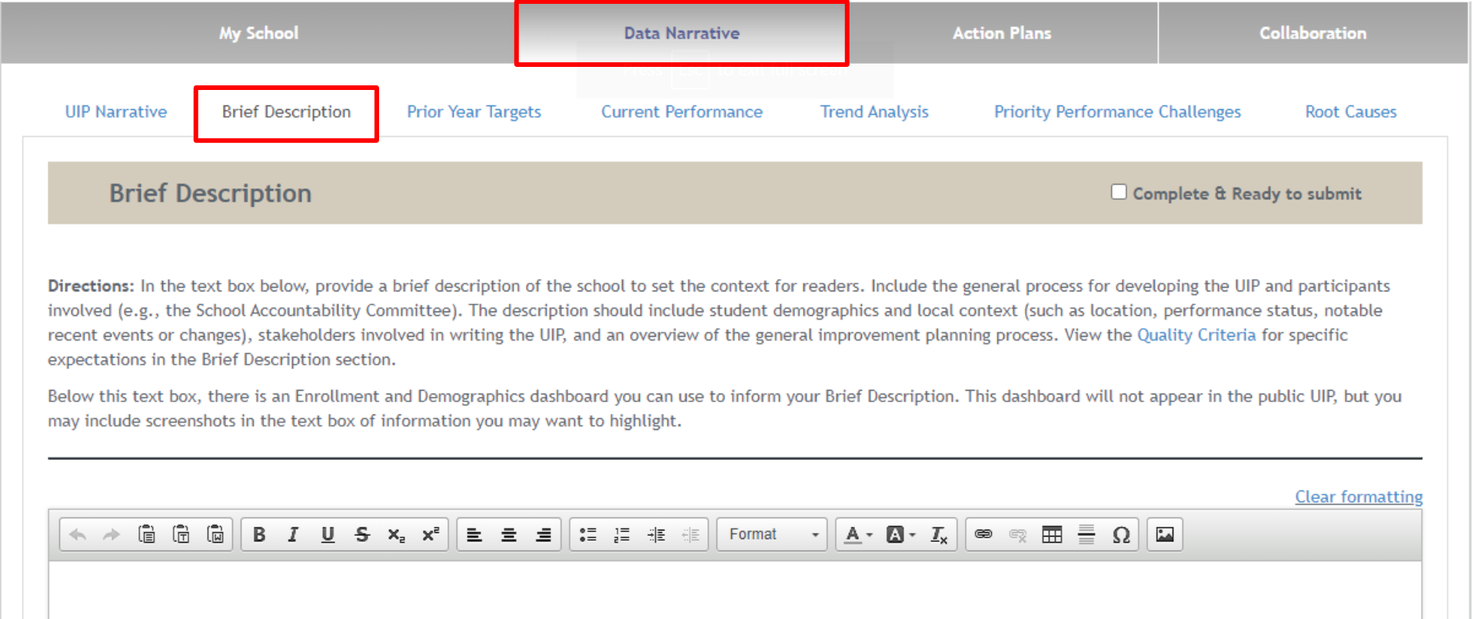

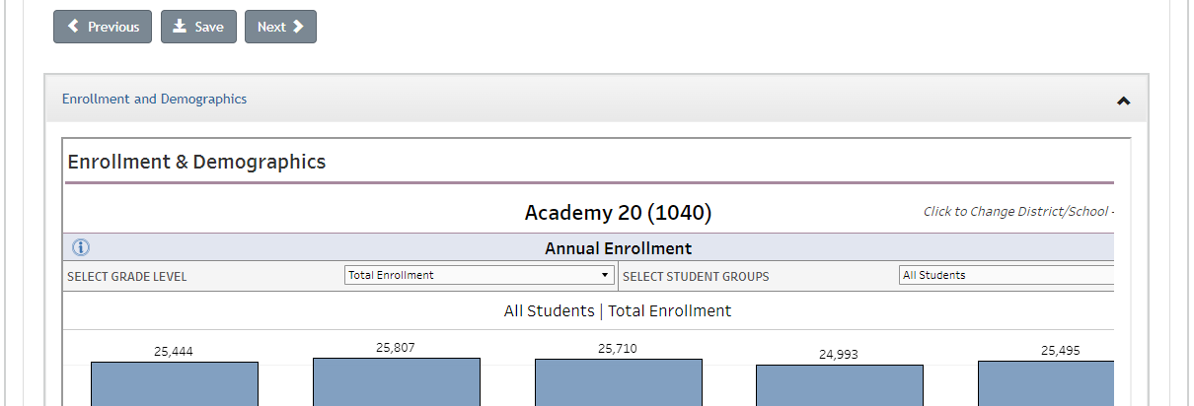

Prior Year Targets
In this step, schools and districts will view their prior year targets and major improvement strategies (if the plan was copied from last year). Users will reflect on what was successful and what may need to be updated or adjusted for the current year. There are two response areas; the first asks about progress on implementing the strategies and if they had the intended effect on systems, adult actions, and student outcomes (e.g. targets). The second box should include a summary of the adjustments that will be made for the current plan based on the reflection. Both responses become a part of the overall narrative.
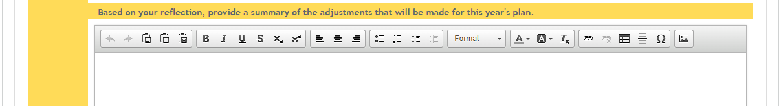
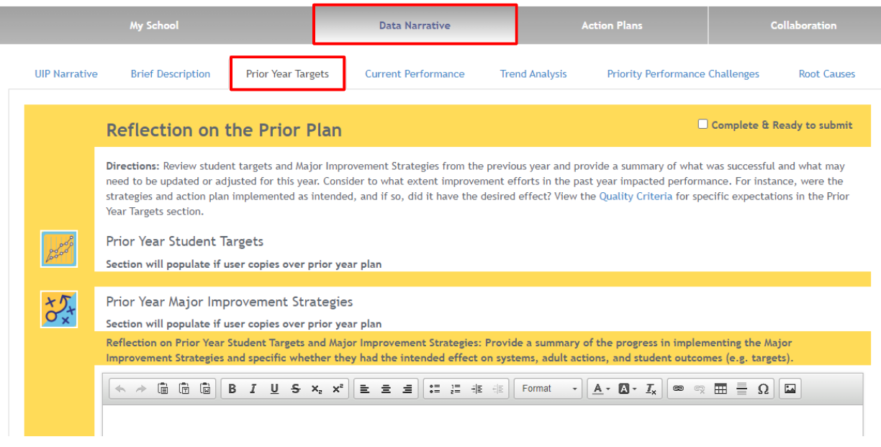

Current Performance
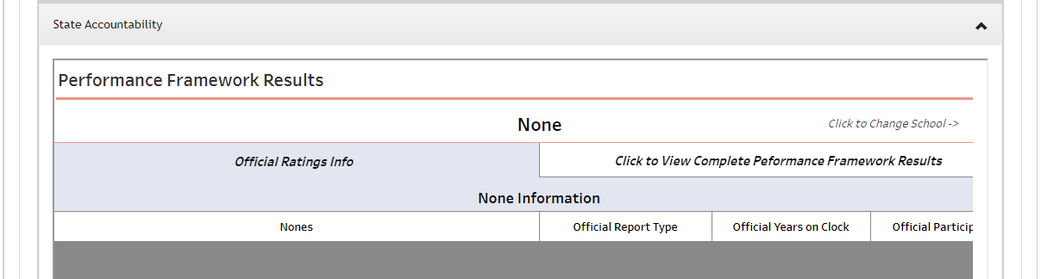
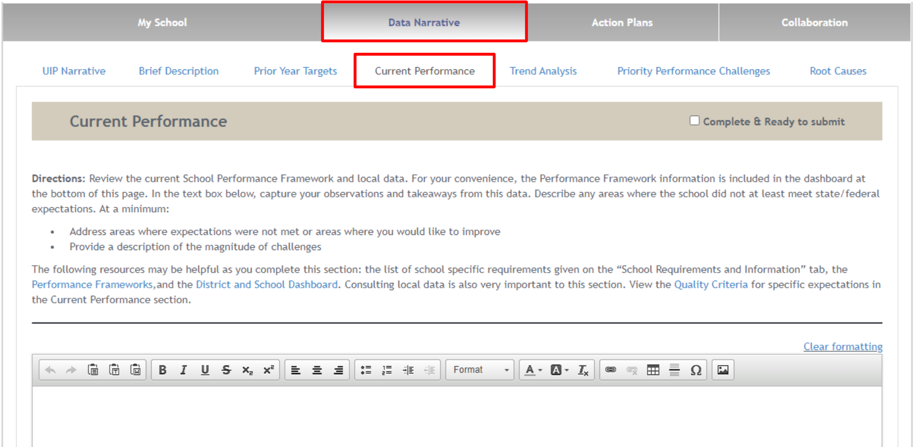
Schools and districts use this text box to reflect on current performance in relation to district and state expectations. This reflection is automatically added to the overall data narrative. Users can review the dashboard embedded in the page to understand Performance Framework results.
Trend Analysis
Trend Analysis includes two components: (1) writing the trend statement; (2) identifying the trend direction. Once the user makes an identification using the “Add Additional Trend Statement” button, an icon representing the trend direction appears. All trends populate in the subsequent Priority Performance Challenges (PPCs) step, allowing schools and districts to reflect on notable trends when developing PPCs.
Trends no longer need to be identified as “notable.” All identified trends will populate on the Priority Performance Challenges tab and will appear in the final UIP.
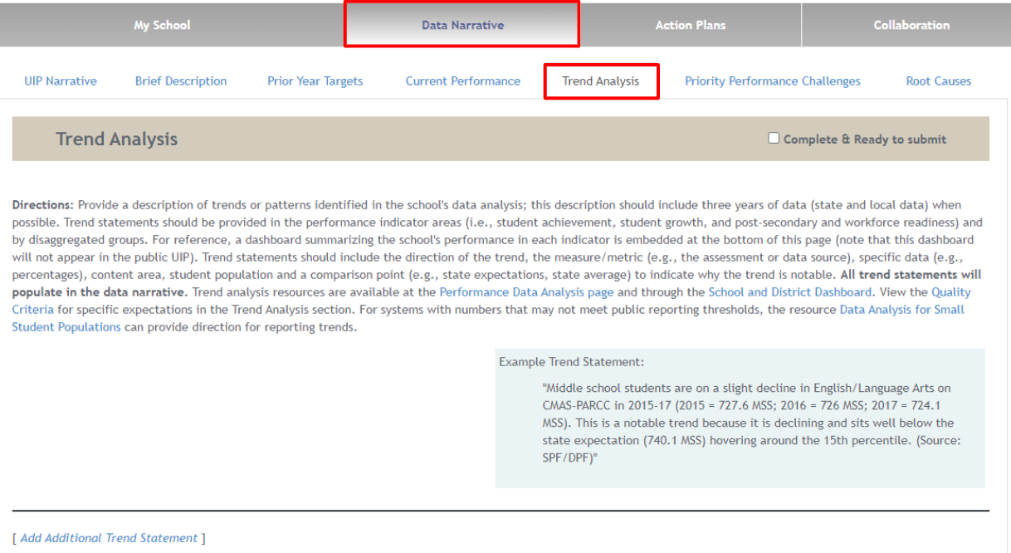

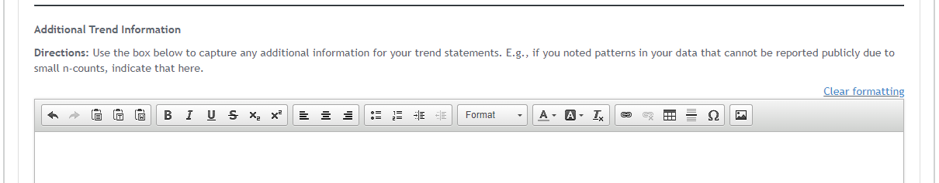
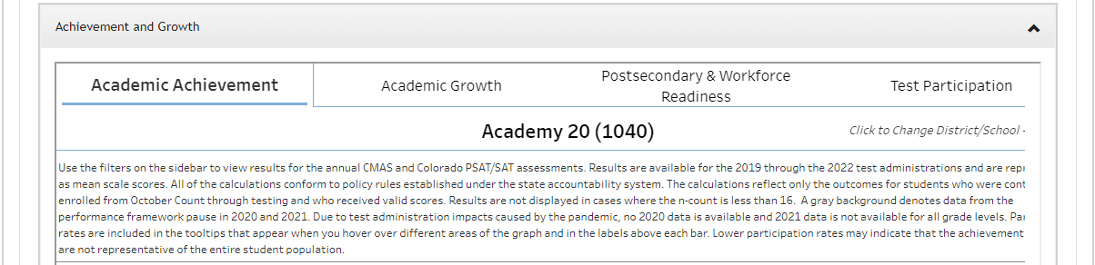

Priority Performance Challenges
All trends identified in Step Four appear at the top of this page and in the published UIP. Schools and districts use these trends to narrow the plan’s focus on the school and district’s greatest Priority Performance Challenges (PPCs). To add PPCs, schools and districts select the “Add Performance Challenge” button. Once schools and districts generate PPCs, schools and districts provide a rationale explaining why these challenges were selected. As with previous steps, the PPCs and rationale automatically populate in the data narrative.
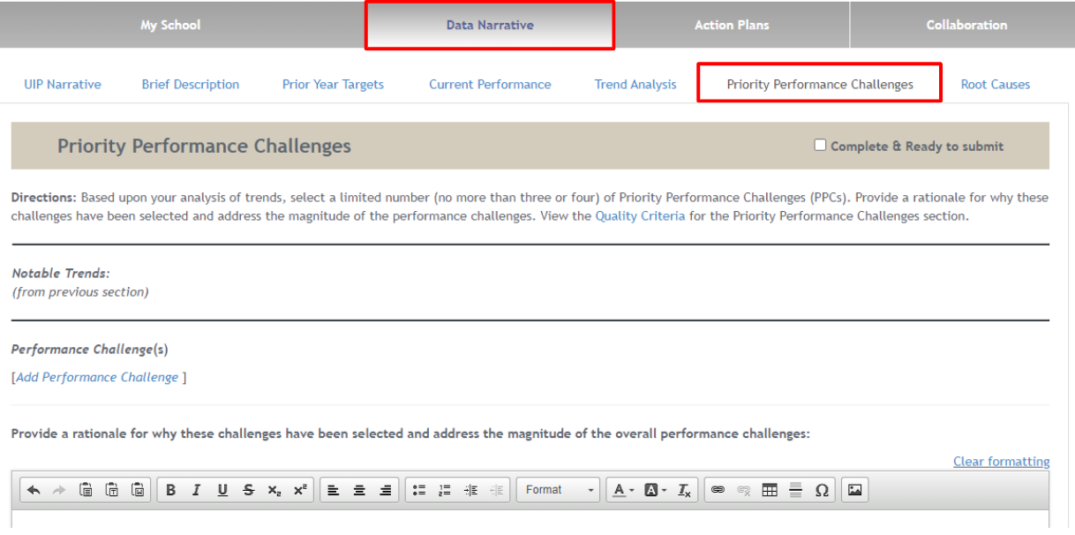

Root Causes
In the Root Cause step, the plan continues to build on itself as all Priority Performance Challenges (PPCs) from the previous step automatically populate. In this step, schools and districts identify the Root Cause(s) of their PPCs. The Online System’s functionality allows schools and districts to create associations between the PPCs and the Root Cause(s) by either adding or associating an already created Root Cause. A Root Cause corresponds with one or more PPCs, schools and districts may “Associate an Already Existing Root Cause.” Once schools and districts create/associate Root Causes, they must provide a rationale for why those Root Causes were selected. Again, the Root Causes and corresponding rationale will merge into the overall data narrative. School and district users can see a list of Root Causes that have not been associated with any PPCs. Users can edit and delete these unassociated Root Causes.
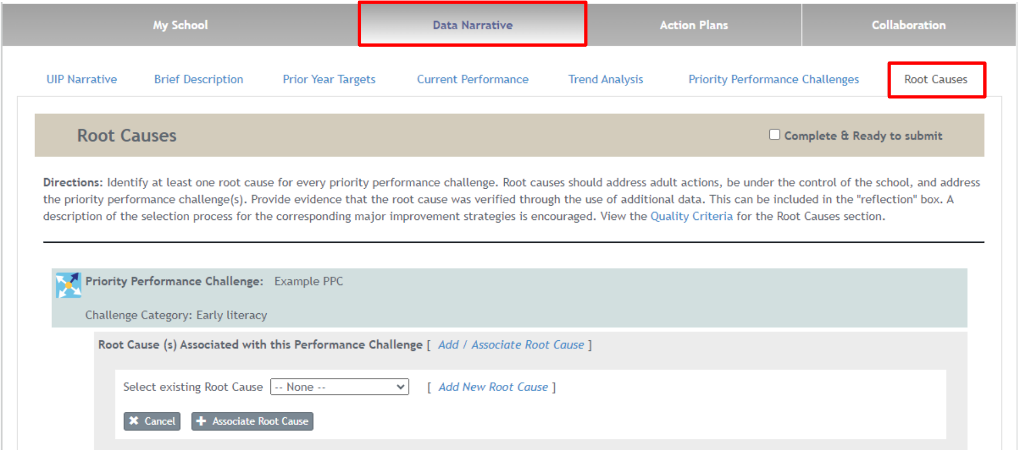

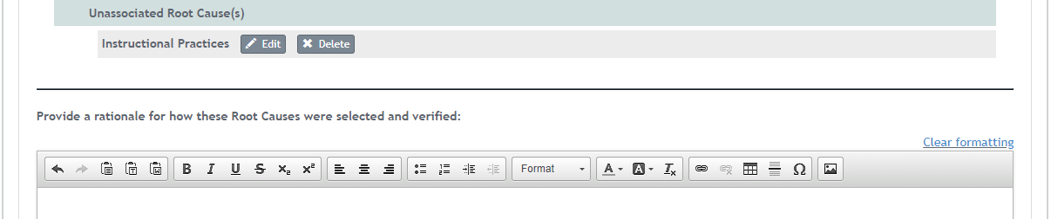
Action Plans
Five tabs make up the Action Planning section of the Online System: (1) Major Improvement Strategies, (2) Planning Form, (3) Full Plan (4) Target Setting, and (5) Report.
Major Improvement Strategies
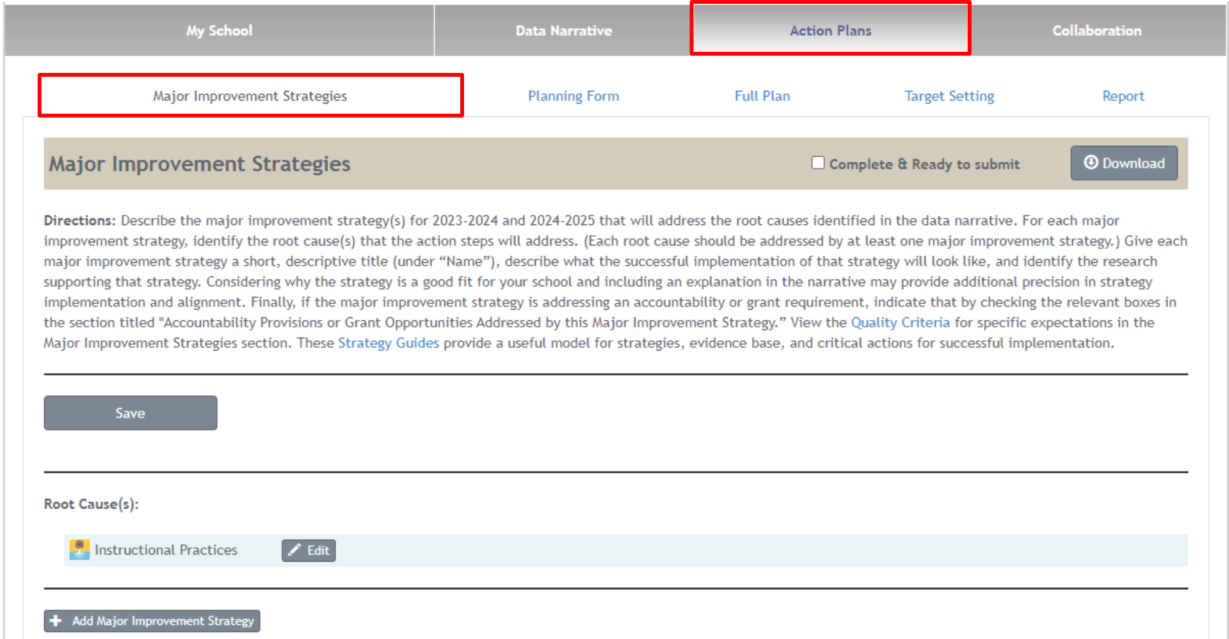
Schools and districts use this section to identify, list, and explain Major Improvement Strategies that will address the Root Causes determined in the Data Narrative. For each Major Improvement Strategy, schools and districts will need to explain what success will look like when this strategy has been enacted and the research supporting the implementation of the strategy. Schools and districts are also asked to select the accountability provision or grant opportunity addressed by the strategy.
Once a school or district populates a Major Improvement Strategy (and the associated accountability provisions), users can either add a new Root Cause or associate the appropriate existing Root Cause(s). To add a new Root Cause, select “Add Root Cause” under the Root Cause label on the left-hand side of the screen.
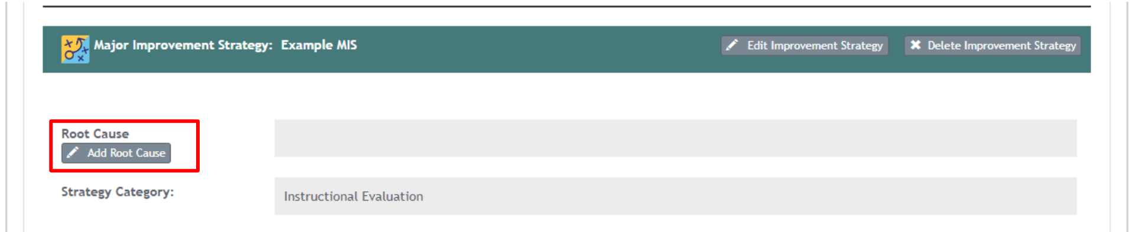

Planning Form
Next, use the Planning Form to create the Action Plan. For each Major Improvement Strategy, Implementation Benchmarks and Action Steps must be completed.
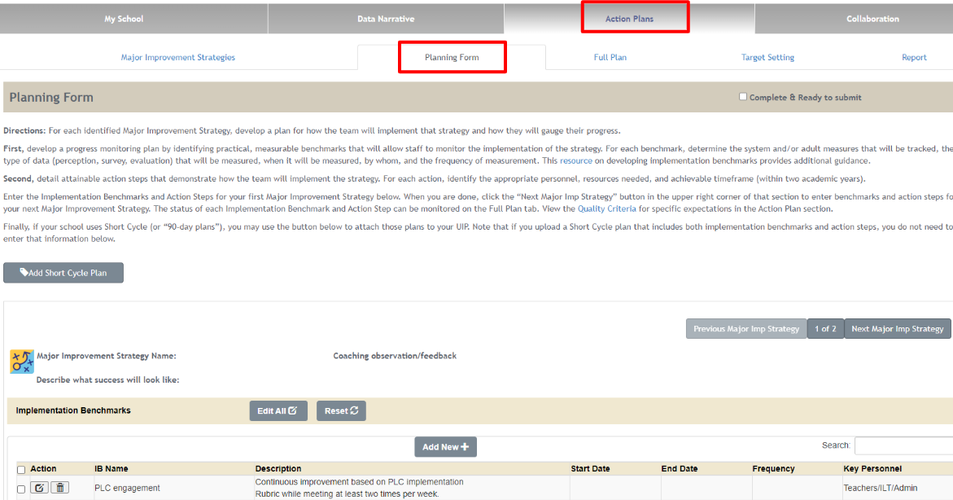
Implementation Benchmarks detail how the implementation of a strategy will be monitored for the Major Improvement Strategies. Users will indicate what practical measurements will be used to track the implementation of the strategies, and they will assign timelines and key personnel to monitor progress.
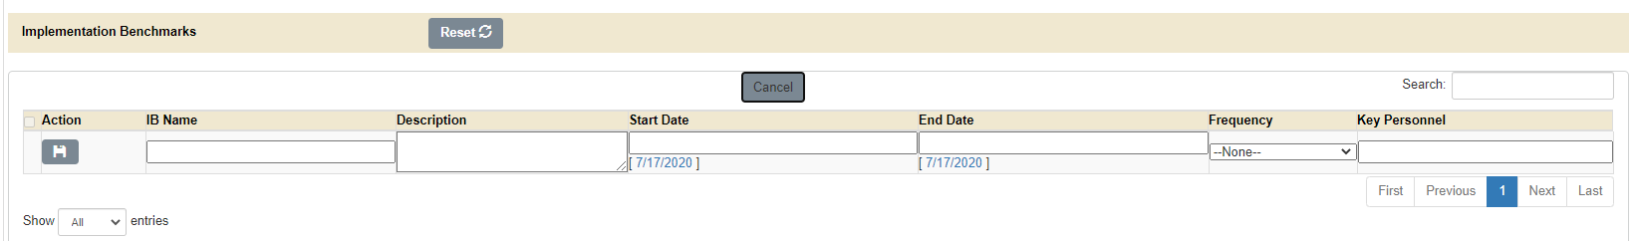
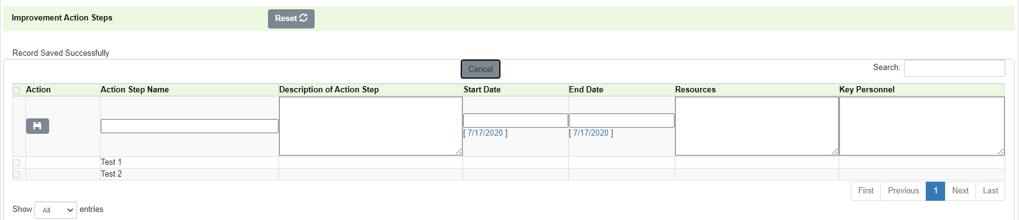
Once Implementation Benchmarks have been completed, to monitor implementation of the strategy, Action Steps can be created to detail the steps taken to carry out the strategy. Action Steps detail how strategies will be broken down into practical, achievable tasks. A timeline, resources, start and end dates, and key personnel will need to be identified. Action Steps and Implementation Benchmarks can be added, deleted, or edited from the Planning Form tab.

At the bottom of the Planning Form tab, there is a Gantt Chart calendar that shows you every item planned for the school year, including what month(s), the span, and the type of action. Implementation Benchmarks are orange, while Action Steps are green. This area is for information only and does not display in the final plan.
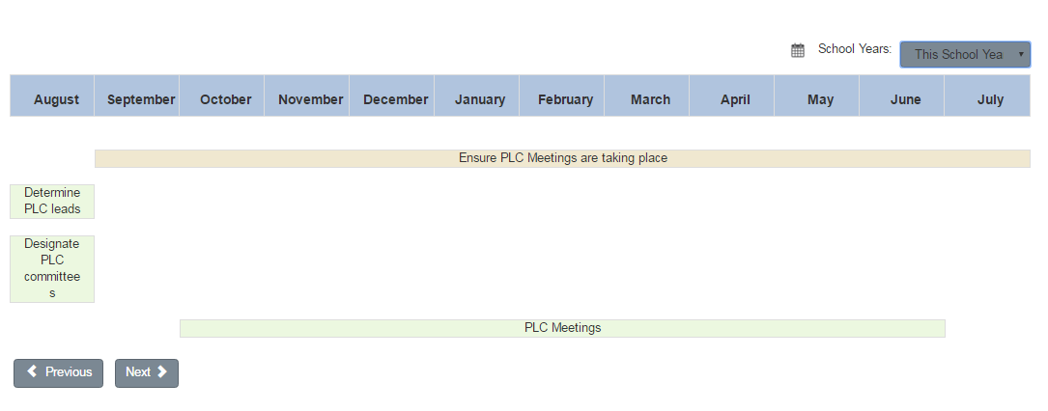

Full Plan
This tab displays the Action Steps and Implementation Benchmarks for every Major Improvement Strategy in one sortable list. This can also be downloaded into Excel.
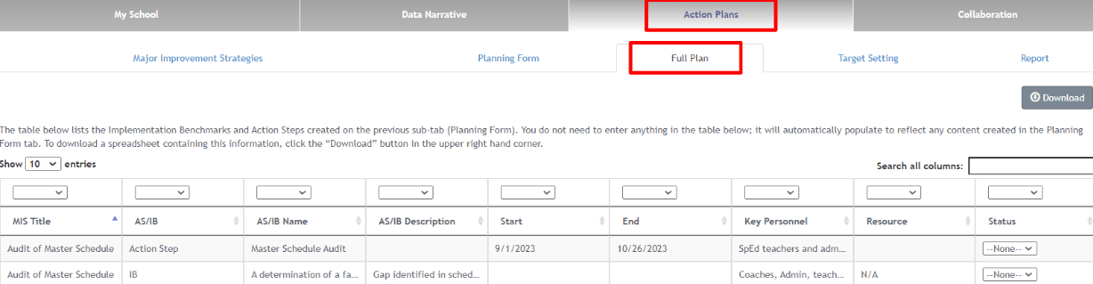

Target Setting
Schools and districts use this section to set Targets for the current and upcoming school years.
The area to add Targets will display after the user has created Priority Performance Challenges. For each target, select the challenge, identify the metric, include the target for the current and upcoming year, and add Interim Measure(s). The Targets set in this form for the current year automatically transfer to Reflection on Previous Year’s Targets in the subsequent UIP.

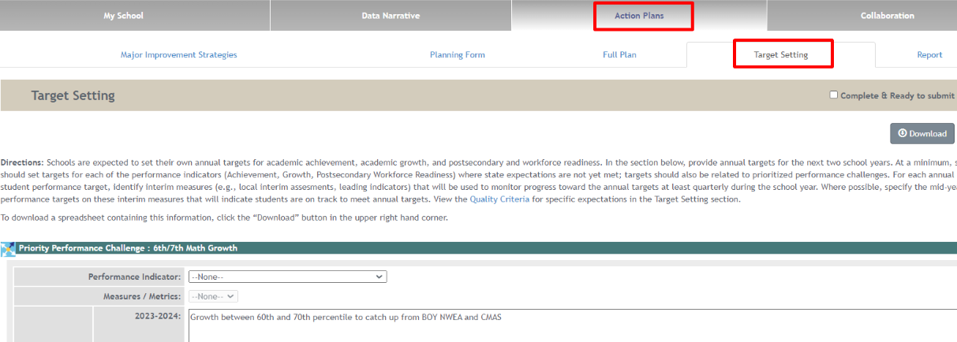

Report
The “Report” tab gives users the option to view a calendar showing action steps and implementation benchmarks listed in the planning form and provides users the ability to download a CSV file of all action steps and implementation benchmarks.

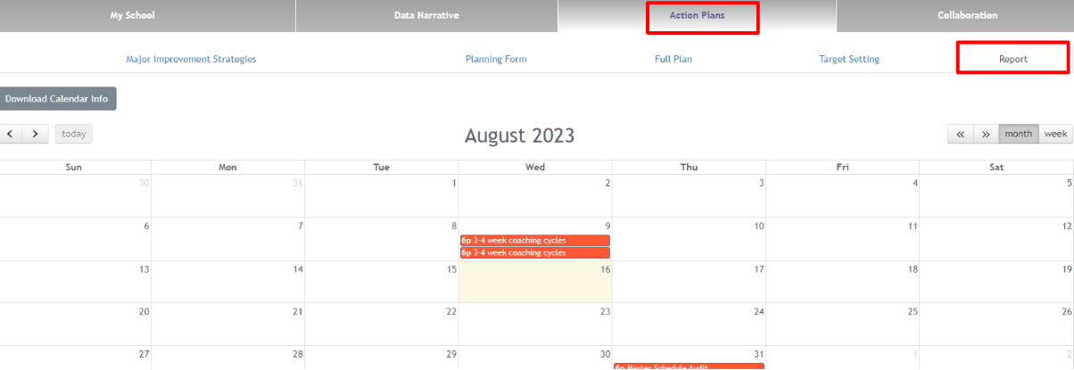

1

Collaboration
Collaboration has two sub tabs: Chatter and UIP Feedback.
Chatter is a way for district and school level users to communicate about their improvement plans; school and district users to talk to each other and CDE to comment on the plan. Use this section like a chat box. This chat will only be seen by users with access to the plan.
After the UIP is submitted and if it is reviewed by CDE, the UIP Feedback tab will contain CDE’s feedback. Districts are notified when this tab is populated.
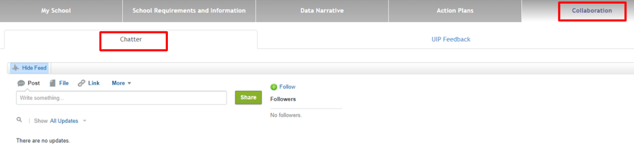

Submitting a Completed Plan

As schools and districts complete each section, mark the “Complete & Ready to Submit” check box in the top bar. These check boxes correspond to the UIP Progress Bar on the first page of the Online System. As schools and districts complete each section, the UIP Progress Bar shows each section as “Ready to Submit.”
Similar to the UIP Progress bar, as schools and districts complete each section of the UIP, the UIP Elements visual populates with the Priority Performance Challenges, Root Causes, and Major Improvement Strategies.
For schools: Once the UIP is complete, hit the ‘Submit for Review’ button, which will indicate to the district that the UIP is ready for review before submission to CDE.
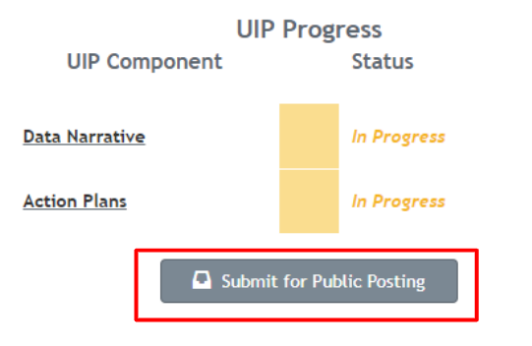

For districts: Once the UIP is complete and ready for CDE review, hit the “Submit for Public Posting” button. A plan can also be submitted by navigating to the UIP online system Administrative pages and hitting the “Submit for Public Posting” button.
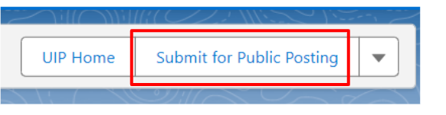

If you have any system problems, please contact the UIP Team at uiphelp@cde.state.co.us.

