Student Name ______________________________________ Date ______________

Upper Case Letters
Dear Parent,
We are learning about the correct use of upper case letters. I hope you enjoy this activity with your child. This assignment is due __________________________________. Thank you!

THINGS TO REMEMBER
Upper case letters also are called capital letters. All sentences, proper names,
and important words in titles must begin with an upper case letter.
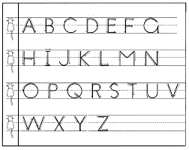

LET’S DO THIS

- With your child: Read this paragraph to your child. Point to each word.

I love rainbows. The colors of a rainbow are red, orange,
yellow, green, blue, and violet. My friend Sara likes to draw
rainbows. Dave likes to see rainbows. Do you like rainbows?

- Ask your child: Circle the upper case letters in the above paragraph.

Tell if the capital letter shows the beginning of a sentence
or a person’s name (proper noun).

- With your child: Read the sentences, below, with your child.

Ask your child: See the words that are underlined.

Fix the start of these sentences to have an upper case letter.

Now, read the sentences to me.

- i eat breakfast every day. 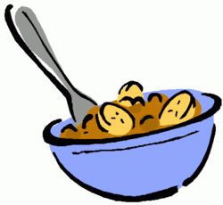
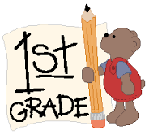

- he is in first grade.

LET’S FIND OUT

- With your child: Read the sentences below to your child.

Ask your child: See the words that are underlined?

Fix these proper names to have upper case letters.

Now, you read the sentence to me
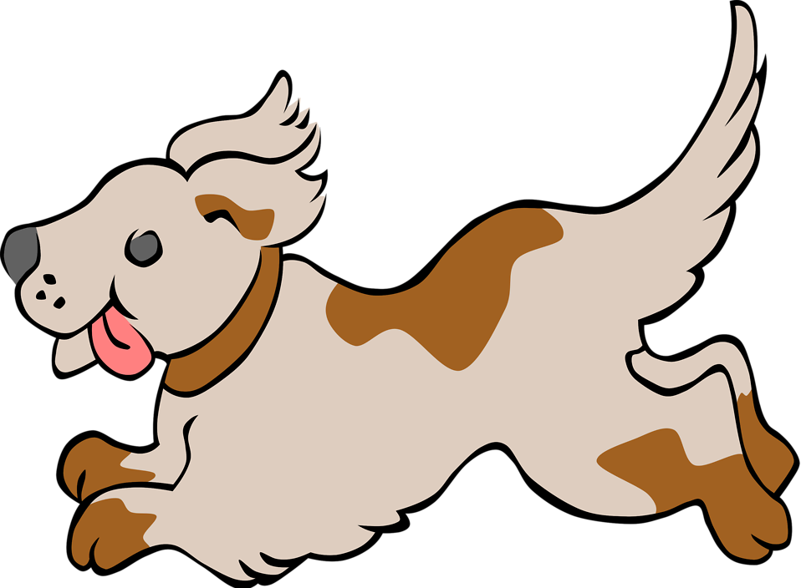

- The dog’s name is spot.

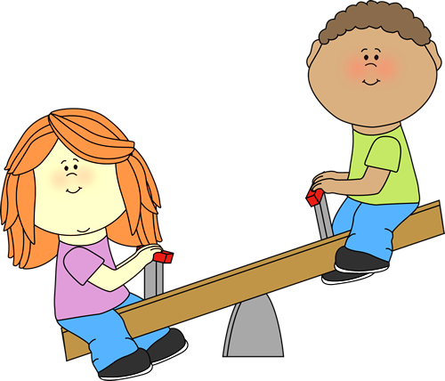

- He is playing with jane.

Ask your child: Draw a picture of two people or pets in your family.

Write their names below the pictures using correct upper case letters.

This is ___________________. This is ____________________.

HOME-TO-SCHOOL COMMUNICATION

Dear Parent,

Please give your reactions to your child’s work on this activity.
Write YES or NO for each statement.
______ 1. My child understood the homework and was able to complete it.
______ 2. My child and I enjoyed the activity.
______ 3. This assignment helped me know what my child is learning in class.

Comment ________________________________________________________________________

Parent Signature __________________________________________________________________

Wilshusen, M., Bognar, J., Handy, T., Epstein, J., & Greenfeld, M. (2016). Teachers Involve Parents in Schoolwork (TIPS) Interactive Homework-Literacy K-3. Colorado Series. Baltimore: Center on School, Family, and Community Partnerships, Johns Hopkins University.

