Student Name ____________________________________ Date _______________

Words Have Families
Dear Parent,
We are learning about word families. These are words that end with the same letters. I hope you enjoy this activity with your child. This assignment is due_________________________.
Thank you!

LET’S DO THIS

- Ask your child: Change the first letter to make a new word In the word family. The picture clues will help.

-ap family

__ ap

__ ap

__ ap
-an family

__ an

__ an

__ an
-at family

__at

__at

__at


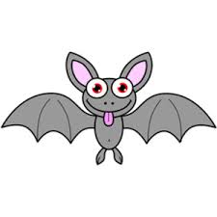

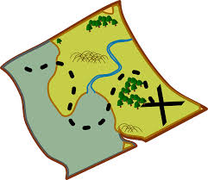



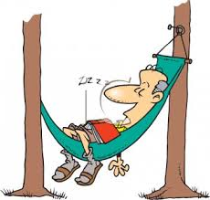

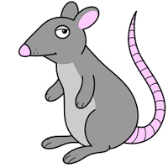

- Read the three sentences, below, to your child pointing to each word.

Ask your child: Read these sentences to me.

Circle the words that are in the same family and draw a picture that goes with the sentence.

The cat sat on a rat.

The map is on my lap.

A man with a tan has a can.

LET’S FIND OUT

- Ask your child:
Here is the –an Word Family. Create your own –en Word Family.
Write 3 –en words in the circles
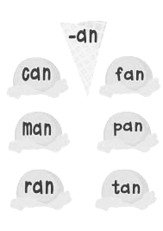
–en

- Ask your child: Read the words in –an and –en Word Families.

- Ask your child:
–ug

Draw pictures of 2 words
for the –ug Word Family.

Write the –ug words on the lines.

Read the words.
Tell me a sentence for
each word in your –ug Family.

HOME-TO-SCHOOL COMMUNICATION

Dear Parent,
Please give your reactions to your child’s work on this activity.
Write YES or NO for each statement.
______ 1. My child understood the homework and was able to complete it.
______ 2. My child and I enjoyed the activity.
______ 3. This assignment helped me know what my child is learning in class.

Comment ________________________________________________________________________

Parent Signature __________________________________________________________________

Wilshusen, M., Bognar, J., Handy, T., Epstein, J., & Greenfeld, M. (2016). Teachers Involve Parents in Schoolwork (TIPS) Interactive Homework-Literacy K-3. Colorado Series. Baltimore: Center on School, Family, and Community Partnerships, Johns Hopkins University.

