Student Name ________________________________________ Date ____________

Beginning and End
Dear Parent,
We are learning that stories have a beginning, middle, and end. I hope you enjoy this activity with your child. This assignment is due _____________________________. Thank you!

LET’S DO THIS

- With your child: Read the story of a pig, a cat, and a dog to your child.
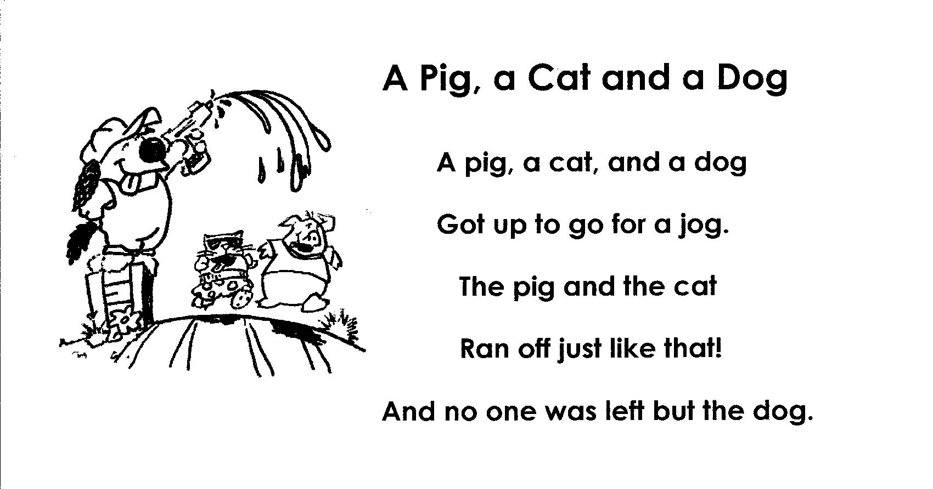
Point to each word.

2. Ask your child: Listen for rhyming words as you read the story again.

Circle the rhyming words. Read them together.

Read the story again using a silly voice.

LET’S FIND OUT

- Ask your child: What happened in the beginning of the story?
Read that part again, pointing to each word.

What happened in the middle of the story? Read that part.
What happened at the end? Read that part.

Now draw and color the 3 parts of the story to show
the beginning, middle, and end of the silly story.

Beginning Middle End

EXTENSION

Ask your child: Tell me a story about what happens at the beginning, middle,
and end of your day.

HOME-TO-SCHOOL COMMUNICATION

Dear Parent,

Please give your reactions to your child’s work on this activity.
Write YES or NO for each statement.
______ 1. My child understood the homework and was able to complete it.
______ 2. My child and I enjoyed the activity.
______ 3. This assignment helped me know what my child is learning in class.

Comment _____________________________________________________________________

Parent Signature ________________________________________________________________

Sampish, A., Wallace, R., Epstein, J., & Greenfeld, M. (2016). Teachers Involve Parents in Schoolwork (TIPS) Interactive Homework-Literacy K-3. Colorado Series. Baltimore: Center on School, Family, and Community Partnerships, Johns Hopkins University.

