# Educational Stability Grant

## Colorado House Bill 18-1306

### History of The Grant Program

Educational Stability Grant

The Educational Stability Grant Program are awarded for three-year terms. The first Cohort was awarded in 2019.

Cohort II of The Educational Stability Grant Program was awarded in May of 2022 to the following grantees:

-Adams 12 Five Star Schools

-CSI New Legacy Charter School

- Greeley/Evans Weld County School District 6,

-Mapleton School District

-Montrose School District

-Poudre School District,

-Pueblo County School District

- Silverton School District 1,

-Thompson School District RE-2.

The next grant competition will open in April of 2025.

In 2018 Colorado Passed House Bill 18-1306; Concerning Ensuring Educational Stability for Students in Out-of-Home Placement. This bill included the creation of the Educational Stability Grant Program, which is intended to support educational stability of highly mobile students. In this context, highly mobile refers to students who experience (or at risk of experiencing) multiple school moves during their K-12 education outside of regular grade promotion.

This includes youth in foster care, those experiencing homelessness, and migrant students. These student groups experience low graduation rates and tend to be disproportionately represented in disciplinary actions and are above the State average in special education designations.

The statutory definition of “highly mobile students” means children or youth who at anytime during the academic were homeless, as defined in section 22-1-102.5, C.R.S.; were in non-certified kinship care, as defined in section 19-1-103, C.R.S.; were students in out-of-home placement, as defined in section 22-32-138(1)(h), C.R.S.; or were migrant children, as defined in section 22-23-103, C.R.S.

The intent of the Educational Stability Grant is to address reducing educational barriers for students who experience high mobility by providing academic and social-emotional services and supports to highly mobile students.

Goals of the Grant Program:

* To improve educational experiences and outcomes for students experiencing high mobility in the following populations:
  + Foster Care (or out-of-home placement)
  + Migrant
  + Homeless

### Purpose of the Program

The purpose of this funding is to support the removal of all educational barriers for children and youth experiencing high mobility with an emphasis on improving school attendance, reducing behavioral and discipline incidents, increasing grade-level promotion, reducing dropout rates, and increasing graduation and completion rates.

To the maximum extent practical, grant funded services shall be provided through programs and mechanisms that integrate highly mobile individuals and non-highly individuals. Activities undertaken must not isolate or stigmatize highly mobile children and youth. Services provided under this program are not intended to replace the regular academic programs. Funds from this grant can be used to supplement existing services, but they cannot be used to supplant services which the Local Education Agency and BOCES have been providing though other means. Collaboration and coordination with other local and state agencies that serve highly mobile children and youth is required (e.g., county child welfare agencies).

**Eligible Applicants**

All Colorado education providers are eligible to apply. “Education provider” means a school district. The state charter school institute, or a board of cooperative educational services the operates a school, public school of a school district, a school operated by a board of cooperative educational services pursuant to article 5 of title 22, C.R.S., an institute charter school authorized pursuant to part 5 of article 30.5 of title 22, C.R.S., a state-licensed day treatment facility, an approved facility school as defined in section 22-2-402 (1), C.R.S.

The State Board of Education shall award educational grants to preschool, elementary, and secondary education providers from money appropriated from the Educational Stability Grant Program Fund.

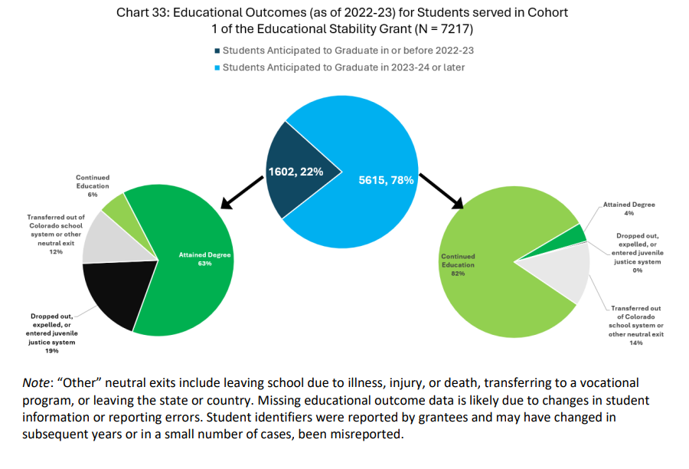

**Student Success Story**

Educational Stability Grantees serve students facing a range of barriers to stable learning environments. The following story was shared as an example of the impact grantees have in improving students’ learning environments. “I had a high school counselor reach out to me regarding a senior. [The senior] had become an UHY [unaccompanied homeless youth] and had nowhere to stay, nothing to eat, and no transportation. She was a high achieving student who was going to have to drop out due to circumstances. We were able to provide emergency shelter, transportation, clothing, laundry services and food to help the students remain at school. While in emergency shelter, I was able to connect her with transitional housing for 18‐24-year-olds. We connected the students with food stamps, and food banks. We continued to provide transportation and grocery cards for food, clothing and hygiene products as needed. She was able to take a couple AP tests, attend prom and purchase her cap and gown. Paperwork was completed to identify her as homeless on her FASFA for college. She graduated and has enrolled in college. She has not declared a major at this point. Without the help of the district through the Ed Stability Grant, I am not sure where this young lady would have landed. She was lost, hurt and ready to give up on her education. She was grateful every step of the way. I am grateful to her counselor for being there for the student and reaching out for help. This is just one success story from this program.”