LMS: CWEL - Creating an Account & Updating Profile CWTS Help Desk: support@coloradocwts.com

LMS: Child Welfare Education Liaison (CWEL)—Creating an Account & Updating Profile
- To create your initial account, visit https://learning.coloradocwts.com/login/index.php and select Create new account.
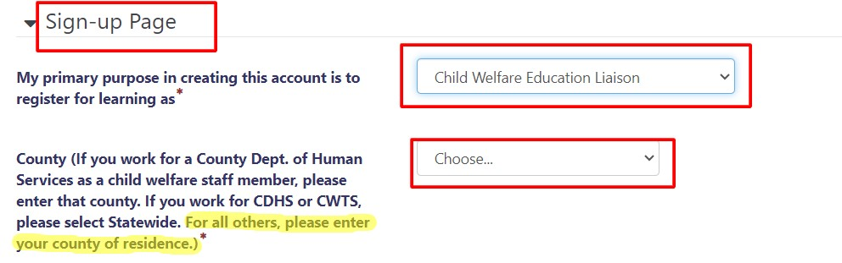
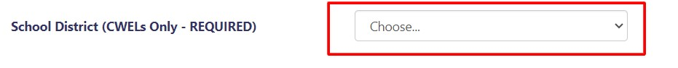
IMPORTANT: NEVER CREATE MORE THAN ONE ACCOUNT (even if you change positions, agencies, or move counties). Creating multiple accounts will affect the integrity of your training record and may prevent necessary annual updates to your certification/recertification status. Contact the help desk at support@coloradocwts.com if you need to make changes to your account, reactivate a previous account, or if you have forgotten your login credentials.

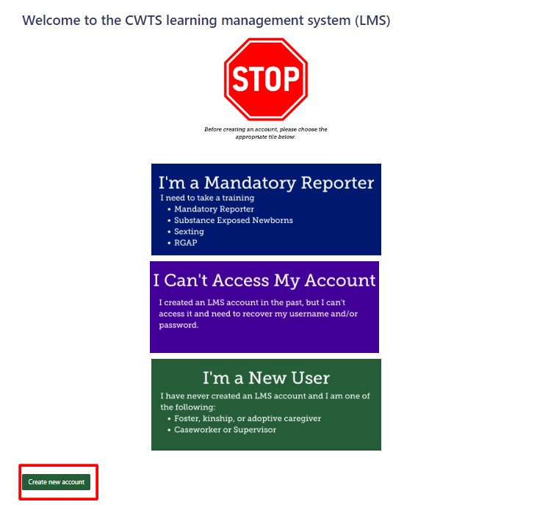
- Complete ALL fields when entering profile information and be sure to scroll all the way down. In the Sign-up Page category, select your primary purpose as Child Welfare Education Liaison, select your county of residence, and select your school district under School District (CWELs Only - REQUIRED).
- Under the Other Child/Family Service Provider category, enter the name of your agency/organization.
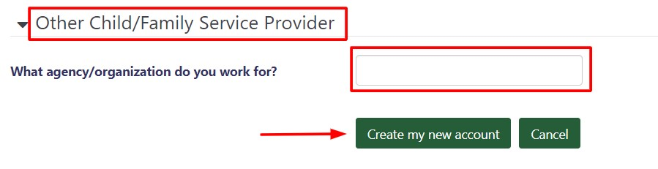
- Click Create my new account at the bottom of the page. You will receive an email to confirm your account. (Please check your spam folder. If you don’t find the email, contact the help desk at support@coloradocwts.com.)
- To update your profile page, click on your username in the top-right corner of the window and select Profile from the dropdown menu. Then, under User details click Edit profile. Update the needed fields, scroll down to the bottom of the page, and click Update profile.
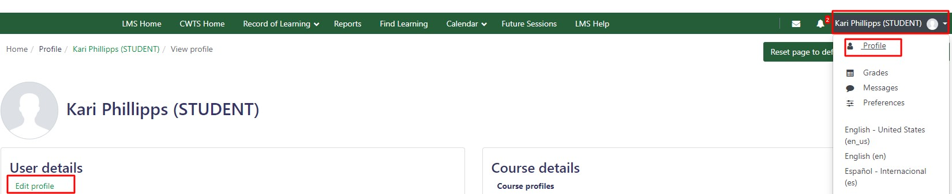
- If you have trouble accessing your account, visit the CWTS Help Desk at https://coloradocwts.com/needhelp/.

