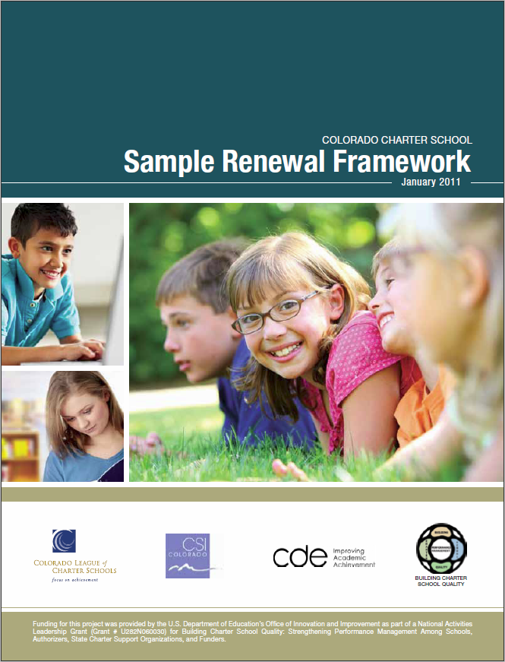
Colorado Charter School Sample Renewal Framework
January 2011
Background
This Sample Renewal Framework provides a Colorado-specific guide to charter school renewal, complementing the Colorado Charter School Standard Application, Checklist, and Review Rubric, A Resource for Developing Charter School Contracts, and Colorado Sample Contract Language and Attachments. All of these documents are a product of a collaborative initiative of the Colorado Department of Education, the Colorado League of Charter Schools, and the Colorado Charter School Institute, and are available at www.charterschoolquality.org.
This Framework draws on publications developed by the National Association of Charter School Authorizers, and specifically on Accountability in Action: A Comprehensive Guide to Charter School Closure. Edited by Kim Wechtenhiser, Andrew Wade, and Margaret Lin (National Association of Charter School Authorizers (2010).
This Framework also benefits from review by authorizers and charter schools. Additional feedback from authorizers and schools will be gathered over time to improve this document to ensure it continues to reflect best authorizing practices in Colorado. This work is part of a larger four-year project entitled, “Building Charter School Quality: Strengthening Performance Management among Schools, Authorizers, State Charter Support Organizations and Funders,” which was supported by a National Activities grant from the U.S. Department of Education.

Table of Contents
Introduction. . . . . . . . . . . . . . . . . . . . . . . . . . . . . . . . . . . . . . . . . . . . . . . . . . . . . . . . . . . . . . . . 4
Sample Renewal Process. . . . . . . . . . . . . . . . . . . . . . . . . . . . . . . . . . . . . . . . . . . . . . . . . . . . . . 5
The Charter School Contract:Foundation for Renewal . . . . . . . . . . . . . . . . . . . . . . . . . . . . . 6
Sample Renewal Timeline. . . . . . . . . . . . . . . . . . . . . . . . . . . . . . . . . . . . . . . . . . . . . . . . . . . . . 8
Conclusion . . . . . . . . . . . . . . . . . . . . . . . . . . . . . . . . . . . . . . . . . . . . . . . . . . . . . . . . . . . . . . . . . 9
Attachment 1:Indicators, Measures, Metrics and Targets. . . . . . . . . . . . . . . . . . . . . . . . . . 10
Attachment 2:Suggested Indicators . . . . . . . . . . . . . . . . . . . . . . . . . . . . . . . . . . . . . . . . . . . . 11
Attachment 3:Access to Data and Information/Accreditation Data and Process. . . . . . . . 12

Introduction
Considering renewal of a charter school contract is a process that an authorizer and a charter school undertake every three to five years, unless a longer contract has been signed to address facility financing issues.

Even in these situations, best practice suggests that a charter school undertake a renewal-like review every five years. Colorado law (C.R.S. 22-30.5-110) outlines specific requirements for the contents of a renewal application, the latest date for submission, and the date by which a district must act on the renewal application:
  - No later than December 1 of the year prior to the year in which the charter expires, the governing body of a charter school shall submit a renewal application to the chartering local board of education. The chartering local board of education shall rule by resolution on the renewal application no later than February 1 of the year in which the charter expires, or by a mutually agreed upon date.
- A charter school renewal application submitted to the chartering local board of education shall contain:
- a report on the progress of the charter school in achieving the goals, objectives, pupil performance standards, content standards, targets for the measures used to determine the levels of attainment of the performance indicators, and other terms of the charter contract and the results achieved by the charter school’s students on the assessments administered through the Colorado student assessment program; and
- a financial statement that discloses the costs of administration, instruction, and other spending categories for the charter school that is understandable to the general public and that will allow comparison of such costs to other schools or other comparable organizations, in a format required by the state board of education.
Colorado law (C.R.S. 22-30.5-110) also specifies the grounds for revoking or not renewing a charter:
- A charter may be revoked or not renewed by the chartering local board of education if it determines that the charter school did any of the following:
- committed a material violation of any of the conditions, standards, or procedures set forth in the charter contract;
- failed to meet or make reasonable progress toward achievement of the goals, objectives, content standards, pupil performance standards, targets for the measures used to determine the levels of attainment of the performance indicators, applicable federal requirements, or other terms identified in the charter contract;
- failed to meet generally accepted standards of fiscal management; or
- violated any provision of law from which the charter school was not specifically exempted.
Within the framework provided by these laws, districts must establish a specific renewal process.

Sample Renewal Process

Key Questions
The renewal process broadly considers the four key questions below:
- Is the educational program a success?
- Are school operations effective and efficient?
- Is the school meeting its legal and other obligations?
- Does the school have excellent governance and leadership?
For each of these questions, indicators, measures, metrics, and targets must be developed. These terms are defined in Attachment 1, and suggested indicators are listed in Attachment 2.1
Examples of Colorado-specific indicators, measures, metrics and targets can be found through several sources:
- Denver Public Schools (DPS) website resource page on School Performance Framework (SPF)- http://communications.dpsk12.org/initiatives/200/160/.
- Charter School Institute (CSI) website home page www.csi.state.co.us/.

The Charter School Contract: Foundation for Renewal

Charter School Objectives
The charter school contract is the foundation for renewal since it includes the goals and objectives for which the charter school is accountable, as well as other important compliance requirements. Objectives included in the Colorado Sample Contract Language and Attachments are provided below to show how key indicators and accreditation requirements are incorporated into the contract:
- School goals. [School goals should be inserted here.]
- Unique School objectives. [Mission-specific School objectives should be inserted here.]
- District accreditation. The School shall be accredited or accredited with distinction in accordance with written District guidelines and state law. The School acknowledges that these indicators may change over time and that the District agrees to provide the School with opportunity for input into any proposed changes before they are finalized.
- District finance, governance, and operations standards. The School shall meet or exceed District standards, if any, for charter schools in the areas of finance, governance and operations. The School acknowledges that these indicators may change over time and that the District agrees to provide the School with opportunity for input into any proposed changes before they are finalized.
The Sample Contract Language and Attachments states that the school must meet or make reasonable progress toward meeting these objectives.

See Sample Contract Language and Attachments at www.charterschoolquality.org > Publications & Tools > Authorizers.
Data Access and Review
The contract ensures that the charter school has access to the data used to determine its accreditation status and an opportunity to appeal its assigned status. A similar opportunity to appeal is provided before operational data is finalized. Then, after data has been finalized, the district provides the school with its preliminary overall assessment of the progress made toward achieving the charter school’s goals and objectives. Again, an opportunity to comment is provided before the assessment of progress is finalized. Sections from the Sample Contract Language and Attachments that ensure a fair process may be found in Attachment 3.
Compliance
The contract also includes key compliance provisions like the one below that is taken from the Sample Contract Language and Attachments.
Transparency. The School shall make Charter Board-adopted policies, meeting agendas and minutes and related documents readily available for public inspection and shall conduct meetings consistent with principles of transparency, the Colorado Sunshine and Open Records laws, and shall adopt and strictly enforce a conflict of interest policy.
The district should monitor compliance with key contract provisions, as well as the extent to which the school uses best governance, finance, and operations practices.
Other Reasons for Non-Renewal
In addition to the reasons for non-renewal listed in the Introduction of this Framework, the charter school contract may identify additional grounds for termination. Examples from the Sample Contract Language and Attachments are provided below.

Grounds for termination, revocation, or denial also include the following:
A. Pursuant to C.R.S. 22-11-210 (1) (d), the School is accredited with a priority improvement plan or turnaround plan for a combined total of five consecutive years or any lesser number of years established by the State Board after which closure or restructuring is required.
B. The School is accredited with a turnaround plan and does not attain a higher accreditation rating at its next performance review in accordance with C.R.S. 22-11-406 (3).
The case for non-renewal is easier to develop and the renewal process is more transparent when more specific grounds like those above are included in the contract.
Summary
The charter contract identifies the goals and objectives that are the basis for charter school accountability and key compliance requirements. The contract supports a fair process by ensuring access to data, annual evaluations of progress and opportunities for school input. The data and evaluations generated by this annual process are the foundation for monitoring progress and compiling the cumulative record that will be used to consider renewal of the charter school contract.
Monitoring Progress and Compiling a Cumulative Record
Monitoring progress means that the district collects data related to the contract objectives (including accreditation), makes a preliminary evaluation of the school based on the data, and gives the school an opportunity to respond prior to finalizing the evaluation. These written evaluations can be as simple as acknowledging that the charter school has met all of its objectives (accreditation, finance, governance, and operations, and unique measures) and is to be commended for its performance. Where a school has not met all of its objectives, the district may comment about whether or not there is evidence of progress. The most difficult situations to evaluate will be where the evidence of progress is not compelling, but the school serves a unique population and meets its unique objectives. Evaluation information from the district should be sent to the charter school board as well as the school’s administrator.
The written correspondence identified in the previous paragraph (data, evaluation of the data by the authorizer, comments about the evaluation by the school, and any revisions to the evaluation) constitute the bulk of the cumulative record that is used to make a renewal decision. In addition, any letters of concern, breach, or notice of a revocation hearing, as well as commendations for outstanding performance, audit results (not otherwise incorporated into the financial indicators), and complaints against the school filed by a government agency should be included in the cumulative record. For schools that participate in a Charter School Support Initiative (CSSI) review, the findings of the review team and the progress that has made at the one-year follow-up to address areas of concern would also be included in the cumulative record.
Renewal Process
If the charter contract includes carefully constructed objectives and data is compiled and evaluated annually, most schools will need to do very little additional work to complete the renewal application. In those limited cases where progress has not been made on many indicators, the school may need to devote considerable resources to making the case for renewal. In either situation, the steps in the renewal process are the same and are described in the table on page 8.
While adhering to statutory deadlines, the specific timeline for renewal that a district establishes should reflect the date that the previous year’s outcome data will be available, the time needed for an appeal, and opportunities for parents to access new choice options.

Sample Renewal Timeline
Date | Task
Spring of the year prior to the charter’s expiration. | The parties meet so that the district can explain the renewal process, application format and timeline, and address any questions regarding the process.
July 1 of the year prior to the charter’s expiration. | District submits preliminary renewal recommendation and supporting data from the cumulative record along with financial information compiled from previously submitted reports to the charter school board and administrator. District staff meets with the school, if requested, to explain or clarify the data or recommendations.
September 1 | Charter school submits comments on the data and recommendations to the district.
November 1 | District submits final recommendations and supporting data to the charter school, including prior year performance information. District staff meets with the school, if requested, to explain or clarify the data or recommendations.
No later than December 1. | The school formally submits the renewal application to the district which includes:  - Charter school comments on the district data and final recommendations.  - Financial information.  - Additional data generated by the school relevant to whether or not the charter should be renewed.  - Changes being requested (and rationale) that would have a material impact on the charter contract.  - 5. Challenges anticipated during the next term of the charter and the plan for addressing them.
Prior to December district board meeting. | District staff reviews the renewal document and adds additional information as needed.
December | District board of education meeting:  - District staff presents the recommendation and supporting evidence at a public meeting.  - Board asks questions and requests clarifications as needed.  - Charter school responds to the staff report and recommendation.  - 4. Public hearing where charter parents and other interested persons address the board.
Prior to January district board meeting. | District staff sends any additional written information and clarifications to the board of education.
No later than February 1. | District board of education acts by resolution to approve or deny the request to renew the charter.
No more than 30 days after the district board decision. | A notice of appeal may be filed with the State Board of Education.
No more than 60 days after the notice of appeal has been filed. | The State Board of Education holds a hearing and makes a decision to uphold the district’s decision or remand the decision back to the district for reconsideration.

Conclusion

Deciding whether or not to renew a charter can be one of the most challenging tasks that a district undertakes because the many factors that must be considered may lead to differing conclusions. This process can be made easier if it is characterized by the following:
- Putting the interests of children first.
- Identifying performance indicators that have been, at least ideally, in place for the duration of the contract.
- Gathering accurate data.
- Undertaking annual performance evaluations.
- Adopting reasonable performance expectations.
  - No charter school should be expected to meet or make progress toward all of its performance targets.
  - No charter school should be penalized for setting high expectations.
  - All charter schools should be held to the same minimum standards as other district schools.
- Considering multiple measures, including comparable school performance, across three or more years.
- Weighting the evidence based on importance, rather than relying on numeric cut scores.
- Listening to the points of view of both the district staff and the charter school.
- Taking into account the number of years that the school has been operating – a new school may not immediately be able to meet performance targets that are reasonable for a long established one.
A renewal process with the above characteristics will not only support good decision making, it will also provide a context that raises performance for all schools.

Attachment 1: Indicators, Measures, Metrics and Targets
Source: A Framework for Academic Quality. Building Charter School Quality (June 2008), www.charterschoolquality.org.

Indicators
Indicators represent general dimensions of academic quality or achievement, such as “Post-secondary Readiness and Success,” that the Consensus Panel has identified as essential. The four key academic quality indicators set forth in this Framework are accompanied by measures, metrics and benchmarks that the Consensus Panel recommends for widespread adoption and use by charter schools and authorizers.
Measures
Measures are general instruments or means to assess performance in each area defined by an indicator. Measures require the application of specific metrics or calculation methods (see Metrics). For example, a measure of postsecondary readiness is high school completion.

Metrics
Metrics specify a quantification, calculation method or formula for a given measure. For example, the typical high school completion metric is a graduation rate, such as “the percentage of ninth-graders graduating in four years.”
Targets
Taking metrics a step further, targets are specific, quantifiable objectives that set expectations or define what will constitute success on particular measures within a certain period of time. For example, a graduation-rate target might be “90% of ninth-graders graduating within four years.” Likewise, state-mandated performance levels are common targets. Having well-conceived and well-defined performance targets is important to achieve and evaluate school success. However, targets should be set by schools, authorizers, and state and federal policy – so the Framework set forth below does not specify targets for each recommended measure and metric.

Attachment 2: Suggested Indicators
Source: A Framework for Academic Quality. Building Charter School Quality (June 2008) and A Framework for Operational Quality. Building Charter School Quality (June 2009), www.charterschoolquality.org.
Charter Renewal Application: Key Questions

1. Key Question: Is the educational program a success?
Academic Performance & Quality of Educational Program
- Achievement of goals and objectives as stated within the charter contract
  - Academic Growth
  - Academic Achievement
  - Post-secondary Access & Readiness (for high schools)
  - Stakeholder Engagement
  - Unique Educational Outcomes
2. Key Question: Is the school meeting its legal and other obligations?
Legal and Institutional Compliance
  - Services for Students with Special Education Needs
  - Services for English Language Learners
  - CMO/EMO and Other Legal Compliance
  - Safe and Secure Facility
3. Key Question: Are school operations effective and efficient?
Effective and Efficient Operations
  - Financial Performance
  - School Demand
  - Unique Organizational Commitments
4. Key Question: Does the school have excellent governance and leadership?
Leadership and Governance
  - Governing Board Leadership
  - Administrative Leadership
  - Teacher Leadership
  - Parental Leadership

Attachment 3: Access to Data and Information/Accreditation Data and Process
Source: Sample Contract Language and Attachments (2011), www.charterschoolquality.org > Publications & Tools > Authorizers.

Access to data and information
The District will timely provide the School with access to any data and information pertaining to the School that it receives from the State or other sources including but not limited to test scores, ESEA school improvement status, Adequate Yearly Progress, accreditation, special education, and funding information.

Accreditation data and process
No later than five business days following the receipt of the information, the District shall provide to the School the data used by the Colorado Department of Education (Department) to conduct its analysis of the School’s performance and the Department’s initial recommendation considering the type of performance plan the School should be required to implement. The District shall give due consideration to any appeal made by the School to the plan assignment, provided that the School has submitted valid and reliable data for consideration in accordance with a reasonable deadline established by the District. The District shall represent any appeal it deems valid to the Department in accordance with CCR 301-1-10.03. No later than five business days following the receipt of the information, the District shall provide to the School the final plan assignment determination that the School shall implement and the final accreditation status assigned to the School and the District’s assessment of the progress made by the School toward the goals and objectives set forth in Section 7.3 of this Contract.
The School will be given an opportunity for input and comment before the District finalizes its assessment of the School’s achievement on the objectives listed above [in Section 7.3] .

Notes

