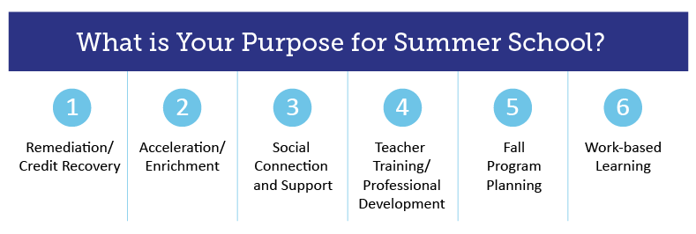
Please use the open spaces below to capture your district’s/school’s Possible Resources and Funding Considerations based on the purpose of your summer school.
View additional summer school resources at http://www.cde.state.co.us/safeschools/summerschool.

1. Remediation/Credit Recovery:
Focused programming on closing gaps for students behind and/or targeted towards all students to close slides that may have occurred this spring. This also includes information and resources to support credit recovery.

Possible Resources:

Funding Considerations:

2. Acceleration/Enrichment:
Summer programming focused on the continued acceleration of learning for all students. Resources are included below for summer programming that includes other enrichment activities including arts, movement, etc.

Possible Resources:

Funding Considerations:

3. Social Connection and Support:
Summer programming focused on providing social and emotional support for students, families and staff.

Possible Resources:

Funding Considerations:

4. Teacher Training/Professional Learning:
Focus on preparing teachers over the summer for the start of the school year in the fall of 2020.

Possible Resources:

Funding Considerations:

5. Fall Program Planning:
Focus on fleshing out innovative ideas for changes to programming for the fall of 2020.

Possible Resources:

Funding Considerations:

6. Work Based Learning (High School/Secondary):
Focused programming on virtual work based learning.

Possible Resources:

Funding Considerations:

