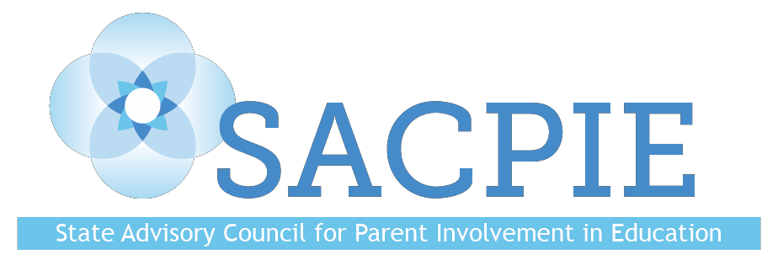

Quarterly Meeting

Tuesday, August 21, 2018
Denver, CO
MINUTES

Members Present: Noemi Aguilar, DJ Anderson, Ann Bruce, Pam Christy (via phone), Kristen Collins, Sofia Esteve, Eryn Kaiser, Leslie Levine, Dee Leyba (via phone), Kim McLachlan (via phone), Caitlin Mendenhall (proxy for Veronica Palmer), Maci O’Grady, Monica Peloso, Joanna Peters, Kay Trotter, Joyce Thiessen-Barrett, Michael Vente, Kim Watchorn (Vice-chair), Stacey Zis, (Chair)

Guests: Evie Hudak, David Ramer, Patty Schmidt (via phone)

Welcome and Introductions
- Members and guests introduced themselves.

Recognition of Outgoing Chair Stacey Zis
- SACPIE recognized Stacey for her contributions to the council.

Public Comment
- No public comment.

Approval of Minutes from Tuesday, May 15, 2018
- Maci mentioned that her name was misspelled. The minutes were approved.

Planning for October – Kim Watchorn, SACPIE Vice-chair, Colorado Department of Education (CDE)
- Kickoff Event will be held in Parker.
- September 7 is the deadline for new posters.
- 65 Promising Partnership Practices (most of any year).
- Holding the event off-site feels more like a celebration.
- Darcy will send a Save the Date flyer.
- Having nametags would be helpful.

Colorado’s 2Gen Initiative Follow-Up – Tara Smith, State Two Generation Program Coordinator, Governor’s Office
- Community Innovation Pilot announcement on August 23.
- 2Gen Action Plan release – September 10.
- Quarterly Webinar #3 – September 24.
- New opportunity: Workforce and Early Child Care and Education.
- Sustaining momentum.

Co-chair Election
- Two candidates: DJ Anderson and Leslie Levine.
- They spoke about why they are interested in being the next co-chair, then members voted.
- Kim Watchorn will tabulate the ballots, including those from members attending the meeting via the phone.

CDE Office of Dropout Prevention and Student Re-engagement – Judith Martinez and Kerry Wrenick
- Colorado House Bill H.B. 09-1243 created the DPSE office.
- Colorado’s dropout rate is 2.3% (the lowest it has ever been). 10,421 dropouts. Was over 16,000 when the office was created.
- Approximately 30,000 students are highly mobile (experience multiple school moves during K-12). More apt to dropout.
- Colorado House Bill H.B. 18-1306, Improving Educational Stability for Foster Youth, was signed by the governor on June 1 of this year.
- Fewer than 25% in foster care graduate in four years.
- During the 2016-2017 school year, Colorado public schools identified and served 21,943 students experiencing homelessness in grades PK-12.
- McKinney-Vento Education for Homeless Children & Youth Program: four-year graduation rate for these students is 54%.

Education Leadership Council Focus Group – David Padrino, Tyler Gamble and Jeff Stsapleton
- Examining the state of education in Colorado.
- Created by executive order by Governor Hickenlooper last year.
- From Early Childhood through the workforce.
- Bi-partisan effort.
- SACPIE members gave feedback.

Committee Sharing
- Committees met but did not report out.

Upcoming SACPIE Meetings
Tuesday, November 13, 2018 11:00 am-3:00 pm
Tuesday, February 12, 2019 11:00 am-3:00 pm
Tuesday, May 21, 2019 11:00 am-3:00pm
Tuesday, August 20, 2019 11:00 am-3:00pm

Disclaimer: The views and opinions expressed in this document are those of the State Advisory Council for Parent Involvement in Education (SACPIE) and do not necessarily reflect the official position or policy of the Colorado Department of Education or the Colorado State Board of Education.

