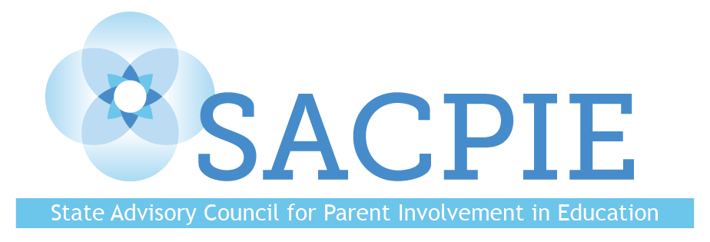

Quarterly Meeting
Tuesday February 12, 2019
MindSpark Learning
455 S Pierce St, Lakewood, CO 80226
AGENDA

11:00 Welcome and Introductions

11:10 Public Comment

11:20 November 13, 2018 Minutes Review and Approval

11:25 CDE Family Partnership Update—Darcy Hutchins

11:35 Family-School-Community Partnering Framework Principles Feedback—Joey Willett, Chris Miller, Darcy Hutchins

12:15 Break

12:25 SACPIE Revamp and Planning for 2019—DJ Anderson, Leslie Levine

1:50 CDE Website Revamp—Dana Smith

2:15 Accountability Rulemaking—Ashley Piche

2:45 Wrap-Up and Next Steps

3:00 Adjourn
Upcoming Executive Committee Meetings
Colorado Department of Education
1560 Broadway Suite 1175 Aspen Conference Room
Denver, CO. 80203

Wednesday September 12, 2018 10:00am-noon
Wednesday October 10, 2018 10:00am-noon
Wednesday January 9, 2019 10:00am-noon
Wednesday March 13, 2019 10:00am-noon
Wednesday April 10, 2019 10:00am-noon
Wednesday June 12, 2019 10:00am-noon

Upcoming SACPIE Meetings
Locations TBD

Tuesday November 13, 2018 11:00 am-3:00 pm
Tuesday February 12, 2019 11:00 am-3:00 pm
Tuesday May 21, 2019 11:00 am-3:00 pm
Tuesday August 20, 2019 11:00 am-3:00 pm

