TFI Data Entry & Report Retrieval Instructions

TFI Data Entry: To be taken by the School Level Leadership Team (If you are not a pbisapps coordinator, survey window needs to already be opened for you from CDE)

Step 1: Log in to pbisassessment.org and click log-in in the upper right corner

Step 2: Select “dashboard” from the top tabs

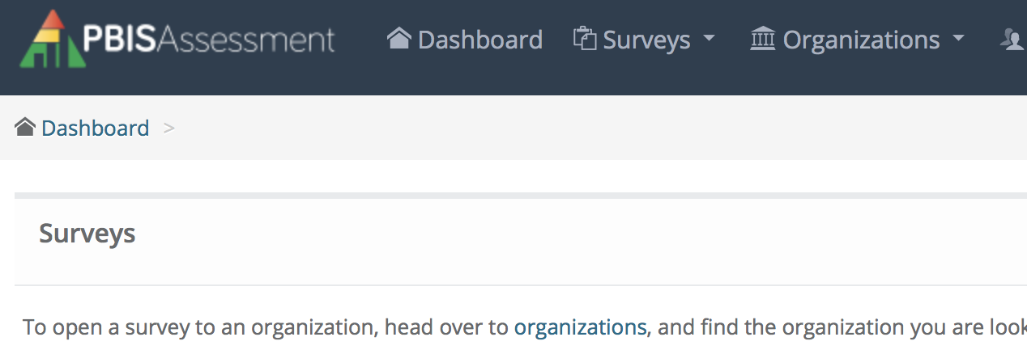
Step 3: Under Open Surveys Window select “School-wide PBIS Tiered Fidelity Inventory 2.10”

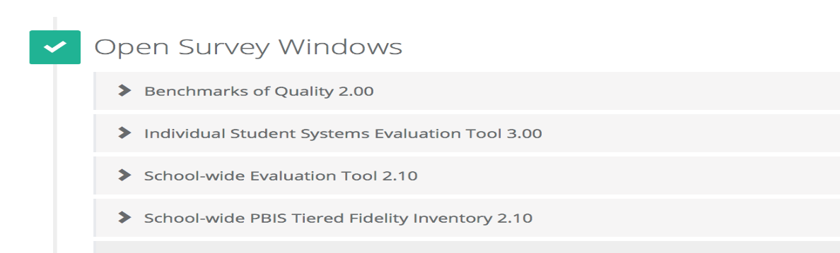

Step 4: Locate the school you want to take the survey and click “take survey”

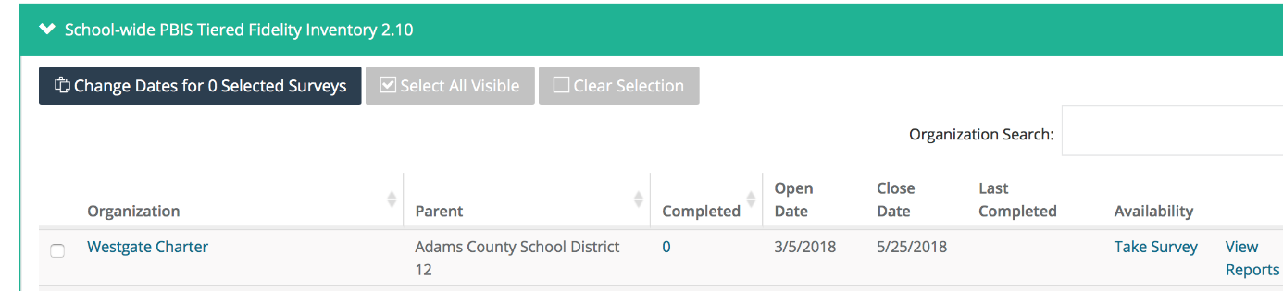

Step 5: At the end of the survey be sure to click “submit” (you will receive a window acknowledging you have successfully submitted the survey

TFI Report Retrieval Instructions
Step 1: Follow steps 1 & 2 from above

Step 2: Click on the “Reports” tab

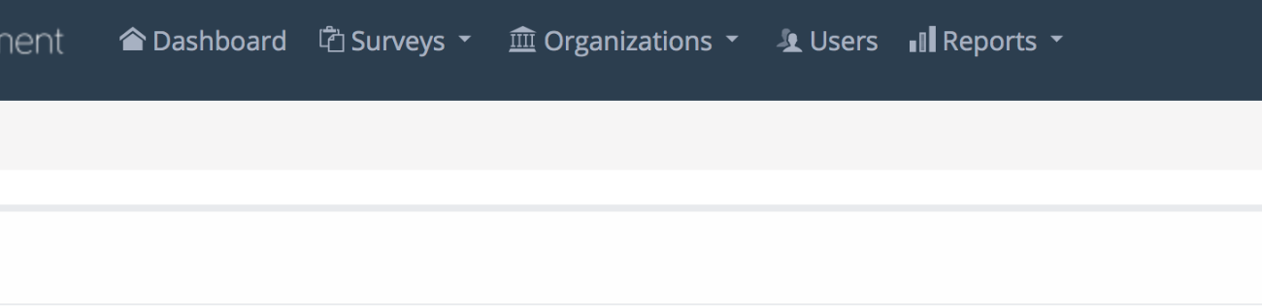
Step 3: Select “Survey Reports” from the drop-down menu

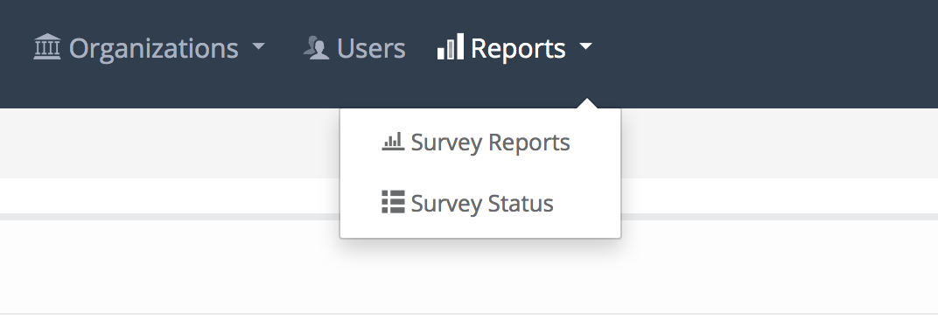
Step 4: Select organization, school district name, and school name

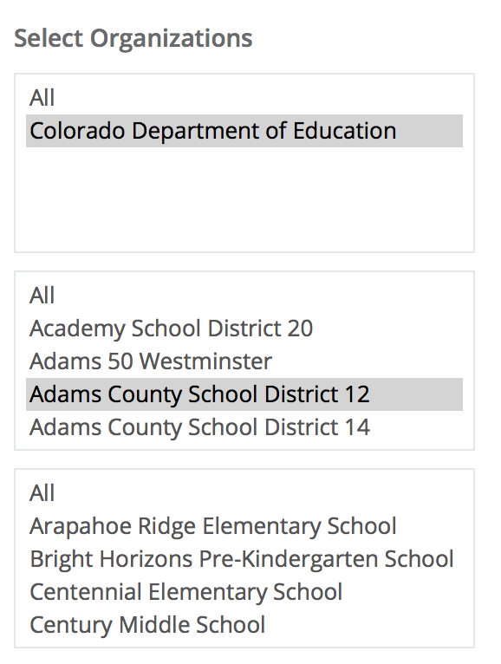
Step 5: Click select report and select which report you want to view (scale and subscale are the 2 we use most) and then click generate report (to save and / or send reports select PDF and it will download to your computer)
