Application Instructions
Application Instructions
Summer Food Service Program
Users must be assigned a user ID and password before using the system. Request access to the system via the New User Request Form. If you are locked out of the system, click on the “Forgot Your Password” link to reset your password.

Accessing the Website
You can access the system by opening your Internet browser and entering the following URL in the browser’s address line: https://cde.cnpus.com/codoe/splash.aspx.

1. Enter your assigned User ID
2. Enter your Password
3. Click Log On

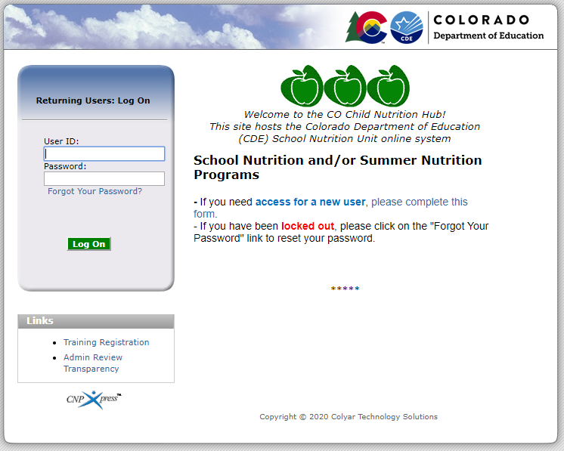

If this is your first time logging on, the system will automatically require you to change your password.
1. Select a new password and enter it into the box provided.
2. Re-enter your new password for confirmation
3. Select Save to continue to the Programs page

Users who also have access to the School Nutrition Programs will see this screen when logging in. Click on the red button, Summer Food Service Program.

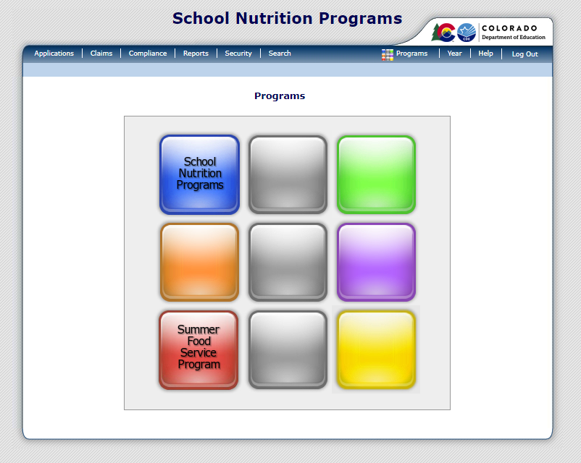

This will take you to the Summer Food Service Program Home Page.

Summer Food Service Program Home Page
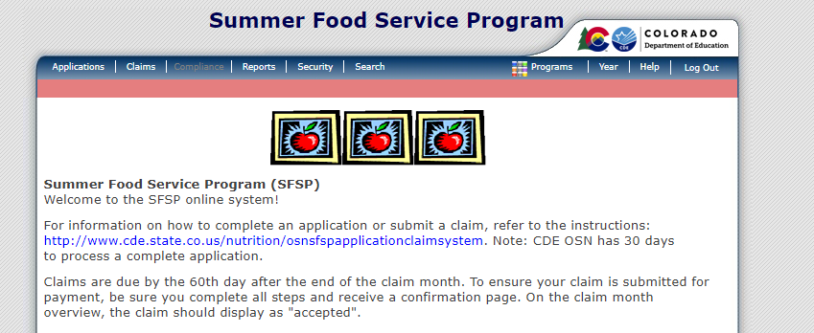
From the Summer Food Service Program home page, you can select a menu item from the blue menu bar at the top of the page.

- Applications: Access to overall application-related items including:
- Application Packet & Forms
- Advances
- Claims: Access to SFSP claim entry screens and sponsor-specific payment history
- Security: Access to change password

To Access an Application Packet
1. On the blue menu bar on the Summer Food Service Program Home Page, select Applications.
2. From the Applications menu, select Application Packet. A screen will come up asking you to add
a sponsor application if you are a new sponsor. Click on Add. If you are a returning sponsor, click on Enroll.
3. The sponsor application will display.

Steps to Complete the Application Packet
Step 1: Sponsor Application
In order to participate in the Summer Food Service Program (SFSP), sponsors must submit a complete and accurate Sponsor Application to the Colorado Department of Education (CDE) Office of School Nutrition (OSN) for review and approval.

Addresses: Input the street and mailing address of the sponsor organization.

Summer Food Service Program Contact Information: Input the contact name, email address, and phone number, etc., for each contact person for the SFSP. Under each contact, indicate if this person attended the CDE required annual training. If yes, indicate the date CDE training was completed. The SFSP Sponsor Contact person will receive application packet emails.

Vendors: Indicate if the sponsor will contract with a vendor/Food Service Management Company (FSMC) to provide unitized meals for the site(s). The vendor contract must be uploaded in the checklist summary.

Training Attendance: Indicate the date the sponsor will conduct training for all staff involved with the SFSP.

General Questions: Question 55-provide a detailed explanation of the sponsor’s staffing and monitoring plans.
Question 56- indicate if the sponsor would like to receive USDA Foods, including DoD Fresh Fruits & Vegetables.

Outreach: Indicate the dates and types of outreach used to promote the SFSP. Closed-enrolled and camp sites can select ‘other’ and indicate that outreach is provided to potential families that may enroll in the program.

Certification: Read the certification statement and check the box next to question 62.

Once the Sponsor Application is completed, click Save. A confirmation screen will appear. Click Edit if the application has errors and revise the application OR click Finish if the application is complete. This will return the user to the main Application Packet Screen.

Step 2: Food Production Facility List
The Food Production Facility section of the Application Packet contains information about each food production facility that the sponsor will use to provide meals to its sites. For example, if the sponsor contracts with a vendor/FSMC or a School Food Authority (SFA) or prepares meals at a central kitchen, this section must be completed. If all sites prepare food on-site, this section does not need to be completed.

To Add a Food Production Facility
1. Select Details next to Food Production Facility List. The Food Production Facilities list screen displays.
2. Click on the Facility Name listed to edit information or Select the Add Facility button to add a new facility; a blank Food Production Facility screen is displayed.
3. Indicate whether food is purchased from a vendor, a SFA, or is the sponsor’s central facility. Questions 3-9 must be completed using the vendor or central kitchen’s contact information.
4. Select Save. A confirmation screen displays.
5. Select Edit to return to the Food Production Facility screen OR select Finish to return to the Food Production Facilities list screen. Click Back to return to the Application Packet.

To Modify a Food Production Facility
1. Select Details next to Food Production Facility List. The Food Production Facilities list screen displays.
2. Select the facility you want to modify. The Food Production Facility screen displays.
3. Modify any desired information.
4. Select Save. A confirmation screen displays.
5. Select Edit to return to the Food Production Facility screen OR select Finish to return to the Food Production Facilities list screen. Click Back to return to the Application Packet.

Step 3: Site Applications
Sponsors must complete a Site Application for each site under their sponsorship. The site applications must be completed prior to completing the budget, checklist summary, or field trip list. The site applications must be completed annually; however, if a site participated last year, some of the site information will roll over. Be sure that the information is accurate before submitting.

To Add a New Site

- Under Site Applications, select Summer Food Service Program. The Application Packet- SFSP Site List screen displays.
- At the bottom of the site list, select Add Site Application. The SFSP Available Site(s) screen displays.
3. If the site you would like to add an application for is listed, select the site. If the site you would like to add an application for is not listed, select Add New Site. The ‘Quick’ Site Profile screen displays.
4. The system automatically defaults the Site ID to the next available ID for this Sponsor. If the site participates in the NSLP/SBP, be sure the site number matches the NSLP/SBP site number.
5. Enter the site name and county.
6. Select Save. The Site Application for the new site is displayed.

To Enter/Modify a Site Application
1. From the Application Packet screen, under Site Applications, select Summer Food Service Program. The Application Packet- SFSP Site List screen displays.
2. Select the site whose application you would like to enter/modify. The site’s Site Application is displayed.
3. Enter/modify any desired information.
4. Select Save. A confirmation screen displays.
5. Select Edit to return to the SFSP Site List screen.
6. Repeat for each site that will participate in the program.
7. When done with all sites, click on Back to return to the Application Packet screen.

- Contact Information
Input all contact information for the site including Street Address, Sponsor Contact, and Site Supervisor. The site information will be provided to partner organizations for the Kids Food Finder map and the National Hunger Hotline so be sure the information is accurate.

- General Site Information & Site Type
Indicate if the site has participated under this sponsor and if the site participates in other child nutrition programs.

- Site Eligibility & Site Operation
Indicate the method used to determine site eligibility. Returning site eligibility data will roll over for five years and does not need to be updated. Refer to the SFSP ‘How to Determine Site Eligibility’ for more information on eligibility methods.
Question 29- indicate any meal service variations, such as ‘closed for the fourth of July’.
Question 31- indicate which meals will be served at the site. The meal service(s) will then populate below.
  - The Meal Service Method is prepared on-site if the meals are prepared at the site or at the sponsor’s central kitchen. The Meal Service Method is purchased from a vendor or SFA if unitized meals are purchased for the site.
  - The Average Daily Participation (ADP) for each meal service should be estimated based on the number of children attending plus no more than a 10% increase to account for fluctuation. If ADP changes during site operation, ADP in the application must be updated prior to submitting a claim.

- Food Production Facility Information
Question 39- Identify where meals are prepared if meals are delivered from a vendor/FSMC or from a central kitchen. The facilities listed in the Food Production Facility List will populate in the drop down box.

- Certification
Read the certification statement and check the box next to question 40.

To View a Site Application
1. From the Application Packet Screen, under Site Applications, select Summer Food Service Program. The Application Packet- SFSP Site List screen displays.
2. Select View next to the site whose application you would like to view. The site’s Site Application is displayed.
To Delete a Site Application
1. From the Application Packet Screen, under Site Applications, select Summer Food Service Program. The Application Packet- SFSP Site List screen displays.
2. Select Modify next to the site whose application you would like to delete. The site’s Site Application is displayed.
3. Select Delete on the Edit menu in the top-right corner.
4. The system transfers you to the bottom of the screen and a warning message is displayed.
5. Select the Delete button at the bottom of the page. A confirmation message displays.

Step 4: Budget Detail
To Add/Modify a Budget Detail
1. Select Modify next to Budget Detail. The Budget Detail screen displays with the most current reimbursement rates.
2. Modify the line items to reflect the program budget. All costs and outside funding to the program must be included.
3. Select Save. A confirmation screen displays.
4. Select Edit to return to the Budget Detail screen OR select Finish to return to the Application Packet screen. Click on Back to return to the Application Packet screen.
- If ADP changes, your budget will change. The budget must be revised to account for the change in ADP.

Step 5: Checklist Summary
A checklist is automatically generated based upon answers to specific questions from the sponsor and site applications. The checklist identifies supplemental documents that need to be submitted to the CDE OSN. The checklist feature allows sponsors to keep track of documents and their dates of submission.

To Access a Checklist
1. From the Application Packet, select details next to Checklist Summary. The Checklist Summary screen displays.
2. Select the sponsor name. The Checklist screen displays for sponsor checklist items.
Select the site(s) for site checklist items, if needed.

3. To access the forms that need to be uploaded, click on the name of the form. Save the form to your computer and fill it out. Once the form is completed, upload the form in the checklist summary.

To Upload an Attachment to a Checklist Item
1. Select the blue paper clip next to the document you wish to upload. The Checklist File Upload Details screen displays.
2. Use the Browse button to select the file to upload. This is the file you will have saved to your computer in Step 3 above. Files in the following formats can be uploaded: .doc, .xls, .pdf, and .jpg. If desired, enter a brief comment.

3. Repeat these steps for all forms that need to be uploaded. (Note for Private Non-Profits: Churches are not required to submit the Documentation of Tax-exempt Status. If you are completing an application for a church, please simply click the “Document Submitted to CDE” box next to this document.)
4. In the checkbox next to each form, under Document Submitted to CDE, click to enter a check in the box.
5. Click on Save.

- Sites that participate in the NSLP/SBP or CACFP At-Risk are not required to request a local health department inspection during the SFSP. If all sites participate in the NSLP/SBP or CACFP At-Risk, you do not need to upload the health department notification letter; however, check the box that the document was submitted to CDE.

Step 6: Submitting the Application to CDE
Once you have completed the Sponsor Application, Food Production Facility List, Site Applications, Budget Detail, and Checklist Summary, go to the Application Packet screen and click on the red Submit for Approval button. Click Okay.

In big red letters, the following message will appear: The Application Packet is currently under review by the State and is unavailable for changes. If corrections need to be made, the packet will be returned in the system, along with comments (on the sponsor and/or site application) on what needs to be corrected. Please keep an eye out on your email (including junk mail, just in case) for communication from the system. You can visit the system to check the application status at any time.

Please allow for 30 days (from the time all requirements are completed) for CDE OSN to approve your applications/forms.

- Once the application packet is approved by CDE OSN, you will receive an email from DOE stating that your application packet is approved. Please check your application packet to determine which sites were approved.
- Any changes to an approved application packet must be submitted to CDE OSN prior to when the change will take effect.

Miscellaneous Items
- To navigate around the system, you can use the Back buttons or use the blue tabs at the top of the screen to go to different pages.

- “Session conflicts”: Sometimes, if you go back to the system without having closed it out completely, a session conflict message will pop up. Click on Activate to log back in.

- Warnings and Errors: Once you submit an application or complete a form, it may come back with warnings and/or errors. Warnings are just a note for you to double-check something. Applications and forms can still be submitted with warnings on them. If you receive an error, however, this will need to be corrected prior to submission.

Site Field Trip List (if applicable)
The Site Field Trip section of the Application Packet contains information about any field trips that an approved site will conduct for the specified year. All field trips must be entered in the system before they occur.

- If the site will take multiple field trips, enter the names of each field trip in the field trip destination text box. Complete the trip details in the order the destinations are listed.

1. Select Details next to Site Field Trip List. The Field Trip-Site list screen displays.
2. Select the Create New Field Trip button.
3. Select the sponsor’s site that will conduct the field trip.
4. Select the Continue button. The Site Field Trip screen is re-displayed with the selected site at the top of the page. This screen has fields required for completion.
5. Complete the form.
6. Select Save. A confirmation screen displays.
7. Select Edit to return to the Site Field Trip screen OR select Finish to return to the Field Trip – Site list screen. Click on Back to return to the Application Packet screen.
To Modify a Site Field Trip
1. Select Details next to Site Field Trip List. The Field Trip – Site List screen displays.
2. Select the site’s field trip you want to modify. The Site Field Trip screen for this site displays.
3. Modify any desired information.
4. Select Save. A confirmation screen displays.
5. Select Edit to return to the Site Field Trip screen OR select Finish to return to the Field Trip – Site list screen. Click on Back to return to the Application Packet screen.

To Cancel a Site Field Trip
1. Select Details next to Site Field Trip List. The Field Trip-Site list screen displays.
2. Check the box next to the field trip that will be canceled.
4. Select Save. A confirmation screen displays.
5. Select Edit to return to the Site Field Trip screen OR select Finish to return to the Field Trip – Site list screen. Click on Back to return to the Application Packet screen.

Advance Requests (if applicable)
Once CDE OSN approves the application, sponsors may use the Advance Requests menu option to submit a request for operational or administrative payment advances and to view the status of their submitted requests.
To Access Advance Requests
1. On the blue menu bar, select Applications. The Applications menu screen displays.
2. On the menu, select Advance Requests. The Advance Request list screen displays.

To Add an Advance Request
1. On the blue menu bar, select Applications. The Applications menu screen displays.
2. On the menu, select Advance Requests. The Advance Request list screen displays.
3. Select Add next to the advance month for which you would like an advance. The Advance Request screen displays.
4. Select the type of advance you are requesting, and click the Certify button.
5. Select Save. A confirmation screen displays.
6. Select Edit to return to the Advance Request screen OR select Finish to return to the Advance Request list screen. Click Back to return to the Application Packet.

- At least one site must have at least ten operating days in the advance month to request an advance.

To View or Modify an Advance Request
1. On the blue menu bar, select Applications. The Applications menu screen displays.
2. On the menu, select Advance Requests. The Advance Request list screen displays.
3. Select the advance you would like to view or modify. The Advance Request screen displays.
4. Update information, if desired.
5. Select Save. A confirmation screen displays.
6. Select Edit to return to the Advance Request screen OR select Finish to return to the Advance Request list screen.

