The CDE-5 Report is available in Data Pipeline and can only be accessed by designated personnel at the school district, for the Financial December Data Pipeline Collection. Typically, the designated person is the districts Business Manager or Finance Director.

Login to Data Pipeline: https://cdx.cde.state.co.us/pipeline

To View the CDE-5 Report
Select “Cognos Report”
then select “Finance December”
then select “CDE 5 Child Nutrition Report”
In the drop down boxes choose the appropriate school year and district code
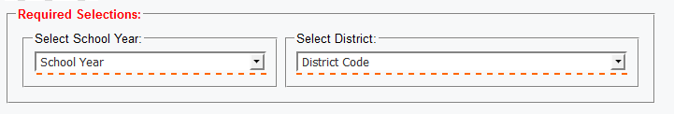
then select “finish”, your report will be display in pdf format.

To Save or Print the CDE-5 Report
Once the report is displayed you are able to save or print the report.
on the footer of the report a toolbar will appear
choose the Save or Printer button to perform the desired action
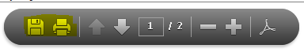

Contacts for Questions in Pipeline
Yolanda Lucero – lucero_y@cde.state.co.us - 303.866.6847
Adam Williams - williams_a@cde.state.co.us - 303.866.6843

