Apply online at [Insert Webpage]
[Insert District Name] 20__-20__ Household Application for Free and Reduced-Price School Meals
Complete one application per household. Please use a black or blue pen (not a pencil).

Birth Date
M M D D Y Y
List ALL Students’ attending [Insert District Name] (if more spaces are required for additional names, attach another sheet of paper)

STEP 1
Grade
Foster Head
Child Start Runaway Homeless Migrant
MI
Student’s Last Name
Student’s First Name
Check all that apply. Read How to Apply for Free and Reduced-Price School Meals for more information.

If any household members (including you) currently receive assistance from any of the following programs: SNAP, TANF or FDPIR list the case number below.
If any household members (including you) currently receive assistance from any of the following programs: SNAP, TANF or FDPIR list the case number below.

STEP 2
Supplemental Nutrition Assistance Program (SNAP), Temporary Assistance for Needy Families (TANF/Colorado Works – Basic Cash Assistance or State Diversion), or Food Distribution Program on Indian Reservations (FDPIR). Provide case number and skip to Step 4.

FDPIR Case Number
TANF Case Number
SNAP Case Number
Report income for ALL household members (skip this step if you provided a case number in STEP 2)

STEP 3
How Often?
Student Income
- Student Income
Please include the TOTAL income, if any, received by all students listed above.
$
Weekly | Bi-Weekly | 2x Month | Monthly | Annually

- All Other Household Members (including yourself)
In the spaces below list all other household members not listed in Step 1 (including yourself) even if they do not receive income. For each household member listed, if they do receive income, report TOTAL GROSS INCOME (BEFORE TAXES AND OTHER DEDUCTIONS) for each source in whole dollars only. If they do not receive income from any source, write ‘0’. If you enter ‘0’ or leave any fields blank, you are certifying that there is no income to report.

Pensions/Retirement/
All Other Income
How Often?
Public Assistance/
Child Support/Alimony
Names of All OTHER Household Members
(First and Last)
Weekly | Bi-Weekly | 2x Month | Monthly | Annually

How Often?
$
$
$
$
$
$
$
$
$
$
$
$
Weekly | Bi-Weekly | 2x Month | Monthly | Annually

How Often?
Earnings from Work
Weekly | Bi-Weekly | 2x Month | Monthly | Annually

Check box if no SSN
XXX-XX-
Last four digits of Social Security Number (SSN) or mark “no SSN” of adult signing this form only if Step 3B has been completed.
Total Household Members
(Students’ and Adults from Steps 1 and 3)

STEP 4
“I certify (promise) that all information on this application is true and that all income is reported. I understand that this information is given in connection with the receipt of Federal funds, and that school officials may verify (check) the information. I am aware that if I purposely give false information, my children may lose meal benefits, and I may be prosecuted under applicable State and Federal laws.”
Contact information and adult signature. Mail signed and completed application to: [Insert School/District Mailing Address]

CO
Mailing Address or PO Box
Apt. # or Lot #
City
State
Zip Code
Email Address

STEP 5 Release of Information
Today’s Date
Printed First and Last Name of Signer
SIGNATURE of Adult Household Member (Required)
Home or Cell Phone Number
The information provided on this application will be used in conjunction with state educational programs and may be shared with Medicaid or State Children’s Health Insurance Program (SCHIP) offices. Please check the box to opt out:
To save you time and effort, the information you gave on this form may be shared with other programs for which your children may qualify. For the following programs, we must have your permission to share your information. Completing this section of the form will not change whether your children get free or reduced price meals. Your information WILL NOT be shared unless you check one of the boxes below:
DO NOT share information with Medicaid/SCHIP

Please share my information with the following programs I have checked:
Advanced Placement (AP) Exam and/or (AP) Book Fees
Accelerate College Opportunity Exam and/or Book Fees

List Specific Program

List Specific Program

See back of application
OPTIONAL Children’s Racial and Ethnic Identities
Race (check one or more):
Asian
American Indian or Alaskan Native
Black or African American
Hispanic or Latino
Not Hispanic or Latino
White
Ethnicity (check one):
We are required to ask for information about your children’s race and ethnicity. This information is important and helps to make sure we are fully serving our community. Responding to this section is optional and does not affect your children’s eligibility for free or reduced price meals.

Native Hawaiian or Other Pacific Islander

You may also qualify for the Supplemental Nutrition Assistance Program! See more information below.

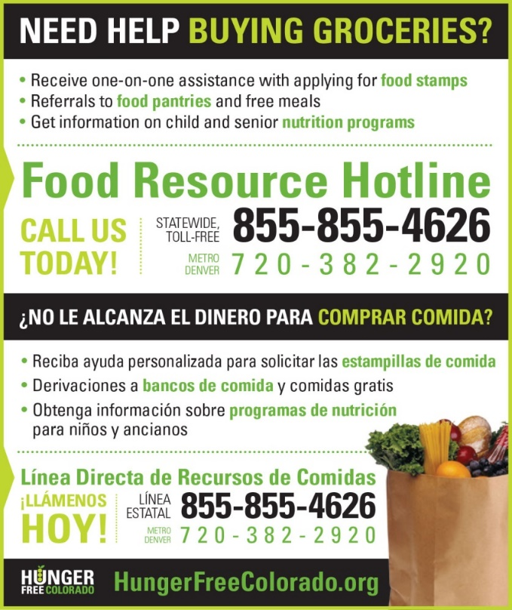
Colorado PEAK is an online service for Coloradans to screen and apply for medical, food and cash assistance programs.
Visit coloradopeak.force.com to learn more.

DISTRICT USE ONLY. DO NOT WRITE BELOW THIS LINE.
Annual Income Conversion: Weekly x 52; Bi-Weekly x 26; 2 Times per Month x 24; Monthly x 12
Application Type:   Total Household Income: $ Household Size:_  Household Income Frequency -  Weekly  Bi-Weekly  2x/Month Monthly Annually  Categorical Eligibility - SNAP FDPIR TANF Foster  Homeless/Migrant/Runaway/Head Start | Application Status:  Approved - Free Reduced  Denied - Over Income Guidelines Incomplete/Missing: Notes:
Determining Official Signature: Approval/Denial Date: Notification Sent:
In accordance with federal civil rights law and U.S. Department of Agriculture (USDA) civil rights regulations and policies, this institution is prohibited from discriminating on the basis of race, color, national origin, sex (including gender identity and sexual orientation), disability, age, or reprisal or retaliation for prior civil rights activity.
Program information may be made available in languages other than English. Persons with disabilities who require alternative means of communication to obtain program information (e.g., Braille, large print, audiotape, American Sign Language), should contact the responsible state or local agency that administers the program or USDA’s TARGET Center at (202) 720-2600 (voice and TTY) or contact USDA through the Federal Relay Service at (800) 877-8339.

To file a program discrimination complaint, a Complainant should complete a Form AD-3027, USDA Program Discrimination Complaint Form which can be obtained online at: https://www.usda.gov/sites/default/files/documents/USDA-OASCR%20P-Complaint-Form-0508-0002-508-11-28-17Fax2Mail.pdf, from any USDA office, by calling (866) 632-9992, or by writing a letter addressed to USDA. The letter must contain the complainant’s name, address, telephone number, and a written description of the alleged discriminatory action in sufficient detail to inform the Assistant Secretary for Civil Rights (ASCR) about the nature and date of an alleged civil rights violation. The completed AD-3027 form or letter must be submitted to USDA by:
1. mail:
U.S. Department of Agriculture
Office of the Assistant Secretary for Civil Rights
1400 Independence Avenue, SW
Washington, D.C. 20250-9410; or
2. fax:
(833) 256-1665 or (202) 690-7442; or
3. email:
program.intake@usda.gov

This institution is an equal opportunity provider.
The Richard B. Russell National School Lunch Act requires the information on this application. You do not have to give the information, but if you do not submit all needed information, we cannot approve your child for free or reduced price meals. You must include the last four digits of the social security number of the primary wage earner or other adult household member who signs the application. The social security number is not required when you apply on behalf of a foster child or you list a Supplemental Nutrition Assistance Program (SNAP), Temporary Assistance for Needy Families (TANF) Program or Food Distribution Program on Indian Reservations (FDPIR) case number or other FDPIR identifier for your child or when you indicate that the adult household member signing the application does not have a social security number. We will use your information to determine if your child is eligible for free or reduced price meals, and for administration and enforcement of the lunch and breakfast programs. We may share your eligibility information with education, health, and nutrition programs to help them evaluate, fund, or determine benefits for their programs, auditors for program reviews, and law enforcement officials to help them look into violations of program rules.

