# INTRODUCTION



COLORADO DEPARTMENT OF EDUCATION

Tiered Intervention Grant (TIG)

**Evaluation of Cohorts 1-4**



**Notable Successes for Cohort 1-4 TIG Schools:**

* The majority (68%) of the TIG schools which are currently open received an Improvement or Performance rating on the 2016 SPF
* More than half (53%) of the TIG schools on the accountability in 2014 came off of the accountability clock this year
* Of the 20 TIG schools with a baseline SPF rating of Turnaround, Priority Improvement, or Improvement, more than half (11 schools, 55%) received a higher SPF rating in 2016 than in their baseline year
* The majority (67%) of the open TIG schools that have completed the grant met exit criteria from federal priority status in 2016

The Elementary and Secondary Education Act (ESEA) provides funding for school improvement grants, which were called School Improvement Grants (SIG) at the national level. The Tiered Intervention Grant (TIG) is Colorado’s version of SIG and was designed to support Colorado’s lowest performing schools identified for improvement under the ESEA Flexibility Waiver (implemented prior to the reauthorization of ESEA). Colorado has opted to continue to support TIG schools during the transition to the latest reauthorization of ESEA, the Every Student Succeeds Act (ESSA).

TIG is a three-year grant in which awardees implement one of four intervention models (Turnaround, Transformation, Restart, and Closure) approved by the U.S. Department of Education (USDE). Under the ESEA Flexibility Waiver, the Colorado Department of Education (CDE) identified Title I Priority schools as eligible for TIG. Title I Priority schools were the lowest performing five percent of Title I schools or Title I high schools with the lowest graduation rates based on three years of school performance data. Annually, districts with TIG-eligible schools would be invited to compete for a grant to partner with CDE in increasing the academic performance of students within identified schools.

To date, seven cohorts of schools have been awarded TIG, including schools that began implementation in 2017-2018. This report summarizes the evaluation of the first four cohorts, which have completed or are in the process of completing their final year of implementation. The evaluation of the impact of the program was based on the schools’ performance on the same metrics that were used for identifying schools for the grant. Additional metrics were used when possible to ascertain the impact of the program.

# EVALUATION METHODOLOGY

## Program Reach: TIG Schools Included in These Analyses

The purpose of this evaluation is to determine the impact of TIG on improving student and school performance. Therefore, only schools that are still open and fully implemented the grant are included in the analyses.

The first TIG cohort was funded in the 2010-2011 school year. Twenty-three schools were funded as part of Cohort 1 beginning in 2010-2011, but three schools had their funding discontinued due to failure to comply with grant requirements after the first year of implementation. As a result, the three defunded schools are not included in this evaluation report. Of the remaining 20 schools, three schools closed upon transitioning (phasing) into other schools and are therefore also excluded from this report. Three schools also closed as a result of implementing the Closure model.

Analyses of schools implementing Closure models are presented separately at the end of this report. The remaining open schools (*N* = 14) from Cohort 1 are included in

February 2018

this evaluation, of which seven schools received an additional fourth year of funding.

Nine schools were funded in Cohort 2, receiving their first year of funding during the 2011-2012 school year. One school did not meet grant requirements, however, and is excluded from this report. Two additional schools have since closed (not a result of TIG implementation), resulting in the inclusion of six schools from Cohort 2.

Cohort 3 (*N* = 9) was funded beginning in the 2012-13 school year. Two schools closed upon transitioning (phasing) into other schools, and, therefore, seven Cohort 3 schools were included in this evaluation. All seven of the remaining schools have received sustaining funds for two additional years, and are currently completing their final year of funding.

Five Cohort 4 schools received their first year in the 2013-14 school year. One school closed as a result of implementing the Closure model (see separate section on Closure models), resulting in the inclusion of four schools from Cohort 4.

One school completed its final year of funding in 2015-16, while the other three schools have received additional sustaining funds and are currently continuing funding.

In total, 31 open schools from TIG Cohorts 1 through 4 are included in this evaluation report. Sixteen of those schools implemented a Turnaround model, while the remaining 15 schools implemented a Transformation model. Analyses based on the four schools implementing Closure models are included in a separate section at the end of this report.

## Data Analyses

The first cohort of TIG schools began implementation in 2010-2011, when Colorado was using the Transitional Colorado Assessment Program (TCAP) as the state assessment. In spring of 2015, Colorado changed state assessments and first administered the CMAS (Colorado Measures of Academic Success) assessment. With the transition to a new assessment, and the switch to mean scale scores as opposed to the percentage of students meeting expectations, it is not possible to directly compare the academic achievement of students in the TIG schools across years. This evaluation report instead focuses on the results of the 2016 School Performance Frameworks (SPF), including the change in school ratings from prior year’s frameworks, as well as the number of schools currently on the accountability clock. The percentage points earned on the 2016 SPF cannot be compared longitudinally because of recent changes to the performance frameworks, such as the inclusion of disaggregated academic achievement results, removal of Adequate Growth Percentiles (AGPs), and inclusion of matriculation rates (for postsecondary and workforce readiness).

With the recent changes to the SPFs, it is important to discuss the performance of TIG schools in comparison to statewide trends to provide context for the changes in performance for these schools. Additionally, the performance of all Title I schools was also compared to the performance of TIG schools to provide an additional reference point.

## Years of Data

In order to compare current school performance with the performance of schools prior to implementation of TIG, a baseline (pre-grant) year, aligned across cohorts, was determined based on the first year of implementation. The baseline SPF rating corresponds to the rating received for the year prior to TIG funding. For example (see Table 1), for Cohort 1 (first funded in 2010-11), the baseline year corresponded to the 2010 SPF rating.

*Table 1. 2016 SPF Ratings by School Type*

|  |  |  |  |
| --- | --- | --- | --- |
| **Cohort** | **Years of Implementation\*** | **Baseline SPF**  (Pre-Grant) | **Year 1** |
| 1 | 3 – 4 | 2010 | 2010-2011 |
| 2 | 3 | 2011 | 2011-2012 |
| 3 | 5 | 2012 | 2012-2013 |
| 4 | 3 – 5 | 2013 | 2013-2014 |

**\* Based on full implementation of the grant, excludes closed schools. Schools implementing closure models typically close after one year of funding.**

To compare the performance of TIG schools with the performance of all schools statewide and of Title I schools (those funded for the 2016-17 school Year), for which a pre-grant year is not available, change in school performance was also evaluated based on the most recent availability of performance frameworks. In particular, the performance of schools based on the 2014 SPF was compared to performance on the 2016 SPF, as performance frameworks were not produced during the 2014-15 school year due to a legislative hold on state accountability.

# RESULTS

## Distribution of 2016 SPF Ratings

The majority (67.7%) of the 31 TIG schools included in this evaluation earned an Improvement or Performance rating on the 2016 SPF (see Table 2). This demonstrates positive progress for many of the TIG schools; however, it is important to recognize that significantly more schools statewide (87.1%) earned those same ratings, indicating that some of the TIG schools continue to perform below state expectations. Title I schools were also more likely to earn an Improvement or Performance rating (79.6%) than the TIG schools.

TIG schools that implemented a Turnaround model were slightly less likely to have earned an Improvement or Performance rating in 2016 (10 out 16 schools, 62.5%) than schools that implemented a Transformation model (73.3%).

*Table 2. 2016 SPF Ratings by School Type*

|  |  |  |  |  |  |  |  |  |  |  |  |
| --- | --- | --- | --- | --- | --- | --- | --- | --- | --- | --- | --- |
|  | 2016 School Performance Framework Official Rating | | | | | | | | | | |
| Turnaround | | Priority Improvement | | Improvement | | Performance | | Insufficient State Data | | **Total** |
| All Schools | 60 | (3%) | 117 | (6%) | 356 | (20%) | 1,217 | (67%) | 56 | (3%) | **1,806** |
| Title I Schools | 52 | (7%) | 77 | (11%) | 179 | (25%) | 380 | (54%) | 14 | (2%) | **702** |
| TIG Cohorts 1-4 | 6 | (19%) | 4 | (13%) | 13 | (42%) | 8 | (26%) | 0 | (0%) | **31** |

## Accountability Clock

Out of the 31 TIG schools included in this evaluation, 17 schools were on the accountability clock for their baseline year, having earned a rating of Turnaround or Priority Improvement. Many of those schools (58.8%) are no longer on the accountability clock based on the 2016 SPF. Similarly, of the 15 TIG schools which were on the accountability clock for the 2014 SPF, more than half (8 schools, 53.3%) came off of the accountability clock this year (see Table 3). This is consistent with the trends statewide (59.2%) and for Title I schools (55.2%).

Only three (18.8%) of the 16 TIG schools which had received an Improvement or Performance rating in 2014 will re- enter year 1 of the accountability clock based on the 2016 SPF. In comparison, 11.2% of Title I schools and 6.2% of all schools receiving an Improvement or Performance rating in 2014 will enter year 1 of the accountability clock.

*Table 3. Current Accountability Clock Status By 2014 SPF Rating*

|  |  |  |  |  |  |  |  |  |
| --- | --- | --- | --- | --- | --- | --- | --- | --- |
|  | Turnaround / Priority Improvement (2014) | | | | Improvement / Performance (2014) | | | |
| Off the Clock (2016) | | On the Clock (2016) | | Off the Clock (2016) | | On the Clock (2016) | |
| All Schools | 106 | (59%) | 73 | (41%) | 1,474 | (94%) | 97 | (6%) |
| Title I Schools | 74 | (55%) | 60 | (45%) | 491 | (89%) | 62 | (11%) |
| TIG Cohorts 1-4 | 8 | (53%) | 7 | (47%) | 13 | (81%) | 3 | (19%) |

## Change in School Performance Framework Ratings

It is important to recognize, however, the substantial improvement that may be necessary for schools to move off of the accountability clock, especially for schools with a Turnaround rating (indicating they are performing in approximately the lowest five percent of all schools). Therefore, schools were also evaluated based on their incremental change in SPF ratings, such as moving from a rating of Turnaround to Priority Improvement.

*Increase in SPF Rating*

Calculations were based on schools with an *initial* SPF rating of Turnaround, Priority Improvement, or Improvement. Schools with a Performance rating were excluded as they earned the highest SPF rating possible, and therefore could not demonstrate an increase in SPF ratings. Schools receiving an Insufficient State Data rating in 2016 were also excluded from these analyses.

Of the 20 TIG schools with a baseline SPF rating of Turnaround, Priority Improvement, or Improvement, more than half (11 schools, 55%) received a higher SPF rating in 2016 than in their baseline year. Similarly, when considering the change in SPF ratings from 2014 to 2016, 13 out of 25 TIG schools (52%) experienced an increase in their SPF ratings (see Table 4). This is consistent with the improvement demonstrated by schools statewide (52.2%), as well as by Title I schools (50.3%).

Of the TIG schools with a 2014 SPF rating of Turnaround, Priority Improvement, or Improvement, a larger percentage of schools implementing a Turnaround model (10 out of 14 schools, 71.4%) received a higher SPF rating in 2016, than those implementing a Transformation model (3 out of 11 schools, 27.3%). The majority (6 schools, 54.5%) of the 11 schools that implemented a Transformation model received the same rating as in 2014, with 5 out of 6 schools maintaining an Improvement rating.

*Decrease in SPF Rating*

For these analyses, calculations were based on schools with an *initial* SPF rating of Priority Improvement, Improvement, or Performance. Schools with a Turnaround rating were excluded as they earned the lowest SPF rating possible, and therefore could not earn a lower SPF rating in subsequent years. Schools receiving an Insufficient State Data rating in 2016 were again excluded.

Nine out of 21 (42.9%) TIG schools with a baseline SPF rating of Priority Improvement, Improvement, or Performance received a lower SPF rating in 2016 compared to their baseline year. It is important to recognize, however, that four of the nine schools were assigned a baseline SPF rating of Performance because they were new schools (phase in models)

or because of insufficient state evidence. It is also important to consider that many (4 schools) of the 9 schools still earned a 2016 SPF rating of Improvement, and as such are not on the accountability clock.

When evaluating the change in SPF ratings from 2014 to 2016, only 6 out of 24 TIG schools (25%) experienced a decrease in their SPF ratings. These results indicate greater decline for the TIG schools, however, in comparison to schools statewide (17.0%) and Title I schools (21.7%).

*Table 4. Change in SPF Ratings, 2014 to 2016*

|  |  |  |  |  |  |  |  |  |
| --- | --- | --- | --- | --- | --- | --- | --- | --- |
|  | 2014 SPF Rating | Change in SPF Rating (2014 to 2016) | | | | | | |
| Moved down | | Stayed the same | | Moved up | | **Total** |
| All Schools | Turnaround |  | | 11 | (20%) | 45 | (80%) | **56** |
| Priority Improvement | 17 | (14%) | 30 | (25%) | 73 | (61%) | **120** |
| Improvement | 52 | (15%) | 139 | (40%) | 154 | (45%) | **345** |
| Performance | 209 | (18%) | 965 | (82%) |  | | **1,174** |
| Title I Schools | Turnaround |  | | 9 | (20%) | 37 | (80%) | **46** |
| Priority Improvement | 16 | (18%) | 23 | (26%) | 49 | (56%) | **88** |
| Improvement | 40 | (19%) | 84 | (40%) | 88 | (42%) | **212** |
| Performance | 80 | (24%) | 247 | (76%) |  | | **327** |
| TIG  Cohorts 1-4 | Turnaround |  | | 2 | (29%) | 5 | (71%) | **7** |
| Priority Improvement | 2 | (25%) | 1 | (13%) | 5 | (63%) | **8** |
| Improvement | 1 | (10%) | 6 | (60%) | 3 | (30%) | **10** |
| Performance | 3 | (50%) | 3 | (50%) |  | | **6** |

## Exit Criteria

Tier I and II schools funded by TIG were identified as Title I Priority Schools for federal accountability. Schools must earn an Improvement or Performance rating for two or more consecutive years in order to meet exit criteria, as approved by the U.S. Department of Education, before being removed from the Title I Priority School list. Exit criteria are reviewed for each school upon completion of their grant; therefore currently funded schools are not included in these analyses.

Of the 31 open TIG schools included in this evaluation, all 20 schools from Cohorts 1 and 2 were included, as they have completed full implementation of the grant. All Cohort 3 schools received a fifth year of sustaining funds, and are currently completing their final year of funding. Three out of four Cohort 4 schools also received a sustaining year of funds, and are also currently funded. One Cohort 4 school did not receive a fourth year of funding, and is therefore also included in these analyses, resulting in a total of 21 schools.

The majority of these schools (14 schools, 66.7%) have met exit criteria from federal priority status. Schools implementing a Transformation model were more likely to meet exit criteria (9 out of 11 schools, 81.8%) than schools implementing a Turnaround model (5 out of 10 schools, 50.0%).

# Closure Models

## Schools included

Three Cohort 1 schools and one Cohort 4 school implementing Closure models through the Tiered Intervention Grant are included in this section. Schools that closed upon transition (phasing) into other schools, and schools that closed for reasons other than TIG implementation, are not included.

## Data Analyses

Closure models are designed to increase student performance by closing a low-performing school and enrolling students who attended that school into other higher-performing schools. Therefore, these analyses look at the change in student performance when students transition from a TIG Closure model school to another school.

The analyses are based on students who were enrolled in the Closure model schools during the final year those schools were open, and who had a valid CSAP/TCAP score for that year. Two of the Cohort 1 schools closed after the 2009-10 school year. Students from those schools who had a valid 2010 CSAP score were included in the analyses. Similarly, one Cohort 1 school closed after the 2010-11 school, therefore students from that school with a valid 2011 CSAP score were included. The Cohort 4 school closed after the 2012-13 school year, and students from that school with a valid 2013 TCAP score were included in the analyses.

Across the four Closure model schools, 196 students had a valid reading pre-test score (corresponding to their CSAP/TCAP score for their final year enrolled in the TIG school). Of those students, 166 also had a valid reading post-test score (corresponding to their CSAP/TCAP score for the next consecutive school year, while enrolled in another school). For writing and math, 195 and 193 students had valid pre-test scores, respectively, and 166 and 165 students also had valid post-test scores, respectively.

In reading, 19 percent (*n* = 31) of the 166 students improved at least one proficiency level when comparing their scores while enrolled in the TIG Closure model school to their scores enrolled in their new school. To determine whether the improvement of these students was related to the overall performance of the schools in which these students enrolled, analyses were run separately based on School Performance Framework (SPF) ratings. Students who improved at least one proficiency level were slightly more likely to have enrolled in a school earning an Improvement or Performance rating (77.4%) than students whose proficiency stayed the same or decreased (75.6%), but the result was not significant (see Graph 1).

*Graph 1. Percent Enrollment by SPF Rating and by Change in Proficiency Level, in Reading*

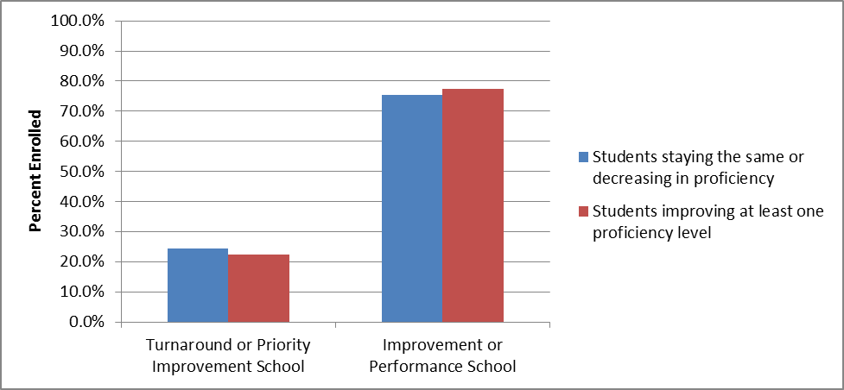

In writing, only 17 percent (*n* = 29) of the 166 students improved at least one proficiency level. Students who improved at least one proficiency level were more likely to have enrolled in a school earning an Improvement or Performance rating (82.8%) than students whose proficiency stayed the same or decreased (74.5%), but this result was also not significant (see Graph 2).

*Graph 1. Percent Enrollment by SPF Rating and by Change in Proficiency Level, in Writing*

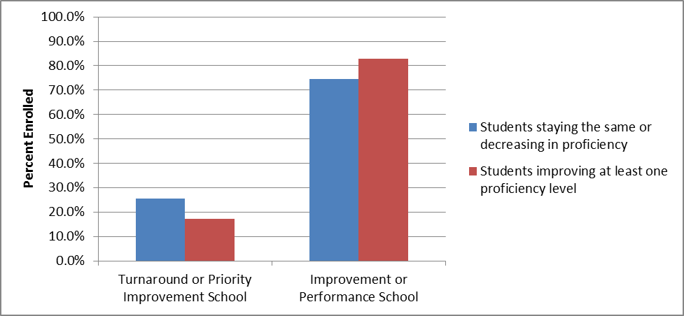

The percent of students improving at least one proficiency level was lowest in math, representing only 7 percent (*n* = 12) of the 161 students (excludes 4 students already at the highest proficiency level [Advanced] on their pre-test). All of the students who improved at least one proficiency level were enrolled in a school earning an Improvement or Performance rating, compared to 74.5% of students whose proficiency stayed the same or decreased, but the small numbers make it difficult to establish statistical significance.

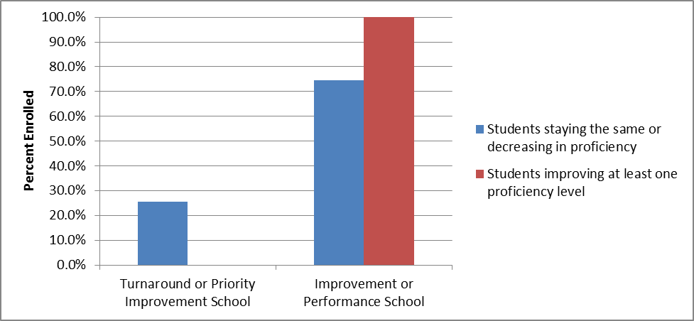

# Conclusions and Next Steps

Report Authors

* Tina Negley
* Nazanin Mohajeri-Nelson

Where Can I Learn More about TIG?

* <http://www.cde.state.co.us/fedprograms/tieredinterventiongrantresources>

TIG is awarded to those schools achieving in the lowest five percent of the state’s Title I schools, and to high schools with low graduation rates. Given their baseline starting performance, and the criteria used to determine eligibility for the grant, the current performance of some of the Cohort 1-4 schools is commendable and warrants future analysis.

Strategies implemented by the first four cohorts are being studied to determine commonalities across the schools with the greatest improvements.