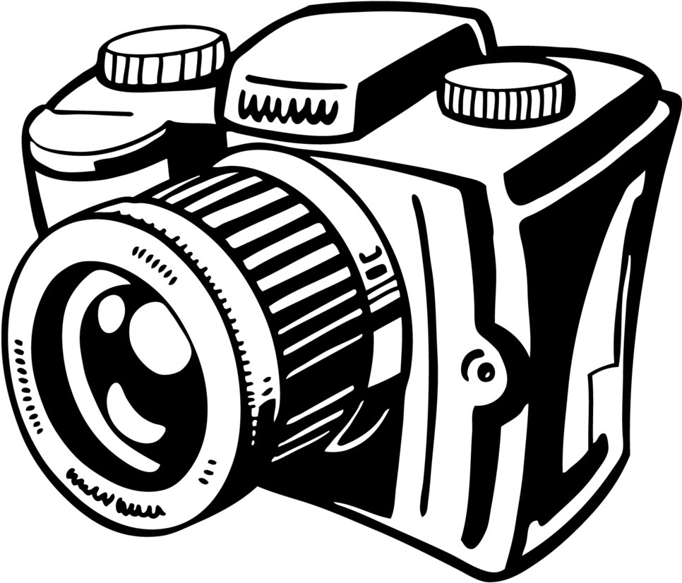

Name: _________________________

Describe the object(s) in the picture. What is it made of? Color?

Picture/Photograph Analysis Sheet

Are there people or objects in the picture? Or both?



**People**

What questions do you have?

Is there any writing? Can you read it? If so, what does it say?

How does this photo compare to today?



**Surprised**

**Sad**

**Angry**

**Nervous**

**Happy**

**Scared**

How does this photograph make you feel?

Where do you think the photo was taken?

What are the people doing in the photograph?



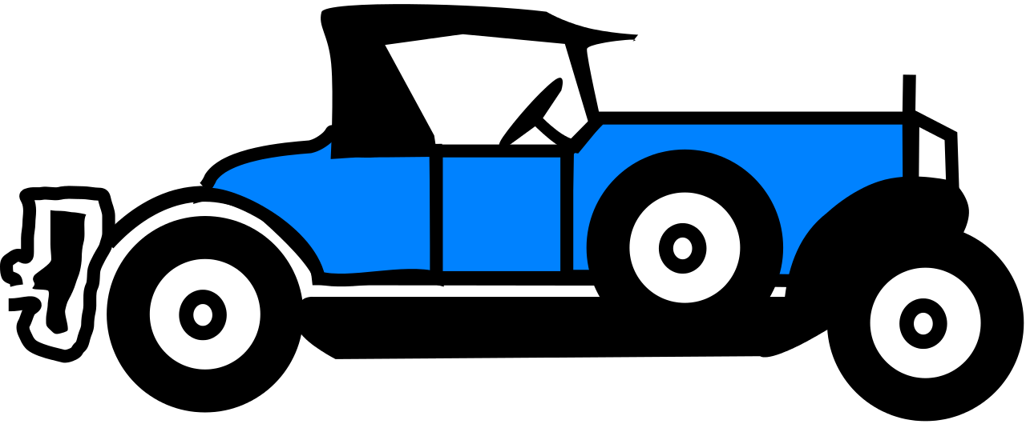

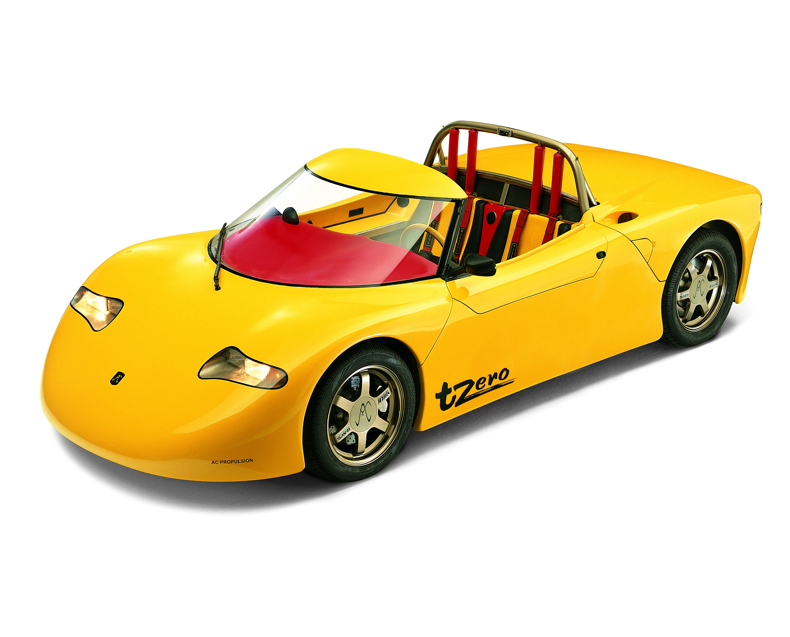

Other: _________________________________





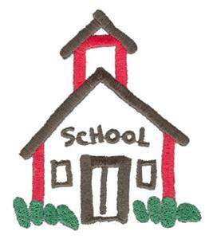



**Object**

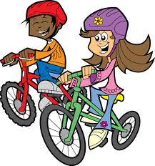

**People and Objects**

What do you see?