Colorado Multi-Tiered System of Supports (CO-MTSS)
State Personnel Development Grant (SPDG)
Cohort 2 Year 1 Kickoff 2018

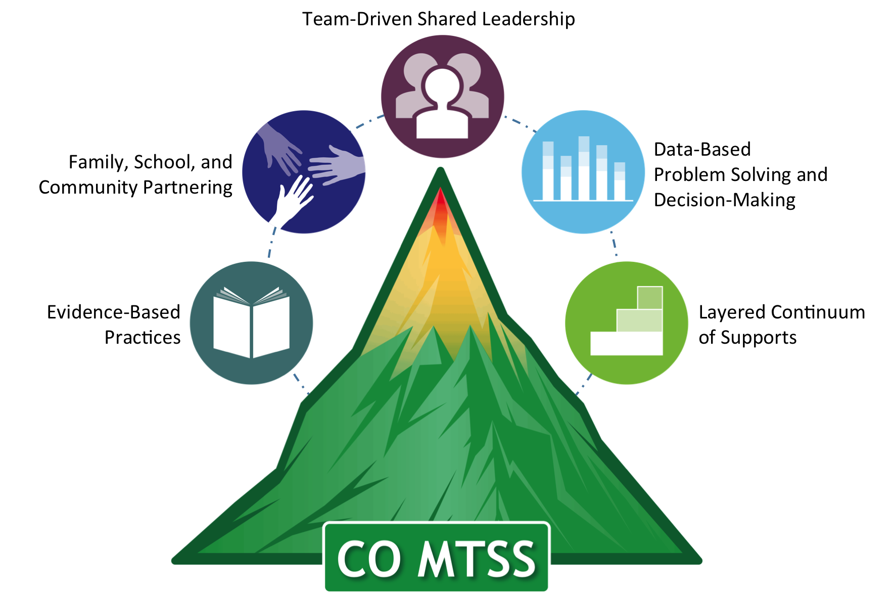

Supplemental Handout

Table of Contents

Training Expectations 3
Activity 1: Desired State 3
Activity 2: Norms 3
Activity 3: Decision Rules 4
Activity 4: Problem Solving Culture 4
Activity 5: Systems-Thinking 5
Activity 6: Problem Solving Process 5
5 Whys Worksheet 7
5 Whys Worksheet: Example 8
Activity 7: Family, School, and Community Partnering Definition 9
Activity 8: Investigate your Strategies 9
Activity 9: Layered Continuum of Adult Supports 10
Activity 10: Hexagon Tool 10
Activity 11: Discussion about the Day 12

- PowerPoint & supplemental material are available at: http://www.cde.state.co.us/mtss/cde-ols-winter2018-mtss-kickoff
- For Kahoot activities, please log on to kahoot.it

Training Expectations
Collaboration:  The purposeful and intentional behavior of working together to accomplish a common vision, goal, or product. | Communication:  The act of sending and receiving message in a positive, efficient, and timely way that maximizes understanding, engagement, teaming, and collaboration. | Respect:  Showing deep regard for another person that is not earned and conveys the notion that an individual’s worth is immeasurable.
- Incorporate active listening skills  - Nurture a “can do” attitude by looking at obstacles as being conquerable  - Look for opportunities to engage in teaming and partnering  - Contribute and participate in discussions | - Be explicit and make points clearly and succinctly  - Allow for multiple voices.  - Focus on the task at hand and be present  - Seek clarity and understand another’s point of view before stating your own opinion. | - Invite different perspectives  - Maintain 4:1 ratio of praise to constructive criticism  - Disagreement is topic related and not personal  - Be on time for meeting starts and for breaks  - Limit side conversations and distracting activities (for yourself or others)

Activity 1: Desired State
From what you have learned about CO-MTSS through
  - Initial CO-MTSS meeting
  - Kickoff Pre Learning Activities
- On your own, use sticky notes to indicate the following:
  - How would your BOCES/District/Schools look different if MTSS was done really, really well.
- Place all sticky notes on one piece of chart paper
- As a team, move the sticky notes into categories
- Based on the indicated categories, decide on one overarching statement about your desired state
- Write your desired state at the top of the chart paper, and post the chart paper for others to see.

Activity 2: Norms

What are your norms for your MLT?

Activity 3: Decision Rules

Primary Decision Rule
Simple Voting
Thumbs Up/Down/Sideways
Fist of Five

Secondary Decision Rule
- If your vote is not 75% one way, what will you do to reach a consensus
‘Set Aside’ Rule
- If you can’t come to consensus on an item in 2 minutes, put it aside, and return to it once you’ve finished the other items within the component

Activity 4: Problem Solving Culture
- Our goal is to create a problem solving culture within your site. What does “problem solving culture” means to you? Include a list of 3 words.

Activity 5: Systems-Thinking
- Why would we shift to a systems-lens or systems-level problem solving? (as opposed to just an individual problem solving focus)?

Activity 6: Problem Solving Process

Step 1: Problem Identification
- What is your total score on the TDSL component, as a percentage? _______%

  - Is this a problem?
Yes No

  - Write the problem as a statement clarifying the difference between the observed outcome and the expected outcome.
Example: “We scored 38% on TDSL and we should have at least 80%”

Step 2: Problem Analysis
- Looking at your items from the MLT Self-Assessment, what patterns or themes emerge? What do you see from the items that help explain the total score on the TDSL component?
Example: We’re meeting as a team, but we haven’t made any infrastructure changes (i.e., budget, policy, lack of alignment of priorities) to support MTSS.

- Considering information from the question above, write a more precise problem statement from your original problem from question 1. Consider who, what, when, where, how often, and why.
Example: The current MLT has scored a 38% on the MLT Self-Assessment because we haven’t adjusted our infrastructure to support MTSS (e.g., budget, policies, lack of alignment of initiatives).

Step 3: Plan Identification and Implementation
- As a team, develop a goal statement from your precise problem statement and draft a couple steps to reach that goal
Example: Goal: By the end of the 2018-19 school year, the MLT will have a clear focus for moving MTSS forward, as evidenced by a vision statement.
- Analyze district-wide data to understand the needs of our students and stakeholders (teachers, families, etc)
- Conduct an inventory of all the initiatives or priorities we currently have in place
- Engage in sense-making and a discussion of priorities
- Develop consensus on key priorities for district
- Draft a vision statement reflecting our priorities

5 Whys Worksheet
List the problem:
Why is it happening?
1. |  |  |  |  |  |  |  | → |  | Why is that?
 |  |  |  |  |  |  |  |  |  | ↓
 |  | 2. |  |  |  |  |  |  |  |  |  | → | Why is that?
 |  |  |  |  |  |  |  |  |  |  |  |  | ↓
 |  |  |  | 3. |  |  |  |  |  |  |  |  |  |  |  | → |  | Why is that?
 |  |  |  |  |  |  |  |  |  |  |  |  |  |  |  |  |  | ↓
 | 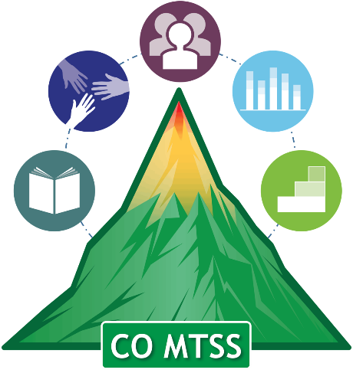 |  |  |  |  | 4. |  |  |  |  |  |  |  |  |  |  |  |  |  | → | Why is that?
 |  |  |  |  |  |  |  |  |  |  |  |  |  |  |  |  |  |  |  |  | ↓
 |  |  |  |  |  |  |  |  | 5.
As you process through the “whys,” focus on alterable variables.
If the last answer is something that you can’t control, go back up to the previous answer.

5 Whys Worksheet: Example
List the problem:
As of Jan 2018, our MTSS Leadership Team hasn’t created or reviewed an action plan to guide implementation of MTSS across ABC District.

Why is it happening?
1. We haven’t had an MTSS Leadership Team in the past |  |  |  |  |  |  |  | → |  | Why is that?
 |  |  |  |  |  |  |  |  |  | ↓
 |  | 2. We’ve had many initiatives, and little understanding of the MTSS strategies for bringing them together |  |  |  |  |  |  |  |  |  | → | Why is that?
 |  |  |  |  |  |  |  |  |  |  |  |  | ↓
 |  |  |  | 3. There has been no clear policy or vision for implementing MTSS in the District ABC |  |  |  |  |  |  |  |  |  |  |  | → |  | Why is that?
 |  |  |  |  |  |  |  |  |  |  |  |  |  |  |  |  |  | ↓
 |  |  |  |  |  | 4. We (district leaders) have not created a clear vision of MTSS in District ABC |  |  |  |  |  |  |  |  |  |  |  |  |  | → | Why is that?
 |  |  |  |  |  |  |  |  |  |  |  |  |  |  |  |  |  |  |  |  | ↓
 |  |  |  |  |  |  |  |  | 5. We (district leaders) have varying knowledge about MTSS
As you process through the “whys,” focus on alterable variables.
If the last answer is something that you can’t control, go back up to the previous answer.

Activity 7: Family, School, and Community Partnering Definition

Partnering is:

Activity 8: Investigate your Strategies

What do you have in place for FSCP?
Step 1:
Individually:
  - Using sticky notes, write one strategy per sticky.
  - Write as many as you can think of…
  - Consider “layers” (For Every Family? Some? A Few?)
Step 2:
As a team:
  - Place your sticky notes on the continuum where
you think they “best fit”.
  - Analyze your continuum: Consider these ideas…
Is there evidence of Impact? What are strengths? Are there gaps? Opportunities?

Activity 9: Layered Continuum of Adult Supports

Step 1- Think of one group of adults that you work with (e.g., gen ed teachers, SPED teachers, para-pros, parents, principals)
Step 2- Identify that customer’s biggest need.

Step 3- Identify supports you currently provide
- Universal: What do you do for all adults in that area?
- Targeted: What do you do for those that need some additional support in that area?
- Intensive: What do you do for those adults that need the highest level of support in that area?

Step 4- What are the biggest gaps you see?

Activity 10: Hexagon Tool

- Activity: With an elbow partner, use the Hexagon Tool (on the next page) to investigate the contextual fit of that practice
  - Fill in the table on the left side of the handout
  - Indicate the biggest contextual fit strengths
  - Indicate the biggest contextual fit weaknesses
  - Are there any areas that you could improve?

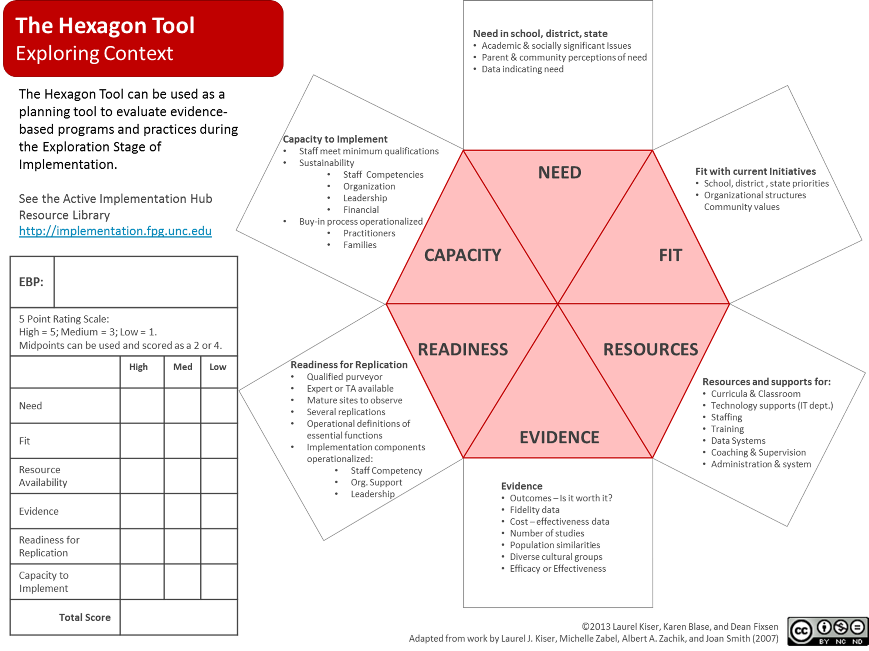

Activity 11: Discussion about the Day

1. Discuss as a table your big take aways from the day
2. What are some immediate actions the MLT can immediately move forward on regarding MTSS?
3. What is one action you would consider doing tomorrow that would improve the implementation of MTSS moving forward?

4. What is one action you would NOT consider doing tomorrow…for whatever reason ?
5. What is 1 enhancement you can make to your environment to increase the likelihood of doing #2 and #3 above?

