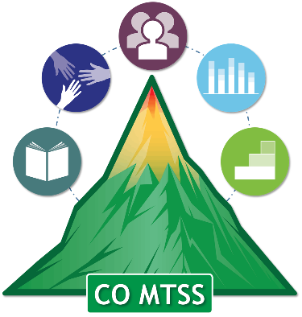

Colorado Multi-Tiered System of Supports (CO-MTSS)
Personnel Development Plan
Activity Protocol

Purpose: The Personnel Development Plan (PDP) was created by the Colorado Department of Education (CDE) Office of Learning Supports (OLS) to help stakeholders analyze and plan high quality personnel development with schools over an extended period of time. The PDP can facilitate the prioritization of support received by schools, as well as the blending and braiding of resources necessary sustain those supports.

Procedure: The CO-MTSS PDP should be completed in teams. It involves the consideration of school need and capacity when developing personnel development for schools. This can be best-achieved through strategic discussions.
The following outlines a possible set of activities that can be completed with a leadership team to over the course of several meetings. Based on the district/BOCES size and relative number of prioritized personnel development needs, the activities may be abbreviated or extended. The main objective of each step is highlighted.

Step 1: Introduce the Personnel Development Planning Activities
  - Preview the Plan and Rubric). Possible topics include (a) the objective of the tools, (b) their value/importance to systems change, and (c) how follow-up and next steps will occur.
  - As needed, provide additional learning materials related to the importance of evidence-based personnel development, including the Evidence-Based Personnel Development Technical Guide or the NIRN AI Hub lesson on creating a training plan: https://unc-fpg-cdi.adobeconnect.com/_a992899727/ai-lesson4/
Step 2: Selection Activities
  - Ensure that the team has engaged in a process of selecting evidence-based practices for personnel development. Many teams used the Initiative Inventory to select the evidence-based practice(s) they want to implement in their school(s). However, additional resources are available to support the selection procedure. These resources include the NIRN hexagon tool, the Contextual Fit article and Evaluation Tool, and the Personnel Development Audit
- Hexagon Tool: Designed to support selection of evidence-based practices through the evaluation of need, fit, resource availability, evidence, readiness for replication, and capacity to implement. A webinar describing the Hexagon Tool is available at https://unc-fpg-cdi.adobeconnect.com/_a992899727/ai-lesson1/
- Contextual Fit article and Evaluation Tool: The Role of Contextual Fit When Implementing Evidence-Based Interventions is an article that goes in depth into 8 components of contextual fit, including Need, Precision, Evidence-Base, Efficiency, Skills/Competencies, Cultural Relevance, Resources, and Administrative and Organizational Support. Accompanying the article is the Contextual Fit Evaluation Tool, which provides a way to evaluate practices for their fit within the region, district, or school.
- Finally, the purpose of the Personnel Development Audit is to evaluate the personnel development already being received by each school within the district/BOCES. The team can use the audit to determine the specific PD needs of each school over the next several year.
Step 3: Complete the Personnel Development Plan with consideration of the items in the PD Rubric
  - Starting with one prioritized personnel development content area, complete the PDP making sure to fill in as many details as possible.
- Pay close attention to areas that warrant further discussion or detail.
- Ensure that the district/BOCES has the capacity to complete each of the proposed personnel development categories over a long period of time.
- Clarify questions generated as a result of completing the PDP in consideration of the scoring rubric.
  - Discuss areas for action planning. As a team, indicate items that are either easily addressed, and/or can have a powerful impact on systems change. Transfer items for action planning over to a Leadership Team action planning form.

