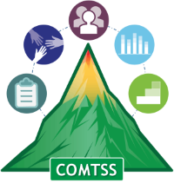
Colorado Multi-Tiered System of Supports
OFFICE OF LEARNING SUPPORTS
Look-For-Tool Template November 2023 V1

Practice/Program/Focus Area Trained On:
Name of District/School:
Date:
Grade Level:
Name of Educator(s)
Name of Reviewer:
Time in/time out (10 minutes):

Features of the focus area that will be looked for in classrooms | 1:  Not yet in place | 2:  Partially in place | 3:  Mostly/Fully in place | No opportunity to observe
What you expect to see teachers saying and doing #1
What you expect to see teachers saying and doing #2
What you expect to see teachers saying and doing #3
What you expect to see teachers saying and doing #4
Engages students in meaningful interactions with content Teacher uses a variety of materials and/or strategies to: Generate new knowledge – OR – Extend critical thinking – OR – Promote reflection by all students on their own learning, effort, or understanding

Notes/Comments:

