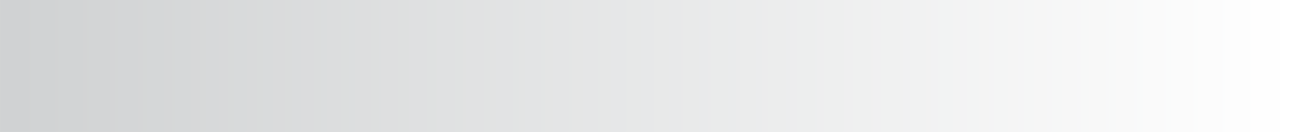

High Achieving Schools Study

**Introduction**



* Theory of Action: “…**if,** we identify effective, supplemental education programs and the requisite foundations for their successful implementation...” And “**… if,** we disseminate best practices to those identified for improvement...” Then: “We can increase the value added by federal education programs administered by these units toward improving the effectiveness of educators and increasing student performance in schools and school districts….”
* Scope of Work: “Recognizing highly effective local programs and educators and utilizing their expertise in support of increased school and district effectiveness.”

**Theory of Action and**

**Scope of Work**

Across the nation, numerous studies have highlighted the characteristics common to effective schools and districts (e.g., Hattie, 2009; Huberman, Navo, & Parrish, 2012; Kannaple & Clements, 2005; Parratt & Budge, 2011; Council of the Great City Schools, 2009; Maryland’s report on The Best Practices of Title I Superlative Highest Performing Reward Schools, 2013; Massachusetts Department of Education’s Reflecting on Success Report, 2013). The Colorado Department of Education’s Unit of Federal Programs Administration (UFPA) has also conducted two previous studies of high performing schools and districts in order to identify best practices. The first study, called the Title I High Growth Schools Study, focused on Title I schools that had demonstrated growth for their lowest performing students on the Colorado Growth Model. The second study, called the Program Quality Indicators (PQI) Study, focused on the English Language Development programs of districts that had demonstrated success with increasing the academic and linguistic performance of English Learners.

In the current study, two Colorado Department of Education units (UFPA and the Exceptional Students Services Unit) worked together to identify common policies, procedures, and practices across high achieving schools, to dive deeper into how they were implementing the policies, procedures, and practices that are contributing to the schools’ success. This study builds upon the lessons learned from the two seminal studies to identify and disseminate the effective practices of high *achieving* schools that have maintained high achievement for three years for their disaggregated groups, specifically English Learners, students with disabilities, students experiencing poverty, and minority students.

# Goals and Objectives of the Current Study

The goal was to conduct a rigorous study of high achieving schools to identify and document the practices that have contributed to the schools’ overall performance and to the performance of the schools’ disaggregated groups, particularly English Learners and students with

disabilities. The objective is to disseminate findings to the field highlighting the effective, replicable practices that have been or could be supported with federal funding (ESEA or IDEA). In Phase II of the study, CDE will establish a network of high achieving schools and create opportunities for high achieving schools to serve as models and mentors for lower performing schools. In order to meet this intent, emphasis was placed on systematically collecting evidence of the practices and procedures that are contributing to the achievement of disaggregated groups, with particular attention to how the schools are implementing those effective practices and procedures.

# Study Methodology

## School Identification

Given the goals and objectives of the current study, for this work to be relevant and meaningful for low performing and struggling schools, it was imperative to identify schools that have variability in demographics and face similar challenges as low performing schools. In order for this study to build upon and serve as a companion piece to earlier CDE studies, schools were identified based on achievement data. As such, the following eligibility criteria were applied in identifying the study schools:

1. Schools had to have a large enough student population within four disaggregated groups (English Learners, students with disabilities, minority students, and students qualified for free or reduced lunch) to have state assessment results for all four groups in reading and math (minimum count of 16 per content per grade level).
2. Of the schools with large enough disaggregated groups, the schools whose percent proficient and advanced for each disaggregated group was above the state’s 60th percentile on reading and math proficiency were considered. Three years of data (2011, 2012, and 2013) were analyzed to ensure maintenance of this level of performance.
3. Additionally, schools must have had earned an overall rating of “Performance” as well as a “Meets” or “Exceeds” rating on the Academic Achievement indicator on the 2013 School Performance Frameworks.
4. Lastly, schools must have had earned a “Meets” or “Exceeds” rating on writing and science achievement on the 2013 School Performance Frameworks to stay on the eligibility list.

The top five eligible schools using the above criteria were:

*Table 1. High Achieving Schools Eligible for the Study*

|  |  |  |  |  |
| --- | --- | --- | --- | --- |
| **Dt.**  **Code** | **District Name** | **School**  **Code** | **School Name** |  |
| 0470 | ST VRAIN VALLEY RE 1J | 1148 | BURLINGTON ELEMENTARY SCHOOL |  |
| 0130 | CHERRY CREEK 5 | 1273 | CANYON CREEK ELEMENTARY SCHOOL |  |
| 1420 | JEFFERSON COUNTY R-1 | 8102 | SOUTH LAKEWOOD ELEMENTARY SCHOOL |  |
| 0980 | HARRISON 2 | 8034 | SOARING EAGLES ELEMENTARY SCHOOL | E |
| 1550 | POUDRE R-1 | 8460 | TAVELLI ELEMENTARY SCHOOL | E |

These five schools were invited to submit a proposal for a grant to participate in the study. All five identified schools applied for and were awarded the grant.

## Methodology

*Funding*

Each participating school received $20,000 for participation in the study. Federal Elementary and Secondary Education Act (ESEA, $50,000) and Individuals with Disabilities Education Act (IDEA, $50,000) programs funded the study expenses.

*Data Collection Team*

Eight CDE representatives from the two participating units comprised the Data Collection Team (DCT). DCT members were selected based on their expertise and experience in various areas relevant to the study. Two members have expertise in programs designed to support students with disabilities; one member has expertise in programs designed to support English learners; two members had school and district systems expertise; one had ESEA (specifically Title I) expertise; one had expertise in competitive grants and awards; and two members had research, data analyses, and program evaluation expertise. In late summer and early fall, the DCT received training on the study protocols and on coding classroom observations. The team practiced coding videos of classrooms to establish inter-rater reliability.

*Pre-visit Telephone Conferences*

Pre-visit telephone conferences were conducted to coordinate the onsite visits and refine onsite schedules and needs. School and district representatives were invited to participate on the call. The school and district were instructed to select the individuals and groups to be interviewed and surveyed, as well as the events to be observed, based on the fact that this was a retrospective study of success obtained in previous years. Schools and districts were requested to include interviews with faculty and staff that would have working knowledge of the factors that contributed to the schools’ success in the 2010-11, 2011-12, and 2012-13 school years.

*Pre-visit Surveys*

Prior to the onsite visit, surveys were sent to district and school personnel, as well as parents, families and community members selected by the school/district. CDE prepared the surveys for collection on SurveyMonkey; responses were collected via SurveyMonkey and sent directly back to CDE. No identifying information was collected from survey respondents and responses are only reported in aggregate, including in any reports back to the school and district. Respondents were permitted three weeks to respond.

Schools and districts determined who participated in the survey. CDE recommended the following survey respondents be considered:

* Survey respondents – Questions are drawn from the Question Bank from the Implementation of Colorado Standards and Indicators for Continuous Improvement School Visit Process
  + Principal
  + Assistant Principal
  + Lead Teachers
  + General Education Teachers
  + Title I Teachers
  + Special Education (SPED) Teachers
  + English Learner (EL) Teachers
  + Any other school personnel that might have knowledge and insight about services provided to disaggregated students [e.g., counselors, paraprofessionals, interventionists, tutors, or **SPED**: Audiology Services (Educational Audiology Services), Counseling Services, including rehabilitation counseling, Interpreting Services (Educational Interpreter Services), Medical Services for diagnostic or evaluation purposes, Occupational Therapy, Orientation and Mobility Services, Parent Counseling and Training, Physical Therapy, Recreation, including therapeutic recreation, School Health Services/School Nursing Services, School Psychology Services, School Social Work Services, School Transportation, Instructional Support/Primary Services, Adapted Physical Education, Specific Disabilities, Speech-language pathologists]

Schools and districts communicated to the survey participants and sent them the link to the survey on SurveyMonkey. CDE provided the SurveyMonkey link and proposed communication to accompany the surveys which explained the purpose of the study and ensured that participation is completely voluntary and respondents may withdraw from participation at any time during the survey.

*Pre-visit document reviews*

Prior to onsite visits, the DCT studied documentation from each school, including documents available to CDE or publicly published on the Internet (school and district website, TELL Colorado Survey website, Schoolview.org), such as:

1. School Profiles: demographics and performance data (overall and disaggregated groups; primarily focused on achievement)
2. District Profiles: demographics and performance data
3. District Consolidated Applications (to the extent that any ESEA funds were awarded to the school) (3 years)
4. School and district UIP (3 years)
5. School and district Teaching, Empowering, Leading and Learning (TELL) data results (last 2 survey results available 2013 and 2011)
6. Schools were invited to share any documentation they felt would be pertinent to the study. Recommendations included:
   1. Curriculum maps (curriculum)
   2. Course schedules (use of time)
   3. School handbooks
   4. District and school policies
   5. Assessments (formative and summative)
   6. Student work (examples)
   7. English Language Acquisition Plan
   8. Sample IEPs
   9. Related community publications
   10. Others recommended by the schools on the pre-visit telephone conferences

*Onsite Visits*

Each onsite visit included observations of classrooms, meetings, or other pertinent events (e.g., tutoring sessions, before and after school programs), interviews with school and district personnel, and focus groups with parents/families, students, and community members.

The onsite visits occurred in the months of October and November, 2014, with two full days devoted to each school site (see Table 2).

*Table 2. Dates of the Onsite Visits*

|  |  |  |  |  |  |
| --- | --- | --- | --- | --- | --- |
| **Dt.**  **Code** | **District Name** | **School**  **Code** | **School Name** | **Grade**  **Level** | **Dates**  **(2014)** |
| 0470 | ST VRAIN VALLEY RE 1J | 1148 | BURLINGTON ELEMENTARY SCHOOL | E | **10/27-10/28** |
| 0130 | CHERRY CREEK 5 | 1273 | CANYON CREEK ELEMENTARY SCHOOL | E | **10/21-10/22** |
| 1420 | JEFFERSON COUNTY R-1 | 8102 | SOUTH LAKEWOOD ELEMENTARY  SCHOOL | E | **10/29-10/30** |
| 0980 | HARRISON 2 | 8034 | SOARING EAGLES ELEMENTARY SCHOOL | E | **11/5-11/6** |
| 1550 | POUDRE R-1 | 8460 | TAVELLI ELEMENTARY SCHOOL | E | **11/19-11/20** |

Schools and districts determined who was to be interviewed and who would participate in the focus groups. Listed below are individuals and groups that were recommended for each. These recommendations included any individuals or groups who might have insight about the school’s success, especially with the instruction and support services provided to disaggregated groups. The titles below are reflective of the roles. Not all schools and districts had individuals in all of these roles. The exact titles of the individuals varied across schools and districts.

* Interview participants – Interview questions were drawn from the Question Bank for the Implementation of Colorado Standards and Indicators for Continuous Improvement School Visit Process
  + Principal
  + Assistant Principal
  + Area Superintendent
  + Superintendent or Assistant Superintendent
  + English Language Coordinator or Director
  + SPED Coordinator or Director
  + Director of Instruction or Curriculum
  + SPED Teachers
  + EL Teachers
  + Title I Teachers
  + Any other school or district personnel that might have knowledge and insight about services provided to disaggregated student groups [e.g., counselors, paraprofessionals, interventionists, tutors, or **SPED**: Audiology Services (Educational Audiology Services), Counseling Services, including rehabilitation counseling, Interpreting Services (Educational Interpreter Services), Medical Services for diagnostic or evaluation purposes, Occupational Therapy, Orientation and Mobility Services, Parent Counseling and Training, Physical Therapy, Recreation, including therapeutic recreation, School Health Services/School Nursing Services, School Psychology Services, School Social Work Services, School Transportation, Instructional Support/Primary Services, Adapted Physical Education, Specific Disabilities, Speech-language pathologists]
* Focus group participants – Implementation of Parent Teacher Association (PTA) Standards and effective parental/family/community engagement
  + Parents/families
  + Students
  + Community members that might have knowledge and insight about services provided to disaggregated student groups (e.g., afterschool program coordinators or providers)
* Observations – visuals, behaviors, and procedures that inspire, teach, share language, explain content that lead to student success
  + Classrooms in session, especially classrooms with SPED and EL students
  + Classroom transition procedures and schedules
  + Lunchroom habits, playground practices, hallway behaviors
  + Planning periods, cross-grade collaboration meetings, cross-content meetings
  + Staff meetings
  + Direct services to students, especially EL and SPED students, including interventions, tutoring sessions, homework clubs; **SPED**: Audiology Services (Educational Audiology Services), Counseling Services, including rehabilitation counseling, Interpreting Services (Educational Interpreter Services), Medical Services for diagnostic or evaluation purposes, Occupational Therapy, Orientation and Mobility Services, Parent Counseling and Training, Physical Therapy, Recreation, including therapeutic recreation, School Health Services/School Nursing Services, School Psychology Services, School Social Work Services, School Transportation, Instructional Support/Primary Services, Adapted Physical Education, Specific Disabilities, Speech-language pathologists]
  + Permission will be requested to photograph areas observed (never the individuals being observed)

Although schools and districts selected the interviewees and focus group participants, interviewees’ and focus group responses will remain ***confidential*** and are only reported, including in reports back to the school and district, in aggregate and not at the individual level. In other words, reports do not provide any direct quotes or an individual’s specific responses. Key themes were identified and only the summary of those key themes are reported.

Interviews, focus groups, and observations were scheduled in the least intrusive times and manners possible. It was recommended that a school employee be designated as an onsite coordinator, who is familiar with the school building, schedule, and personnel, and could help guide the onsite visit and ensure that plans were followed as intended. At each site, either the principal and/or assistant principals served as the liaisons.

Schools were responsible for planning and communicating to the DCT the schedule and location of interviews, focus groups, and observations one week prior to the onsite visit. A template was provided for providing this information to the DCT in a structured manner to increase consistency across the schools.

Schools and districts were responsible for communicating with all interview and focus group participants, as well as anyone being observed. CDE provided draft communication, including participation ***consent forms*** that the school and district used to obtain consent from all participants, including those being observed. The consent forms included the purpose of the study, and informed participants that participation is voluntary and participants may withdraw from interviews and focus groups at any time or not answer any of the questions without any penalty.

Observations were designed to be non-disruptive and observers did not interact with or ask any questions of adults or students in the classrooms or events scheduled. Classrooms that were engaging in small group work

and independent work, permission would be obtained to interact with the students and the teachers. Observers entered rooms or events as quietly as possible and silently coded behaviors, practices, and visuals observed.

When the allotted time ended, observers quietly left the classroom or event with as little disruption as possible.

All participating schools and districts have consented to have their names and photographs of the environment (not individuals) included in reports.

The table below delineates the number and hours of interviews, focus groups, and observations conducted in total and by school. Across the five schools, a total of 67 interviews (60.6 hours) and 44 focus groups (36.4 hours) were conducted to obtain opinions and perspective of stakeholders pertaining to the achievement, policies, procedures, and practices of each school. A total of 112 observations (89.4 hours) provided evidence of the instructional practices, and verification of the information provided during interviews and focus groups.

*Table 3. Number and Hours of Study Events*

|  |  |  |  |  |  |  |  |  |
| --- | --- | --- | --- | --- | --- | --- | --- | --- |
|  | **Interview** | | **Focus Group** | | **Observation** | | **Total** | |
| **School** | **N** | **Hours** | **N** | **Hours** | **N** | **Hours** | **N** | **Hours** |
| **Burlington Elementary** | 9 | 7.00 | 7 | 5.75 | 35 | 29.75 | **51** | **42.50** |
| **Canyon Creek Elementary** | 9 | 8.58 | 2 | 2.00 | 12 | 8.75 | **23** | **19.33** |
| **Soaring Eagles Elementary** | 20 | 16.92 | 13 | 10.25 | 15 | 11.42 | **48** | **38.58** |
| **South Lakewood Elementary** | 15 | 15.75 | 8 | 8.00 | 24 | 21.17 | **47** | **44.92** |
| **Tavelli Elementary** | 14 | 12.33 | 14 | 10.42 | 26 | 18.30 | **54** | **41.05** |
| **Total** | **67** | **60.58** | **44** | **36.42** | **112** | **89.38** | **223** | **186.38** |

*Post-visit Work*

After the onsite visit, the DCT met to review the events of onsite visits, document observations and trends noted, and identify any clarifications or additional information needed. Any follow-up questions or items needing clarification were communicated to the school, with an opportunity to provide responses or clarification as needed.

Each participating school and district received the summary report for the participating school and was given opportunity to provide feedback, edits, or suggestions on the summary report prior to the report being finalized.

***Structure of the Reports***

The intent of this segment was to summarize the purpose and methodology of the study with sufficient detail to make the study replicable by other researchers.

The next segment, the synthesis report, provides the common findings across all of the schools.

Finally, each of the five individual school summary reports provides any additional findings pertaining only to that school. Although the synthesis report identifies the common characteristics across the schools, the school summary reports highlight the schools that were a particularly strong model or example of a common characteristic. The intent of those segments is to allow other schools to identify the school(s) that would be of interest for a site visit or networking.

**The Colorado Department of Education**

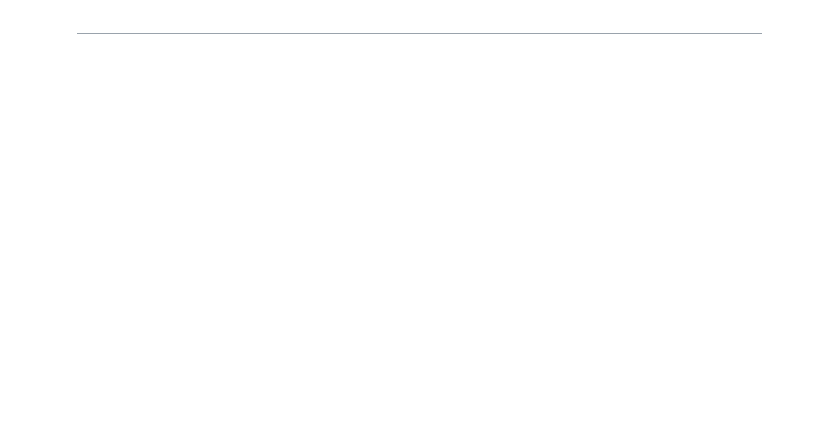

**For information about the study, contact Nazanin Mohajeri-Nelson**

* [Mohajeri-nelson_n@cde.state.co.us](mailto:Mohajeri-nelson_n@cde.state.co.us)
* (303) 866-6205

**For information about the High Fliers Network, contact Lynn Bamberry**

* [Bamberry_l@cde.state.co.us](mailto:Bamberry_l@cde.state.co.us)
* (303) 866-6813

**Report Authors**

* Nazanin Mohajeri-Nelson
* Lynn Bamberry
* Wendy Dunaway
* Ellen Hunter
* Jeff Klein
* Courtney Kuntz
* Tina Negley
* Rebekah Ottenbreit
* Robin Singer

1560 Broadway, Suite 1450, Denver, CO 80202 • 303-866-6205