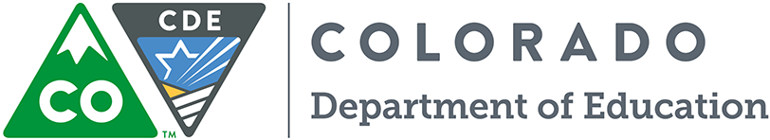

Federal Programs Unit
1560 Broadway, Suite 1100
Denver, CO 80202-5149

To: ESSA State Plan Stakeholders
From: Patrick Chapman, Executive Director, Federal Programs Unit.
Date: February 10, 2017
Re: Notice Inviting Public Comment –The Every Student Succeeds Act (ESSA) Colorado State Plan Draft

In order to demonstrate that Colorado meets the requirements of ESSA and to access the funding allocated to the state, CDE must submit a plan to the United States Department of Education for approval. Fundamental to the requirements of the ESSA plan, is that the department engage in meaningful consultation with a broad range of education stakeholders in developing the plan and, once a draft of the plan has been completed, to make the plan available for public comment. The draft of this plan will be open for public comment for 30 days, beginning on Friday, February 10, 2017, and closing on Friday, March 10, 2017.

There are two ways to submit your comments on Colorado’s ESSA State Plan:
- Visit our online portal to access the survey or upload a document: http://www.cde.state.co.us/fedprograms/essastateplanfeedback, or
- Mail your comments to:
Colorado Department of Education
Federal Programs Unit
1560 Broadway, Suite 1100
Denver, CO 80202-5149

We invite you to read the letter from Commissioner Anthes on Colorado’s ESSA State Plan Development and release of the state plan draft prior to submitting your comments: http://www.cde.state.co.us/fedprograms/essapubliccommentletter

This stage of Colorado’s ESSA plan development is important as it is your chance to react to the plan. The comments we receive from you will be compiled, included with the plan when it is submitted to the USDE, and incorporated into the plan as appropriate. Next, the plan will be reviewed with the Governor and ultimately presented to Colorado’s State Board of Education for approval to submit to the U.S. Department of Education in April. Comments received will be compiled and included with Colorado’s state plan submission and incorporated into a draft of CDE’s final draft as appropriate.

CDE also intends to post a draft of the state plan in Spanish and encourages members of the public to contact us at essaquestions@cde.state.co.us with any questions or requests related to accessibility.

CDE sincerely values your thoughts and perspectives on these issues and encourages you to share them with us.

