SCHOOL TRANSFORMATION NETWORK

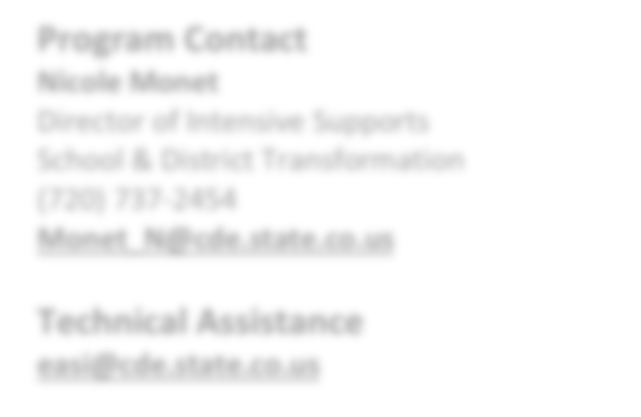

**EASI Route: Offered Services**

# Introduction

The Colorado School Transformation Network (Transformation Network) will accelerate student achievement for select schools through targeted support, resources, and flexibility. The Network is a highly collaborative and accountable endeavor between local schools, their Local Education Agency (LEA), and the Colorado Department of Education. Schools in the Network will benefit from enhanced diagnostic reviews and planning support; personalized, professional learning opportunities with a cohort of peer schools; and additional resources through supplemental grant

**Program Contact**

**Nicole Monet**

Director of Intensive Supports School & District Transformation (720) 737-2454

[**Monet_N@cde.state.co.us**](mailto:Monet_N@cde.state.co.us)

**Technical Assistance**

[**easi@cde.state.co.us**](mailto:easi@cde.state.co.us)

funding. CDE’s Theory of Action is that by supporting both LEAs and schools together, we will see lasting, sustained improvement in the lowest-performing schools. 1

The Transformation Network uses the [Four Domains of Rapid School Improvement](https://www.cde.state.co.us/accountability/cde-school-four-domains-diagnostic-rubric-v8) to support schools in developing a rigorous improvement plan around four research-based conditions to improve school performance and student achievement:

* **Leadership**: Customize and target leadership development to meet the improvement needs at all levels of the educational system.
* **Talent Management**: Employ systems and strategies to recruit, develop, evaluate, and retain excellent teachers and staff.
* **Instructional Transformation**: Design and implement a rigorous, aligned, and engaging academic program that is responsive to student learning needs, is driven by data, and is flexible to meet the needs of all students.
* **Culture and Climate Shift**: Build an equitable school culture focused on student learning and parent and community engagement.

All participating Transformation Network schools will receive access to specialized professional development, on-site performance management sessions, and regular Transformation Network events.

Each Transformation Network school will be assigned a School Transformation Specialist from CDE, who will serve as a resource and partner to the LEA and school. All participating Transformation Network schools will be required to engage a “district partner” to serve as a key support and advocate for the school at the LEA level. The district partner must be a senior-level LEA staff member who will attend all Transformation Network professional development opportunities and events with the school team. The district partner should remain assigned to the school for the duration of the Transformation Network participation and will be responsible for ensuring the conditions for success are established at the school and supported by the LEA.

1 In July of 2022, the Transformation Network completed a quantitative and qualitative evaluation with the Center for Assessment, Design, Research and Evaluation (CADRE) at the CU Boulder School of Education. More information can be found here: Diaz-Bilello, E., York, A., and Mork, K. (2021)[. Learnings from a Multi-site Case Study of Former Turnaround Schools.](https://www.colorado.edu/cadre/2022/08/12/learnings-multi-site-case-study-former-turnaround-schools) Boulder, CO: The Center for Assessment, Design, Research and Evaluation (CADRE), University of Colorado Boulder.

Updated August 2024

# Eligibility & Prioritization

*Eligibility.* Schools that meet the following criteria are eligible to apply:

* Schools identified for improvement under ESSA as Comprehensive Support (CS), Targeted Support (TS), or Additional Targeted Support (ATS); and/or
* Schools with a state identification School Performance Framework plan type of Priority Improvement, Turnaround, or On Watch

*Prioritization.* If not all EASI proposals can be funded, proposals that meet grant expectations will be funded in the order of the EASI school-level prioritization list. Schools with the highest number of prioritization points will be funded first. Details on how prioritization points are calculated and the points for each EASI eligible school are available on the [EASI Resources and Technical Assistance](https://www.cde.state.co.us/fedprograms/easiappresourcesandtechnicalassistance) webpage.

*Limitations.* Transformation Network is a direct CDE support, and the number of new schools awarded each grant cycle may be limited due to CDE staff capacity. Transformation Network’s service capacity is based on several factors including CDE staffing, number of active school sites from prior cohorts, level of need at each site, and number of schools in each geographic region with available staff. If not all EASI proposals for Transformation Network can be supported, prioritization points and service capacity in a single district or region may be considered.

# Program Considerations & Fit

*Program Considerations*. Success in the Transformation Network is evidenced by the willingness and engagement of school and district teams in a partnership with CDE staff. Progress monitoring, performance target setting, and use of funds are done through this partnership and customized to the needs identified in the school diagnostic review.

*Program Fit*. The Transformation Network is a good fit for schools with systemic challenges and the following characteristics:

* Strong LEA support and buy-in, and
* School leadership demonstrates a mindset of learning and growth

This grant opportunity is not a good fit for schools currently participating, or recently completed, Connect for Success or schools that are currently going through a principal transition and have not selected a permanent school leader before the grant application deadline.

# Sequence of Program Support

The sequence of the work is determined in partnership with School Transformation Specialist following an initial school diagnostic review in the spring following award notifications. In partnership with the School Transformation Specialist, schools can expect regular site visits, ongoing professional learning opportunities, and ongoing progress monitoring.

[Transformation Network’s 2024-25 School Leader Professional Learning series](https://drive.google.com/file/d/1_Oj0H-UT4lyKKd6fykvxX4lKApsHirmD/view?usp=sharing) is available to review to better understand the scope and sequence.

# Available Funds & Duration

*Available Funds.* Applicants may request up to the maximum award amount for a school. Award may be:

* Up to $20,000 per school in Year 1 (2024-25)
* Up to $80,000 per school in Year 2 (2025-26)
* Up to $80,000 per school in Year 3 (2026-27)

*Duration.* Program support is designed to support schools with funding for a period of 2.5 years (2024-25 to 2026-27). Transformation Network additionally provides support for one additional school year (2027-28), but no additional grant funding is available in the final year.

# Allowable Use of Funds

Funds are intended to support evidence-based strategies and practices that align with the findings of the CDE diagnostic review and support major improvement strategies. Allowable use of funds includes costs associated with:

* Professional development including registration and travel costs. Schools in the past have attended Teach Like a Champion workshops, Relay, Standards Institute, EL, Together Leader, etc.
* Additional planning time for teachers to bring staff back early or costs for substitute teachers during the school year.
* Parent and Family Engagement strategies.
* Marketing and branding to support the school’s mission/ vision and core values.
* Purchasing curricular resources and/or intervention materials.
* Purchasing assessment platforms.
* Visiting bright spot schools or exemplar schools.
* Schools may use funds for FTE, however, the school will need to provide rationale for how the role is building capacity, aligned to their Major Improvement Strategies and how the position will be funded once Transformation Network funds are spent.

*Budget Recommendations.* A budget and plan will be jointly developed with CDE following the spring school diagnostic review. For the application submission, enter a draft budget with the following budget lines as shown below.

* Year 1 (2024-25)- Placeholder for activities informed by the spring diagnostic review determined in partnership with CDE for $20,000
* Year 2 (2025-26)- Placeholder for activities determined in partnership with CDE for $80,000
* Year 3 (2026-27)- Placeholder for activities determined in partnership with CDE for $80,000

*Note: If entering indirect costs, the total request amount may not exceed the maximum allowable amount.*

## Fund Considerations.

* Funds from this opportunity must be used to **supplement and not supplant** any federal, state, and local funds currently being used to provide activities.
* Post-award revisions must be approved by 06/30 and funds drawn down by 09/30 of each respective fiscal year.
* A school or district may carry funds forward in alignment with funding source restrictions and with CDE approval. At the end of the grant performance period, any non-requested federal funds are reverted and any unspent state funds must be returned to the state.
* CDE may terminate a grant award upon thirty days’ notice if it is deemed by CDE that the applicant is not fulfilling the requirements of the funded program as specified in the approved project application, or if the program is generating less than satisfactory results.
* Multi-year or future award year amounts are contingent on allocations of state and federal funds to CDE in each respective fiscal year.

# Important Program Dates

|  |  |
| --- | --- |
| **Program Dates** | **Activity** |
| **September- December** | Meet with CDE School Transformation Specialist to discuss interest in applying for support and outline a proposed budget |
| **December** | Application due |
| **January** | Award notifications |
| **March-May** | CDE conducts half-day diagnostic review of school |
| **May-June** | School, LEA, and CDE collaborate to conduct initial planning, goal setting, budget development; optional professional development sessions |

**Evaluation and Reporting**

Each grantee of the program must, at a minimum, agree to the following evaluation, reporting, and/or progress monitoring components:

* Engage in Transformation Network performance management routines, protocols, and documentation
* Utilize an online Performance Management (PM) tool, which will require entering, managing, and sharing schools’ Unified Improvement Plan (UIP) action steps and interim data. Key school improvement data to be collected in the PM tool includes:
  + School improvement plan implementation;
  + Student daily attendance rates;
  + Student chronic absenteeism rates;
  + Student suspension data; and
  + Student achievement and growth on local, interim assessments.
* Each school will be asked to frequently track key school improvement indicators and will be asked to submit major improvement strategies, implementation benchmarks and quarter 1 action steps for the 2025-26 school year by June 30, 2025.
* Transformation Network schools will also be asked to participate in network-wide surveys to provide feedback to CDE about the Transformation Network services.
* Annual Financial Report (AFR) each fiscal year by 09/30

*Note: Only aggregate data will be entered or shared in the PM tool. In entering or sharing aggregate data, LEAs and schools will use an n-size which preserves the privacy of student level data. CDE will work with each participating school and LEA to ensure that any data entered and shared does not contain PII or violate n-size privacy concerns.*

*Note: All data collected will protect personally identifiable information (PII) protected and is only reported on an aggregate level for purposes of evaluating the EASI support and/or supporting future program improvements.*

# Program Assurances

## District Leadership Commitments (i.e. District Partner or participating principal’s supervisor:

* Attend and participate in all Transformation Network convenings and professional development events.
* Attend and actively participate in quarterly performance management sessions with principal and CDE staff at the school and start to lead PM sessions by mid-year of Year 2. District partner will play an active role in facilitating regular school site visits. The district partner may be asked to maintain a district partner site visit log. If you cannot attend the PM Session, ask to reschedule with CDE Transformation Support Manager.
* Utilize the PM Tool for regular conversations with school leaders to track progress and next steps.
* Provide actionable feedback regularly to principal based on classroom observations, review of student work, observation of weekly data teams, etc.
* Ensure school has systems for observation and feedback, weekly data teams, and short cycle assessments.
* Commit to establish, protect, and support necessary and identified conditions such that the principal is able to make dramatic improvements at the school.
* Take ownership and hold oneself accountable for the results at the school.
* Approve the school’s Transformation Network budget and ensure alignment with Major Improvement Strategies.

## School Leadership Commitments:

* Attend and participate in all Network convenings and professional development events.
* Attend and participate in monthly (year 1) or quarterly visits (years 2 and 3) with district partner and CDE staff at the school.
* Visit with the district partner at the school every week and document the visit in an online tracker tool.
* Engage in performance management process throughout the year - providing and entering data into the tracker tool as relevant data becomes available.

**ADDITIONAL INFORMATION AND RESOURCES**

[**Colorado Department of Education’s EASI Website**](http://www.cde.state.co.us/fedprograms/easiapplication)[**EASI: School Transformation Network**](http://www.cde.state.co.us/fedprograms/cdeofferedservices-turnaroundnetwork)

[**CDE: School Transformation Network**](http://www.cde.state.co.us/accountability/turnaroundnetwork)

* Ensure every teacher receives observations and actionable feedback.
* Ensure data teams meet weekly and review student work.
* Establish systems for short-cycle assessments and planning.
* Share aggregate progress monitoring and leading indicator data, which may include: student attendance rates, student behavior data, local interim assessment data, teacher attendance data, TLCC survey results, teacher evaluation data, principal evaluation data, budget analyses, use-of-time audits, or other relevant indicators.
* Commit to establish, protect, and support necessary and identified conditions in order to make dramatic improvements at the school.
* Ensure that the school’s Network budget is used for high leverage initiatives and aligned to Evidence Based Interventions.
* Take ownership and hold oneself accountable for the results at the school.

## CDE Transformation Support Manager Commitments:

* Support and coach school and district partners during professional development and on-site support.
* Attend and facilitate monthly/quarterly performance management sessions with district partner and principal at the school.
* Gradually release responsibility of PM sessions to district partner and principal.
* Advocate within CDE and the LEA to establish, protect, and support necessary and identified conditions in order to see dramatic improvements at the school.
* Initiate honest conversations about the school's performance and potential impact with regards to the state accountability system.
* Identify and negotiate additional resources and
* supports for identified conditions.
* Be champions of your work in schools and your district.
* Ensure Network funds are spent in alignment with high leverage improvement strategies.

**Successful participation in the Transformation Network will result in:**

* Dramatic increases in student achievement as measured by ambitious and specific goals.
* Meeting and improving on identified school goals through implementation of prioritized strategies as measured by local culture and academic data indicators.
* Active engagement by all parties to find productive, collaborative, and innovative solutions to challenges.
* Demonstration of commitment, by school and LEA, to urgent and dramatic improvements to result in increased student learning.
* Successful school efforts will be recognized and advocated for if the school remains on the state Accountability Clock.