CONNECT FOR SUCCESS

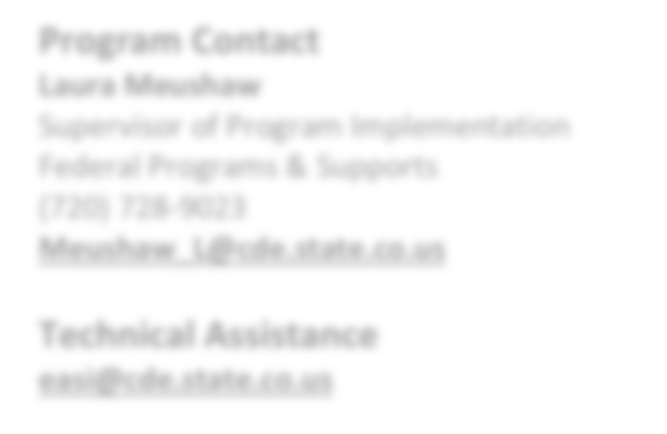

**EASI Route: Offered Services**

# Introduction

The Connect for Success (CFS) grant was the result of a 2014 Colorado Department of Education (CDE) study of five high achieving elementary schools identified based on their overall performance, as well as the performance of their student groups, specifically English Learners, students with disabilities, students experiencing poverty, and minority students. The study focused on how these schools are attaining higher academic achievement than other schools in the state. The school and LEA leadership, personnel, families, and students participated in surveys,

**Program Contact**

**Laura Meushaw**

Supervisor of Program Implementation Federal Programs & Supports

(720) 728-9023

[**Meushaw_L@cde.state.co.us**](mailto:Meushaw_L@cde.state.co.us)

**Technical Assistance**

[**easi@cde.state.co.us**](mailto:easi@cde.state.co.us)

focus groups, and interviews to help identify the factors contributing to the schools' success with the identified groups. The following [High Achieving Schools (HAS) Study](http://www.cde.state.co.us/fedprograms/dper/evalrpts) summarizes the study purpose and methods, overall findings highlighting effective strategies common across the five schools in the 2014 study, and effective strategies unique within each school: [www.cde.state.co.us/fedprograms/dper/evalrpts](http://www.cde.state.co.us/fedprograms/dper/evalrpts)**.**

In 2018, CDE added four new high achieving schools to the study: a rural elementary school, a middle school, a high school, and an alternative education campus (AEC). The same methodology was used to identify practices that are contributing to the success of the newly identified schools. Although three of the four schools were secondary schools, many of the same trends were noted across the second round of high achieving schools as has been evidenced in the first study. CDE is in the process updating the HAS study and historical and any new related reports will be posted on Federal Programs- Program Evaluations and Analyses website ([www.cde.state.co.us/fedprograms/dper/evalrpts)](http://www.cde.state.co.us/fedprograms/dper/evalrpts).

The CFS grant is an opportunity for eligible schools to connect with and learn from the HAS effective practices and strategies. Schools that participate in the Connect for Success grant receive a diagnostic visit and a report that includes recommendations from a CDE team based on the findings of the HAS study. After hearing a panel of HAS school leaders and connecting with them at a kickoff meeting, grantees visit one of the HAS to see the effective practices in person.

Schools identify and/or hire an implementation coach who works with a CDE Implementation Manager to replicate HAS strategies as well as monitor the implementation of those practices.

# Eligibility & Prioritization

*Eligibility.* Schools that meet the following criteria are eligible to apply:

* Schools identified for improvement under ESSA as Comprehensive Support (CS), Targeted Support (TS), or Additional Targeted Support (ATS); and/or
* Schools with a state identification School Performance Framework plan type of Priority Improvement, Turnaround, or On Watch

*Prioritization.* If not all EASI proposals can be funded, proposals that meet grant expectations will be funded in the order of the EASI school-level prioritization list. Schools with the highest number of prioritization points will be funded first. Details on how prioritization points are calculated and the points for each EASI eligible school are available on the [EASI Resources and Technical Assistance](https://www.cde.state.co.us/fedprograms/easiappresourcesandtechnicalassistance) webpage.

Updated September 2024

*Limitations.* Connect for Success is a direct CDE support, and the number of new schools awarded each grant cycle may be limited due to CDE staff capacity. Connect for Success’s service capacity is based on several factors including CDE staffing, number of active school sites from prior cohorts, level of need at each site, and number of schools in each geographic region with available staff. If not all EASI proposals for Connect for Success can be supported, prioritization points and service capacity in a single district or region may be considered.

# Program Considerations & Fit

*Program Considerations*. Schools should demonstrate readiness and willingness to rethink current strategies and practice with those of HAS.

*Program Fit*. Connect for Success is a good fit with current or potentially new EASI supports including School Turnaround Leadership Development or Facilitated Board Training for School Improvement. Connect for Success is not a good fit for schools that:

* Schools who completed Exploration Supports in the last two years;
* Schools currently supported by Accountability Pathways or in Year 4 or later on the state Accountability Clock;
* Schools who are currently supported by or recently completed (last two years) Transformation Network; or
* Online schools

# Sequence of Program Support

The sequence of the work is informed by the school visit and subsequent diagnostic review. In partnership with CDE, schools will then prioritize areas for improvement, develop an implementation plan, monitor plan using a CFS progress monitoring tool and build upon improvement efforts through High Achieving School visits.

# Available Funds & Duration

*Available Funds.* Applicants may request up to the maximum award amount for a school. Award may be:

* Up to $20,000 per school in Year 1 (2024-25)
* Up to $80,000 per school in Year 2 (2025-26)
* Up to $80,000 per school in Year 3 (2026-27)

*Duration.* Program support is designed to support schools or LEAs for a period of 2.5 years (2024-25 to 2026-27).

# Allowable Use of Funds

Funds are intended to support the implementation of the Connect for Success program.

Allowable use of funds **must** be used for costs associated with:

* Site visits to High Achieving School site (travel, substitutes, stipends)
* Travel and attendance of school/LEA leadership to attend state meetings in Denver area
* Strategies and practices that align with the findings of the CDE site visit and the High Achieving Schools Study

Allowable use of funds **may** be used for costs associated with:

* Implementation Coach (appointed or hired by LEA)
* Staff stipends and/or substitute pay to create time for job-embedded learning opportunities and/or time for collaboration
* Leadership development
* CDE diagnostic visit (surveys, translating, and substitutes)

*Budget Recommendations.* A budget and plan will be jointly developed with CDE following the spring site visit and diagnostic review. For the application submission, a draft budget may include the following budget lines:

* Year 1 (2024-25)- Placeholder for activities informed by the spring diagnostic review determined in partnership with CDE for $20,000
* Year 2 (2025-26)- Placeholder for activities determined in partnership with CDE for $80,000
* Year 3 (2026-27)- Placeholder for activities determined in partnership with CDE for $80,000

*Note- If entering indirect costs, the total request amount may not exceed the maximum allowable amount.*

## Fund Considerations.

* Funds from this opportunity must be used to **supplement and not supplant** any federal, state, and local funds currently being used to provide activities.
* Post-award revisions must be approved by 06/30 and funds drawn down by 09/30 of each respective fiscal year.
* A school or district may carry funds forward in alignment with funding source restrictions and with CDE approval. At the end of the grant performance period, any non-requested federal funds are reverted and any unspent state funds must be returned to the state.
* CDE may terminate a grant award upon thirty days’ notice if it is deemed by CDE that the applicant is not fulfilling the requirements of the funded program as specified in the approved project application, or if the program is generating less than satisfactory results.
* Multi-year or future award year amounts are contingent on allocations of state and federal funds to CDE in each respective fiscal year.

# Important Program Dates

|  |  |
| --- | --- |
| **Program Dates** | **Activity** |
| **September- December** | Meet with CDE School Transformation Manager to discuss interest in applying for support and outline a proposed budget |
| **December** | Application due |
| **January** | Award notifications |
| **February-April (post-revisions)** | CDE conducts school visits and provides recommendations for HAS strategies and practices to be implemented |
| **May** | School, LEA and CDE collaborate to conduct initial planning, goal setting, and  budget development |
| **June** | School submits next year’s plan, budget, and baseline monitoring indicators |
| **August** | Planning and learning opportunity for all Connect for Success grantees |

**Evaluation and Reporting**

Each grantee of the program must, at a minimum, agree to the following evaluation, reporting, and/or progress monitoring components:

* School information as part of the diagnostic review school visit after the grant is awarded but before planning and implementation
  + Parent surveys – distributed by the school; collected and analyzed by CDE; 30% of parents’ (or at least 50) response
  + Personnel surveys – distributed by the school; collected and analyzed by CDE; at least 50% of staff response
  + Observation/walkthrough data – collected by a team from CDE and/or the CDE Implementation Manager; and
  + Interviews with school leadership, teachers, staff, families, and students – collected by a team from CDE and/or the CDE Implementation Manager.
* At the end of Year 1, schools must provide a description of the planning process and the plans for the next year of the grant. Description must include an implementation plan to replicate the HAS strategies and practices and based on CDE recommendations from the diagnostic visit.
* Implementation plan and, when available, implementation data to demonstrate the extent to which implementation occurred with fidelity
* Quarterly progress monitoring reports submitted using the CDE Progress Monitoring Template
* Annual Financial Report (AFR) each fiscal year by 09/30

*Note: All data collected will protect personally identifiable information (PII) protected and is only reported on an aggregate level for purposes of evaluating the EASI support and/or supporting future program improvements.*

# Program Assurances

## LEA Commitments:

* Hire or designate an Implementation Coach that meets the minimum competencies
* Ensure both district and building leadership possess the qualifications and have committed the time necessary to accomplish grant activities to lead to student achievement gains
* Allow flexibility for school to adjust for mid-course corrections if data does not indicate progress toward increasing achievement
* Support school in using data to monitor student progress to inform instructional practice to accelerate performance
* Conduct monthly instructional rounds at school site (LEA /school/implementation coach, if applicable)
* Foster principal’s leadership in the school and support leadership growth opportunities
* Ensure that funds are being leveraged with other local, state, and federal funds (e.g., Titles I, II, III, V, and IDEA) and that accountability for cost-effective management is provided
* Work with and provide requested data to CDE for the Connect for Success funding opportunity within the periods specified
* Will not discriminate against anyone regarding race, gender, national origin, color, disability, or age;
* Use funds to supplement and not supplant any moneys currently being used to provide services and grant dollars will be administered by the appropriate fiscal agent
* Maintain appropriate fiscal and program records on funded projects and conduct fiscal audits of this program as a part of regular audits
* Maintain sole responsibility for the project even though subcontractors may be used to perform certain services
* Misuse of these funds will result in the revocation of funds

## School Leadership Commitments:

* Provide CDE with the annual evaluation and quarterly progress monitoring information required
* School leadership team with LEA representation will attend the state sponsored professional development and/or networking opportunities
* School leadership will collaborate with the Implementation Coach, hired or designated by the LEA, to develop and implement a plan to replicate HAS practices and strategies based on the CDE recommendations from the diagnostic visit
* Reevaluate use of Title I and IDEA funds (e.g., Coordinated Early Intervening Services - CEI) to meet needs of minority students, students experiencing poverty, students with disabilities, and English Learners
* School Leadership will:
  + Conduct regular instructional walkthroughs
  + Perform ongoing performance monitoring of instructional staff and provide timely feedback to teachers
  + Ensure ongoing data analyses and participating in data meetings
  + Ensure that time for data meetings, analysis, and use is protected

**ADDITIONAL INFORMATION AND RESOURCES**

**Colorado Department of Education’s EASI Website** [**www.cde.state.co.us/fedprograms/easiapplication**](http://www.cde.state.co.us/fedprograms/easiapplication)

**EASI: Connect for Success** [**www.cde.state.co.us/fedprograms/cdeofferedservices-connectforsuccess**](http://www.cde.state.co.us/fedprograms/cdeofferedservices-connectforsuccess)

**CDE: Connect for Success** [**www.cde.state.co.us/fedprograms/ti/sitig**](http://www.cde.state.co.us/fedprograms/ti/sitig)

* + Ensure time for collaboration is created and protected
  + Make student-centered decisions (including grouping of students, class schedules, etc.)
  + Set high expectations of staff, families, and students
  + Budget sufficient funds and time to participate in required grant activities
  + Address issues of teacher stability and training
  + Exercise leveraging of Title I, IDEA, and other funding sources
  + Evaluate the impact of these funds on student achievement and participate in the external evaluation of the initiative

## Teacher Commitments:

* Rethink current practices and modify those that are ineffective based on examination of student data
* Develop theoretical and practical knowledge of best practices
* Administer screening, diagnostic, and classroom progress monitoring assessments to inform instructional practice
* Help shape the culture of the school in a positive way