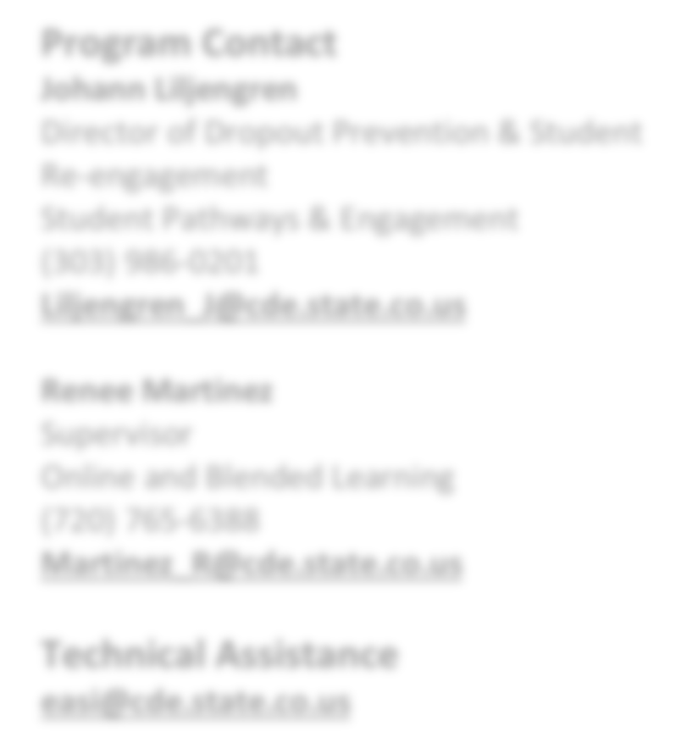

ALTERNATIVE EDUCATION CAMPUS & ONLINE SCHOOL REVIEWS

**EASI Route: Exploration Supports**

# Introduction

The Diagnostic Review and Planning for Alternative Education Campuses (AECs) and Online schools is ideal for schools that are working to prioritize improvement efforts. The support started in 2018 and has provided support to more than 30 AECs or Online schools. The service is meant to help schools reflect on progress, prioritize improvement efforts, and develop implementation plans. The service is designed based on the unique needs and focus of AECs and Online schools.

**Program Contact**

**Johann Liljengren**

Director of Dropout Prevention & Student Re-engagement

Student Pathways & Engagement

(303) 986-0201

[**Liljengren_J@cde.state.co.us**](mailto:Liljengren_J@cde.state.co.us)

**Renee Martinez**

Supervisor

Online and Blended Learning (720) 765-6388

[**Martinez_R@cde.state.co.us**](mailto:Martinez_R@cde.state.co.us)

**Technical Assistance**

[**easi@cde.state.co.us**](mailto:easi@cde.state.co.us)

1. Self- Assessment and Reflection: Using AEC or Online specific CDE tools and staff survey, school leadership teams conduct a self- assessment on current areas of strength and growth.
2. On-Site Diagnostic Review: A team of 2-3 CDE staff and a current school leader will spend at least one day at the school to conduct a diagnostic review examining the design, ongoing operations,

and practices of the school through review of materials, interviews of staff, students and families, and observations. CDE will provide a formal report that will highlight strengths and include prioritized recommendations.

1. Follow-up Support and Implementation planning: Through 3-6 monthly check-ins, CDE will review the formal report, support prioritization, and assist with development of an implementation and short cycle plans aligned to the Unified Improvement Plan. Many sites also conduct site visits or other collaboration opportunities with other sites.

## [Framework for Effective Practices](https://drive.google.com/file/d/1QtHOcS9O2087ON821PJV8OaNo94Y1-Ky/view?usp=sharing)

CDE staff have developed a framework for effective practices of AEC and online schools. This framework uses the [**Four**](https://www.cde.state.co.us/fourdomains/fourdomainsfinalreport)[**Domains**](https://www.cde.state.co.us/fourdomains/fourdomainsfinalreport)that CDE is using for their Quality Schools School Improvement initiatives. These components were adapted based on research from the National Alternative Education Associations [**(NAEA) 15 Exemplary Practices**,](https://www.the-naea.org/exemplary-practices.html) national research on effective high school practices, rubrics from iNACOL on blended learning, and observation of Colorado schools and structures for alternative education and online learning.

# Eligibility & Prioritization

*Eligibility.* Schools that meet the following criteria are eligible to apply:

* + Designated Alternative Education Campus (AEC) or Online school for the previous and current school years. All types of AECs are eligible including online, blended, charter, and district-run schools; and
  + Schools identified for improvement under ESSA as Comprehensive Support (CS), Targeted Support (TS), or Additional Targeted Support (ATS); or
  + Schools with a state identification School Performance Framework plan type of Priority Improvement, Turnaround, Improvement, or On Watch

Updated August 2024

*Prioritization.* If not all EASI proposals can be funded, proposals that meet grant expectations will be funded in the order of the EASI school-level prioritization list. Schools with the highest number of prioritization points will be funded first. Details on how prioritization points are calculated and the points for each EASI eligible school are available on the [EASI Resources and Technical Assistance](https://www.cde.state.co.us/fedprograms/easiappresourcesandtechnicalassistance) webpage.

*Limitations.* AEC and Online Schools Review is a direct CDE support. The number of new schools awarded each grant cycle may be limited due to CDE staff capacity. If not all requests for AEC and Online Schools Review can be supported, prioritization points and service capacity in a single district or region may be considered.

# Program Considerations & Fit

*Program Considerations*. This support is a short-term commitment to planning for and implementing effective practices.

*Program Fit*. Schools and districts that have been most successful in this support have been willing to reflect on current practice and look for ways to improve. It can be used as a good launching point for improvement efforts and some applicants apply for additional funding to support larger implementation after completion of the Diagnostic Review.

Support from a principal supervisor or district liaison helps build long term support of the school’s plan. This support should not be done in combination with other Diagnostic Review support.

# Sequence of Program Support

The sequence of the work is determined in partnership CDE through the AEC and Online Schools Review support. The sequence of the work will include four components including diagnostic review, improvement planning, stakeholder engagement, and early implementation as illustrated in the diagram below.

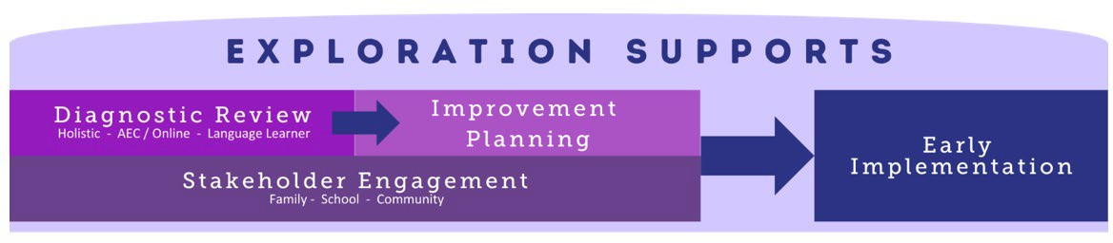

# Available Funds & Duration

*Available Funds.* Applicants may request up to the maximum award amount for a school. Awards may be up to

$42,000. The recommended fund allocation is $10,000 for the diagnostic review, $10,000 for stakeholder engagement,

$2,000 for improvement planning, and $20,000 for early implementation.

*Duration.* Program support is designed to support schools or LEAs for a period of 18 months (2024-25 to 2025-26).

# Allowable Use of Funds

Funds are intended to support the four components of Exploration Supports. Allowable use of funds includes costs associated with:

* + - Review visit or staff time to support the visit (e.g., stipends, substitutes, etc.)
    - Stakeholder engagement (e.g. stipends, translation, childcare, etc.)
    - Development of an improvement plan (or strategic plan, at the district level)
    - Early implementation of the plan activities (e.g., leadership or teacher development, stipends to support job- embedded training or teacher collaboration, etc.).
    - Travel to other school sites
    - Other expenses to support process (e.g., stipends, substitutes, etc.)

*Budget Recommendations.* For the application submission, the budget should include each of the components of Exploration Supports- review, stakeholder engagement, improvement planning, and early implementation. General placeholders in the budget are acceptable for stakeholder engagement, improvement planning, and early implementation as specific activities will be determined by the outcome of the diagnostic review.

For example, the draft budget for AEC and Online Schools Review may include the following budget lines:

* + - * Year 1 (2024-25)- Specific expenses outlined to support diagnostic review visits up to $10,000. Any remaining amount should be requested in the placeholders for other components of Exploration Supports.
      * Year 2 (2025-26)- Placeholder for stakeholder engagement activities as determined by the outcome of the diagnostic review for $10,000.
      * Year 2 (2025-26)- Placeholder for improvement planning activities as determined by the outcome of the diagnostic review for $2,000.
      * Year 2 (2025-26)- Placeholder for early implementation activities as determined by the outcome of the diagnostic review for $20,000.

*Note: If entering indirect costs, the total request amount may not exceed the maximum allowable amount.*

## Fund Considerations.

* + Funds from this opportunity must be used to **supplement and not supplant** any federal, state, and local funds currently being used to provide activities.
  + Post-award revisions must be approved by 06/30 and funds drawn down by 09/30 of each respective fiscal year.
  + A school or district may carry funds forward in alignment with funding source restrictions and with CDE approval. At the end of the grant performance period, any non-requested federal funds are reverted and any unspent state funds must be returned to the state.
  + CDE may terminate a grant award upon thirty days’ notice if it is deemed by CDE that the applicant is not fulfilling the requirements of the funded program as specified in the approved project application, or if the program is generating less than satisfactory results.
  + Multi-year or future award year amounts are contingent on allocations of state and federal funds to CDE in each respective fiscal year.

# Important Program Dates

|  |  |
| --- | --- |
| **Program Dates** | **Activity** |
| **September- December** | Meet with CDE leads to discuss interest in applying for support and outline a proposed budget |
| **December** | Application due |
| **January** | Award notifications |
| **February** | Orientation and check-in |
| **February-April** | Diagnostic Review site visit and report |
| **April – October** | Follow-up Support and Implementation Plan |

**ADDITIONAL INFORMATION AND RESOURCES**

**Colorado Department of Education’s EASI Website** [**www.cde.state.co.us/fedprograms/easiapplication**](http://www.cde.state.co.us/fedprograms/easiapplication)

**Evaluation and Reporting**

Each grantee of the program must, at a minimum, agree to the following evaluation, reporting, and/or progress monitoring components:

* + Incorporate findings into their Unified Improvement Planning Process
  + Provide feedback to CDE on the tool and process that are used as part of this service
  + Annual Financial Report (AFR) each fiscal year by 09/30

*Note: All data collected will protect personally identifiable information (PII) protected and is only reported on an aggregate level for purposes of evaluating the EASI support and/or supporting future program improvements.*

# Program Assurances

## LEA Commitments:

* + Use the findings of the Diagnostic Review to inform the comprehensive needs assessment of the school’s improvement plan and include selected strategy(s) in the Unified Improvement Plan.