**EASI Cohort 8 2024-25 Prioritization Overview**

|  |  |
| --- | --- |
| **If the school has a Federal AND a State identification, the school receives the point value for whichever identification has higher points (State or Federal), then receives 1 bonus point as per the information below.** | |
| **Criteria** | **Prioritization Points** |
| **Federal (ESSA) School Identifications** | |
| Comprehensive Support (CS) Lowest 5% or Low Graduation Year 4+ | 8 |
| Comprehensive Support (CS) Lowest 5% | 6 |
| Comprehensive Support (CS) Low Graduation | 6 |
| Comprehensive Support (CS)- Persistently ATS (more than 3 years ATS for same student group) | 6 |
| Additional Targeted Support & Improvement (ATS) | 5 |
| Comprehensive Support (CS) Lowest 5% - on Watch | 4 |
| Comprehensive Support (CS) Low Graduation - on Watch | 4 |
| Targeted Support & Improvement (TS) | 3 |
| Targeted Support & Improvement or Additional Targeted Support & Improvement - Not Exited by District | 2 |
| Any Federal identification – identified for Participation Only | 1 |
| **State (Accountability Clock/Performance Watch) School Identifications** | |
| Year 4+ of Priority Improvement or Turnaround | 8 |
| Year 4+ on Watch (Performance/Improvement Year 4+) | 6 |
| Year 3 of Priority Improvement or Turnaround | 6 |
| Year 2 of Priority Improvement or Turnaround | 5 |
| Year 1 of Priority Improvement or Turnaround | 4 |
| Year 2 -3 On Watch (Performance/Improvement Year 2 or 3) | 3 |
| Insufficient state data on HOLD (Prior to ISD was Years 1+ on Performance Watch) | 3 |

|  |  |
| --- | --- |
| **Bonus Points** | |
| School has not been previously been awarded an EASI grant | 1 |
| School has both a Federal identification AND a State identification of Turnaround or Priority Improvement (exception: LEAs that did not exit ATS or TS schools) | 1 |

Notes:

* In the event that CDE receives more grant requests than available funding, CDE may take into consideration: a) The status of current and previous EASI grant awards, unspent funds, and fulfillment of prior EASI/program requirements; and b) State school identifications of Priority Improvement or Turnaround as a result of decreased due to participation.
* The list of eligible schools and awarded prioritization points may change following updates to state and federal identifications that occur through December. Updates that may change prioritization points for a school may include ESSA identification of K-2 schools and successful Request to Reconsider applications that change the state school identifications.

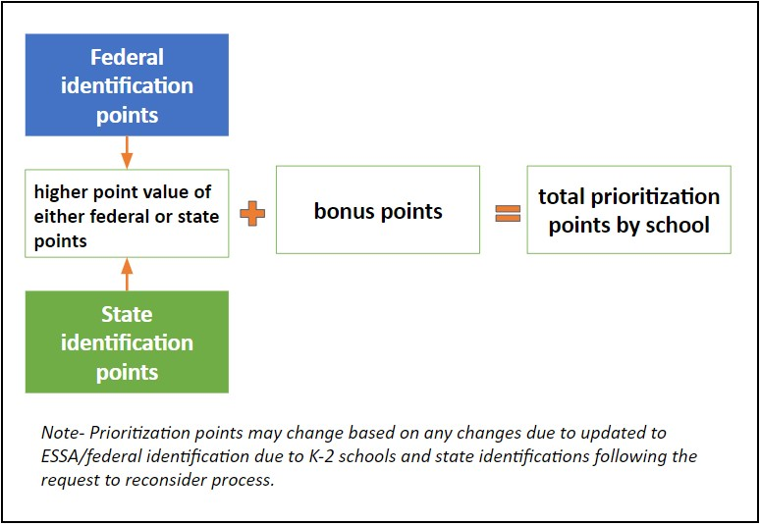

***District Prioritization***

There are several EASI routes that are awarded at the district, rather than the school level (Accountability Pathways, District Designed and Led, Exploration Services-District Strategic Planning, COMTSS, and Facilitated Board Training). Similar to school level, districts eligible for Accountability Pathways funding will be considered first in the allocation of state funds. Other than Accountability Pathways, when evaluating district-level requests that are fundable, CDE will consider the prioritization scores of the schools that will be served by the supports.

Additionally, districts with a high concentration of identified schools in the district will be awarded one bonus point for district-level EASI service requests. A district with a high concentration is one with a high percentage of schools that are either ESSA (Comprehensive Support, Targeted Support, or Additional Targeted Support) or state (Priority Improvement, Turnaround, or On Watch) identified based on the number of schools in a respective district. Districts are sorted into three bands based on the number of schools. The top quartile, based on the percentage of identified schools, in each band is considered a district with a high concentration of identified schools for purposes of prioritization in district-level EASI service requests. District-level supports that the bonus point may be added to include: District Strategic Planning, Language Learner Partnership (if serving at the district), District Designed & Led (if serving multiple schools under a common improvement strategy), COMTSS, or Facilitated Board Training for School Improvement.