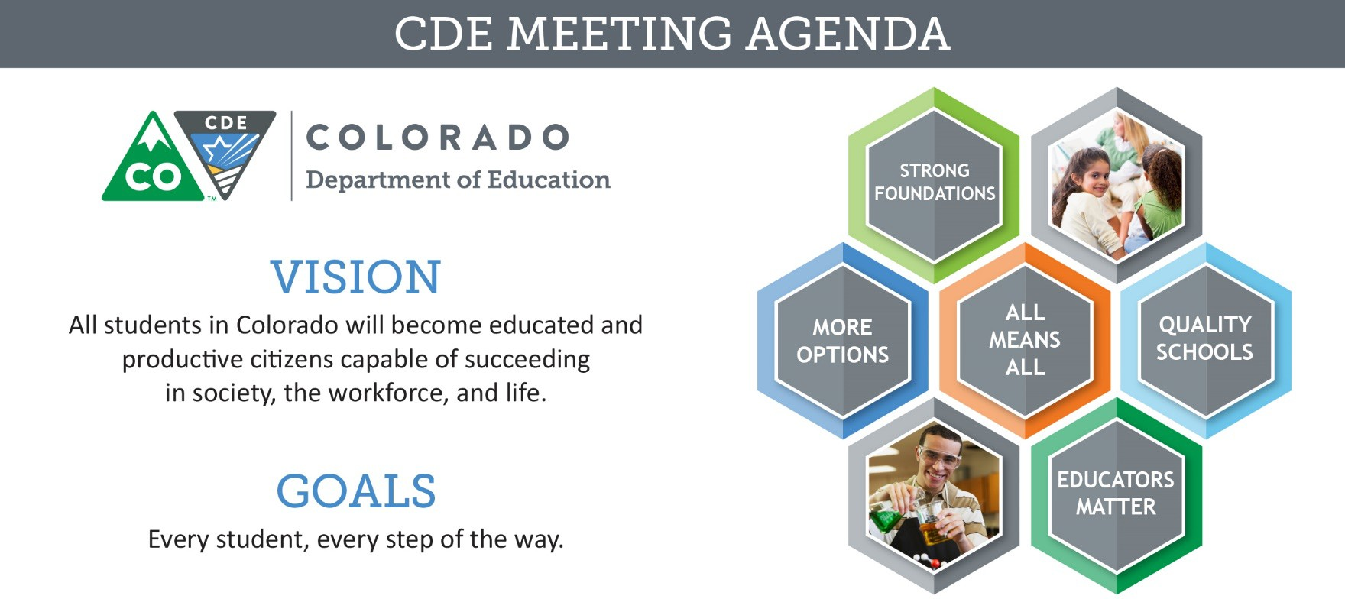

Meeting Logistics & Desired Outcomes
Meeting: ESSA Committee of Practitioners Date & Time: April 26, 2018 9:30 am
Location: Colorado Children’s Campaign
Meeting Leads: Jesús Escárcega, Clinton Allison, Colleen Brooks
Objectives: To allow the Colorado Department of Education the opportunity to provide updates to and elicit recommendations from the Colorado Committee of Practitioners regarding relevant and timely issues related to CDE’s responsibilities under the Elementary and Secondary Education Act, including:
- Staffing in the Office of ESEA Programs
- CoP Membership requirements and commitments for the 2018-2019 school year
- CDE’s ESSA State Plan
- Potential Professional Development Grant Opportunity,
- Supports to New ESEA Directors,
- Consolidated Application, and
- Monitoring

Agenda Items and Next Steps

9:30 – 9:45 Committee Business
Jesús Escárcega, Clinton Allison, Colleen Brooks
Topic | Preparation and Process | Expected Outcome | Summary
Approval of January and February Meeting Minutes | Prep: None | Decision | - Meeting minutes from last meeting - Approved
Approval of January and February Meeting Minutes | - Review minutes from previous meetings | Decision | - Meeting minutes from last meeting - Approved
CoP Membership | Prep: Respond to inquiries regarding attendance at previous meeting, if  contacted | Update | - Let Colleen know if members would like to

CDE Values: All Students, Collaboration, Communication, Customer Service, Honesty, Innovation, Integrity, Respect, Transparency.

Topic | Preparation and Process | Expected Outcome | Summary
 | - Review bylaws and requirements regarding membership, including member representation and term limits  - Determine the approximate number of vacancies that will need to be filled during the upcoming year |  | continue in their position or no longer continue  - Giving everyone two weeks to consider what they want to do  - If Colleen doesn’t hear from you, we will assume that you either will finish up your membership or not continue  - CDE will send out an email with the application and the areas that are needed
ESEA Staff and Organizational Changes | Prep: None | Update | - Out of the five offices that we have, we are going to merge three of them  - Nazie will be the director of that new office  - CLDE: We are looking to add staff members  - Working on communication of who the districts need to reach out to from our office
ESEA Staff and Organizational Changes | - New ESEA Staff Members:  - Kristen Collins, Consultant  - Jeremy Meredith, Title II Coordinator and ESEA Specialist  - Michelle Prael, Program Support  - Updates regarding Office of ESEA Programs organizational structure and staff roles | Update

9:45 – 10:15 Executive Director’s Update
Pat Chapman
Topic | Preparation and Process | Expected Outcome | Summary
ESSA State Plan | Prep: None | Update | - We still don’t have approval
ESSA State Plan | - Update on the approval process of Colorado’s ESSA State Plan | Update | - We still don’t have approval
Supports Coordinator | Prep: None | Feedback | - There is a from CDE and the field to clarify points of contact  - A letter will be sent out this week to identify who CDE should reach out to and who the districts should contact from CDE  - Planning to attend meetings for BOCES and superintendent groups for feedback  - Districts that didn’t write district defined:  - Easy  - Everyone is on  board
Supports Coordinator | - Update regarding the role of CDE’s Supports Coordinators | Feedback

Topic | Preparation and Process | Expected Outcome | Summary
- Unsure as to what
we can and can’t ask for
- Would be helpful to hear what district defined did
- District Defined:
  - Biggest issue: Time
  - Planning upfront would have been
helpful

10:15 – 11:30 Technical Assistance
Nazanin Mohajeri-Nelson, Morgan Cox, Alice Collins, Jennifer Simons, Colleen Brooks
Topic | Preparation and Process | Expected Outcome | Summary
Supports to Schools Identified for Improvement | Prep:  - Discuss the use of the Rubric for Comprehensive Support Plans with appropriate district personnel to provide feedback regarding the use and process  - Discuss the following questions regarding the development and implementation of Targeted Support Plans  - Where are your schools in developing TS improvement plans?  - How have you been supporting the schools in this process? Which parts have you been supporting? Who is involved in the development?  - What process are you going to use for review and approval before schools implement their plans? Who | Feedback | - Creating a process about CS Schools and how they have to build an improvement plan  - We want them to be approved by April 2019  - The rubric should be released by the end of June  - CDE has reached out to some of you about

Topic | Preparation and Process | Expected Outcome | Summary
 | will be involved in the review and  approval? If process has been determined, please describe the review and approval process.  - What are your plans for monitoring implementation of the TS improvement plans? Who will be involved? If monitoring plans have been developed, please describe your monitoring plans.  - If applicable, what is the BOCES role in supporting member districts and schools in the development, implementation, and monitoring of TS plans?  To review the Targeted Support and Improvement plan requirements, visit:  http://www.cde.state.co.us/fedprograms/ess a_csi_tsi |  | these conversational  questions  - Cold calls are difficult to jump into. Might not be talking to the right person and that will get incorrect information  - Districts appreciate that they don’t have to get more documents and like that we are trying to make this a unified whole  - Document needs to be sent out electronically  - Might be better to have a face to face meeting about this instead of a webinar  - That is the intent  - Call Nazie with any questions
- Follow-up discussion regarding the rubric for Comprehensive Support plans
- Discussion regarding status of Targeted Support plan development
- Presentation of opportunities available to support schools identified for improvement
EL Redesignation Guidance | Prep: None | Feedback
EL Redesignation Guidance | - Presentation of updated redesignation guidance | Feedback
Licensure Updates and Possible Professional Development Grant Opportunity | Prep: Review documents related to EL professional development requirements. | Feedback | - Educators coming out will be prepared and wouldn’t have to the PD part  - Districts don’t want it to be a unfunded mandate  - There are funding sources available if they are align with the standards  written into
 | - Presentation of updated requirements for professional development for all in- service educators  - Presentation of potential professional development grant opportunity under Title III, Part A | Feedback

Topic | Preparation and Process | Expected Outcome | Summary
the licensure
rules
- Non-public schools are not excluded from it.
New ESEA  Directors: Toolkit and Supports | Prep: Connect with ESEA Directors and Administrators in your district or BOCES to determine the highest priority need to know areas for the first year of working in this  position. | Feedback | - In the process of developing a resource for new individuals coming into a new director role. What would that look like, what would you like see from CDE?  - We are going to do outreach with districts and bring back  suggestions
New ESEA  Directors: Toolkit and Supports | - Discussion regarding supports CDE may provide to new ESEA Directors and Administrators that would be the most helpful throughout their first year in this position | Feedback

11:30 – 12:15 Consolidated Application
DeLilah Collins, Colleen Brooks, David Schneiderman
Topic | Preparation and Process | Expected Outcome | Summary
Guidance Update | Prep: Review District Managed Activities Guidance and Carryover for Equitable  Services to Non-public Schools documents | Update | - In the process of developing a resource for new individuals coming into a director role. What would that look like and what would you like to see from CDE?  - Action: do outreach with districts to bring back suggestions
Guidance Update | - Presentation of guidance documents and waiver/request process | Update

Topic | Preparation and Process | Expected Outcome | Summary
2018-19  Application Platform | Prep: Review webinar recording and  associated documents from April 18 Virtual Network Meeting (if unable to participate live) (http://www.cde.state.co.us/fedprograms/vir tualnetworkingmeeting) | Update | - Platform will be available  May 4th  - Streamline the application – will not allow incomplete application submissions  - Assurances will change depending on your selection  - Significant changes to the BOCES application – specifically for the ARAC to avoid erros  - Trainings will start after the launch of the application  - Metro and pueblo will combine in training and be in Castle Rock May 22nd  - Will open office hours in June to provide additional support  - Let CDE know if there are any issues or anything that needs to be changed  - SNS due May 30th –  requires board action
2018-19  Application Platform | - Preview and discuss updates to the application platform and provide update regarding in-person training opportunities  - Present and discuss Consolidated Application Manual; provide feedback regarding changes or improvements | Update
ESSA Grant Award Letters | Prep: None | Update | - GALs instead of GANs  - Biggest change: CDE needs wet signatures (two of them) before sending to districts  - Districts do not have to sign it but nonprofit and non- government agencies do have to sign it  - This starts July 1st
ESSA Grant Award Letters | - Provide information regarding updated Grant Award Notification process | Update

12:15 – 1:00 Break for Lunch

1:00 – 4:00 Joint Monitoring Stakeholders Workgroup and CoP Meeting
Joey Willett, DeLilah Collins, Colleen Brooks
Topic | Preparation and Process | Expected Outcome | Summary
Process and Protocols | Prep: None | Update | - Goal: we want 10-15 indicators  - Currently have 25 universal indicators  - Monitoring Process  Document:
Process and Protocols | - Review CDE process and protocols, including the risk assessment tool, for use in desk review and onsite monitoring | Update

Topic | Preparation and Process | Expected Outcome | Summary
lored/compliance –
need to make language uniform
- Appreciate the graphs and timeline but difficult to read (move to appendix)
- Update from 17/18 calendar year since it is ending
- Identify what qualifies low, middle, high risk
- Email Joey on comments
or thoughts about the document
Indicators | Prep: None | Feedback | - Instead of Schoolwide Plan indicator – make Evaluation of Schoolwide programs a universal indicator  - TA Evaluation would be a better universal indicator than Identifying TA Programs  - Overall: 10-11 require additional submissions, 8 already have information in place, and 3-5 will be  based on the final expenditure report
Indicators | - Review prioritized monitoring indicators to determine appropriate content and scope for desk reviews in alignment with risk assessment tool  - Review indicator resources by category identify to identify available supports, as well as gaps therein or non-existent resources | Feedback
Next Steps | Prep: None | Feedback

Topic | Preparation and Process | Expected Outcome | Summary
 | - Determine appropriate next steps in the  monitoring process rollout, as well as the role of the monitoring stakeholder workgroup |  | - Continue forward and look  at the 25 as a universal indicator set  - June 7th is our next scheduled meeting in Aurora  - Send Joey ideas to revise the documents  - Think about guiding questions  - Will hear from Lindsay or Joey about the guiding questions for next meeting  - CoP meeting: May 17th 10- 12 virtually

