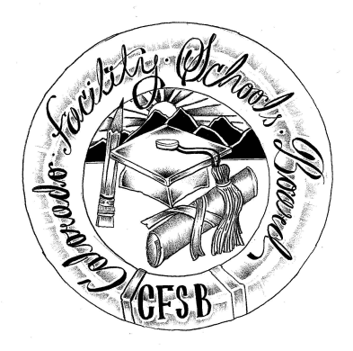
Colorado Facility Schools Board Agenda
November 11, 2021
11:30 a.m. until the completion of the agenda

Virtual – Zoom Meeting

Time | Activity | Presenter
11:30 | Board Meeting will start - Call to Order  Approval of Minutes  Approval of Agenda | Action Item  Action Item
11:35  11:45 | Poplar Way – Request for removal of contingency  Facility Schools Unit Update  - CDE/Facility Internal Updates  - Data Management and Systems Support  - iReady/Tuition Cost  - Monitoring/Updates from the Field  - Frontline/Anlar/State Assessments  - Curriculum/Induction/OOD Consortium  - Update from Attorney General’s Office | Deongella Roberts  Judy Stirman  Lori Kochevar  Ann Symalla/Robin Singer  Annie Haskins  Wendy Dunaway  Isabel Broer
12:15  12:25  12:45  12:55  1:00  1:20 | Disability Law Colorado – Monitoring Visits  SEFAC Recommendations – Tuition Cost  BREAK  Allocation to Facility Schools  JBC/Stakeholders Group/Bill  Opportunity for the Public to Address the Board  Members of the public who wish to address the board must sign up prior to the meeting. Presentations are limited to 5 minutes. | Judy Stirman  Judy Stirman/Lori Kochevar  Carolena Steen  Judy Stirman  Wendy Dunaway
1:25 | Next Steps
2:00 | Adjournment of Meeting

