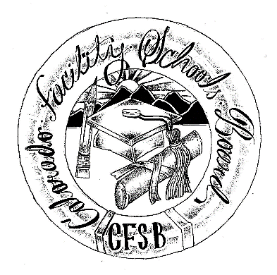

Facility Schools
Education Director’s Meetings

2019 - 2020 Meeting Schedule

Shiloh Pavilion – Conference Room
9700 E Easter Lane, Centennial, CO 80112
Date | Time | Location
August 9, 2019 | 9:00am – 4:00pm | Shiloh Pavilion  Conference Room
September 13, 2019 | 9:00am – 4:00pm | Shiloh Pavilion  Conference Room
October 11, 2019 | 9:00am – 4:00pm | Shiloh Pavilion  Conference Room
November 8, 2019 | 9:00am – 4:00pm | Shiloh Pavilion  Conference Room
December 13, 2019 | 9:00am – 4:00pm | Shiloh Pavilion  Conference Room
January 10, 2020 | 9:00am – 4:00pm | Shiloh Pavilion  Conference Room
February 14, 2020 | 9:00am – 4:00pm | Shiloh Pavilion  Conference Room
March 13, 2020 | 9:00am – 4:00pm | Shiloh Pavilion  Conference Room
April 10, 2020 | 9:00am – 4:00pm | Shiloh Pavilion  Conference Room
May 8, 2020 | 9:00am – 4:00pm | Shiloh Pavilion  Conference Room
June 12, 2020 | 9:00am – 4:00pm | Shiloh Pavilion  Conference Room
**Unless otherwise specified, the Facility Schools Education Director meetings will be at the Shiloh Pavilion in Centennial, CO

