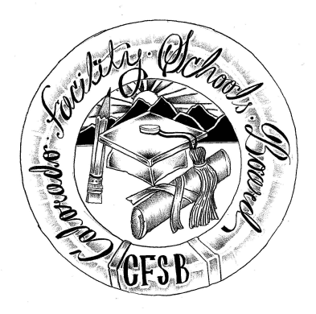 **Colorado Facility Schools Board Meeting**

**Thursday, November 7, 2024**

**9:30a.m. – 12:30pm**

**Virtual Meeting Only**

Please use this link to access the meeting and to provide public comment online: [Zoom Link](https://us02web.zoom.us/j/86497670287?pwd=njbCiVT0ube2BcANM4CzuMpNLdU6Hf.1)

**In-Person meeting at TACT has been cancelled due to weather related issues and will be rescheduled at a later date.**

9:20am Join Zoom meeting - : [Zoom Link](https://us02web.zoom.us/j/86497670287?pwd=njbCiVT0ube2BcANM4CzuMpNLdU6Hf.1)

9:30am Board Meeting (Co-Chair calls meeting to order)

Approval of Minutes Action Item Board

Approval of Agenda Action Item

9:35am The facility schools board will convene an executive session to receive legal advice on specific legal questions related to the facility schools board’s and CDE’s roles in reports about Joshua School pursuant to section 24-6-402(3)(a)(II), C.R.S.

10:05am Public Comment –Members of the public who wish to address the board must sign up 24 hours prior to the meeting using this link – [Public Comment Sign-up Sheet](https://docs.google.com/document/d/1pyNiup2I5b8AoWbvHWQOx4xAuvLQHJ1D/edit?usp=sharing&ouid=109064965828814916998&rtpof=true&sd=true). Presentations are limited to 3 minutes, with a maximum of 10 people. Additional guidance on public comment on the following page. If you plan to attend a meeting and need translation or accommodations, please notify Lori Kochevar,  [Kochevar_L@cde.state.co.us](mailto:kochevar_l@cde.state.co.us), at least 2 weeks prior to the meeting date. Advance notice allows CDE time to set up requested accommodations or translation services before the meeting.

10:15am TACT Tour – Cancelled. Discuss rescheduling of this meeting Board

10:30am Board Discussion Time – Updates on TACT’s new program Danny/Lori

10:45am Operating Procedures Jenna Zerylnick Public Comment Protocol

11:15am Break

11:25am New OFS staff member Wendy Dunaway

11:30am Monitoring Strategic Plan Goals or Measures Virginia Winter Board debrief of Kaleidoscope

11:50am Team Updates FS Staff

12:30pm Adjournment of Meeting Board

Next meeting Date – December 12, 2024 In Person – Shiloh House, Centennial, CO

**Colorado Facility Schools Board Meeting**

**November 7, 2024**

**9:30a.m. – 12:30pm**

**Additional information for those wishing to provide public comment** –

This meeting will be open for members of the public for the entire meeting via the zoom link - <https://us02web.zoom.us/j/86497670287?pwd=njbCiVT0ube2BcANM4CzuMpNLdU6Hf.1>

Members of the public who wish to address the board must sign up 24 hours prior to the meeting using this link – [Public Comment Sign-up Sheet](https://docs.google.com/document/d/1pyNiup2I5b8AoWbvHWQOx4xAuvLQHJ1D/edit?usp=sharing&ouid=109064965828814916998&rtpof=true&sd=true). Presentations are limited to 3 minutes, with a maximum of 10 people. Additional guidance on public comment below.

Accommodation and Translation Notice:

If you plan to attend a meeting and need translation or accommodations, please notify Lori Kochevar,  [Kochevar_L@cde.state.co.us](mailto:kochevar_l@cde.state.co.us), at least 2 weeks prior to the meeting date. Advance notice allows CDE time to set up requested accommodations or translation services before the meeting.

If you have requested accommodations or translation services for a meeting and are then unable to attend, we ask for at least a 72-hour notice of cancellation, so that CDE can be proactive with cancelling requested accommodation services ahead of the meeting. Thank you!

Information regarding public comment:

**DO:**

§ *Introduce yourself* and where you are from*. If you are speaking on behalf of an organization, identify the organization and your association.*

**DO:** (Continued)

§  *If speaking to a specific agenda item, limit your remarks to the subject of the agenda item and avoid repeating what others have said.*

§  *Be brief, to the point, and concise.*

§  *If you believe an issue needs to be explained in-depth, and you bring handouts, please pass them to staff prior to making your comments. Be sure to include your name and date of the meeting on the handout.*

**DO NOT:**

§  *Expect the board to answer any questions you may have.*

§  *Expect the board to be able to intervene with local school district issues. As Colorado is a local control state, district-specific issues should be resolved locally.*

*If you have questions about state law and local requirements, CDE staff may be able to assist you in finding an appropriate way to address your concerns.*

§  *Discuss personnel matters with the board. This should be done in private with the chair and/or vice-chair of the board.*