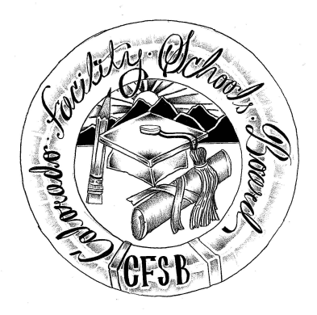
Colorado Facility Schools Board Agenda
September 7, 2023
9:30a.m. until the completion of the agenda

Shiloh Family Resource Pavilion In-Person & Zoom

9:15am  9:30am  9:40am  10:15am  10:20am  11:00am  12:00pm  12:30pm | Arrival  Board Meeting will start - Call to Order  Approval of Minutes  Approval of Agenda  Rule Making – Process and Procedure  Break  Facility Schools Unit Update  - CDE/Facility Internal Updates  - Data Management and Systems Support  - iReady/Tuition Cost/December Staff  - Monitoring/Updates from the Field  - IEP System Updates/ State Assessments  - Curriculum/Induction/OOD Consortium/Workgroup  - Program Support  - Attorney General’s Office update  Practice for ESSU Directors Presentation  Lunch  Board Development  - Review Board Leadership Positions  - Responsibility Matrix  - Annual Calendar/Rule Making Calendar | Action Item  Action Item  Melissa Bloom  Judy Stirman  Annie/Lori  Lori Kochevar  Robin Singer/Ann Symalla  Annie Haskins  Wendy Dunaway  Darren Serrato  Joe Peters  Board/Callen Ware/ Nancy Ingalls  Viginia Winter
2:30pm  2:40pm | Opportunity for the Public to Address the Board  Members of the public who wish to address the board must sign up prior to the meeting. Presentations are limited to 5 minutes.  Next Steps/Adjournment of Meeting | Members of the Public  Board

