SB22-070: State Model Evaluation System

Overview of Scoring System Revision

Overview
In preparation to implement Senate Bill 22-070, the Colorado State Model Evaluation System (SMES) will undergo a revision to its scoring system. Specifically, to align with the requirements outlined in the new statute to shift the composition of final effectiveness ratings (FERs) from 50% professional practices and 50% measures of student learning/outcomes (MSLs/MSOs) to 70% and 30% respectively, revisions will be made to the scoring of professional practices, MSLs/MSOs, and FERs.
The revision will adjust the total available points for an educator’s final rating to 1000 (from the current total of 1080) and will seek to increase transparency in the scoring process as well as solidly reflect earned scores. The revised scoring was created with input from stakeholders, tested for consistency with historic pilot data from over 5,000 teachers, and will begin with implementation of SB22-070 in the 2023-24 school year.

Assumptions and Intentions
The following assumptions and intentions are key factors in the revision to the SMES:
- Align scoring to the shift in percentage split between professional practices and MSLs/MSOs in the final rating, that is, a clear emphasis on professional practices. Scoring will be aligned with the FER percentage shift, which emphasizes professional practices.
- Capitalize on elements in the scoring that can remain the same/familiar to educators and evaluators.
- Capitalize on opportunity to revise scoring to simplify calculations and increase transparency and understandability for educators and evaluators.

Final Effectiveness Score and Rating
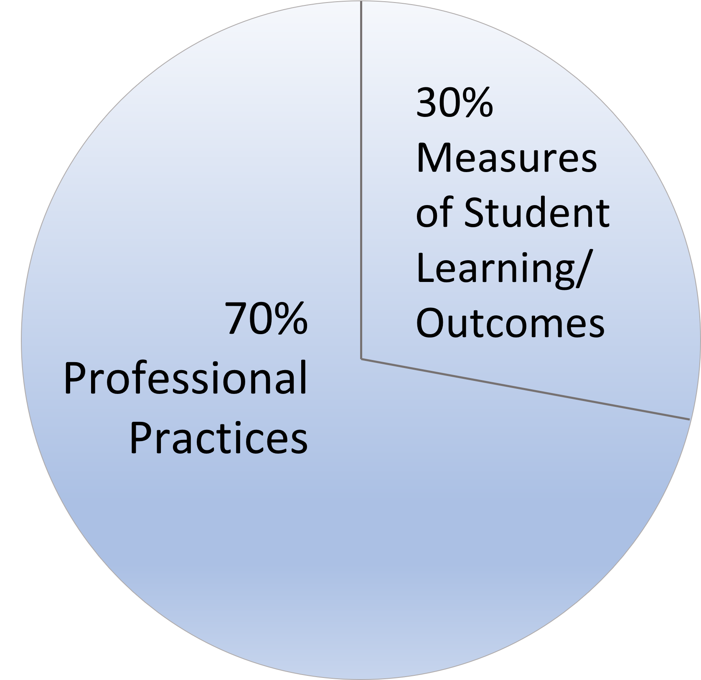
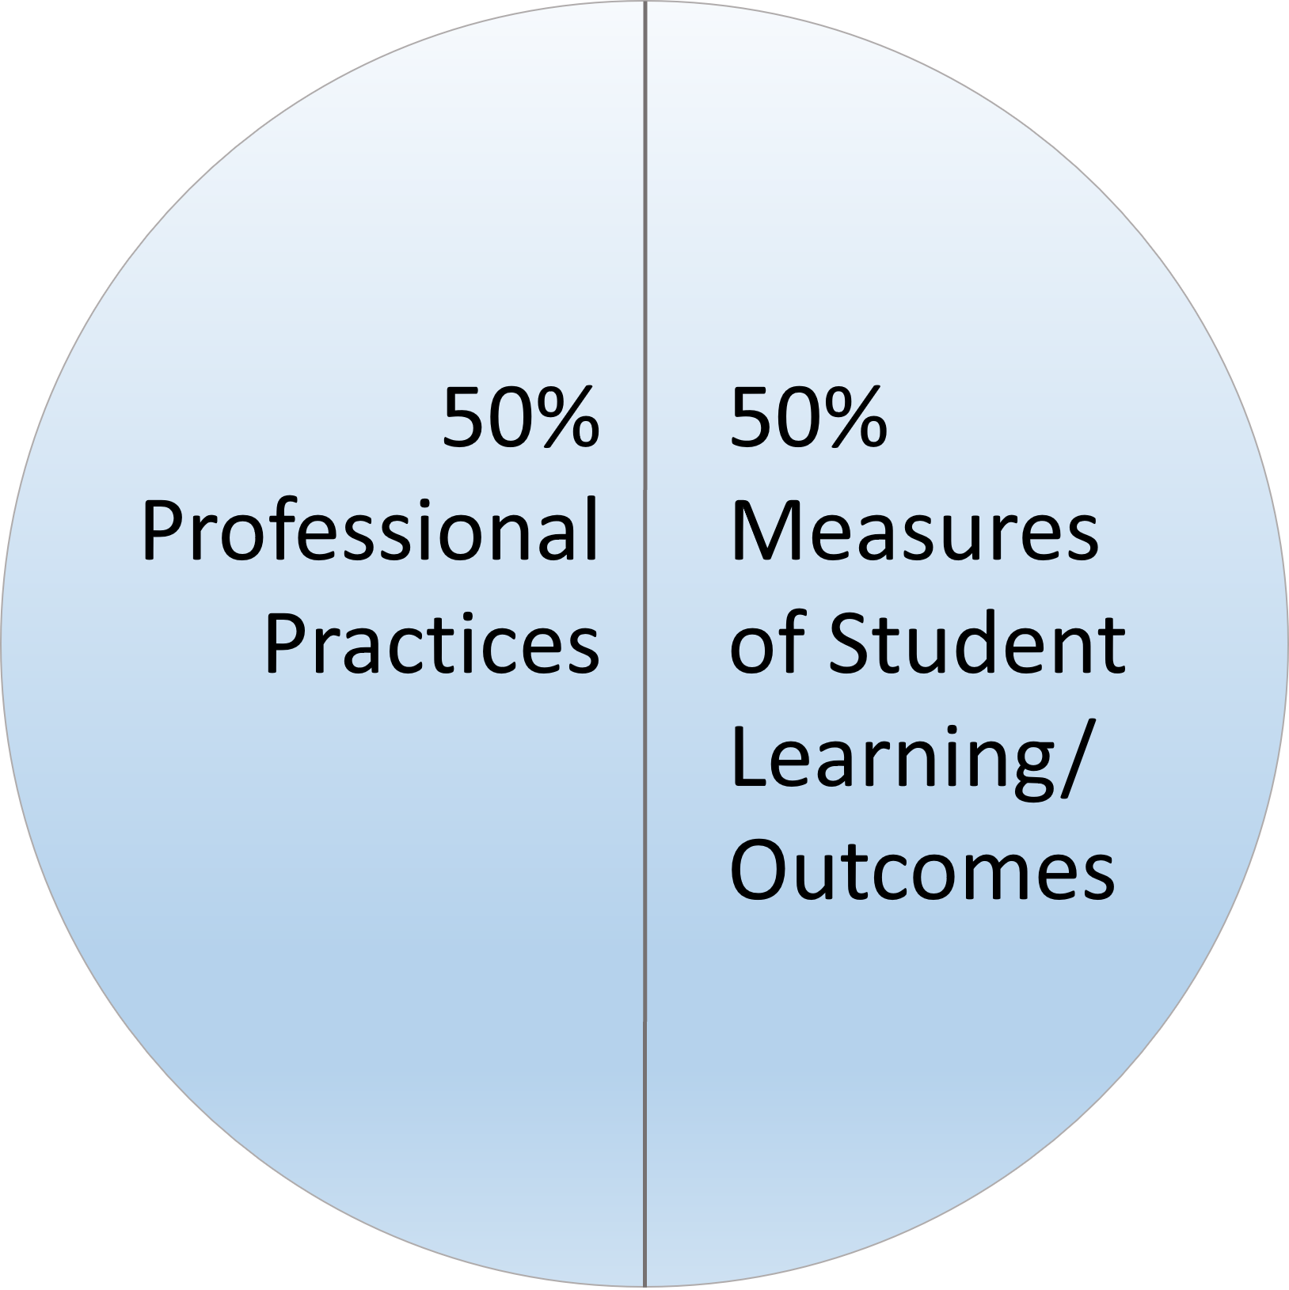
Building on past feedback from focus groups and district leaders, the revised scoring will honor requiring a preponderance of evidence to earn ratings as well as rigorous expectations for achieving the highest ratings. An educator’s final rating will continue to be determined by combining scores from professional practices (i.e., Quality Standards) and MSLs/MSOs—although the percentages will shift starting in the 2023-24 school year.
FER scores 2011 to 2022-23
FER scores 2023-24 and beyond
The following highlights what will remain the same and what revisions will be made to final rating scores starting in the 2023-24 school year:
- No change to combining professional practice score and MSL/MSO score to arrive at FER.
- Revision to the total points available and corresponding cut points for each rating.
  - Total points available will be 1000 points (professional practices 700 points + MSL/MSO 300 points)
  - Revision to scores and ratings reflects the increased influence of professional practices in the FER, i.e., 70%
  - Revision to scores and ratings reflects the decreased influence of MSLs/MSOs in the FER, i.e., 30%
PLEASE NOTE:
- A final rating of Effective remains the rating to meet the state standard.
  - A Partially Effective rating should indicate areas for growth and development towards meeting the state standard.
  - Educators rated Highly Effective should expect to earn a professional practice rating that is above the state standard (i.e., Accomplished or Exemplary) and a minimum MSL/MSO rating of Expected.
- If an educator earns an MSL/MSO rating of Less than Expected, the highest FER they can achieve is Effective.
- The revised scoring expands the available FER points of Effective (i.e., meeting the state standard) and ensures that a final rating of Highly Effective is achieved when there is alignment between professional practice and MSL/MSO scores.

Professional Practices Scoring
The following highlights what will remain the same and what revisions will be made to the scoring for professional practices starting in the 2023-24 school year. Please note that Level 3 within the Quality Standards rubrics and a total score of Proficient remain the scores that meets the state standard.
- No change to any existing rubrics.
- No change to base scoring for professional practices, i.e., total of 20 points.
- No change to base cut points for earning a score for each standard and overall professional practices, i.e., overall professional practices scores will remain consistent.
- No change to levels and descriptors for professional practices scores, i.e., Levels 1 to 5 within the rubric, and Basic, Partially Proficient, Proficient, Accomplished, and Exemplary for overall professional practice rating.
- Revision to the total points available for professional practices and corresponding cut points when aligned with the revised total FER points (1000), i.e., total points for professional practices score is 700.

Measures of Student Learning/Outcomes Scoring
The following highlights what will remain the same and what revisions will be made to the scoring for MSLs/MSOs starting in the 2023-24 school year:
- No change to the total base points available towards the MSL/MSO score.
- Revision to the levels available for the MSL/MSO score – reduction from four levels to three.
  - Current score levels: Much Less than Expected, Less than Expected, Expected, and More than Expected
  - Revised score levels: Less than Expected, Expected, and More than Expected
- Revision to the total points available for MSL/MSO score and corresponding cut points when aligned with the revised total FER points (1000), i.e., total points for MSL/MSO score is 300.
Colorado Department of Education
Educator Effectiveness Office
educator_effectiveness@cde.state.co.us

