ASSURANCE PROCESS FOR 2019
Each year, by July 1st, Colorado districts and BOCES are required to submit assurances that they are implementing the State Model Evaluation System or another evaluation system that is aligned with Senate Bill 10-191 and State Board Rules.

In an effort to reduce the burden on districts and BOCES the assurances will be collected using the online platform, Wufoo. Below are step-by-step instructions for submitting your district/BOCES assurances. Wufoo is very simple to use, but you will need to prepare all of your data and materials prior to going into the system because you CANNOT save and return to it later. Prior to accessing the submission form, please read through this entire document to ensure you have all the needed items completed for the submission, including the required Superintendent’s and Board Chairperson’s signatures on the signature form.

- Click on the link to access the form. https://educatoreffectiveness.wufoo.com/forms/assurances-2019/

- Read through the information at the top of the form. Note: This information will appear at the top of each page of the form.
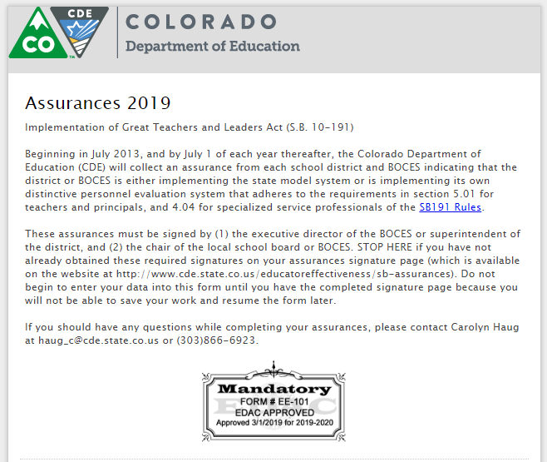

- Complete the contact information.

- Indicate whether you are submitting your assurance on behalf of a district or BOCES. Depending on your choice, you will be routed to either the district or BOCES page.

- Select your district or BOCES from the drop down list.

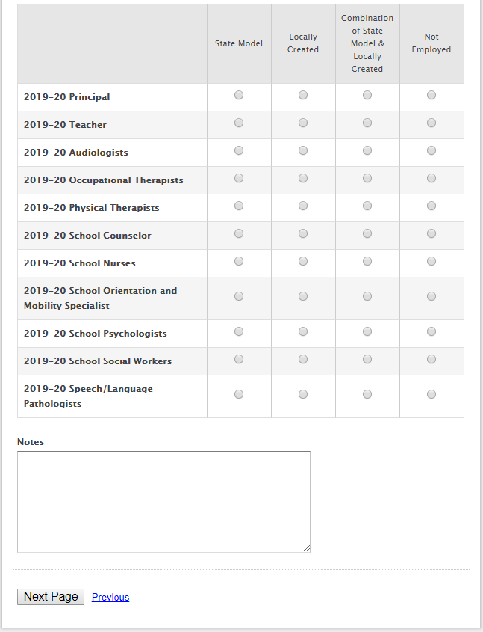
- Select the correct option for each of the categories of licensed personnel listed. If you are using a combination of the State Model and other evaluation systems to evaluate any of the categories listed. (Example: One district has several zones, one zone is using the State Model, another zone may be using the Danielson Framework, and a third using a locally created system) please use the notes section to explain.

- Verify your District/BOCES web address. As noted in the description, this MUST be the exact web address to the description of your educator evaluation system for your district/BOCES, not the main landing page for your District/BOCES website.

- Lastly, check the box acknowledging your school/BOCES is meeting all required elements of a local evaluation system as well as upload a copy of your signature form.

- Hit submit, and you will be redirected to the confirmation page.

- Once submitted, you will receive a confirmation email message with a copy of everything you submitted. Please keep a copy for your records.
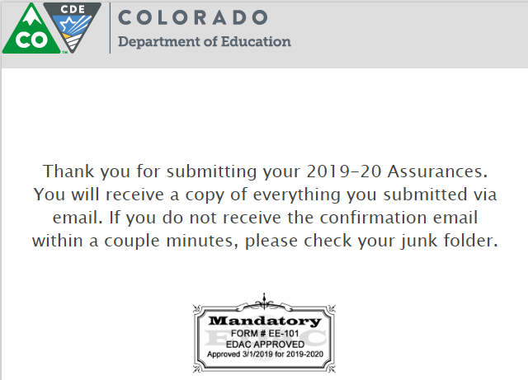

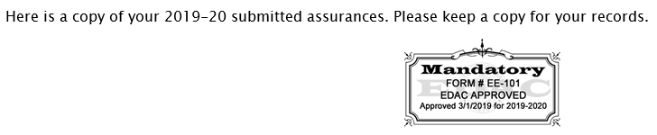
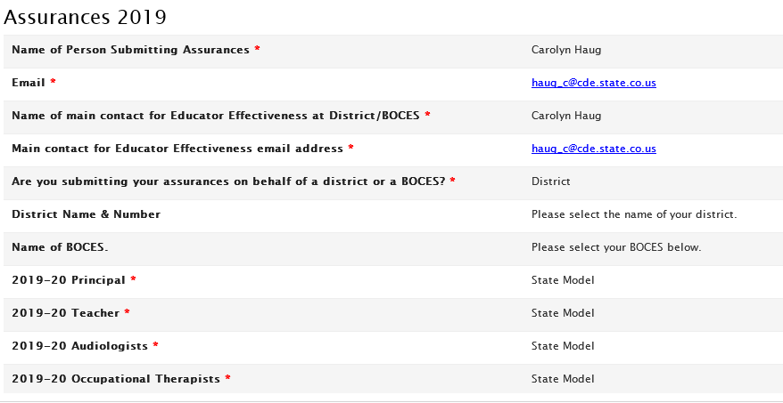
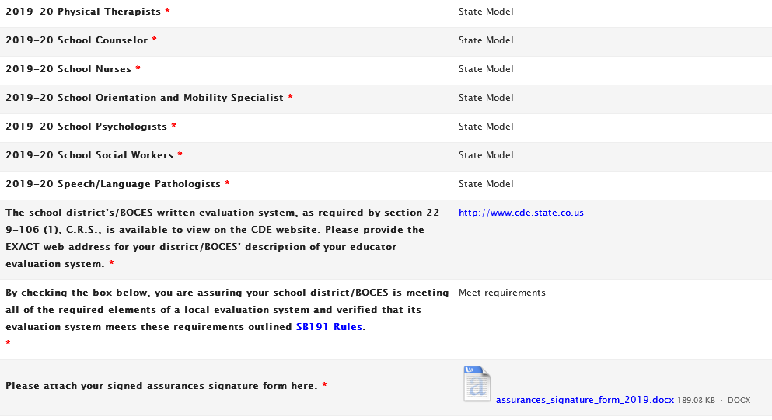

Where can I learn more?
- Assurances Resources: http://www.cde.state.co.us/educatoreffectiveness/sb-assurances
- View all CDE fact sheets: www.cde.state.co.us/communications/factsheetsandfaqs

