Student Engagement Evaluation System (SEES)
Frequently Asked Questions for SRG Interim Reporting

List of questions:
- What is SEES?
- How do I access SEES?
- Who is my district LAM and what is her/ his role?
- How do I identify my district L AM ?
- What are the components of the end-of-year progress report in SEES?
- What are the best practices for completing the survey on SEES?
- When is the interim progress report due?
- What are the benefits of using the SEES evaluation system?

1) What is SEES?
SEES (Student Engagement Evaluation System) is the new evaluation system that will be used for the end-of-year progress report and future reports moving forward. All SRG grantees will be required to use this system to fill out a survey.

2) How do I access SEES?
Your district LAM (Local Access Manager) will need to provide you with access to the SEES system. Once you have received access, test your login at https://cdeapps.cde.state.co.us/index.html by going to applications in the left navigator bar and clicking on Student Engagement Evaluation System (SEES).

Username: email
Password: click on the ‘forgot my password’ to reset it

3) Who is my district LAM and what is her/his role?
The LAM is the local access manager. Their role is to maintain identity management. You will need to work with them to gain access to the SEES system and enter in your end-of-year data.

4) How do I identify my district LAM?
If you do not know who your LAM is, please complete the online request form at
https:/ /cdeapps.cde.state.co .us/ index.htm l .

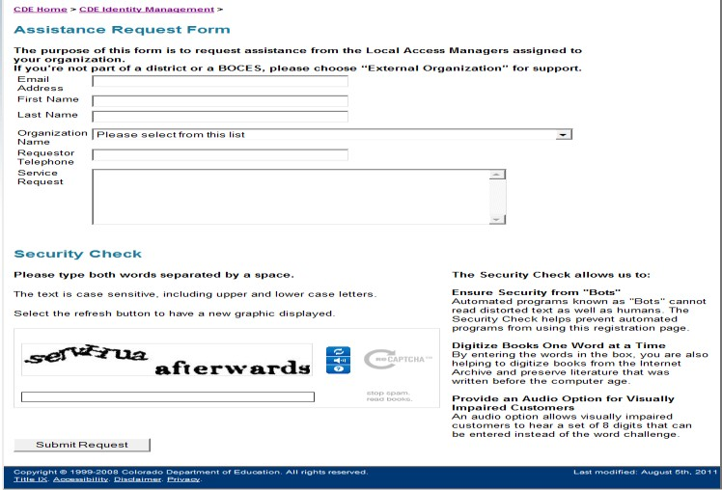

5) What are the components of the interim progress report in SEES?
The report will include the following:
- Survey component to complete on SEES

6) What are the best practices for completing the survey on SEES?
It is recommended that EARSS grantees fill out the MS Word guidance document version of the end-of-year report before entering and submitting this information through the SEES system. The benefits of completing the MS Word document first include:
1) Written record of your responses
2) Ability to gather responses from multiple individuals (if necessary)
3) Avoid losing data if SEES times out or if an entry was not saved

When you are completing the survey on SEES, please remember to SAVE after every question!

7) When is the interim progress report due?
The interim survey should be completed uploaded by October 3, 2016

8) What are the benefits of using the SEES evaluation system?
The primary benefit in using SEES is that it will inform the CDE of your progress to date. For example, you will be reporting on the number of students and parents served, programs strategies and services used, and progress on objectives and outcomes for parents and students served. It will also inform the CDE on management of the SRG program. It can help identify service and support needs for technical assistance and identify actions taken to sustain your program. The SEES program also allows for convenient data reporting all in one location.

