TSDL Migrant Student Cognos List User Guide

This guide is designed to support Local Education Agencies (LEAs) with accessing their Teacher Student Data Link (TSDL) Cognos Migrant Student List.

Ensure your districts ‘Migrant Student List’ is accurate and up to date by uploading a current Student School Association file (SSA). Should you have questions regarding your Migrant List, please reach out to your local Migrant Education Programs who coordinate and deliver services to migrant students by accessing this link: <http://www.cde.state.co.us/migrant>. The district must have the TSL LEAUSER or TSL LEAVIEWER role to see the ‘Student Profile’ folder in Cognos.

Districts are required to report on Migrant students in grades 8-12th for all course completion and credits earned.

Step 1: Log into data pipeline (<https://www.cde.state.co.us/idm/datapipeline>)

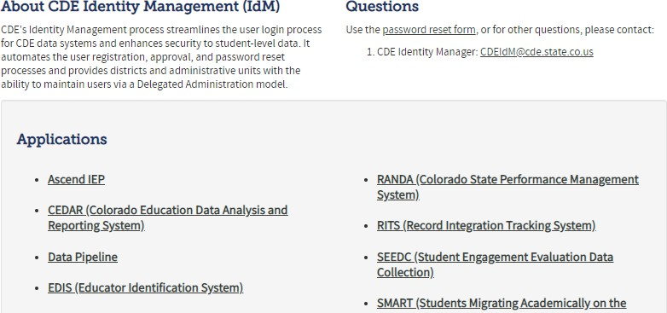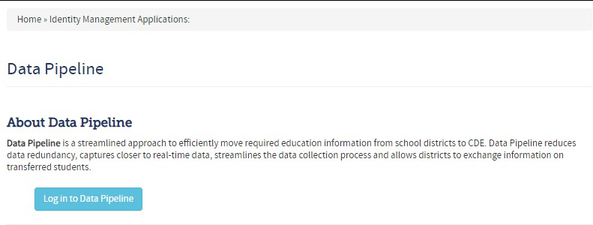

Step 3: Enter your username (which is your full email address) and password then click continue.

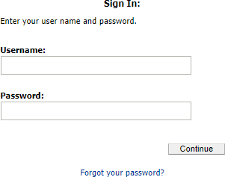

Enter your user credentials.

open within your browser.

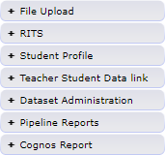

Step 5: Click on the ‘Teacher Student Data Link’ tab.

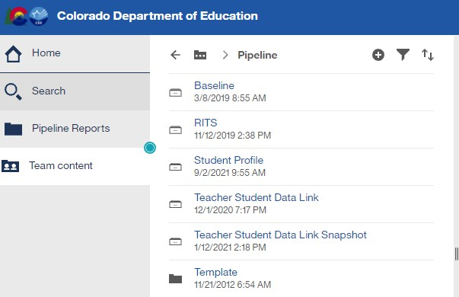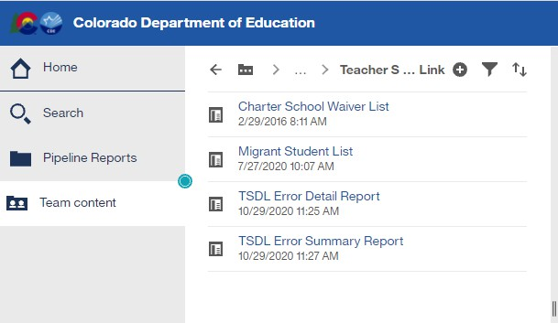

Step 7: Select School Year and District from the dropdown list then click finish.

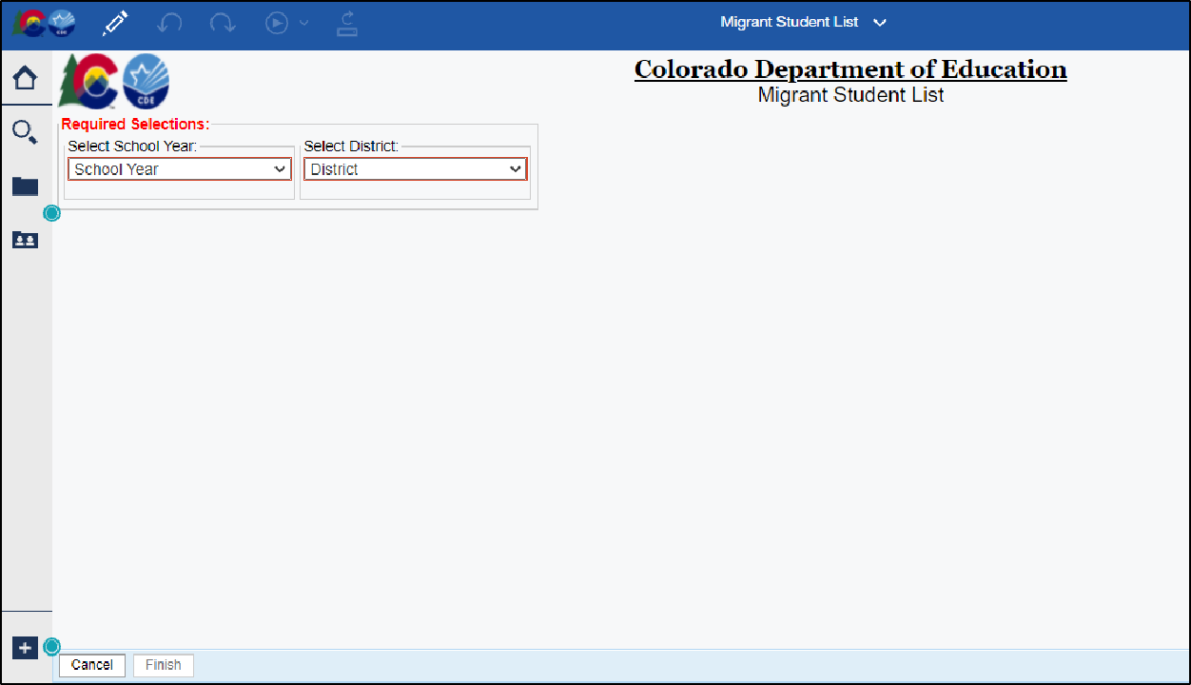

Select the school year and district then click [Finish].

following columns: *SASID, Last Name, First Name, Birth Date, School Code, Migrant Arrival Date and Migrant End Date*.

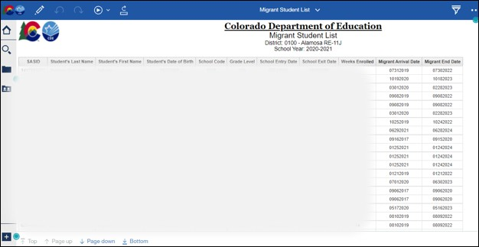

Step 9: To export the data click on the icon. A dropdown list of the most used export formats is available for downloading. Select your preferred format, and the report will be downloaded to your computer.

