Elementary Classroom Primary Source Set: Station Activity

Tuberculosis Immigration
Additional Resources
- Ex-Patients’ Tubercular Home
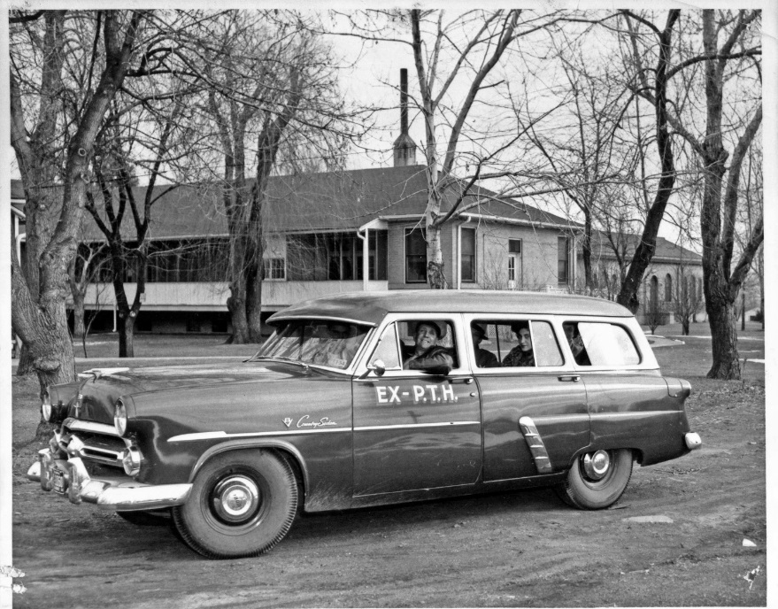
Founded in 1908, the Ex-Patients' Tubercular Home goal was “to provide a home and care for patients who have been directed from a tuberculosis hospital or sanatorium, who are in need of further treatment, and to rehabilitate those patients so they will again become self-respecting and self-supporting citizens.” One fundraising effort was through the sale of seals. The seals could be placed alongside stamps on mail to show your support for a cause, although they did not count as postage.

Former patients riding in the Ex-Patients’ Tubercular Home Car, 1930s

- Fundraising Stamp, circa 1940
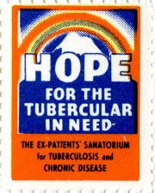
Just like the Tuberculosis sanatoriums, the Ex-Patients Home was provided free to those who stayed there. Providing care was very expensive and required a lot of fundraising. One method of fundraising was selling stamps like this people would affix to letters they mailed. The fundraising stamps did not count toward postage costs but were a way to show you supported the cause.

- Believe It or Leave It, 1942
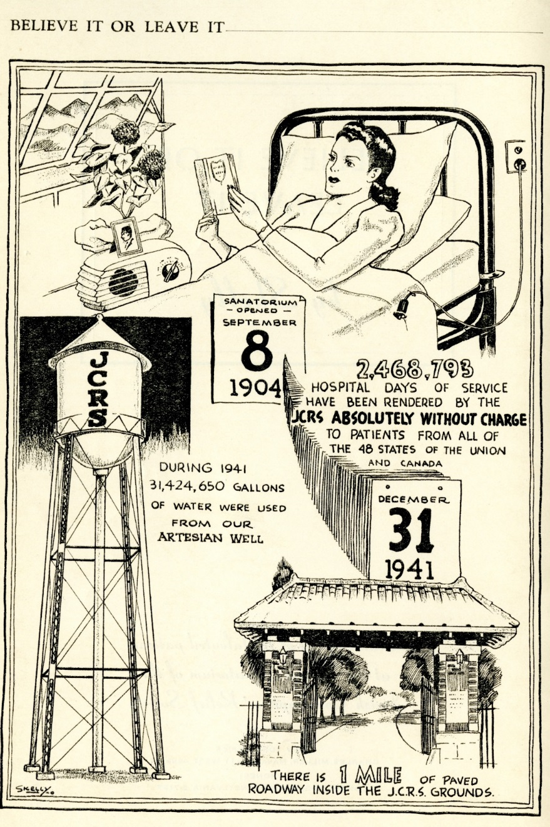
Illustrated by a patient at the JCRS, this booklet highlights achievements and fun facts about the sanatorium through cartoon like drawings. It includes that the sanatorium patients eat 1,600 latkes (potato pancakes) in one meal!

- Patient Instruction Booklet, National Jewish Hospital, 1940s

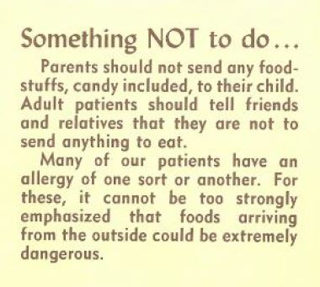
Patients staying at either the JCRS or NJH came from all over the world and would stay for very long periods of time. This booklet was sent to patients or parents of young patients so they would know what to expect when they arrived. The booklet also has a list of things to bring with you, a map of the campus and when parents are allowed to visit.

- For the Sake of the Child booklet, circa 1950

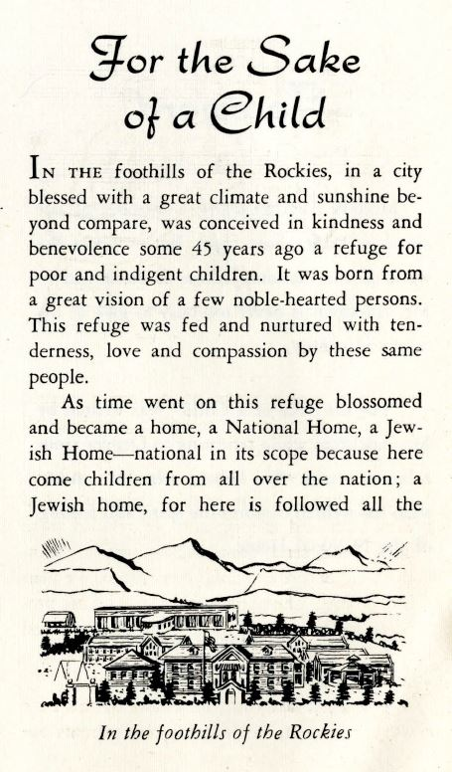
The Denver Sheltering Home later expanded from an orphanage to a treatment facility for children suffering from respiratory diseases and was re-named the National Home for Jewish Children. Sending a child far from home could be scary for families and this booklet was meant to make the children and families feel better about the treatment process.

- Dance Recital at the National Home for Jewish Children in Denver, c. 1940s
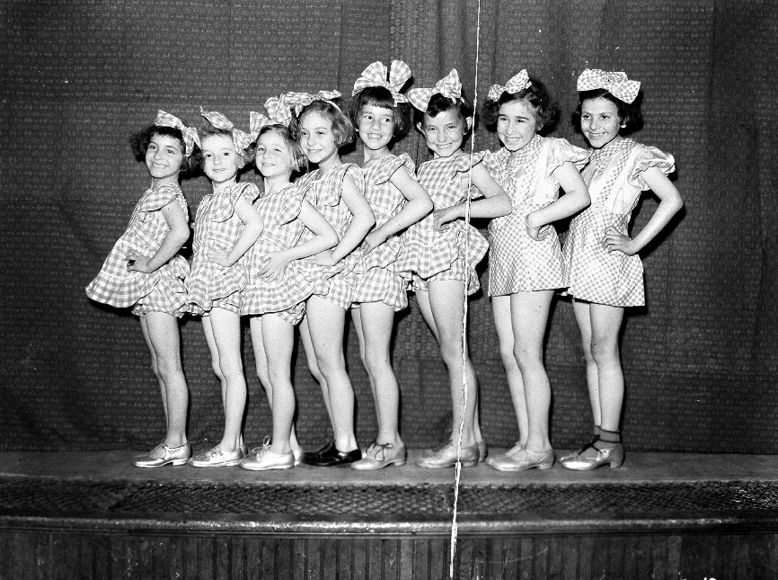
For patients who were away from home for months or even years, it was important to try to provide the same opportunities they would have if they were not in the hospital. Whether it was an art class at the JCRS or an English language learning class at NJH, the patients had lots of options to keep them busy. Children in the care of the National Home didn’t miss out either! These girls are performing in a dance recital at the home.

- Patient Statistics, 1918

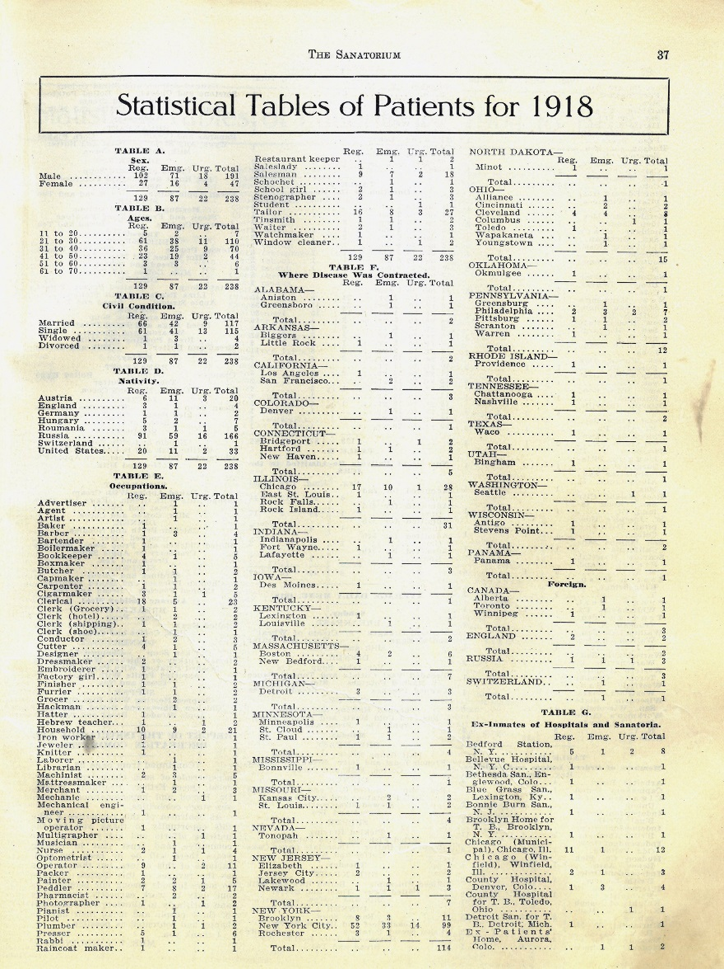
Tuberculosis could infect anyone. It didn’t matter where you were born or what you did for a living. Here you can see what jobs the patients of the JCRS had before they came to the sanatorium, where they were born, and where they lived when they got sick.

- Patient Sample Menu, 1918

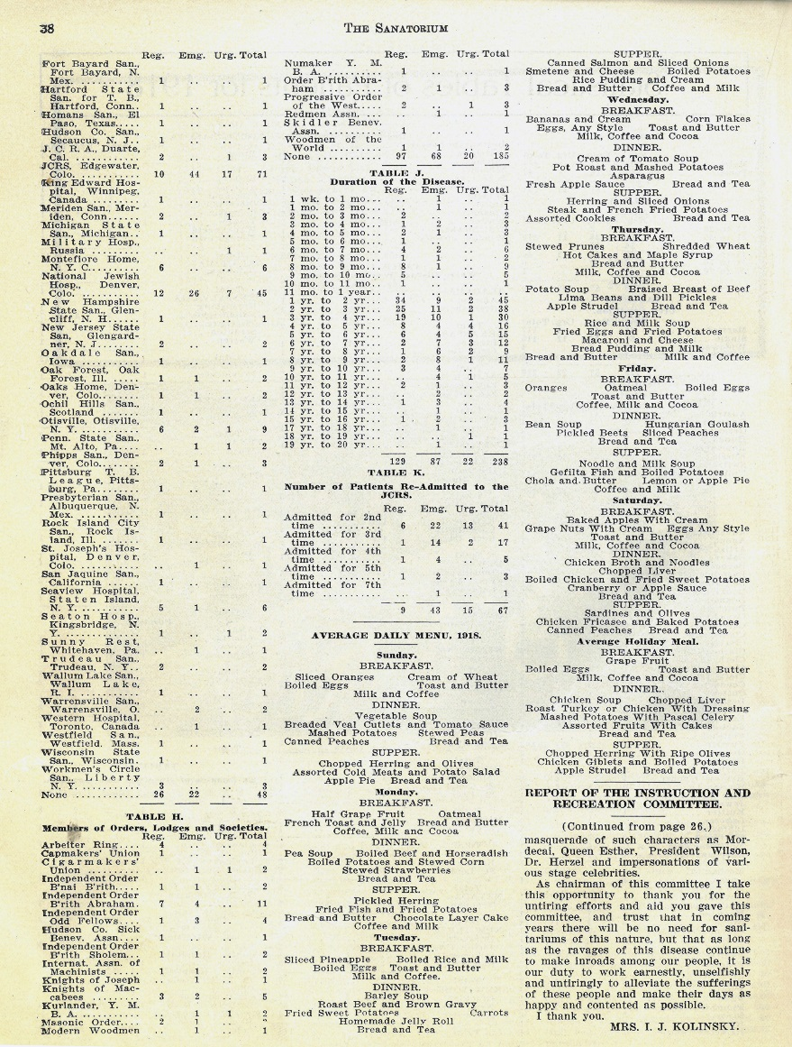
With no known cure for tuberculosis, nutrition was a major focus in treatment of the disease. As long as a patient was strong enough they were expected to have their meals in the dining hall with the other patients and staff of the hospital. Doctors developed diets meant to help get patients healthy again. There were even special meals on holidays complete with chopped liver, herring and olives, and chicken giblets. Yum!

- JCRS Solarium, 1920s
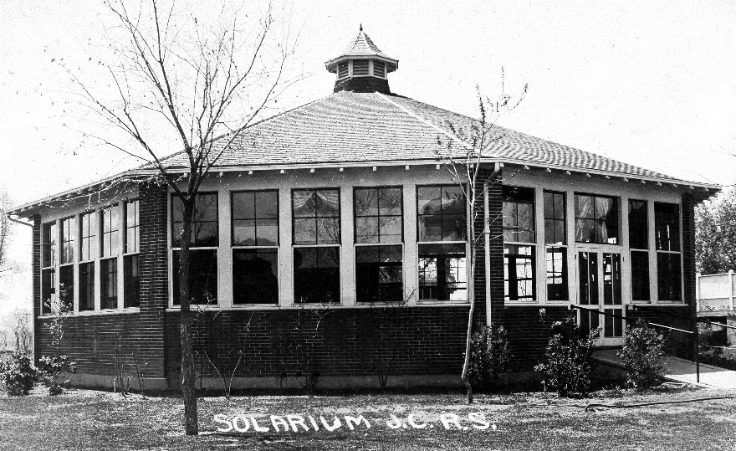
Fresh air and sunshine was also an important aspect of treatment for tuberculosis sufferers. The solarium on the JCRS campus provided a large open area for patients undergoing heliotherapy to receive treatment. A solarium is a room with mostly windows instead of solid walls to let in sunlight.

