Grade Level:
Kindergarten

Essential Question:
How do you think school and play today is different from going to school and playing in the past?
Supporting Questions:
- What subjects do you think your grandparents studied in school?
- What did your parents’ schools look like?
- How can we learn about children in the past by learning about what they did in school?
- What does a school tell us about the community in which it is located?

Source 1:  Public playgrounds, Denver (between 1900 and 1910)  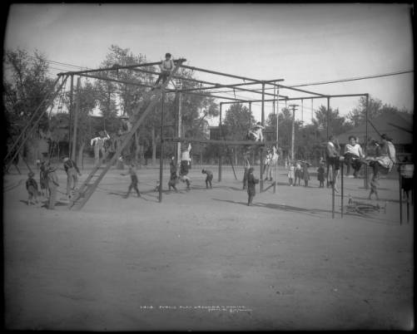  Large group of children play in public playground, Denver, Colorado  http://digital.denverlibrary.org/cdm/ref/collection/p15330coll22/id/409 | Source 2:  Calisthenics (between 1900 and 1905?)  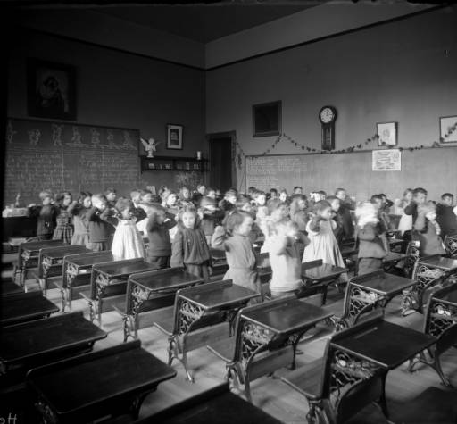  One African-American girl and white girls and boys stand beside desks and touch their hands to their shoulders in a classroom in Gilpin School at 29th and Stout Streets in the Five Points neighborhood of Denver.  http://digital.denverlibrary.org/cdm/ref/collection/p15330coll22/id/60972

Background Knowledge / Contextual Paragraph for Teachers: Every town had a school for its children. At first, children attended private schools. The school master or school “marm” (a woman school teacher) decided how long the term would be. Later there were public schools for all of the children. Sometimes they went to school in spring, summer, and fall. The snow might be too deep in winter for them to get to school. The teachers tested the children at the end of each month to see how much they had learned. The newspaper editor printed the names and test scores in the newspaper. He printed deportment (behavior) grades for the children in the newspaper. … Children in grades one through twelve … studied reading arithmetic, science, health, geography, grammar, literature, and the history of the world, United States, and Colorado. They practiced penmanship each day. (Mather 2014, pp. 46-48)

Building Background Knowledge for the Student
- Who attended school in the past? Who taught at schools? Who built and paid for schools?
- How did children get to school in the past? How did you get to school today? What are all the transportation methods that students might use to get to a school?
- What kinds of skills and concepts did students learn in school? What activities did children do?
- Where did children study before there was a school? Were the schools usually in town or outside of town?
- What time of year did children go to school?
- Why do parents send their children to school? What do you like about school? What do you not like about school? Do you think children in the past liked and disliked the same things?
- Do people prefer to go to school near their homes or far away?
- Why might some children not go to school? Did children have to work? Did they study at home?

Strategy Instruction:
- Start by reading to students the description of going to school in “On the Banks of Plum Creek” by Laura Ingalls Wilder.
- Ask some of the questions about schools as suggested in the Background Knowledge section.
- Denver Playground photo: What are kids doing here? Does this look like a playground today? What is different? What is the same? Talk about what children are wearing? Are boys and girls doing the same thing?
- Project the images of the inside of schools in Sources 2, 3, and 4. What can you learn about a community from looking at its schools? Do you think these people had a lot of money or a little money to spend on their schools? What is different in your classroom from the classrooms in these pictures?
- Look at the picture of the Gold Hill School location (Source 11). Encourage the students to make geographic observations about the photo. What kinds of physical features are there (trees, mountains, fields, buildings)? What type of place is it (small town, big city)? From where do you think this picture was taken (airplane, hill)? What kinds of things did people do who lived in this town? Would it be hard or easy to get to a school in this town?
- Look at the pictures of the Town of Gilpin School (Source 5) and Mancos High School (Source 6). Why do you think that people took pictures outside of buildings (needed light for the photographs, it was easier to see everyone at once, they wanted a historic record)? Do we have pictures like this of everyone at our school?

Strategy Instruction Differentiation:
These primary sources have little to no text. The images can allow students to practice historical detective work without basic reading.

Discussion:
Talk with students about what was happening at the turn of the last century (1900). Many of these photos were taken between 1900 and 1910.
- Look at how students were dressed. What can clothing tell us about children in the past?
- What kinds of activities were children doing? What does that tell us about people?
- What subjects did your grandparents study? Did they have a computer class?
- Why do you think it is a good idea to go to school?

Assessment:
Have students draw their classroom or playground. Have them discuss the changes from the old classroom and/or playground to today.

Colorado Academic Standards - Social Studies:
- Standard 1: History: GLE 1a: Ask questions about the past using question starters. Questions to include but not limited to: What did? Where? When did? Which did? Who did? Why did? How did?
- Standard 1: History: GLE 1c: Use correctly the word “because” in the context of personal experience or stories of the past using words. Words to include but not limited to past, present, future, change, first, next, last.
- Standard 1: History: GLE 2a: Order sequence information using words. Words to include but not limited to past, present future, days, weeks, months, years, first, next, last, before, and after.
- Standard 1: History: GLE 2b: Explore differences and similarities in the lives of children and families of long ago and today

Colorado Academic Standards Reading and Writing:
- RWC Standard 1: GLE 1a: Describe familiar people, places, things, and events and, with prompting and support, provide additional detail.
- RWC Standard 3: GLE 1a: Use a combination of drawing, dictating, and writing to compose opinion pieces in which they tell a reader the topic or the name of the book they are writing about and state an opinion or preference about the topic or book (e.g., My favorite book is…)
- Standard 4: Research and Reasoning: GLE 1b: Use a variety of resources to answer questions of interest through guided inquiry.

Sample Activities:
- Have students look closely at Sources 1-4. Ask them to identify as many things in the photographs as they can.
- Take a picture of the classroom - have students compare the photographs of the old classroom with their classroom. Ask them why they think the classrooms look so different? What might it have been like to go to school in the old classroom?

Source 3:  Inside a One Room Schoolhouse - Overpopulated and Underfunded. c. 1890  During the 1930s about half of all children went to school in rural areas, where the proportion of children to adults was higher than in the cities. Rural schools on average spent about half what urban schools spent per pupil. In 1930, Arkansas spent $33.56 per pupil per year, while New York spent $137.55 and the nation as a whole spent $76.70.  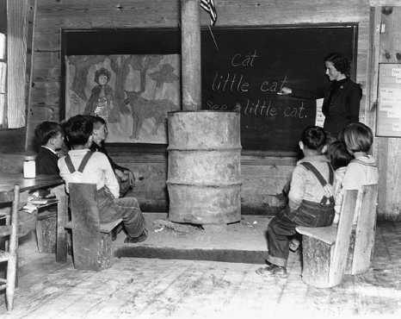  http://callisto.ggsrv.com/imgsrv/FastFetch/UBER2/adec_0001_0004_0_img0479 | Source 4:  Inside the St. Elmo Schoolhouse. Old books, students' desks and an organ in the back.  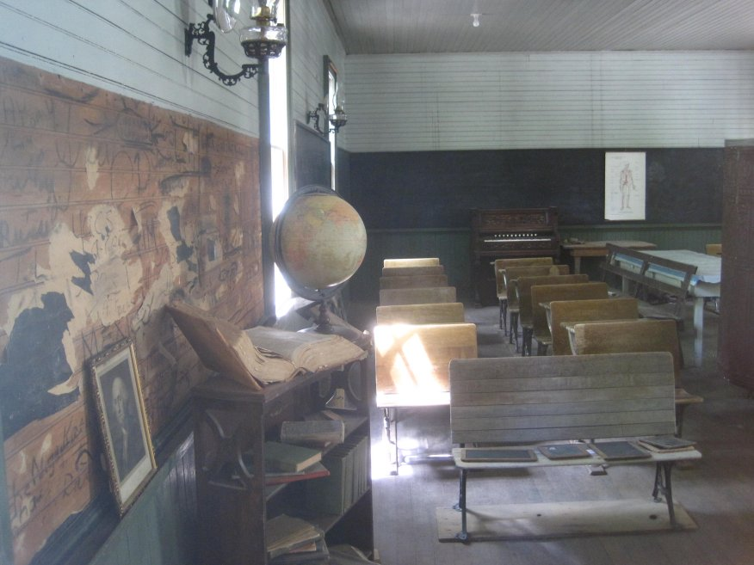  http://www.st-elmo-colorado.com/schoolhouse.htm
Source 5:  The town of Gilpin school, circa 1900 (Gilpin is a ghost town now). Photo courtesy of Gilpin History Museum  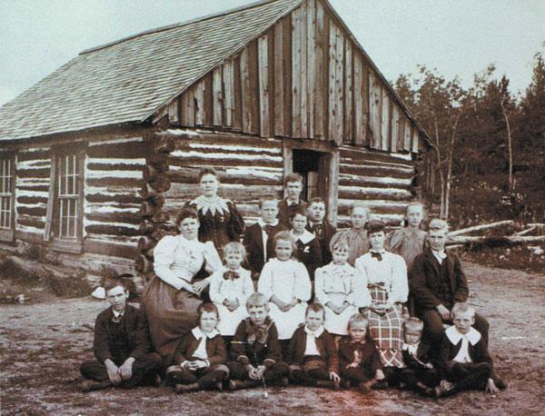  As late as 1945, half of our nation’s schools were still one-room buildings. Colorado had more of these as a percentage than the rest of America because of our many isolated mining towns. Today there are fewer than 400 one-room schools across America and many of those are in small Western mining towns.  http://coloradogambler.com/colorado-history-one-room-schoolhouses/ | Source 6:  Mancos High School, opened in 1910. Mancos High School has the distinction of being the oldest continuously used high school in the State of Colorado, and is listed on the National Historic Register. When it was opened, the local paper noted “With nothing to hinder, but all things to help, this year should be the best in work well executed, hopes inspired, noble ends achieved, and higher resolves fixed by determination that irresistibly forces men and women into boundless activity.  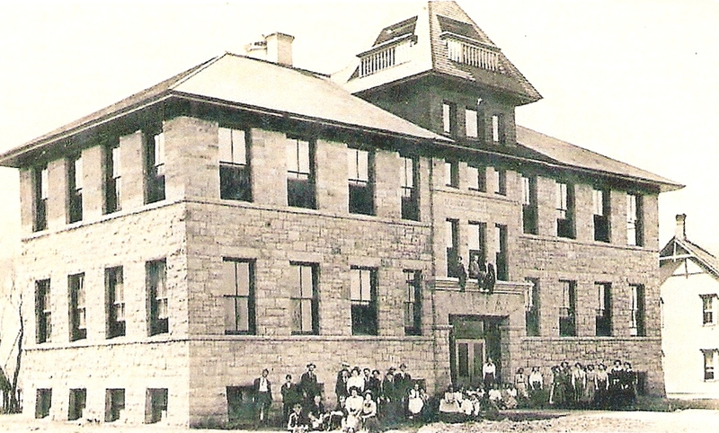  http://mancos.schoolfusion.us/modules/cms/pages.phtml?pageid=73395&SID
Source 7:  The Gold Hill School. Gold Hill is a historic mining town nestled in the mountains above Boulder. Founded in 1873, Gold Hill School is the oldest continuously run elementary school in Colorado. Once a one-room schoolhouse, the school now has three rooms and two teachers. The school is small, experiential and a vital part of this vibrant mountain community. With only two teachers in a six-year period, transitions between grades are easier, and strong, lasting relationships tend to form.  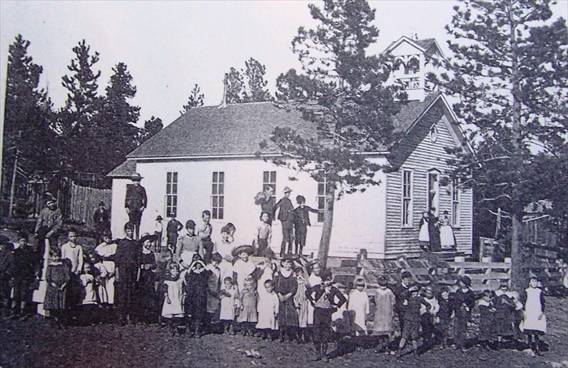  Photo courtesy of the Gold Hill Museum | Source 8:  The Gold Hill School Today  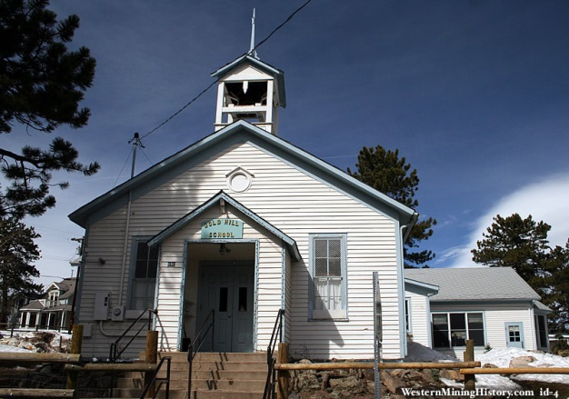  http://www.westernmininghistory.com/special/schools/4227
Source 9:  “Inside the Gold Hill School” – This is a photograph from the Gold Hill Museum exhibit on the Gold Hill School. These are actual artifacts from the schoolhouse.  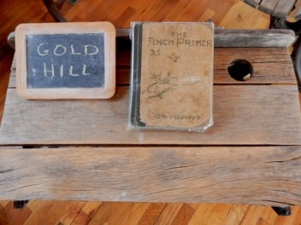  Photo courtesy of John A. Sand – personal collection | Source 10:  “Inside the Gold Hill School” – This is a photograph from the Gold Hill Museum exhibit on the Gold Hill School. These are actual artifacts from the schoolhouse.  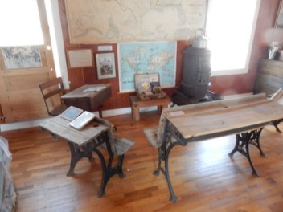  Photo courtesy of John A. Sand – personal collection
Source 11:
The town of Gold Hill - Gold Hill is a historic mining town nestled in the mountains above Boulder. Founded in 1873, Gold Hill School is the oldest continuously run elementary school in Colorado. Once a one-room schoolhouse, the school now has three rooms and two teachers. The school is small, experiential and a vital part of this vibrant mountain community. With only two teachers in a six-year period, transitions between grades are easier, and strong, lasting relationships tend to form.

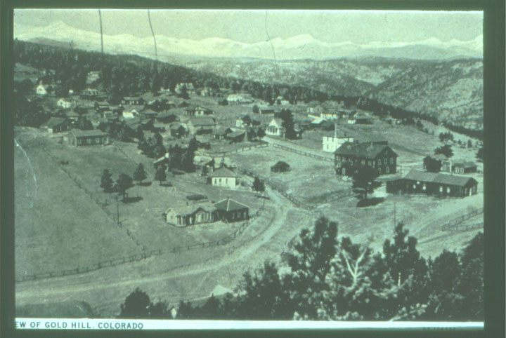

http://coloradopreservation.org/wp-content/uploads/2011/05/epp_00_08_historic.jpg

