Grade Level:
Elementary / 5

Essential Question:
What challenges were faced by the new nation?

Supporting Questions:
- What growing pains did the new nation encounter as the country’s boundaries expanded?
- How did “Americans” work to develop a national identity?
- What challenges were faced by the Founding Fathers in establishing a new national government?
- What is the importance of establishing equal rights for all Americans?
  - Were the Founding Fathers successful in establishing equal rights for all?

Source 1  - Carington Bowles New Map of North America, 1783  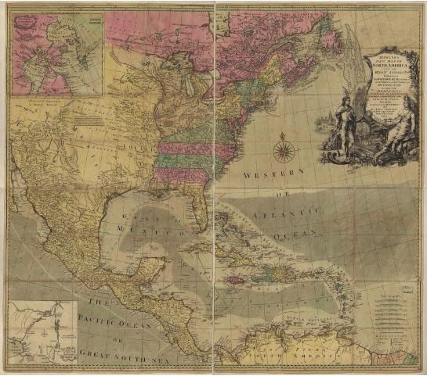  Bowles's new map of North America and the West Indies, exhibiting the British Empire therein with the limits and boundaries of the United States as also the dominions possessed in that quarter, by the Spaniards, the French & other European states, the whole compiled from the best surveys and authentic memoirs which have appeared to the present year, 1783.  https://www.loc.gov/resource/g3300.ar010000/ | Source 2  - The Organization of Territories in the United States since 1803  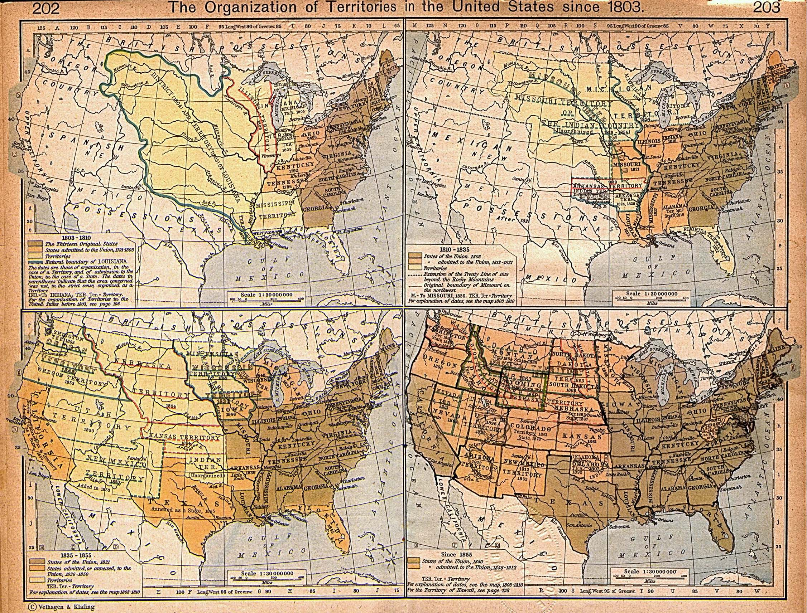  Map I. 1803-1810, Map II. 1810-1835, Map III. 1835-1855, Map IV .Since 1855. From The Historical Atlas by William R. Shepherd, 1923  http://www.lib.utexas.edu/maps/historical/shepherd/us_expansion_shepherd.jpg
Source 3  - The territories northwest and southwest of the Ohio River are depicted on this map of the early United States (1783–1803). From the William R. Shephard - The Historical Atlas, 1923.  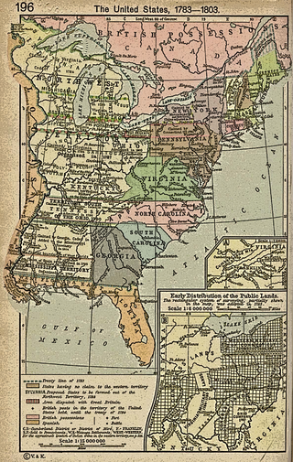  https://en.wikipedia.org/wiki/Northwest_Ordinance#/media/File:Poster_united_states_1783_1803_shephard1923.png | Source 4  - The Northwest Ordinance of 1789  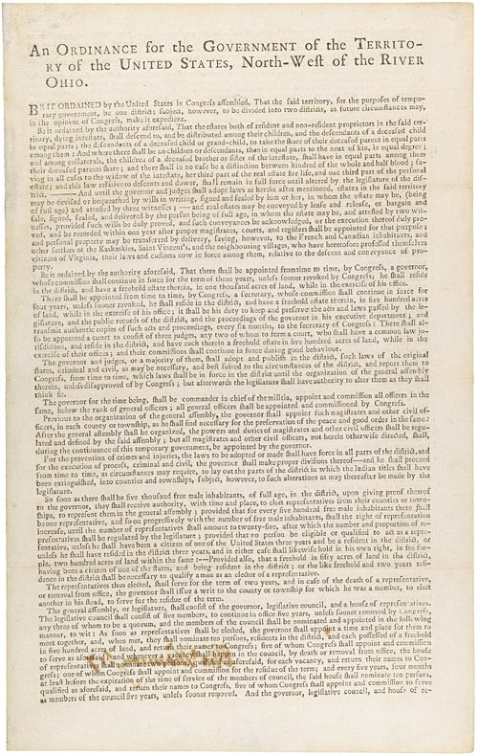  https://www.ourdocuments.gov/doc_large_image.php?doc=8
Source 5  - The Articles of Confederation  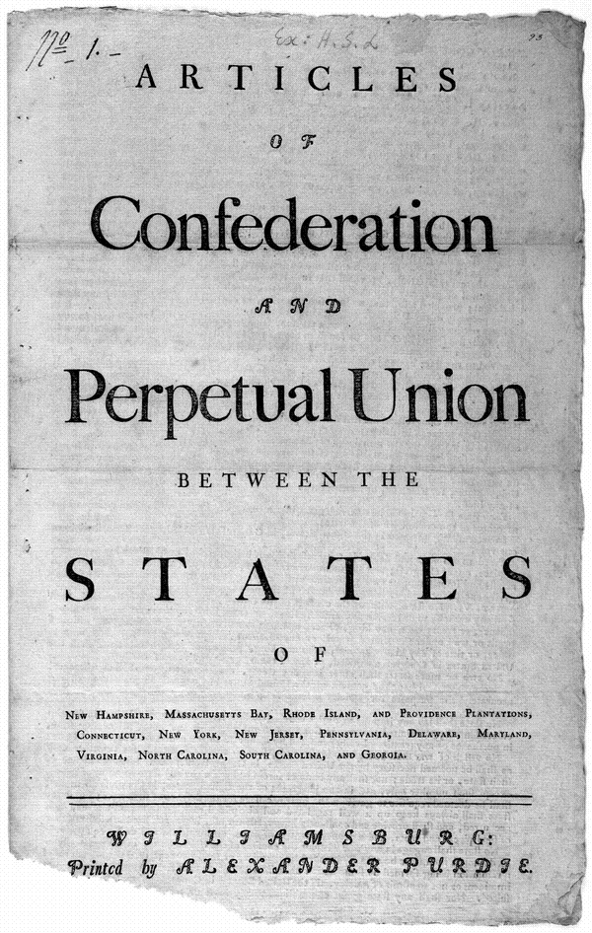  http://hdl.loc.gov/loc.rbc/rbpe.17802600 | Source 6  - A simplified version of the Articles of Confederation

Source 7  - The Bill of Rights  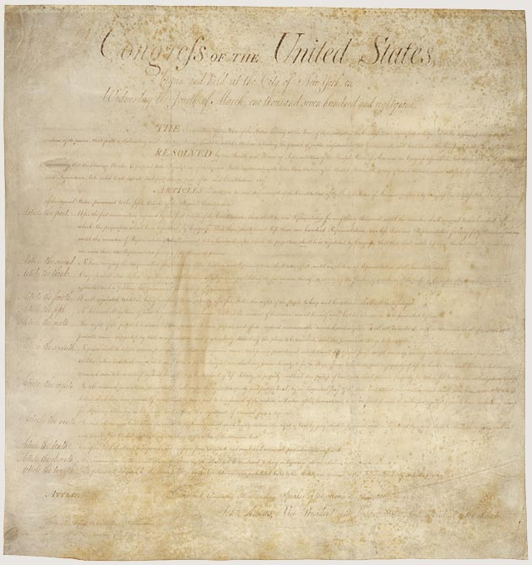  https://www.archives.gov/founding-docs/bill-of-rights | Source 8  - A simplified version of the Bill of Rights
Source 10  - Pg. 1 of the Constitution of the United States  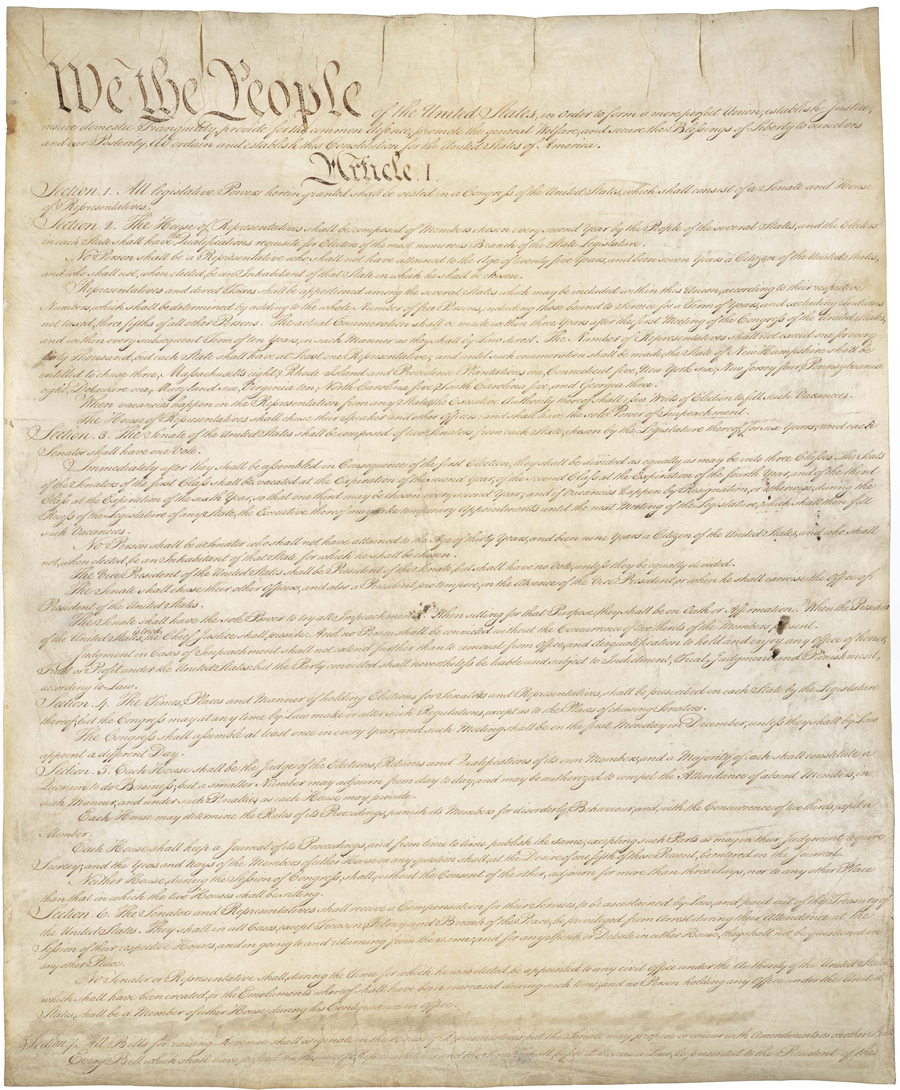  https://www.archives.gov/founding-docs/constitution-transcript | Source 11  - A simplified version of the Constitution

Background Knowledge / Contextual Paragraph for Teachers:
This primary source set is designed to show how Americans struggled to put the ideals of the Revolutionary era into practice as they defined a new system of democratic government and new roles for the people of the United States.
- The New Nation: https://www.learner.org/courses/amerhistory/units/6/overview.html
- The Northwest Ordinance: http://www.history.com/this-day-in-history/congress-enacts-the-northwest-ordinance
- The Articles of Confederation: http://www.history.com/topics/articles-of-confederation
- The addition of the Bill of Rights: http://www.pbs.org/ktca/liberty/chronicle_philadelphia1791.html
- High resolution downloads of the Constitution, Bill of Rights https://www.archives.gov/founding-docs/downloads

Building Background Knowledge for the Student
- Short videos on the Building of a New Nation: http://study.com/academy/topic/the-making-of-a-new-nation-1776-1800.html

Strategy Instruction:
Timeline (Free online timeline creator: www.timetoast.com)
Sentence, phrase, word: http://tpsconnect.org/2016/09/08/literacy-activity-sentence-phrase-word/
Summarizing
Four Fold Concept and Vocabulary Building Activity: http://tpsconnect.org/2016/07/06/four-fold-concept-and-vocabulary-building-literacy-activity/

Strategy Instruction Differentiation:
For differentiation, you could provide your high level readers with sections of the original text of the Constitution in a side-by-side look at the corresponding text of the simplified version of the Constitution. For struggling readers, provide students with a vocabulary list with definitions to help them work through the simplified version of the Constitution

Discussion:
Begin by highlighting the basic concerns and issues that faced the new nation after the Revolutionary War.
Some of these issues might include:
- Sovereignty of each individual state to conduct its own affairs without what it considered "undue influence" from a central government
- Protections against an oppressive central government
- Economic issues, such as taxation without representation, as well as maintaining a laissez-faire system which would protect business and industrial interests
- The ability of the national government to protect business interests from foreign interference
- The ability of the national government to protect itself and the nation from foreign military power as well as protecting itself from internal sedition.
- The division of the new nation into two camps those who feared a strong, powerful central government and wanted to preserve individual liberties as well as the local sovereignty of each state and those who believed that the union would fall apart without a strong central government.
Other discussion question possibilities:
- What are the challenges of creating a new nation?
- What key ideas and documents shaped the new nation?
- How do you balance individual liberties with the needs of a nation?
- How has the Constitution represented some people but not others?
- What is a right? Do you think there are “basic human rights” that all people should have?
- What responsibilities go along with our rights?
  - Can you have rights without responsibilities?
  - Explain what you think are some of the most important responsibilities you have in order to protect your rights.

Assessment:
Students can create an annotated timeline of events illustrating the challenges faced in building the new nation. The timeline should contain dates, images, and an explanation of the significance of the events selected. Students may create a digital timeline using a website such as Timetoast (www.timetoast.com) or create a paper version of their timeline.

Colorado Academic Standards - Social Studies:
- CO Standard 1 - History
  - Analyze historical sources from multiple points of view to develop an understanding of historical context.
    - (b) Examine significant historical documents. Topics to include but not limited to the Stamp Act, the Declaration of Independence, and the Constitution
  - The historical eras, individuals, groups, ideas and themes in North America from 1491 through the founding of the United States government.
- CO Standard 2 - Geography :
  - Use several types of geographic tools to answer questions about the geography of the United States.
    - (a) Answer questions about regions of the United States using various types of maps
  - Causes and consequences of movement
    - (a) Identify variables associated with discovery, exploration, and migration.
    - (e)Give examples of the influence of geography on the history of the United States

Colorado Academic Standards - Reading and Writing:
- CO Standard 2 - Reading for All Purposes
  - Ideas found in a variety of informational texts need to be compared and understood
a. Use Key Ideas and Details to:
i. Quote accurately from a text when explaining what the text says explicitly and when drawing inferences from the text. (CCSS: RI.5.1)
d. Use Range of Reading and Complexity of Text to:
i. By the end of the year, read and comprehend informational texts, including history/social studies, science, and technical texts, at the high end of the grades 4–5 text complexity band independently and proficiently. (CCSS: RI.5.10)

Sample Activities:
Articles of Confederation Activity:
Begin by explaining the purpose of the Articles of Confederation. Provide some background about this first attempt at establishing a national government.

Consider having students look at the original text of the Articles of Confederation side-by-side with the simplified version.
Distribute the simplified version of the Articles of Confederation

Give students some time to read and compare the text of the 2 versions. Have students complete the Four Fold Concept and Vocabulary Building Activity: http://tpsconnect.org/2016/07/06/four-fold-concept-and-vocabulary-building-literacy-activity/ for words they find difficult.

Lead a class discussion about the weakness of this document and why it was necessary to bring together representatives of the 13 colonies to write a new document - the Constitution.

Constitution Activity:
Introduce students to the Constitution. Discuss its purpose and importance.
Have students complete an initial read of the Preamble.
- How many of the words do they know? Are the any parts of the preamble that they understand?
- Handout the Preamble Worksheet that has students read the Preamble, identify keywords, write a summary of the Preamble and then re-write it in their own words (the worksheet is part of the ancillary materials for this primary source set on the website)
Discuss the 6 major parts of the Preamble (“ordain and establish this Constitution for the United States, establish justice, insure domestic tranquility, provide for the common defense, promote the general welfare and secure the blessings of liberty).
- Have students create 6 symbols to represent each of the 6 parts of the Preamble and write a sentence that tells what each symbol means.
Next explain to students that the rest of the Constitution outlines how the government of the United States should be organized.
The Constitution is divided into several sections:
- The first part, the Preamble, explains who is writing the Constitution and why.
- The second part, which is composed of seven Articles, explains how our government will work.
- The third part, the Bill of Rights, is a list of amendments, or additions, that the Constitution writers thought were important. These additions name the rights or freedoms that Americans have. After the first 10 amendments in the original Bill of Rights, the Constitution includes other additional amendments that have been added over time.

Prior to distributing the simplified version of the Constitution, you may want to introduce students to the concepts of separation of powers, and limiting the power of the government.

Distribute the simplified version of the Constitution
Break students into groups (Teachers may want to split Article 1 into two groups, and combine some of the last Articles). Provide each group with the applicable guiding questions:
- Article 1 (Sections 1-5): Establishes the Legislative Branch
  - How did the Framers of the Constitution organize Congress?
  - How do Sections 1 - 5 represent separation of powers?
  - What are the requirements to become a Senator and a Representative?
  - How many Senators can each state have?
  - How many Representatives can each state have?
- Article 1 (Sections 6 - 10): Establishes the Legislative Branch
  - What is the role of Congress?
  - How do Congress and the President work together to pass a bill?
  - What “powers” does Congress have?
  - What are things that Congress is not allowed to do?
- Article 2: Establishes the Executive Branch
  - What is the job of the President?
  - What is the branch of the President called?
  - What powers does the President have?
  - What are the requirements to become President?
- Article 3: Establishes the Judiciary
  - What is the role of the Supreme Court?
  - How does the Judiciary branch work to balance the power among the 3 branches of government?
- Article 4: States Rights
  - What rights are given specifically to the states?
- Article 5: How to Change the Constitution
  - What does it take to make changes to the Constitution?
- Article 6: Concerns laws and treaties of the United States
  - What do laws and treaties of the United States become?
  - What must federal and state officers do in order to be hired?
- Article 7: Explains how the Constitution was ratified.
  - What did it take for the states to accept the Constitution?

Consider having groups share what they’ve learned from their specific sections. Have students create a storyboard illustrating the structure of the government as outlined in the Constitution.
Bill of Rights Activity:

For this activity, students will discuss some important questions about the responsibilities of citizens. Divide the class into groups of 5. Assign each group a “right.” Distribute the simplified version of the Bill of Rights.

Begin with: Most of us agree we all should have certain basic rights. For example, we all want the right to speak freely. We want the right to believe as we wish. We also want to be able to own property and to travel wherever we want to go. Is it fair to say that if we want these rights, we must also take on some responsibilities? Let's examine this question.
- Group 1. Freedom of Expression
Your government cannot unfairly limit your right to speak freely. What responsibilities might go along with this right?
- Group 2. Freedom of Religion
Your government cannot interfere with your right to believe as you wish. It cannot unfairly limit your right to practice your religious beliefs. What responsibilities might go along with these rights?
- Group 3. The Right to be Treated Equally
Your government may not favor some people over others because of such things as their age, sex, race, or religion. What responsibilities might go along with this right?
- Group 4. The Right to be Treated Fairly by Your Government
Your government must be fair to you when it is gathering information and making decisions. What responsibilities might go along with this right?
- Group 5. The Right to Vote and Run For Public Office
When you are eighteen, you will have the right to vote. You will also have the right to run for public office if you want to. What responsibilities might go along with this right?

Source: http://www.civiced.org/resources/curriculum/lesson-plans/452-what-responsibilities-accompany-our-rights

