Grade Level:
2nd Grade

Essential Question:
How do maps show changes over time?

Supporting Questions:
- What natural changes occurred over time and how does a map represent them?
- What man-made changes occurred over time and how does a map represent them?

Source 1:  - 1954 Map of Limon  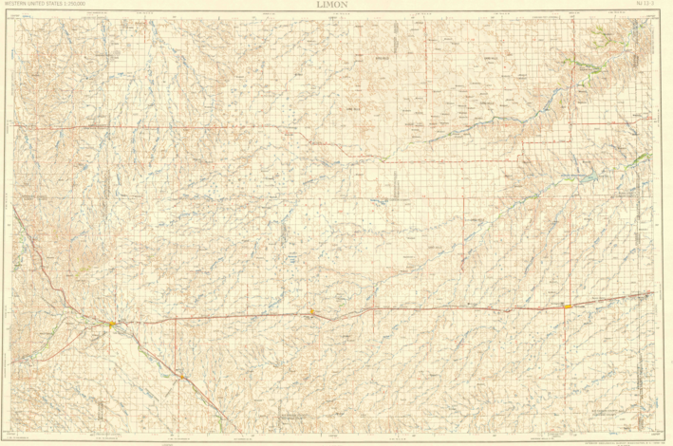  https://ngmdb.usgs.gov/img4/ht_icons/Browse/CO/CO_Limon_403154_1958_250000.jpg | Source 2:  - Present-day Map of Limon (Google Map)  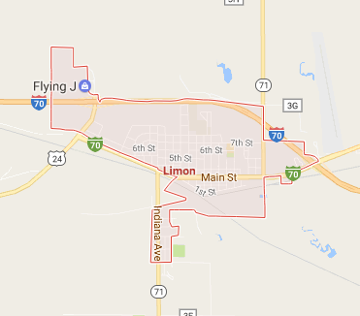  https://www.google.com/maps/place/Limon,+CO+80828/@39.2660592,-103.72631,13z/data=!3m1!4b1!4m5!3m4!1s0x876d518484bc6433:0xc3630bec75a0f713!8m2!3d39.2638762!4d-103.6921737
Source 3:  - Limon Resident Interview: Virginia Wanona Anderson taken on October 20, 2014. Interview by Cambria Carlson Reading in 2009 and 2010 as well as portions taken from a taped interview conducted by Linda Carlson in April 2006. Retrieved from: https://familysearch.org/photos/artifacts/10976401  An excerpt:  Virginia Wanona Anderson was born at home on June 19, 1923 in Limon, CO, a small town of about 1500 people. Virginia says that Wanona is an Indian word, and that her daddy picked it. But she never liked the name, so she used the letter “A” in place of her middle name after she got married.  She was the 4th of five children; Floreine, Thelma, Wilford Elmer “Bud”, Virginia, and then Glenn William. She said they all got along pretty well, but she was closest to Bud. Their home was very small and she lived there with her 4 siblings and her parents. There was only one bathroom, down in the basement, and they had a “party-line” telephone. Her family belonged to the American Lutheran Church, and she was baptized in the Zion Lutheran Church in Limon, Colorado...Virginia loved school. She attended Limon Elementary, Jr. High, and High School. Reading was her favorite subject and as a young girl she especially enjoyed reading books such as “Black Beauty” and “Heidi”...  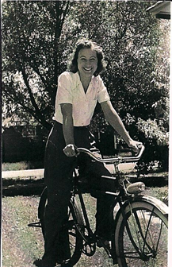  Virginia Wanona Anderson  https://familysearch.org/photos/people/3119605 | Source 4:  - Zion Lutheran Church Image Present-day  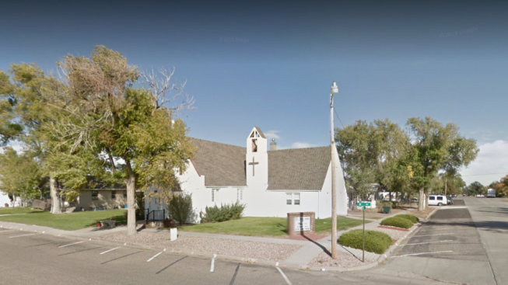
Source 5:  - School images from 1940 and Present-day - Limon  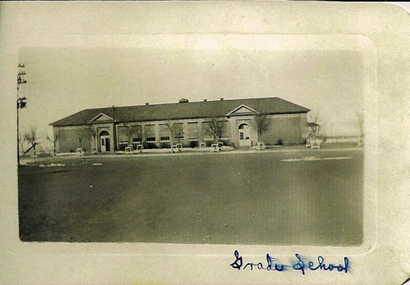  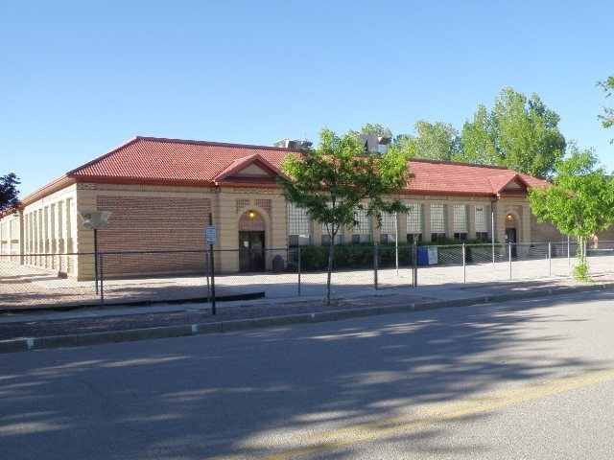  http://coloradopreservation.org/crsurvey/schools/images/hs_1920_limon.JPG | Source 6:  - 1879 Map of Leadville, CO  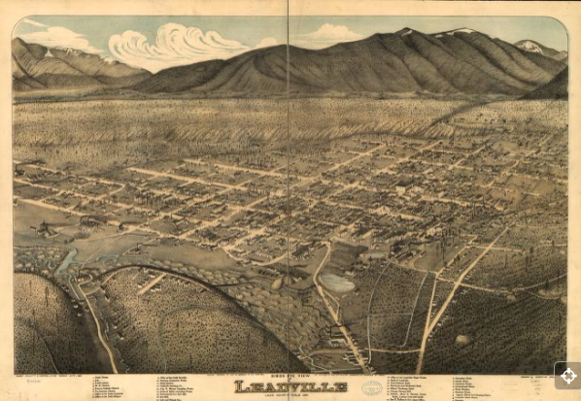  https://www.loc.gov/resource/g4314l.pm000710/
Source 7:  - 1882 Map of Leadville, CO  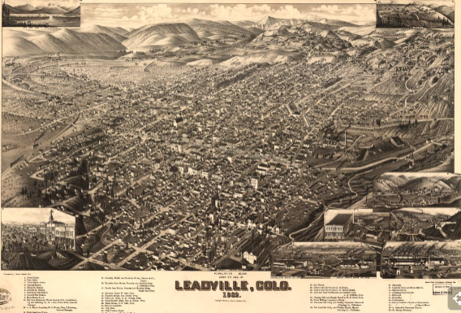  https://www.loc.gov/resource/g4314l.pm000720/ | Source 8  - Present-day Leadville (google map)  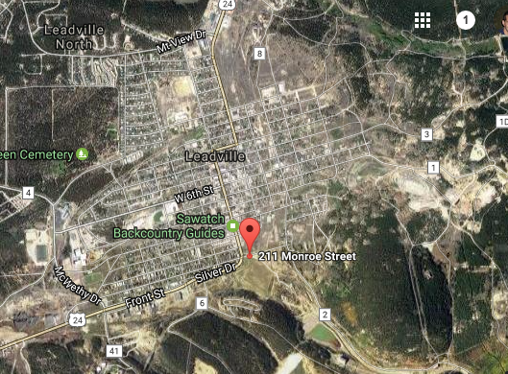  https://www.google.com/maps/place/211+Monroe+St,+Leadville,+CO+80461/@39.2439353,-106.2910318,509m/data=!3m2!1e3!4b1!4m13!1m7!3m6!1s0x876a91243b08979d:0x45a43089dfe8ed21!2sLeadville,+CO+80461!3b1!8m2!3d39.2508229!4d-106.2925238!3m4!1s0x876a912fd6dcf189:0xd91bf4f017b73076!8m2!3d39.2439168!4d-106.2894645

Background Knowledge / Contextual Paragraph for Teachers:
Limon, Colorado
Limon became a town in 1909, because of railroad construction in the area. It is considered a hub town because there are multiple major roads that run through it. The town is located on the north side of the Big Sandy Creek, a river that flows from the Arkansas river. It is on the eastern edge of the Colorado piedmont region of the great plains, the Colorado Piedmont runs along the base of the foot hills in the great plains. Limon lies at the junctions of Interstate 70, U.S. highway 40, 24, and state highway 71.
Leadville, Colorado
The area around Leadville was first settled in 1850 during the Pikes Peaks gold rush. The town of Leadville was founded in 1878 by Horace Tabor and August Meyer at the start of the Colorado silver boom. The location was chosen because it was flat land that was below the tree line. Leadville is just north of the California Gulch where gold, silver, lead, copper, manganese, and zinc were found. In the early 1880’s Leadville experienced a population boom where the population jumped up from 15,000 to 50,000 people. By the 1880’s Leadville had at least 5 churches, 3 hospitals, an opera house, 6 banks, and multiple businesses including at least 100 licensed saloons and a dozen gambling halls. In addition, the town had 3 railroads that connected it to other areas in Colorado and beyond the state. Due to workers’ strikes Leadville experienced an economic crisis in 1890. WWI brought some relief however, because of the demand for steel which caused Leadville’s economic output to drastically increase.

Because of mining, the surrounding environment of Leadville was greatly impacted. The soil and surface water became contaminated by lead, zinc, and other heavy metals. Because of this, some mining operations closed as it would be too costly to operate under the EPA regulations. In 1993, the EPA started to clean up portions of the California Gulch and an 11.6 mile Mineral Belt Trail was opened up in 200 as a national recreational trail.

Source: http://realcoloradotravel.com/leadville-history/980/

Building Background Knowledge for the Student
- Lead the class in a discussion asking these probing questions:
- What is a map? Why is it important?
- Where are maps used or found?
- How many of you ever used a map before to locate a place? Who can share with us your experience?
- What are some features you might see on a map?
- Introduce students to the following vocabulary through a Read Aloud:
  - Compass Rose, Legend, Scale (Map my Home by Jennifer Boothroyd)
  - Title, Highway, Houses/buildings( My Map book by Sara Fenelli)
  - Plowed lands, Rivers, Grass/fields( Follow that Map by Scot Ritchie)
- Using the Mapping Vocabulary Worksheet (Handout #1), have students create their own definitions for each of the words as well as create a symbol for it.

STRATEGY INSTRUCTION:
SOURCES 1-5:
- Mapping a Resident Strategy
  - Read the interview with Virginia Anderson (Source 3) to the students.
  - Show Source 1 (Map of Limon 1954), and Source 2 Present-day Map of Limon on Google map) and have students locate the church and grade school that Virginia Anderson refers to in Source 3.
  - The Zion Lutheran Church is located at 408 H Avenue Limon, CO 80828 United States. After students locate the church on both maps, show Source 4 (Zion Lutheran Church Image Present-day).
  - The grade school is located at 874 F Avenue Limon, CO 80828. After students locate the school on both maps show, Source 5 (School Image from 1940 and Present-day).
  - Have students notice the changes from then and now based on the images and maps.

SOURCES 1-2:
- Map Analysis Sheet
  - Have students complete the Map Analysis Worksheet on Source 1 (Map of Limon 1954). Then use that as a way to compare it to Source 2. The following are questions to ask:
  - What natural changes can you see? (e.g., creek disappears, waterways around it aren’t there, lakes gone, river, the hills or mountains if visible.)
  - What type of map would be better suited to help us with showing natural changes over time?
  - What man-made changes can you see? (e.g., buildings that have moved or are no longer there, the train tracks, and train station, the airport)
  - What type of map would be better suited to help us with showing man-made changes over time?
  - If I wanted to put a road through a mountain, and I was to dig a tunnel is that human change or natural change?

- Mapping Changes Worksheet
  - Provide the Differences Over Time worksheet (Handout #2) that includes a map of a community from 10 years ago and present-day. Have students notice the changes on the present-day map and circle them.
  - Natural Changes: river gets smaller, mountains erode
  - Man-made Changes: more roads, more buildings, dam built, tunnel through the mountains

SOURCES 6-8
- 1879 Leadville Maps Discussion
  - Teacher: I want us to look at the map and tell me some of the things that you see that we have been learning about. Looking For: Legend, streets, the legend lists building by numbers so that they can be found on a map.
  - Teacher: Looking at the map what do you observe about it? What are some aspects on our map that you think can be used as landmarks? What are some features that will tell you about the landscape? Looking For: Rivers, lake, roads, factories, churches dam, mountains, hills, and the town is surrounded by hills/ in a bowl, how open it looks, less buildings farther from the center of town. With each possible observation ask the students if it a natural feature or one that is manmade (See Lesson Limon: Then and Now Geography) Write the observations on a chart.
  - Teacher: I want us to look at the streets and look for Harrison Ave. this is a main street, what does it mean for a street to be a main street? Looking For: The one that is used the most, it normally has shops and business building along it.
  - Teacher: Main Street is another street that is use most frequently. Find where it crosses Harrison Ave. What type of buildings do you think are at the corner of Main St. and Harrison Ave.? Looking For: Anything that is not homes, they can say that theses building is larger than some that are not on theses streets, they look like buildings they see around town that they know are not homes.
  - Teacher: Together I want us to find the building with the number 26 on it; it is at the corner of Main St. and Harrison Ave. This building is the Clarendon Hotel. We could find it using the streets.
  - Teacher: I want us to find Meyers Sampling Works, the number is listed on that legend and it is on Harrison Ave. What number does the legend say the building is? If we know that is it on Harrison Ave. what can we do to find Meyers building? Follow Harrison Ave. Looking For: Elm or Front Street, here was can talk about how to be accurate with directions we can say the street that the building is on along with the streets that it is between.
  - Teacher: Meyer’s Sampling Works is located on Harrison Ave. between Front and Elm Street.
  - Teacher: I want everyone to pick at least three buildings from the list and find the closest cross streets. Then record the building and its streets on your observations chart for 1879. It is important for you to keep track of your buildings because you will be using the same buildings and streets for the other maps.

1882 Leadville Map Discussion
- Review: Before showing the map of 1882 show the students the map of 1879 to remind them of the size and the how spaced to buildings are. Give them about a minute to look at the map.
The Map of 1882 is three years after the first map. The town of Leadville has been around for 4 years now.
- Teacher: This would be a good point to have the students observe that map and share what they notice that is different about the community from 1879 and 1882.
- Looking For: The town is bigger, more buildings, the buildings are closer together, and the population is at 16,000, there is a train, train tracks, buildings are on the side of the hills, the street names were changed.
- Teacher: On the classroom chart, we can write what is new or different about the community now. Write the observations on a chart. The students should have some time to fill out the 1882 portion of the graphic organizer.
- Note: It is incredibly important to note that the direction of the map is different. In the 1879, the mountains were north of the town where the map of 1882 the mountains are to the west. Having the students find Harrison Ave. would be helpful in orientating them with the new map. This should probable be done after you have let them look at the map for a bit. They might mention that the street names are different. Point out where Meyers Sampling Works is and how Elm Street is now being called South Second Street and Front Street is called South Third. This will hopefully help the students.
- Direction: Have the students find their buildings from 1879 on the new map.
Questions: Are they still there? Did they become different buildings? Why do they think the buildings were different?
- Direction: Have the students record what they see is different about their building or the area surrounding their building.
- Teacher: What changes did the community go through between 1879 and 1882? Look for: There are more buildings, the town got bigger, the community grew, and more people came to live in Leadville.
- Questions: How do we know the community changed/ grew from using the maps? Look for: The maps showed that the community grew by the increase of buildings, roads and overall space the town now takes up.
Present-day Leadville Map Discussion (Google map)
  - Review: Show students the map of 1882 for a minute before they look at the present-day map. Ask them what they think will be different about the present map from the other two.
  - Note: Show the Google map at 500ft. This will be more zoomed out than the other two maps but it will do a good job of showing the whole town.
  - Teacher: Have the students share what they observe and the changes the town has made. The current population is at 2,580 this is not on the map but it will help so that the population has decreased from 16,000 in 1882 to 2,580 in 2017.
  - Looking For: The town is smaller, there is more open space the railroad is gone. Write the changes on the class chart.
  - Teacher: Write the observations on a chart. The students should have some time to fill out the present day portion of the graphic organizer. Show the students where Meyer’s Sampling Works should be. Explain that it is now an empty lot.
  - Directions: Have the students look up their buildings. Are they still in town? The courthouse and post office are still there why do you think the town's post office and courthouse did not go away? What did other build go away? What is now at the location of where your building used to be?
Looking For: The realizations that if the community does not need or use the build it can be destroyed or changed into something else.

SOURCES 6-8
- Leadville Community Changes Graphic Organizer (Handout #3)
  - The students will choose three different buildings as they are listed on the 1879 and 1882 Leadville Maps: (a) Courthouse, (b) Jail, (c) Public School, (d) M. E. Church, (e) Roman Catholic Church, (f) Presbyterian Church, (g) Office of Daily Chronicle, (h) Office of Daily Eclipse, (i) Office of the Daily Reveille, (j) Harrison Reduction Works, (k) Grant Smelter, (l) Leadville Smelting Company, (m) Aug. R. Meyer’s Sampling Works, (o) James & Eddy’s Sampling Works, (p) Buchanan Y Company’s Saw Mill, (p) Saw Mill, and (q) Lath and Shingle Mill, Office of the Leadville Water Works, (s) Bank of Leadville, (t) First National Bank, (u) Merchants and Mechanics Bank, (v) Miners’ Exchange Bank, (w) Chicago Planing Mill, (x) Halleck, Shute, & Havens’ Livery Stable, Lumber Yard and Corall, (y) Jay G. Kelley & Company’s Assay Office, (z) Clarendon Hotel, (aa) Grand Hotel, (bb) American House, (cc) International Hotel, (dd) Hotel Windsor, (ee) Hotel Windsor, (ff) Mansion House, (gg) Agnew, Fisk, & Company’s Sleeping Palace, (hh) Leadville Boiler Works, and (ii) hospital.

Strategy Instruction Differentiation:
For the Town Changes Map Activity the teacher can provide them a set of buildings that includes 10 homes and 1 of each of the other buildings instead of following the legend.

Town Changes Map Activity
- Students will make changes to a map to demonstrate how maps record change.
- In groups, students will use Map of Town as the starting town format and will follow the below directions to complete the activity:
  - Place students in groups of 3-4. Give each group a different amount of houses (at least 20 so that the population increases by 100 people). The reason for each group having different amounts of homes is because this will make the students have different buildings added to the town.
  - Each group should have at least one shop per 5 homes, one hospital per 20 homes, one post office, police station and fire station per every 30 homes, one school for every 20 homes, the students can have as many parks as they want, they probably do not need more than 4 bridges.
  - Once the students know how many building they can use, have them place the buildings on the map and draw in the roads. The students can add bridges, parks, dams, freeways, tunnels. The students can increase the size of the forest, cause a landslide, form a lake or split the river. For these changes the students have to explain what caused these changes.

Town Map
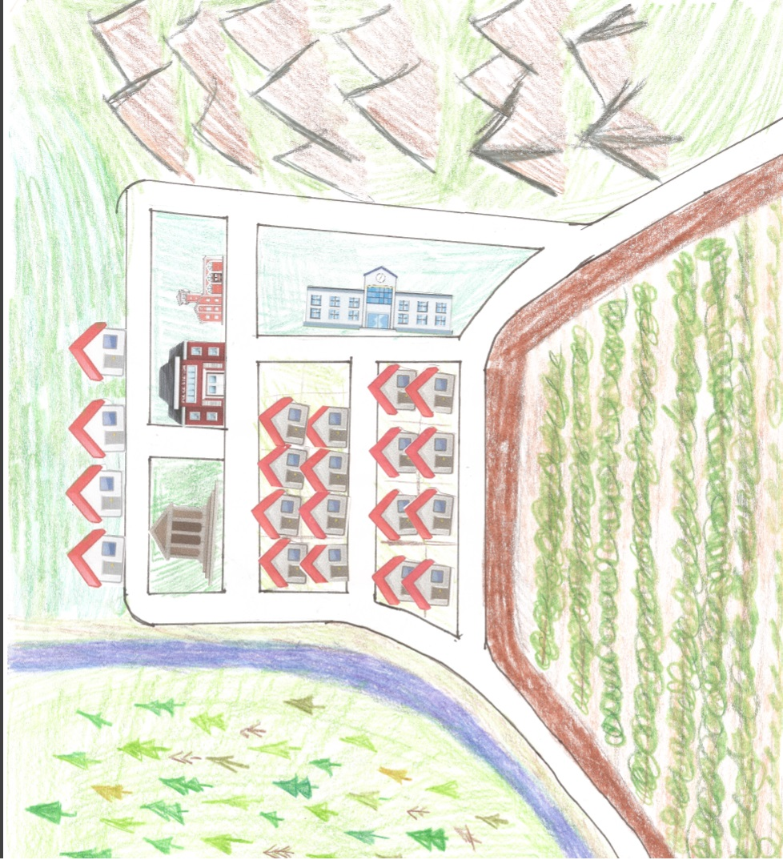

Map Legend (Handout 4)
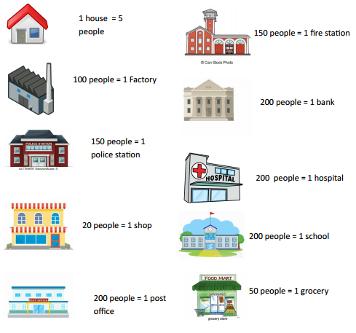

Map Images (Handout 5)

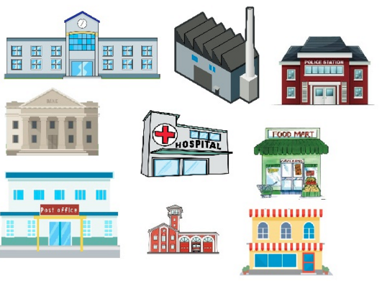

Housing (Handout 6)

Assessment:
Town Changes Map Activity
- The students will make changes to a map to show how overtime towns change and how the surrounding area is affected. This activity demonstrates how the environment has to change to allow for town growth.

Colorado Social Studies Standards:
- SS2. S2. GLE1.EOa. Use map keys, legends, symbols, intermediate directions, and compass rose to derive information from various maps (DOK 1-2)
- SS2.S2.GLE1.EOb. Identify and locate various physical features on a map (DOK 1)
- SS2.S2.GLE1.EOd. Identify and locate cultural, human, political, and natural features using map keys and legends (DOK 1-2)
- SS2.S2.GLE2.EOb.Identify local boundaries in the community (DOK 1)
- SS2.S2.GLE2. EOc. Explain why people settle in certain areas (DOK 1-2)
- SS2.S2.GLE2. EOd. Identify examples of physical features that affect human activity (DOK 1-2)
- SS2.S2.GLE2. EOe. Describe how the size and the character of a community change over time for geographic reasons (DOK 1-2)

Reading & Writing Standards:
- RWC2.S1. GLE2.EOaii.Build on others’ talk in conversations by linking their comments to the remarks of others. (CCSS: SL.2.1b)
- RWC2.S1. GLE2.EOd.Use text features to locate, interpret, and use information (table of contents, illustrations, diagrams, headings, bold type)
- RWC2.S4.GLE2.EOe.Recall information from experiences or gather information from provided sources to answer a question. (CCSS: W.2.8)
- RWC2.S3.GLE2. EOc. Organize ideas using pictures, graphic organizers, or story maps

