Name: ___________________________

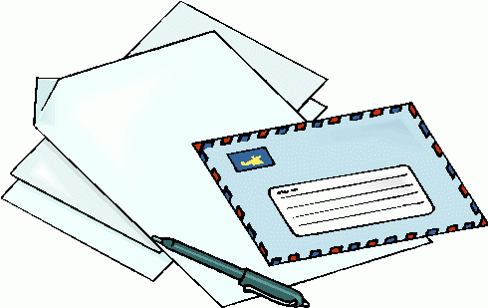

Written Document Analysis Sheet

Are there any words that you don’t know?

If so, look them up in the dictionary to learn what they mean.

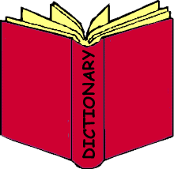

Who wrote the document?

Cite Evidence

List 2 quotes from the text that supports the main idea:

How important is this document in our history?

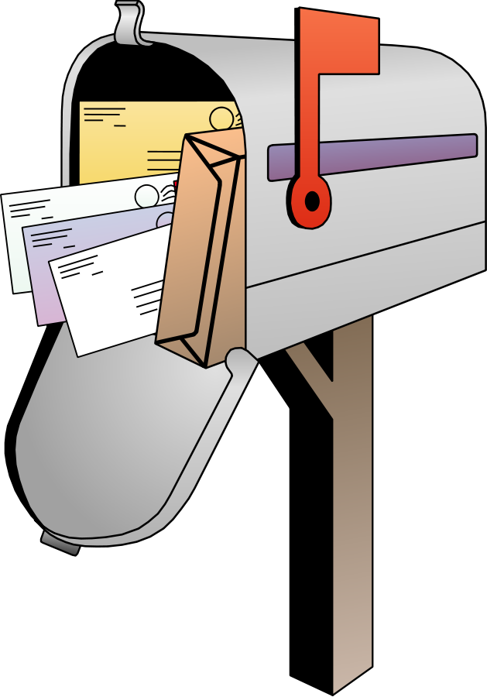

Who received the document?

Cursive or printed?

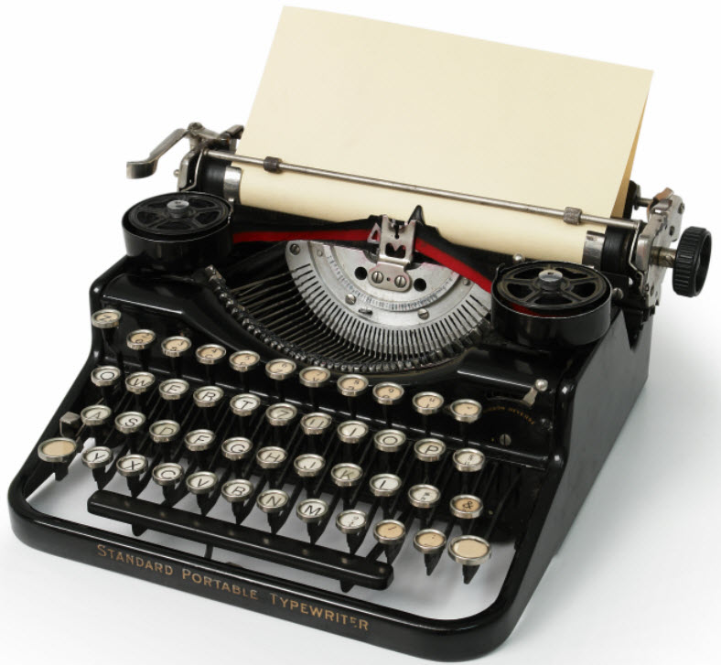

TYPED

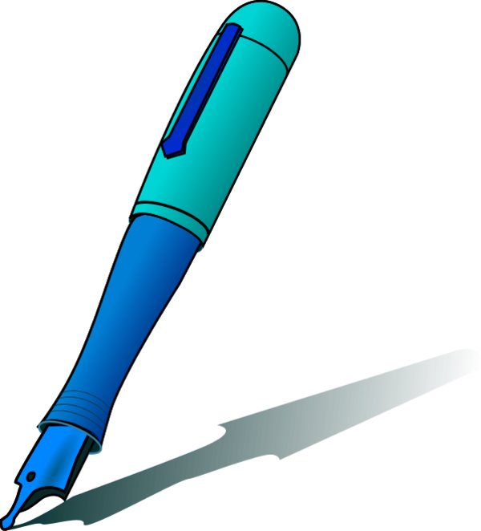

Handwritten

Is the document:

Other:

__________



What questions do you have about the document?

1.

2.



What is the main idea/topic of the document?



What is the date of the document?

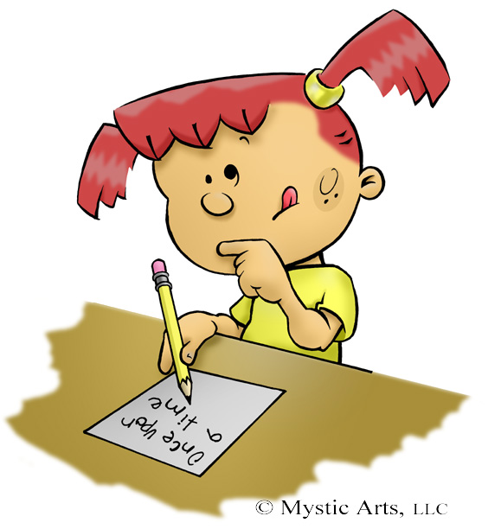

Are there any special markings on the document?

Stamp

Postmark

Special Letterhead

Official

Seal

