Resource Set
Original Rough Draught of the Declaration of Independence | Creating the United States - Inverative | In Congress, July 4, 1776. The unanimous declaration of the thirteen United States of America. | The Declaration of Independence | Timeline of events from June 7, 1776 to January 18, 1777 | His Majesty's most gracious speech to both houses of Parliament, on Friday, October 27, 1775
The "original Rough draught" of the Declaration of Independence, shows the evolution of the text from the initial "fair copy" draft by Thomas Jefferson to the final text adopted by Congress on the morning of July 4, 1776. | Connect particular phrases and ideas set down in the Declaration of Independence with texts that preceded it. | The first issue of the Declaration of Independence printed with the names | National Archives Declaration of Independence page with copies of the document | A timeline of major events leading to and following the writing of the Declaration of Independence | King George III's address to Parliament discussing his views on the rebellion in the American Colonies
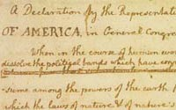 | 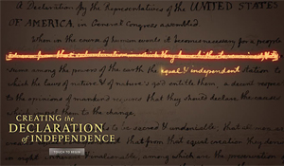 | 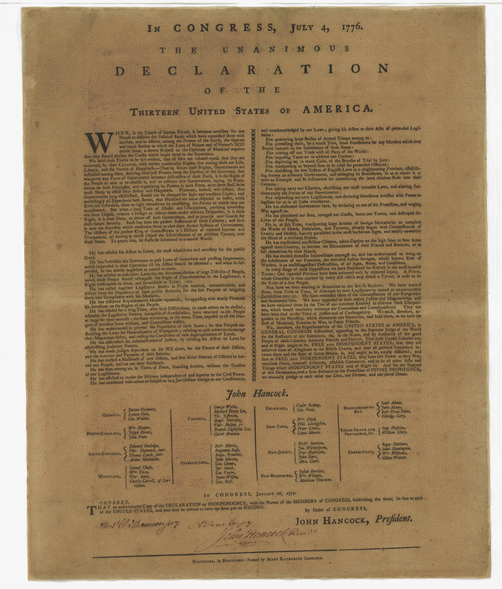 | 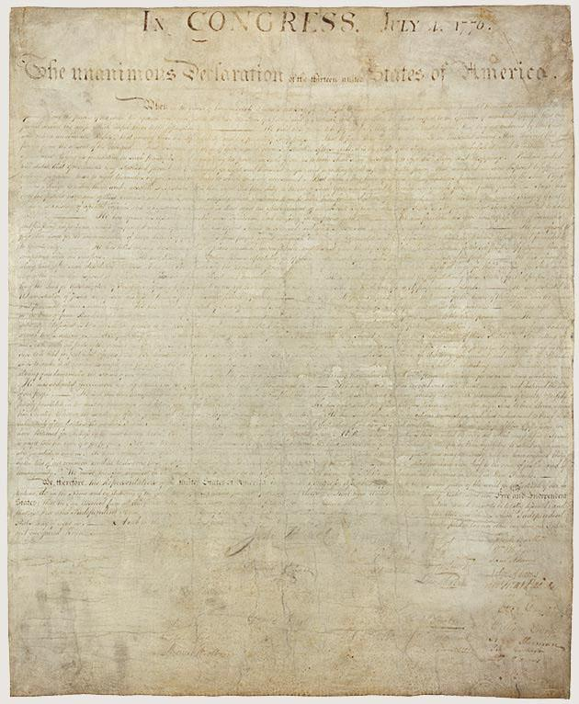 |  | 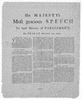
https://www.loc.gov/exhibits/treasures/trt001.html | http://www.loc.gov/exhibits/creating-the-united-states/interactives/declaration-of-independence/ | https://www.loc.gov/item/90898037/ | https://www.archives.gov/founding-docs/declaration | https://www.loc.gov/exhibits/declara/declara2.html | http://www.loc.gov/teachers/classroommaterials/presentationsandactivities/presentations/timeline/amrev/shots/address.html
Notes/Comments:

Resource Set
A patriot’s letter to his loyalist father | Extravagant and Inadmissible Claim of Independency | (Resource Title Here) | (Resource Title Here) | (Resource Title Here) | (Resource Title Here)
In February 1778, Timothy Pickering Jr., a general in George Washington’s Continental Army, wrote his dying father this moving letter of farewell on February 23, 1778, from his post in Yorktown, Virginia. Timothy Pickering Jr. revered his father but disagreed with him on one critical issue: colonial independence from Great Britain. | Article with the story of England's reaction to the Declaration of Independence including King George III address to Parliament Oct. 31, 1776. | (Short Description) | (Short Description) | (Short Description) | (Short Description)
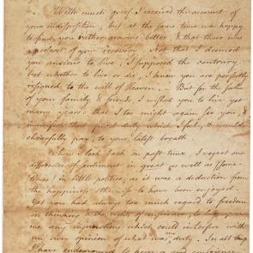 | 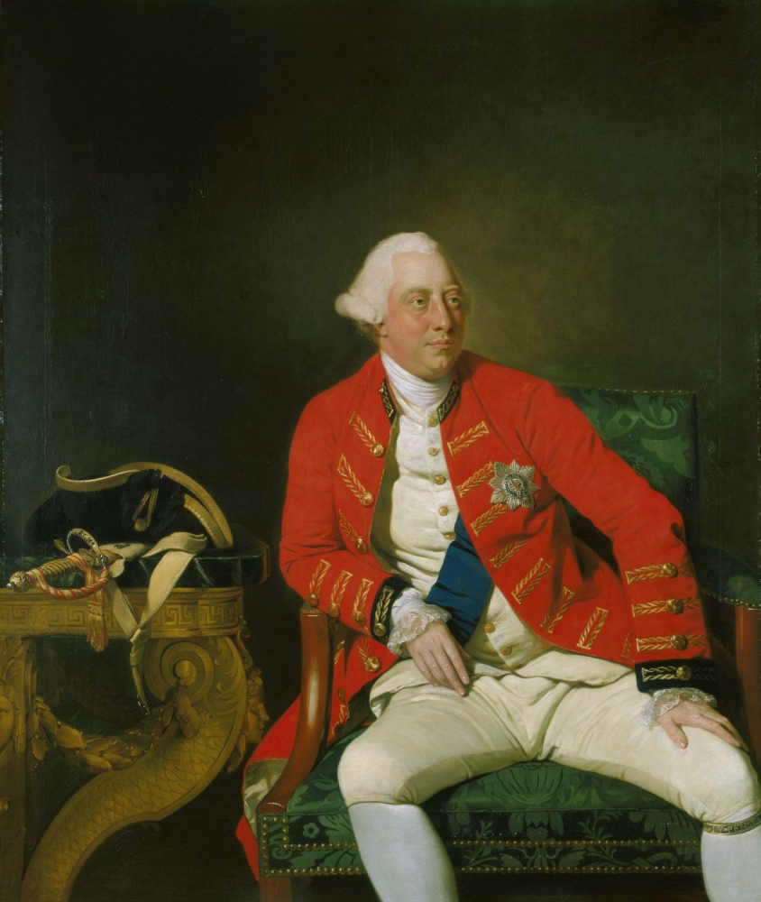 | (Right Click on the Image Placeholder then click “Replace Image”) | (Right Click on the Image Placeholder then click “Replace Image”) | (Right Click on the Image Placeholder then click “Replace Image”) | (Right Click on the Image Placeholder then click “Replace Image”)
https://www.gilderlehrman.org/history-by-era/war-for-independence/resources/patriot%E2%80%99s-letter-his-loyalist-father-1778 | http://declaration.fas.harvard.edu/blog/september-kings-speech | (Resource Link Here) | (Resource Link Here) | (Resource Link Here) | (Resource Link Here)
Notes/Comments:

Resource Set
(Resource Title Here) | (Resource Title Here) | (Resource Title Here) | (Resource Title Here) | (Resource Title Here) | (Resource Title Here)
(Short Description) | (Short Description) | (Short Description) | (Short Description) | (Short Description) | (Short Description)
(Right Click on the Image Placeholder then click “Replace Image”) | (Right Click on the Image Placeholder then click “Replace Image”) | (Right Click on the Image Placeholder then click “Replace Image”) | (Right Click on the Image Placeholder then click “Replace Image”) | (Right Click on the Image Placeholder then click “Replace Image”) | (Right Click on the Image Placeholder then click “Replace Image”)
(Resource Link Here) | (Resource Link Here) | (Resource Link Here) | (Resource Link Here) | (Resource Link Here) | (Resource Link Here)
Notes/Comments:

